Heavy Nucleosides LLC

**BUSINESS PLAN INNOVATIVE PROJECT**

Development of technology for isotope labeling of nucleosides

Nizhny Novgorod 2021

Table of contents

Introduction 5

Distribution of authorized capital 5

Information about the location, legal address 5

The field of activity of the enterprise, types of products and / or services provided 6

SCIENTIFIC COMPONENT OF AN INNOVATIVE PROJECT 6

Isotope indicator 6

Stable isotope labeling 7

Meselson-Stahl experiment 8

Overall needs assessment 9

Theoretical justification 10

Nuclear reactions 12

Carbon isotope 14С 14

Irradiation of nucleosides 15

H50287 1,3-Dimethyluracil-5-carboxaldehyde 16

L19664 1,3-Dimethyluracil 17

H33038 2,2'-O-Cyclouridine 18

L03686 2',3'-Isopropylideneuridine 19

44748 2-Aminoadenosine 20

A11166 2'-Deoxyadenosine monohydrate 21

A16026 2'-Deoxyuridine 22

H27412 2-Fluoroadenosine 23

H52741 3'-O-(4,4'-Dimethoxytrityl)-2'-deoxyinosine 24

H52408 3'-O-(4,4'-Dimethoxytrityl)thymidine 25

B21190 4-Methylumbelliferyl-beta-D-glucuronide 26

H61919 4-Thiouracil 27

L01996 5,6-Dihydro-5-methyluracil 28

L02292 5,6-Dihydro-6-methyluracil 29

L01918 5,6-Dihydrouracil 30

44378 5-Acetyluracil 31

L04452 5-Aminouracil 32

H27260 5-Bromo-2'-deoxyuridine 33

B21034 5-Bromo-4-chloro-3-indolyl-beta-D-galactopyranoside 34

A14799 5-Bromouracil 35

A18507 5-Bromouridine 36

44639 5-(Chloromethyl)uracil 37

L08490 5-Cyanouracil 38

L10861 5-Ethyluracil 39

L16496 5-Fluorocytosine 40

L01682 5-(Hydroxymethyl)uracil 41

B25173 5-Iodo-1,3-dimethyluracil 42

A18994 5-Iodouracil 43

H64259 5-Methyluridine 44

H55913 5-Nitro-6-methyluracil 45

A12448 5-Nitrouracil 46

44815 5'-O-(4,4'-Dimethoxytrityl)thymidine 47

H52780 5'-O-[(Diisopropylamino)-(2-cyanoethoxy)phosphinyl]-3'-O-(4,4'-dimethoxytrityl)-2'-deoxyinosine 48

H52301 5'-O-(tert-Butyldimethylsilyl)thymidine 49

H52782 5'-O-[(Diisopropylamino)-(2-cyanoethoxy)phosphinyl]-3'-O-(4,4'-dimethoxytrityl)thymidine 50

L16196 5-(Trifluoromethyl)uracil 51

44379 5-Vinyluracil 52

B25448 6-Amino-1-methyluracil 53

L03332 6-Aminouracil 54

B21131 6-Chloro-3-indolyl-beta-D-galactopyranoside 55

B21068 6-Chloro-3-indolyl-beta-D-glucuronide cyclohexylammonium salt 56

B21985 6-(Chloromethyl)uracil 57

L01875 6-Chlorouracil 58

H51694 6-(Diethoxymethyl)uracil 59

H66634 6-Iodouridine 60

B24191 6-Methyluracil 61

44467 6-(Trifluoromethyl)uracil 62

L03544 8-Bromoadenosine 63

L02992 8-Bromoguanosine hydrate 64

A16964 Adenine sulfate 65

L14029 Adenosine-5'-diphosphate disodium salt 66

L14051 Adenosine-5'-monophosphoric acid 67

L14522 Adenosine-5'-triphosphate disodium salt hydrate 68

A10781 Adenosine 69

L09020 beta-D-Glucosamine pentaacetate 70

H26557 Casein Peptone 71

A13707 Casein 72

H52427 D-erythro-Sphingosine hydrochloride 73

H27853 (E)-5-(2-Bromovinyl)-2'-deoxyuridine 74

H26507 Ethyl uracil-5-carboxylate 75

A14495 Flavin adenine dinucleotide disodium salt hydrate 76

A12024 Guanine 77

A11532 Guanine hydrochloride 78

A11328 Guanosine 79

A18579 Hematoporphyrin dihydrochloride 80

H26694 Meat Peptone 81

H31888 Methyl 1,2,3,4-tetra-O-acetyl-beta-D-glucuronate 82

H52303 N-Benzoyl-2'-deoxyadenosine 83

H52306 N-Benzoyl-3'-O-(4,4'-dimethoxytrityl)-2'-deoxyadenosine 84

H52799 N-Benzoyl-3'-O-(4,4'-dimethoxytrityl)-2'-deoxycytidine 85

H52807 N-Benzoyl-5'-O-[(diisopropylamino)-(2-cyanoethoxy)phosphinyl]-3'-O-(4,4'-dimethoxytrityl)-2'-deoxyadenosine 86

H52732 N-Benzoyl-5'-O-[(diisopropylamino)-(2-cyanoethoxy)phosphinyl]-3'-O-(4,4'-dimethoxytrityl)-2'-deoxycytidine 87

H52309 N-Benzoyl-5'-O-tert-butyldimethylsilyl-2'-deoxyadenosine 88

H52296 N-Benzoyl-5'-O-tert-butyldimethylsilyl-2'-deoxycytidine 89

H52730 N-Isobutyryl-2'-deoxyguanosine 90

H52746 N-Isobutyryl-3'-O-(4,4'-dimethoxytrityl)-2'-deoxyguanosine 91

H52411 N-Isobutyryl-5'-O-[(diisopropylamino)-(2-cyanoethoxy)phosphinyl]-3'-O-(4,4'-dimethoxytrityl)-2'-deoxyguanosine 92

H52726 N-Isobutyryl-5'-O-tert-butyldimethylsilyl-2'-deoxyguanosine 93

L16407 O,O'-Bis(trimethylsilyl)-5-fluorouracil 94

A11493 Thymidine 95

A15879 Thymine 96

H27219 Uracil-5-boronic acid 97

H51098 Uracil-5-carboxaldehyde 98

H50469 Uracil-6-carboxaldehyde monohydrate 99

A15570 Uracil 100

A18601 Uridine-5'-monophosphate disodium salt 101

Innovativeness 102

Created commercial product and its characteristics. 102

PROSPECTS FOR COMMERCIALIZATION 105

Competitive advantages 106

Planned cost of the product. Cost calculation. 106

Description of the business model of the project. Promotion strategy. 107

PROJECT TEAM 107

The number of employees, the direction of their activities and their qualifications 107

TECHNICAL SUPPORT OF PROJECT IMPLEMENTATION 108

FINANCIAL PLAN 109

Total project financing 109

Список литературы 111

## Introduction

**Project name**

Development of technology for isotope labeling of nucleosides.

**Business name**

NOTE: Heavy Nucleosides LLC, the working name of the future startup, has not yet been registered.

## Distribution of authorized capital

The authorized capital of Heavy Nucleosides LLC is distributed in a ratio of 51% owned by the founders and 49% - by investors involved at the stage of project acceleration.

## Information about the location, legal address

Depends on the accelerator

**Project site**

https://sites.google.com/view/bio-isotope-cloud

## The field of activity of the enterprise, types of products and / or services provided

The main activity of the company is the development of software and hardware for nuclear medicine and biotechnology to order, as well as modification and adaptation of third-party hardware and software, the development of robotic systems and IoT systems. The developed products are used for the production of radioactive isotopes for biotechnology labeled with radioactive isotopes of biological materials.

# SCIENTIFIC COMPONENT OF AN INNOVATIVE PROJECT

In connection with the growth of biotechnological, chemical, pharmacological, materials science (nanotechnology) research, the demand for tools and consumables used in research and production is growing. Isotope labeling is one of the widespread research methods.

Isotope labeling is a technique used to track the passage of an isotope (an atom with detectable variations in the number of neutrons) through a reaction, metabolic pathway, or cell. A reagent is "labeled" by replacing its specific atoms with an isotope. The reagent is then allowed to react. The position of isotopes in foods is measured to determine the sequence in which an isotopic atom follows in a reaction, or the metabolic pathway of a cell. Nuclides used in an isotopic label can be stable or unstable - radionuclides. In the latter case, the marking is called a radioactive label.

In isotopic labeling, there are several ways to detect the presence of labeled isotopes; through their mass, normal vibrations or radioactive decay. Mass spectrometry detects the difference in the mass of the isotope, while infrared spectroscopy detects the difference in the vibrational modes of the isotope. Nuclear magnetic resonance detects atoms with different gyromagnetic ratios. Radioactive decay can be detected using an ionization chamber or gel autoradiography.

An example of the use of isotopic labeling is the study of phenol (C6H5OH) in water by replacing ordinary hydrogen with deuterium (deuterium labeling). When phenol is added to heavy water (water containing D2O in addition to regular H2O), deuterium is substituted for hydrogen in the hydroxyl group of phenol (resulting in C6H5OD), indicating that phenol easily enters into hydrogen-water exchange reactions. Only the hydroxyl group is affected, indicating that the other 5 hydrogen atoms are not involved in exchange reactions.

## Isotope indicator

Isotopic markers or isotopic labels are used in chemistry and biochemistry to help understand chemical reactions and interactions. In this technique, one or more of the atoms in the molecule of interest is replaced with an atom of the same chemical element but a different isotope (eg, a radioactive isotope used in radioactive tracing). Since a labeled atom has the same number of protons, it will behave in much the same way as its unlabeled counterpart and, with a few exceptions, will not interfere with the reaction under study. However, the difference in the number of neutrons means that it can be detected separately from other atoms of the same element.

Nuclear magnetic resonance (NMR) and mass spectrometry (MS) are used to study the mechanisms of chemical reactions. NMR and MS reveal isotopic differences, which makes it possible to determine information about the position of labeled atoms in the structure of products. Having information about the arrangement of isotopic atoms in products, it is possible to determine the reaction path that the initial metabolites use to convert into products. Radioactive isotopes can be checked with a gel autoradiograph in gel electrophoresis. The radiation emitted by compounds containing radioactive isotopes darkens a piece of photographic film, registering the position of the labeled compounds relative to each other in the gel.

Isotope tracers are usually used in the form of isotope ratios. By studying the ratio between two isotopes of the same element, we avoid effects related to the total abundance of the element, which usually overlap much smaller variations in isotope abundance. Tracers are some of the most important tools in geology because they can be used to understand the complex mixing processes in earth systems. Further discussion of the application of isotope tracers in geology is contained in the section on isotope geochemistry.

Tracer isotopes generally fall into two categories: stable isotope indicators and radiogenic isotope indicators. Stable isotope indicators include only non-radioactive isotopes and are usually mass-dependent. In theory, any element with two stable isotopes can be used as an isotopic indicator. However, the most commonly used indicators of stable isotopes include relatively light isotopes that are readily fractionated in natural systems (isotope signature). A radioactive isotope tracer includes an isotope resulting from radioactive decay, which is usually in proportion to non-radioactive ones.

## Stable isotope labeling

Stable isotope labeling involves the use of non-radioactive isotopes, which can act as indicators used to model several chemical and biochemical systems. The selected isotope can act as a label on this compound, which can be identified using nuclear magnetic resonance (NMR) and mass spectrometry (MS). Some of the most common stable isotopes are H2, C13 and N15, which can be further converted to NMR solvents, amino acids, nucleic acids, lipids, general metabolites, and cell growth media. Compounds obtained using stable isotopes are determined either by the percentage of labeled isotopes (i.e. 30% of homogeneously labeled C13 glucose contains a mixture 30% labeled with a C13 carbon isotope and 70% natural C12 carbon) or by specially marked carbon positions per compound ( i.e. 1-C13 glucose, which means that the first glucose position is C13).

Let us consider the sequence of reactions borrowed from the glycolysis and pentose phosphate pathways, in which the labeled carbon isotope is rearranged to different carbon positions throughout the reaction network.

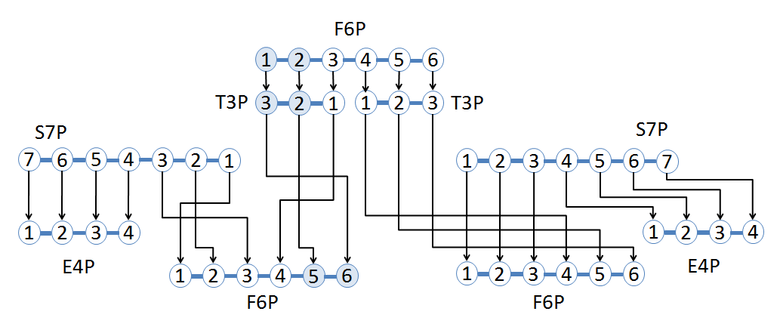

Figure 1 - An example of using a stable isotope tag to detect rearrangement of carbon atoms by reactions using position-specific labeled compounds.

The sequence starts with fructose-6-phosphate (F6P), which has 6 carbon atoms labeled with 13 C at carbon positions 1 and 2. 1,2-C13 F6P converts to two glyceraldehyde-3-phosphate (G3P), one 2,3 - C13 T3P and one unmarked T3P. 2,3-C13 T3P can now be reacted with sedoheptulose 7-phosphate (S7P) to form unlabeled erythrose 4-phosphate (E4P) and 5,6-C13 F6P. Unlabeled T3P will react with S7P to synthesize unlabeled products.

## Meselson-Stahl experiment

The Meselson-Stahl experiment illustrates not only a variant of the research approach, but also the need for isotopic production when using this biotechnological tool.

Meselson and Stahl conducted their famous DNA replication experiments using E. coli bacteria as a model system. They began by growing E. coli in a nutrient medium containing the "heavy" nitrogen isotope N15. When grown in this medium, the bacteria absorbed nitrogen and used it to synthesize new biological molecules, including DNA.

After many generations of cultivation in N15 media, the nitrogenous bases of bacterial DNA were labeled with heavy N15. The bacteria were then transferred to a medium containing the N14 isotope and allowed to grow for several generations. The DNA created after the switch must include the N14 isotope, as that would be the only nitrogen available for DNA synthesis.

Meselson and Stahl knew how often E. coli cells divide, so they were able to collect small samples in each generation, extract and purify DNA. They then measured the DNA density (and indirectly, the N14 and N15 isotopes) using density gradient centrifugation. This method separates molecules such as DNA into strips by rotating them at high speed in the presence of another molecule, such as cesium chloride, which forms a density gradient from the top to the bottom of the rotating tube. Density gradient centrifugation allows for very small differences - for example, between N14 and N15 labeled DNA, but sufficient for detection.

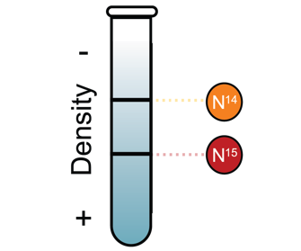

Figure 2 - Principle of determination of isotopes by density

When analyzing the DNA of the first four generations of E. coli, a band pattern was obtained, shown in the figure below:

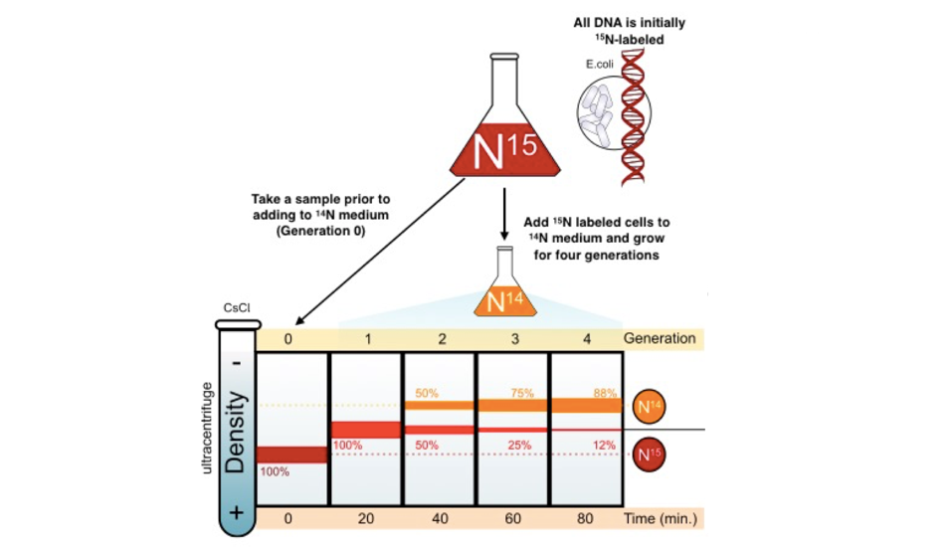

Figure 3 - Analysis of the results of the Meselson-Stahl experiment

Based on this historical experiment, Meselson and Stahl concluded that DNA replicates semi-conservatively. The structure of two separate bands - one at the position of the hybrid molecule and one at the position of the light molecule - is exactly what is expected from semi-conserved replication (as shown in the diagram below).

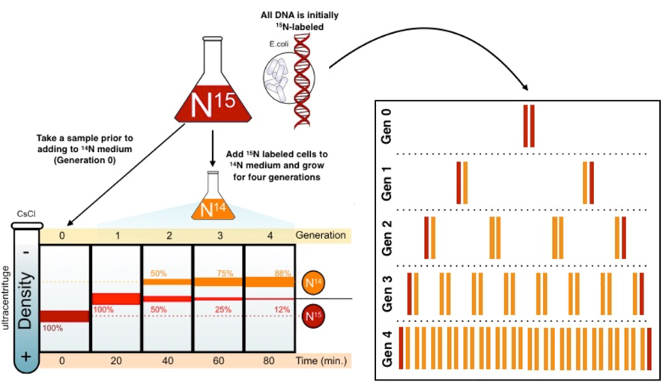

Figure 4 - Analysis of the results of the Meselson-Stahl experiment

## Overall needs assessment

As shown in the examples above, biotechnology researchers need isotopes as labels.

We conducted a market analysis and identified the most commonly performed type of experiment - isotopic DNA labeling. For this method, there is a demand for isotopes O15, N15, C13.

The following nuclear reactions:

N14 -> N13 -> C13,

N14 -> O17,

O16 -> O17,

O17 -> C14

can be carried out in laboratory conditions using sources of ionizing radiation.

There are source restrictions on nuclear reactions. In laboratory installations, sources produced by the State Corporation Rosatom of JSC "Isotope" can be used and, accordingly, only those reactions that are possible with available sources will be possible. If it is impossible to cooperate with Rosatom State Corporation, it is possible to purchase sources on the European or American market, and it is also possible to use sources from household appliances, for example, from fire alarm sensors.

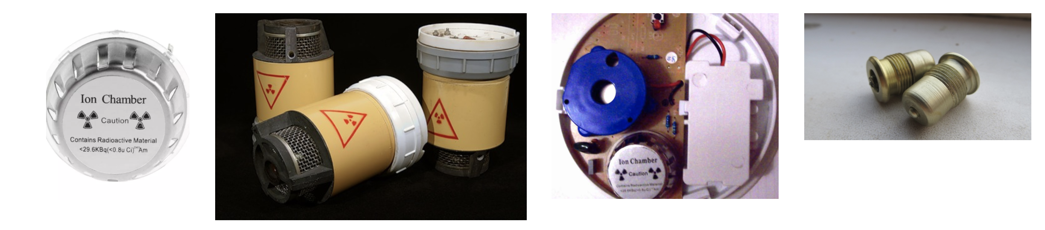

## Theoretical justification

Nucleosides are the structural subunit of nucleic acids such as DNA and RNA. The nucleoside, consisting of a nitrogenous base, is pyrimidine (cytosine, thymine, or uracil) or purine (adenine or guanine), a five-carbon sugar that is ribose or deoxyribose. Nucleosides play an important role in intermediate metabolism, biosynthesis of macromolecules and transmission of cellular signals through interaction with purinergic receptors. In the medical field, several nucleosides are used as antiviral or anti-cancer agents. Several new nucleosides show a high degree of activity and selectivity against herpes viruses. Nucleosides are responsible for encoding, transmitting and expressing genetic information in all living things.

Nucleotides are the building blocks of nucleic acids, DNA and RNA. Nucleotides are composed of a nitrogenous base, five carbon sugar (ribose or deoxyribose), and at least one phosphate group. Thus, a nucleoside plus a phosphate group produces a nucleotide. The components used in the de novo synthesis of nucleotides are derived from biosynthetic precursors of carbohydrate and amino acid metabolism, as well as from ammonia and carbon dioxide. Nucleoside triphosphates (ATP, GTP, CTP and UTP) play a central role in cell metabolism. Defective nucleotides are one of the main causes of all types of cancer known today.

Certain nucleotides and nucleoside analogs inhibit revarese-transcriptase, an enzyme that controls the replication of the genetic material of the human immunodeficiency virus (HIV) and other retroviruses.

|  |  |  |
| --- | --- | --- |
| Nitrogen base | Nucleoside | Deoxynucleoside |
| Chemical structure of adenine  Adenine | **A**  Chemical structure of adenosine  Adenosine | **dA**  Chemical structure of deoxyadenosine  Deoxyadenazine |
| Chemical structure of guanine  Guanine | **G**  Chemical structure of guanosine  Guanosine | **dG**  Chemical structure of deoxyguanosine  Deoxyguanosine |
| Chemical structure of thymine  Timin | **m5U**  Chemical structure of 5-methyluridine  5-Methyluridine | **dT**  Chemical structure of thymidine  Deoxythymidine |
| Chemical structure of uracil  Uracil | **U**  Chemical structure of uridine  Uridine | **dU**  Chemical structure of deoxyuridine  Deoxyuridine |
| Chemical structure of cytosine  Cytosine | **С**  Chemical structure of cytidine  Cytidine | **dC**  Chemical structure of deoxycytidine  Deoxycytidine |

Isotope-labeled nucleosides are used in research works [2] “Most of the methods used to detect replication activity are based on the incorporation of modified nucleosides into replicated DNA and their subsequent detection. The first nucleoside markers used radioisotopes to label and detect them. Examples of such isotopically labeled nucleosides are N15-thymidine [3] and C14-thymidine [4-6]. This technology has shown that, for example, thymidine is a precursor of DNA, but not RNA [3]. "

In 1957, Taylor and colleagues developed a method in which they used H3-thymidine to label replicated DNA in the root of a bean and autoradiography to detect it.

There are alternative methods of labeling, however "... the efficiency of phosphorylation and incorporation into DNA of nucleosides not labeled with isotopes is usually lower than in the case of nucleosides labeled with isotopes." [2]

The expansion of Meselson-Stahl research has led to the study of DNA-based stable isotopes, which allow the study of the relationship between metabolic function and the taxonomic identity of microorganisms in the environment without the need to isolate cultures. Proteins can be labeled by cultivating them in an isotopic environment.

If we look at the composition, we see that for marking we need isotopes of the elements: H, N, O, C.

#### Nuclear reactions

***Isotope of hydrogen – Tritium***

36Li + n -> 13H + 24He

Tritium has a half-life (12.32 ± 0.02) years [7]

***Nitrogen isotopes***

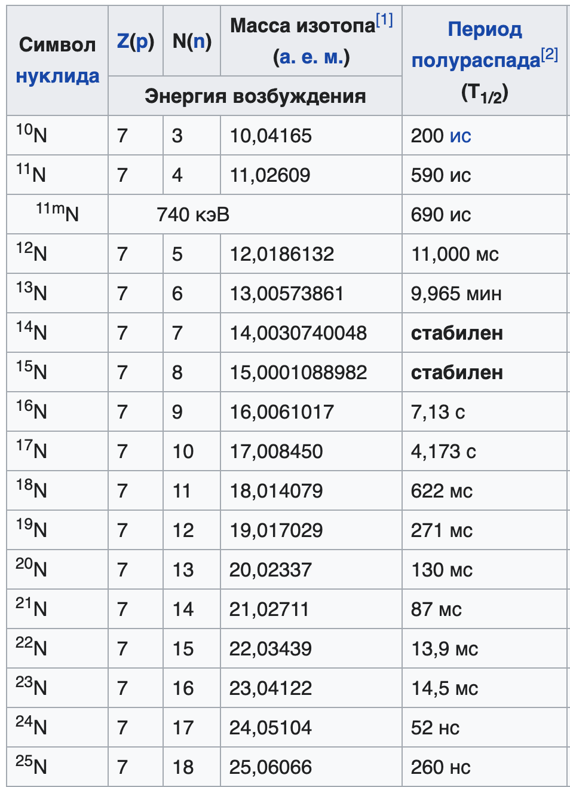

Data are given in [8-9]

Natural nitrogen 7N consists of two stable isotopes:

* natural nitrogen 14N – 99,6%;
* nitrogen 15N – rest.

The rest of the isotopes can be obtained using nuclear reactions.

714N+ **γ** -> 713N + n [10]

815O -> 715N + e+ +νe

615C -> 715N+ e- +νe—

Decay modes [11]

712N->612C+ e+ +νe T1/2=11мс

713N->613C+ e+ +νe

716N->816O+ e- +νe-- T1/2=7,13(2)с

716N->612C+24He + e- +νe-- T1/2=7,13(2)с

717N->816O+1n + e- +νe-- T1/2=4,173(4)с 95%

***Oxygen isotopes***

Natural oxygen consists of three stable isotopes, 16O, 17O and 18O, of which the isotope 16O is the most abundant (99.762%) oxygen isotope

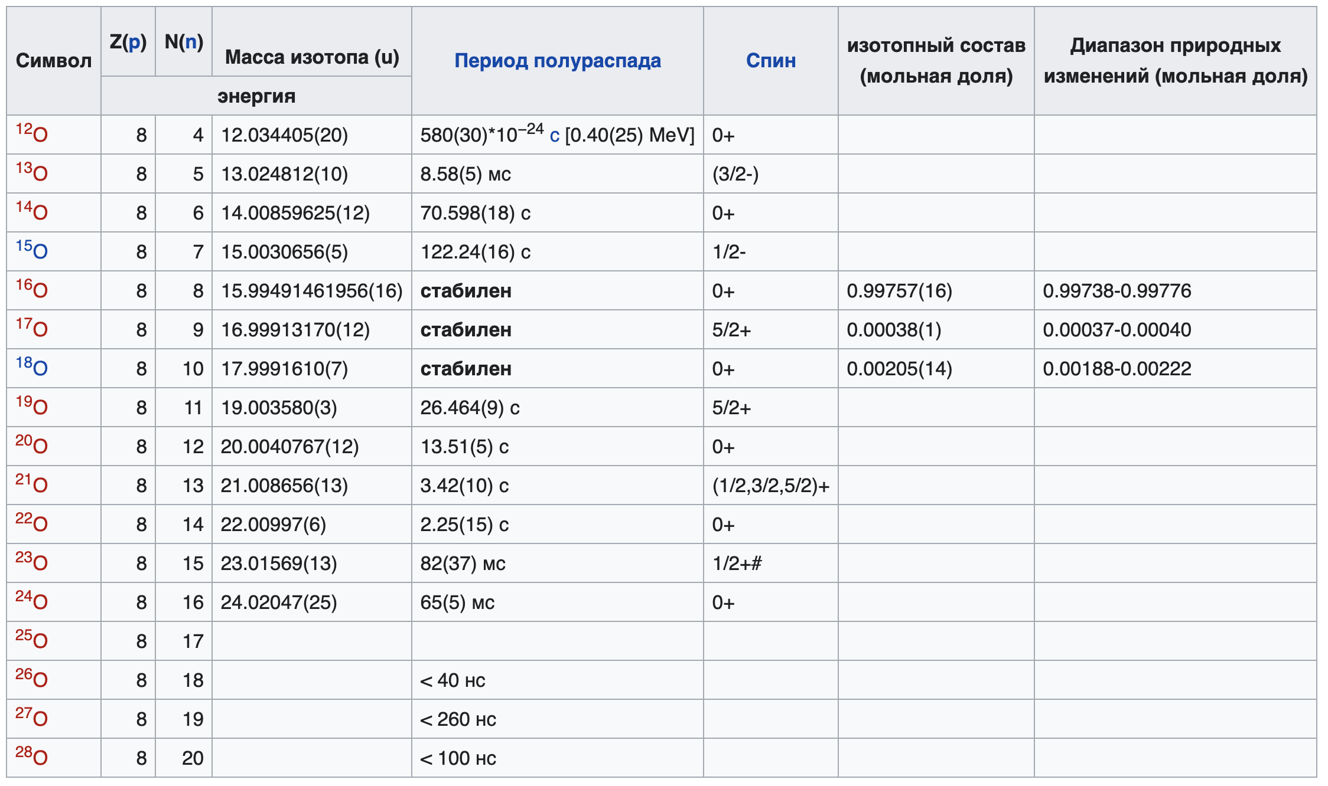

Basic reactions:

714N+ 24He -> 817O + 11p – Rutherford reaction 1919г.

816O+ **γ** -> 815O + 1n [11]

#### Carbon isotope 14С

Carbon has two stable isotopes, 12C and 13C. The content of these isotopes in natural carbon is 98.93% and 1.07%, respectively. There are also known 13 radioactive isotopes of carbon (from 8C to 22C), of which one - 14C - occurs in nature (its content in atmospheric carbon is about 10-12).

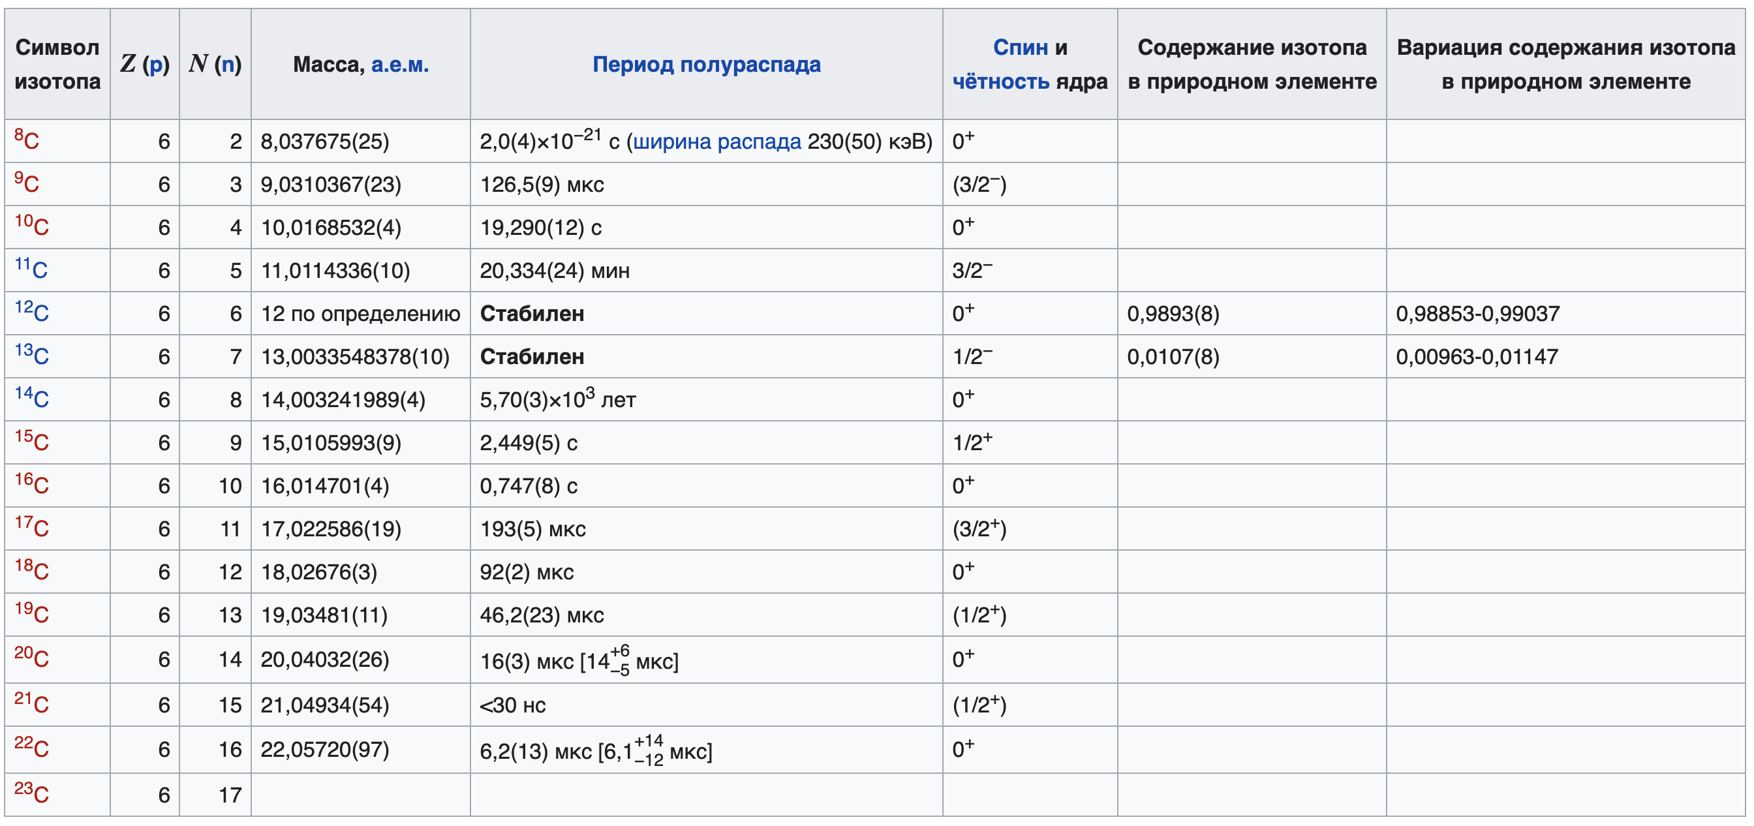

In addition to stable isotopes of carbon, the radioactive isotope 14C (radiocarbon) is found in nature. It is formed by irradiation with 14N neutrons by the following reaction:

714N+ 1**n** -> 614N + 11p

In addition to the nitrogen reaction, 14C can be formed upon neutron irradiation of the oxygen isotope 17O by the reaction:

817O + n → 614C + α, however, the content of 17O in the atmosphere is extremely low and this path of 14C formation is taken into account only in nuclear technologies.

**Marking methods**

For the production of radioisotope labeling, you can use a laboratory installation with the following schematic diagram:

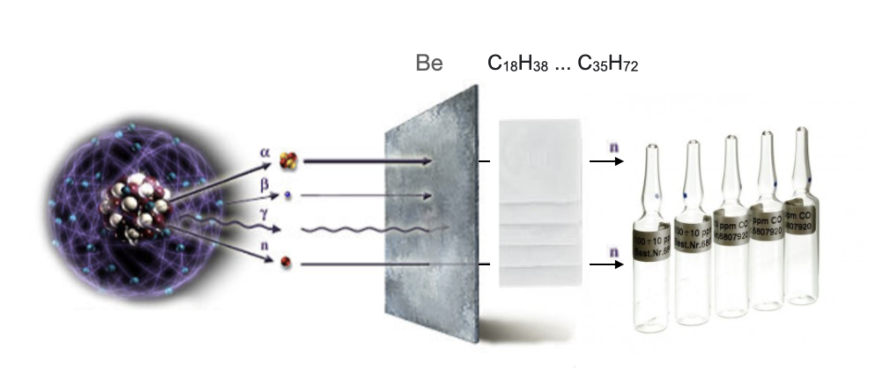

Three types of marking are possible:

1. Irradiation of the nucleoside

2. Chemical substitution

3. Cultivation of biological culture in an isotopic environment

The last two methods are more laborious, since, in addition to compliance with radiation safety standards, requirements for chemical and biological protection are added, therefore the first method is promising - irradiation of nucleosides.

### Irradiation of nucleosides

The technological process is quite simple - we place the ampoule with the nucleoside into the neutron flux.

Objective of the study: to clarify the dependence of the release of labeled nucleosides on the flux intensity, type of radiation, radiation time, as well as the type of label H, N, O, C and the probability of release.

Nucleosides are commercially available, below was the cost of the supplier AlfaAesar by Thermo Fisher Scientific [12]

Some drugs are fluorogenic. Their use is valuable in that there are two ways to measure concentration - by isotope and by luminescence intensity, and if you use short-lived isotopes, it is also possible to determine the speed, provided that the fluorescent properties will not be lost during the decay of the label.

The obtained dependences will have commercial value, according to which it is possible to create technological processes for the production of radioisotope-labeled drugs for modern biotechnological research.

The scientific value of this area is the search for opportunities and options for using short-lived isotopes in biotechnological research.

#### H50287 1,3-Dimethyluracil-5-carboxaldehyde

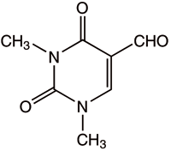

1,3-Dimethyluracil-5-carboxaldehyde [13]

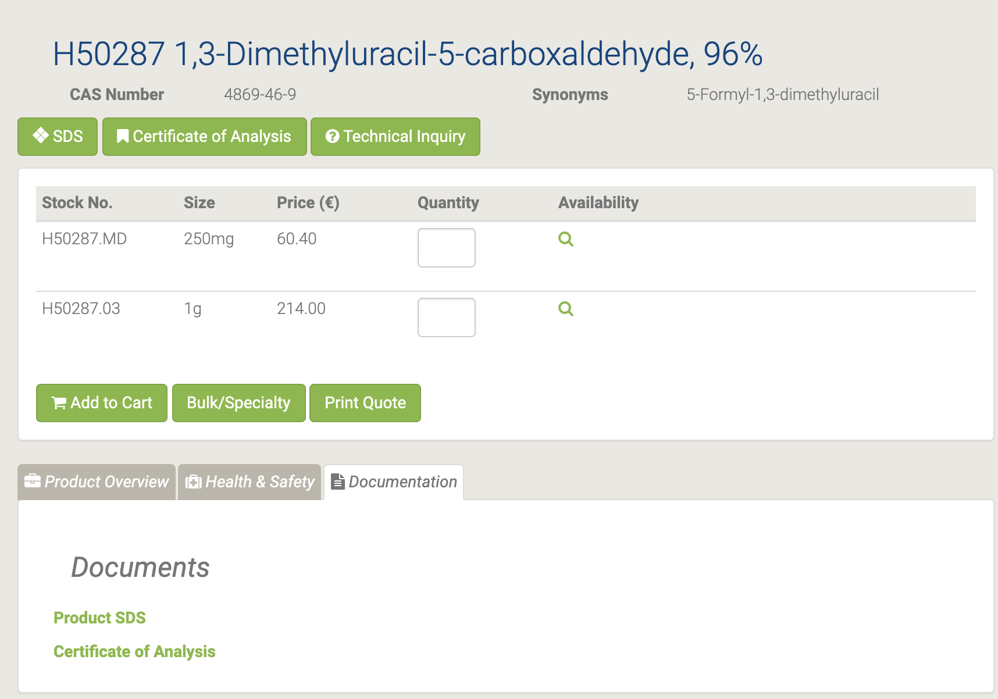

#### L19664 1,3-Dimethyluracil

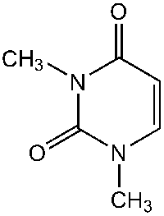

L19664 1,3-Dimethyluracil [14]

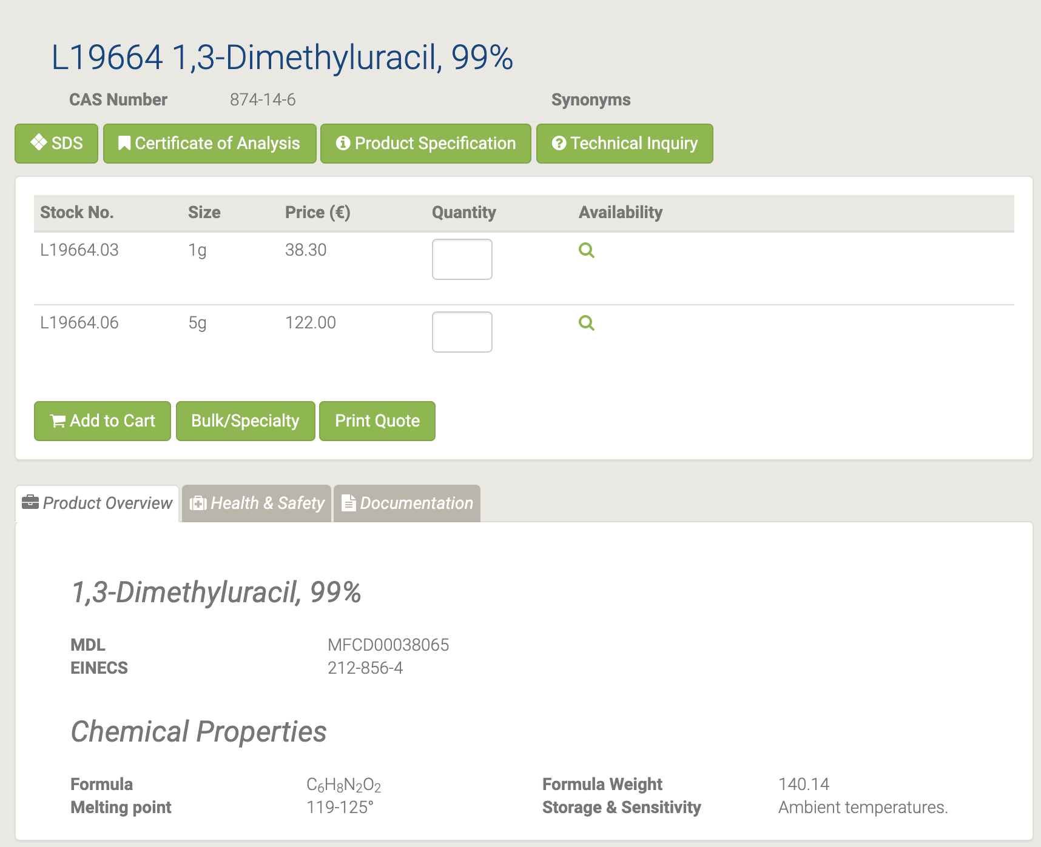

#### H33038 2,2'-O-Cyclouridine

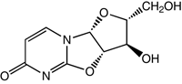

H33038 2,2'-O-Cyclouridine [15]

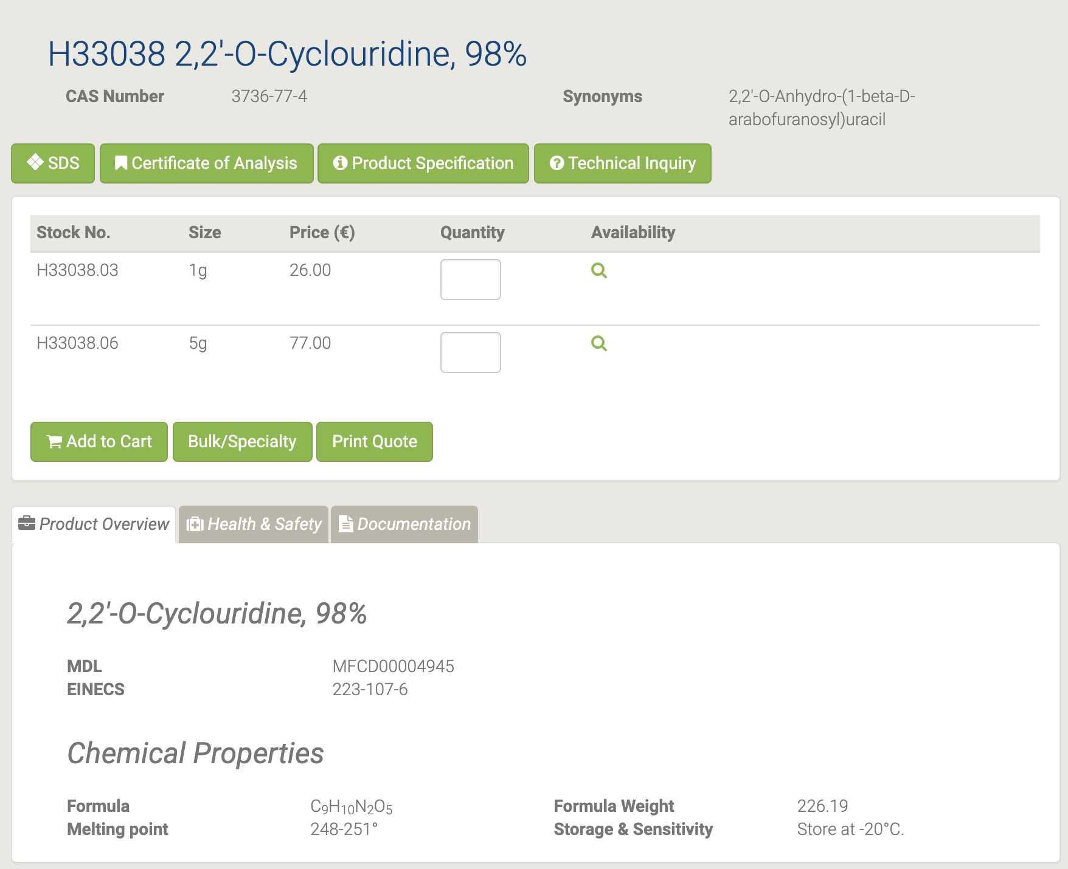

#### L03686 2',3'-Isopropylideneuridine

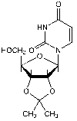

L03686 2',3'-Isopropylideneuridine [16]

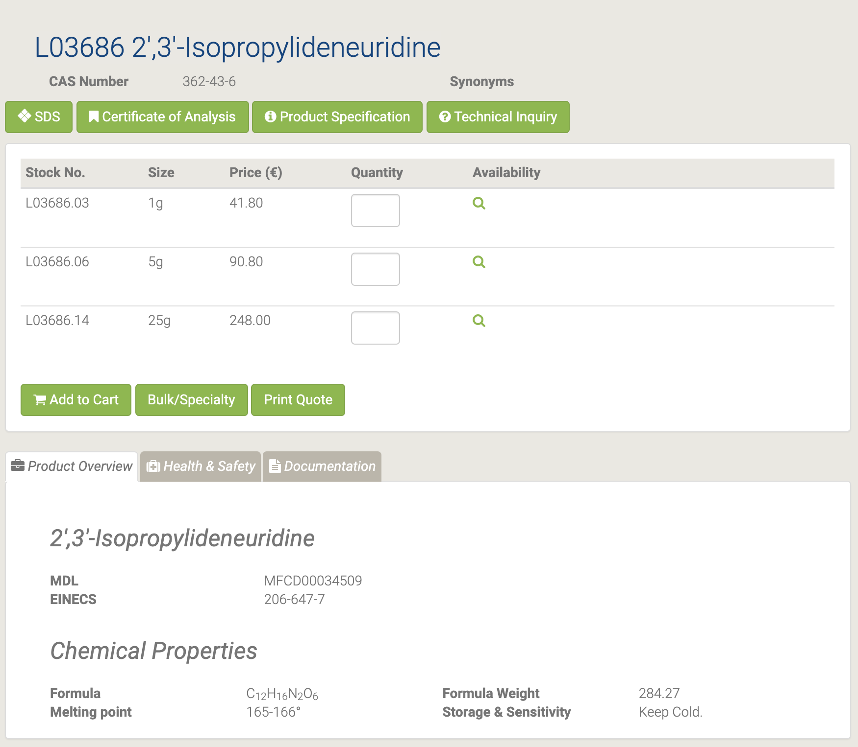

#### 44748 2-Aminoadenosine

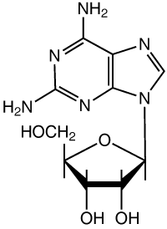

44748 2-Aminoadenosine [17]

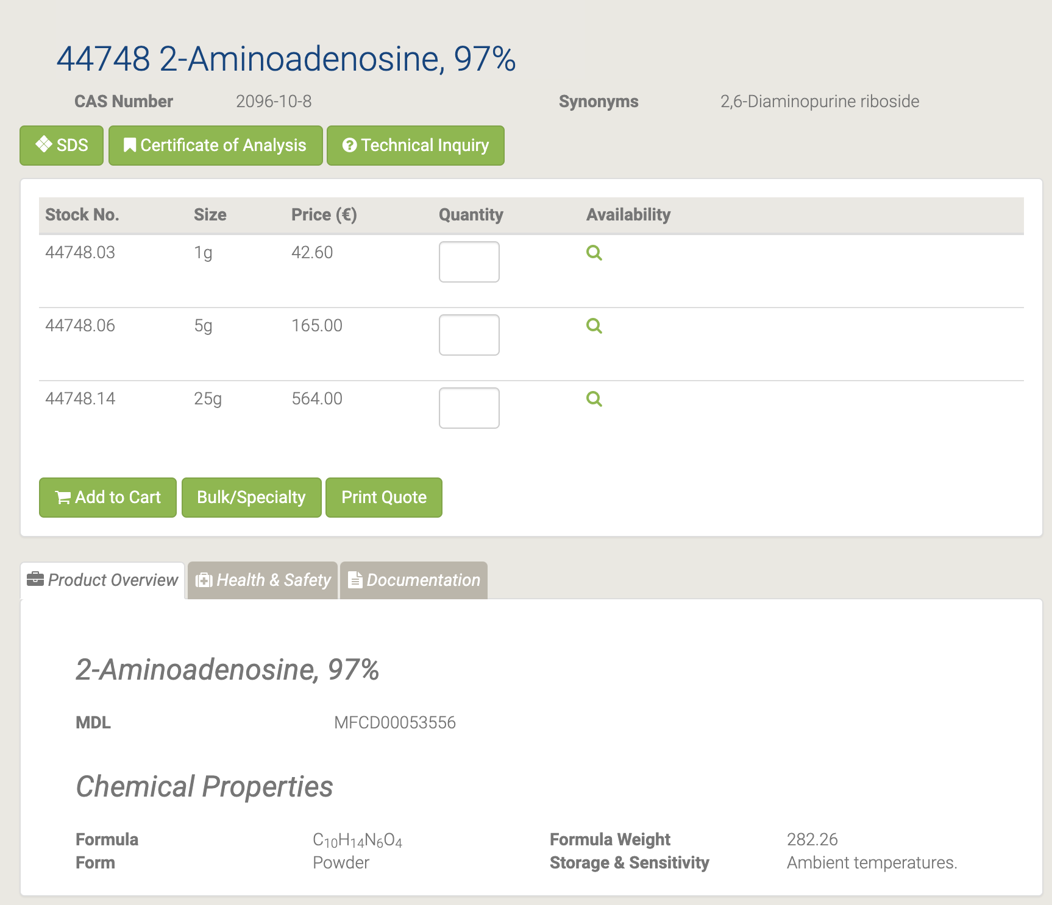

#### A11166 2'-Deoxyadenosine monohydrate

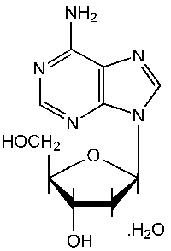

A11166 2'-Deoxyadenosine monohydrate [18]

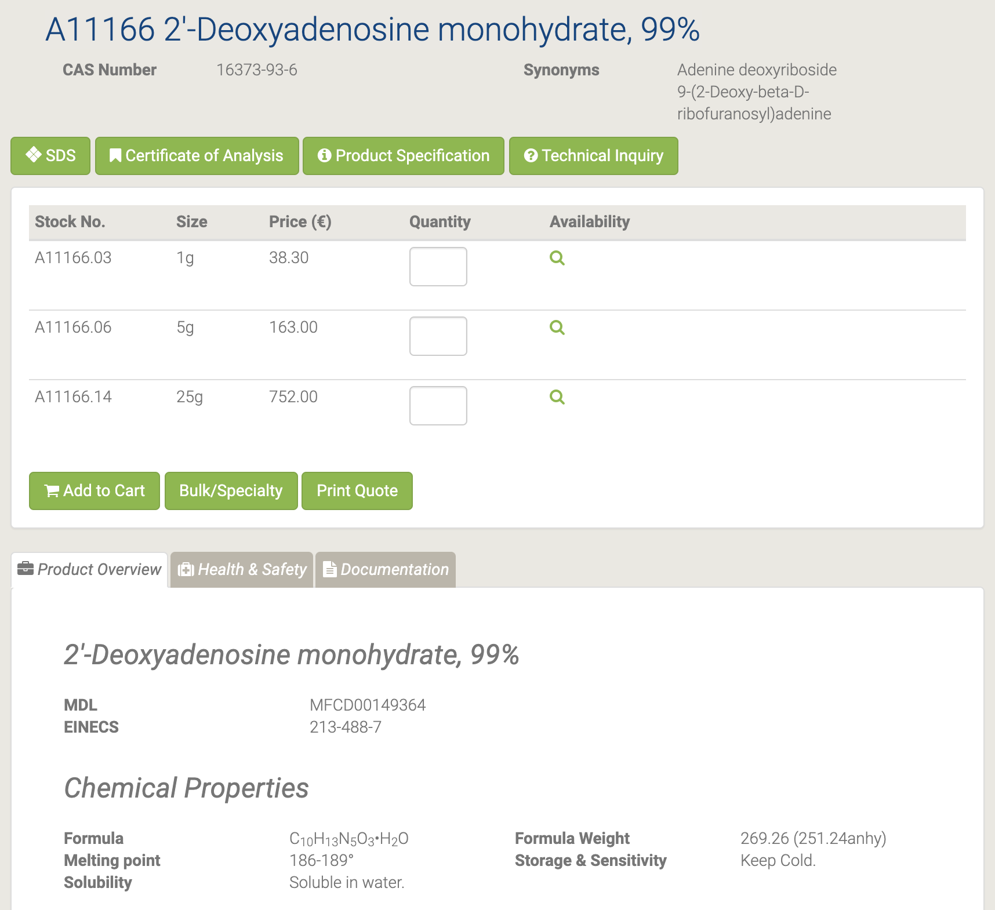

2’-Деоксиаденозин используется некоторыми клетками в качестве источника энергии в условиях энергетического стресса и влияет на уровни цАМФ. 2’ - Деоксиаденозин используется в сравнительных исследованиях функций аналогов аденозина на различные биологические процессы.

#### A16026 2'-Deoxyuridine

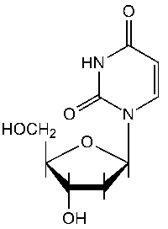

A16026 2'-Deoxyuridine [19]

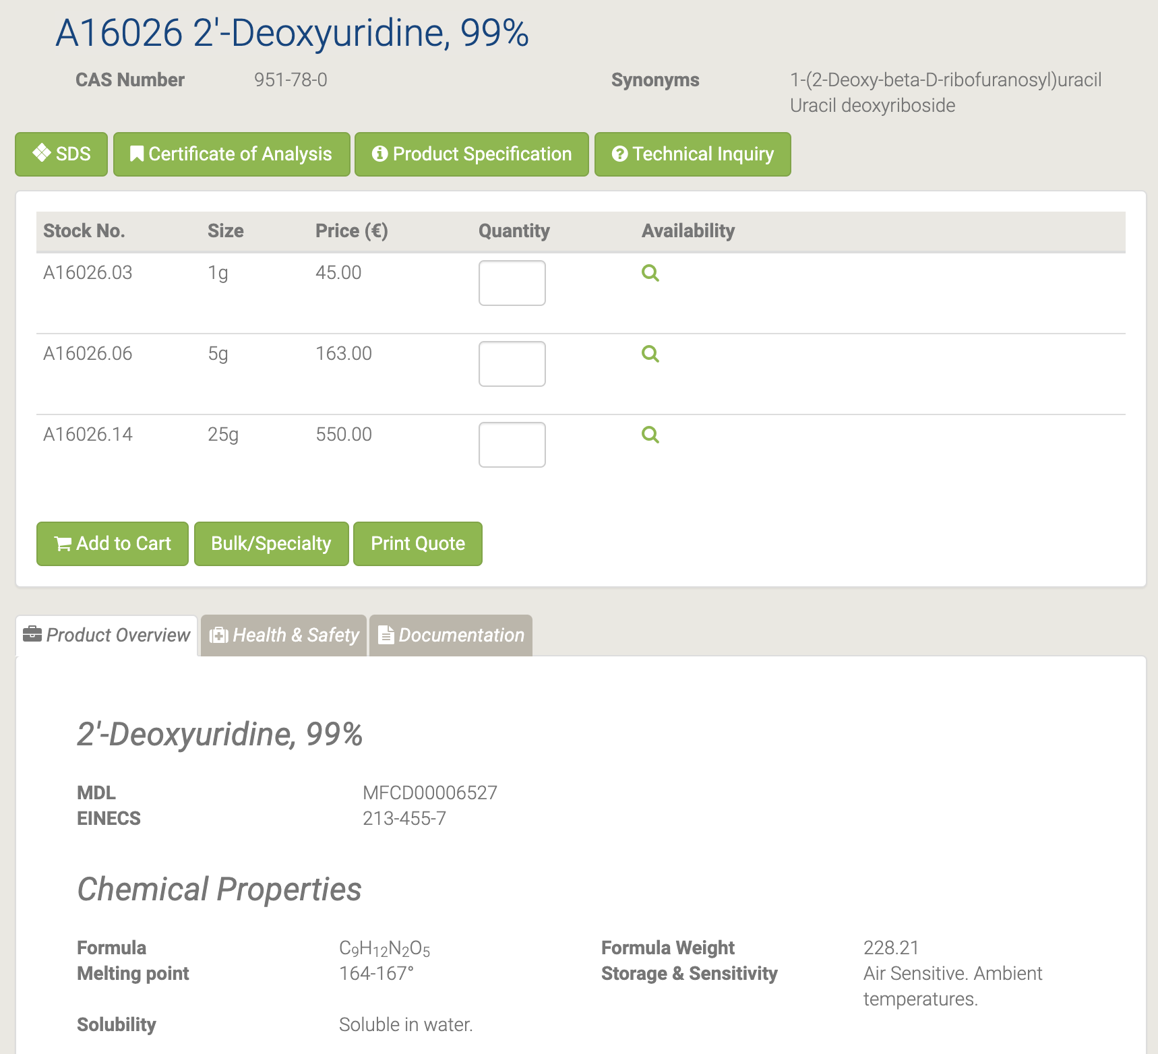

2'-дезоксиуридин часто галогенируют для создания аналогов тимидина, полезных для изучения механизмов синтеза и деградации ДНК. Дериватизированные 2’-деоксиуридины, используемые в качестве субстратов для мечения, включают хлор-2’-дезоксиуридин (CldU), бромдезоксиуридин (BrdU) и / или йоддезоксиуридин (IdU). Другие полезные аналоги 2’-дезоксиуридина включают 5-этинил-2’-дезоксиуридин (DdU) и 5-гидроксиметил-2’-дезоксиуридин (HmdU). Лабораторное подавление дезоксиуридина используется для диагностики мегалобластных анемий из-за дефицита витамина B12 и фолиевой кислоты. Дезоксиуридин (dU) используется для косвенного определения наличия достаточных уровней фолиевой кислоты и кобаламина в образцах клеток или тканей.

#### H27412 2-Fluoroadenosine

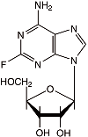

H27412 2-Fluoroadenosine [20]

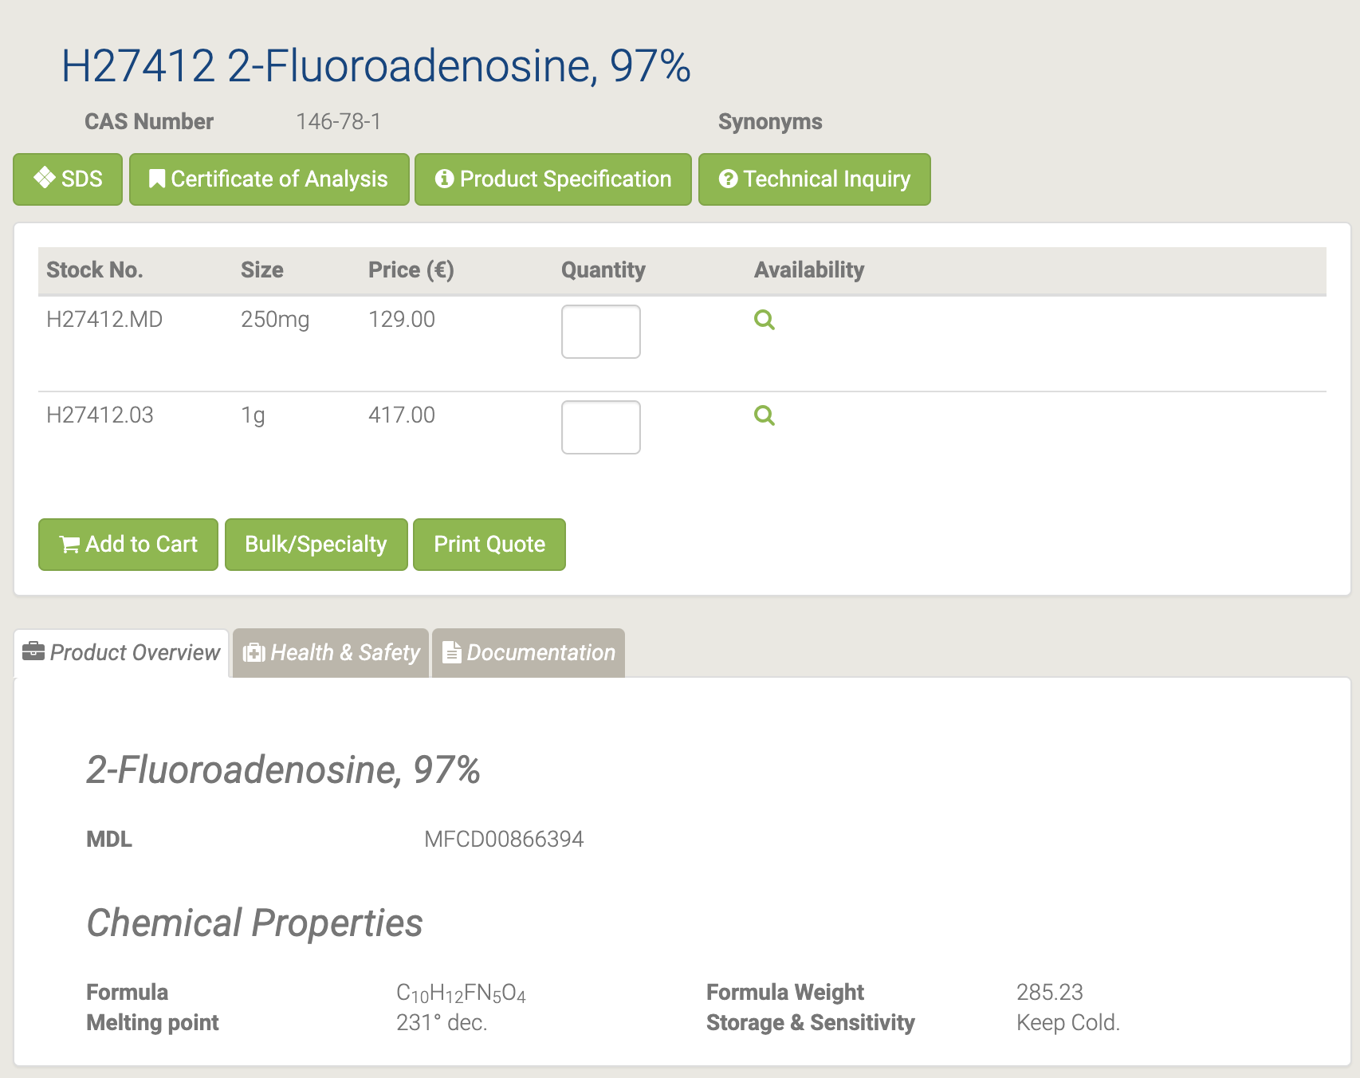

#### H52741 3'-O-(4,4'-Dimethoxytrityl)-2'-deoxyinosine

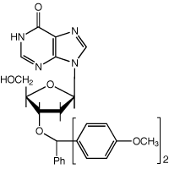

H52741 3'-O-(4,4'-Dimethoxytrityl)-2'-deoxyinosine [21]

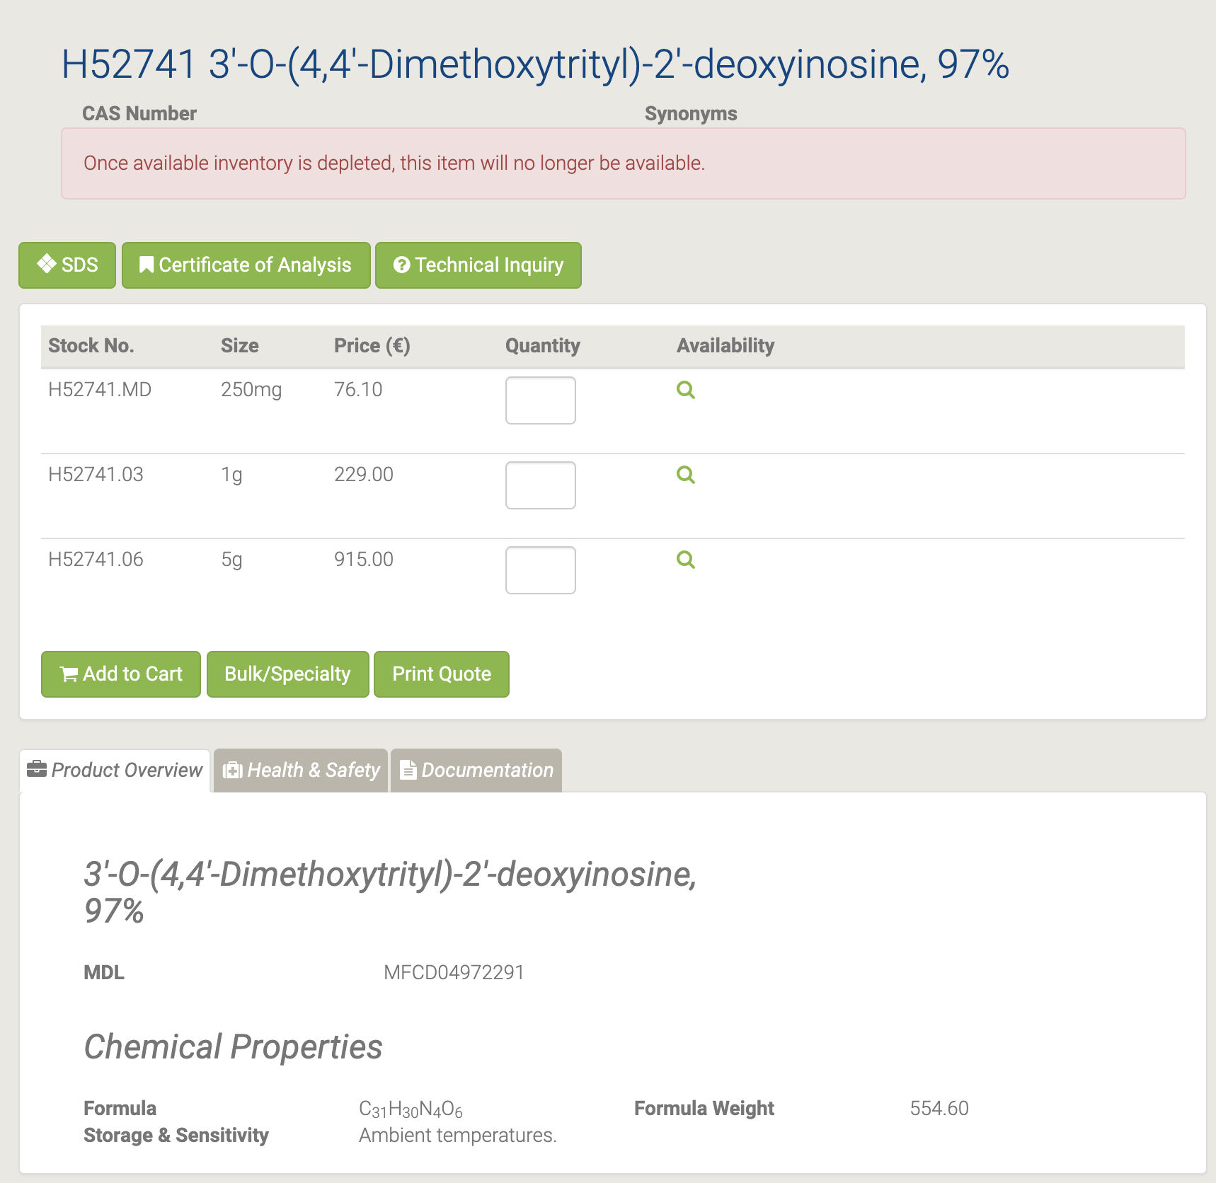

#### H52408 3'-O-(4,4'-Dimethoxytrityl)thymidine

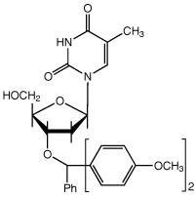

H52408 3'-O-(4,4'-Dimethoxytrityl)thymidine [22]

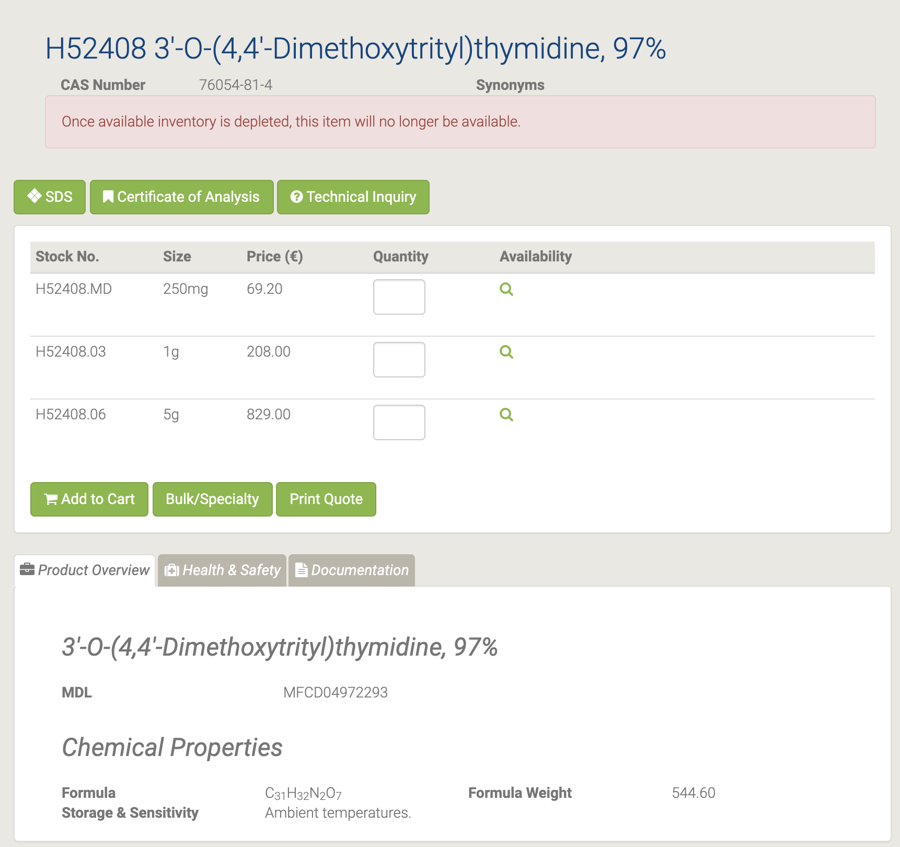

#### B21190 4-Methylumbelliferyl-beta-D-glucuronide

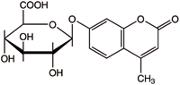

B21190 4-Methylumbelliferyl-beta-D-glucuronide [23]

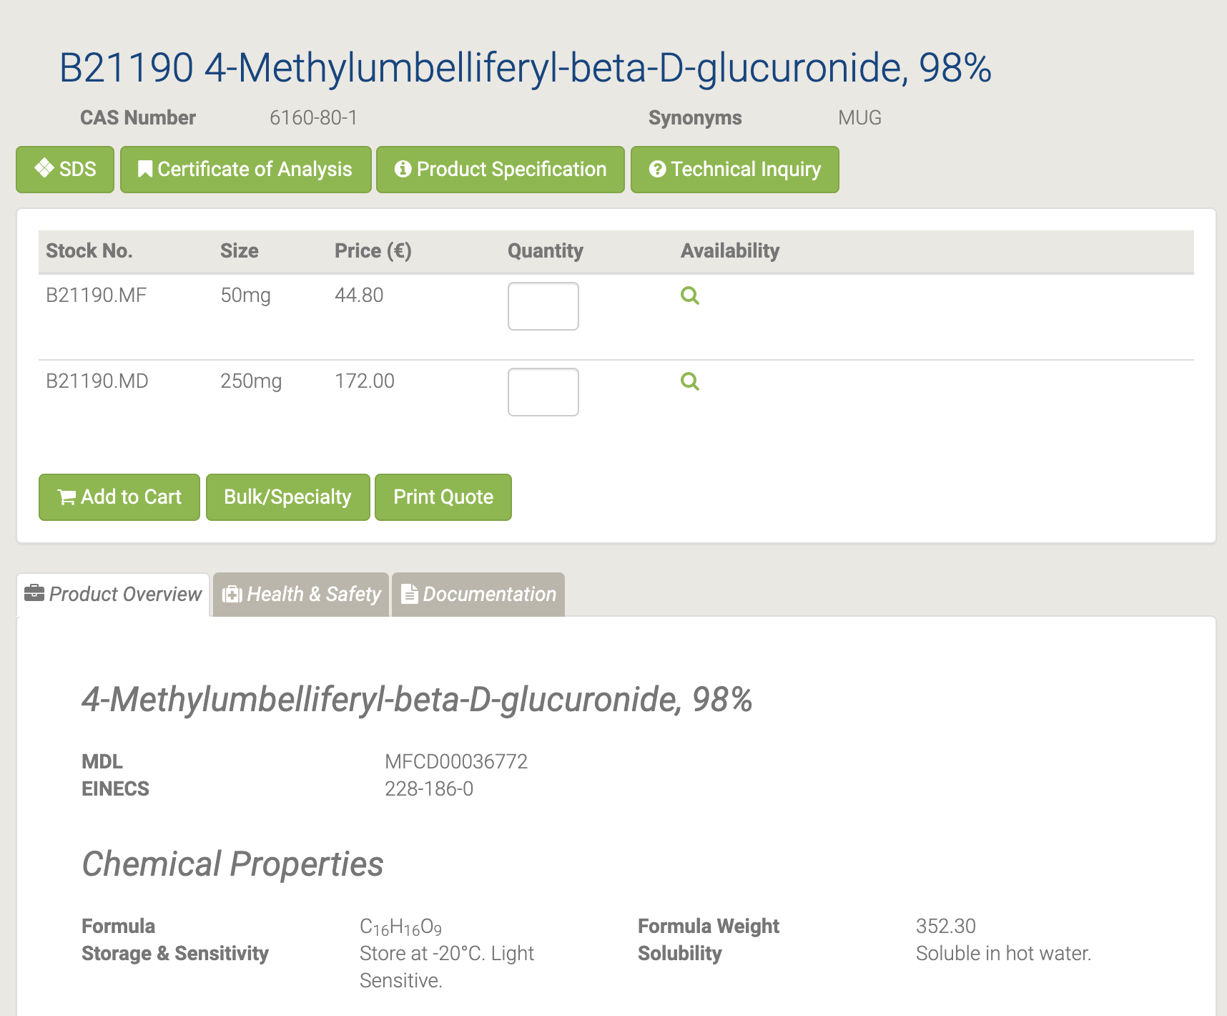

Это флуорогенный субстрат для измерения активности ß-глюкуронидиазы для быстрой чувствительной идентификации Escherichia coli. MUG является субстратом для глюкуронидазы. Он идеально подходит для молекулярных исследований растений как способ изучения экспрессии генов под различными промоторами. И хотя он хорошо работает для измерения активности лизата растений и дисков листьев, он также может работать в анализах всего растения.

#### H61919 4-Thiouracil

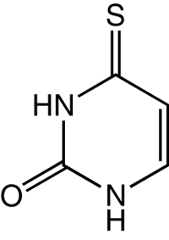

H61919 4-Thiouracil [24]

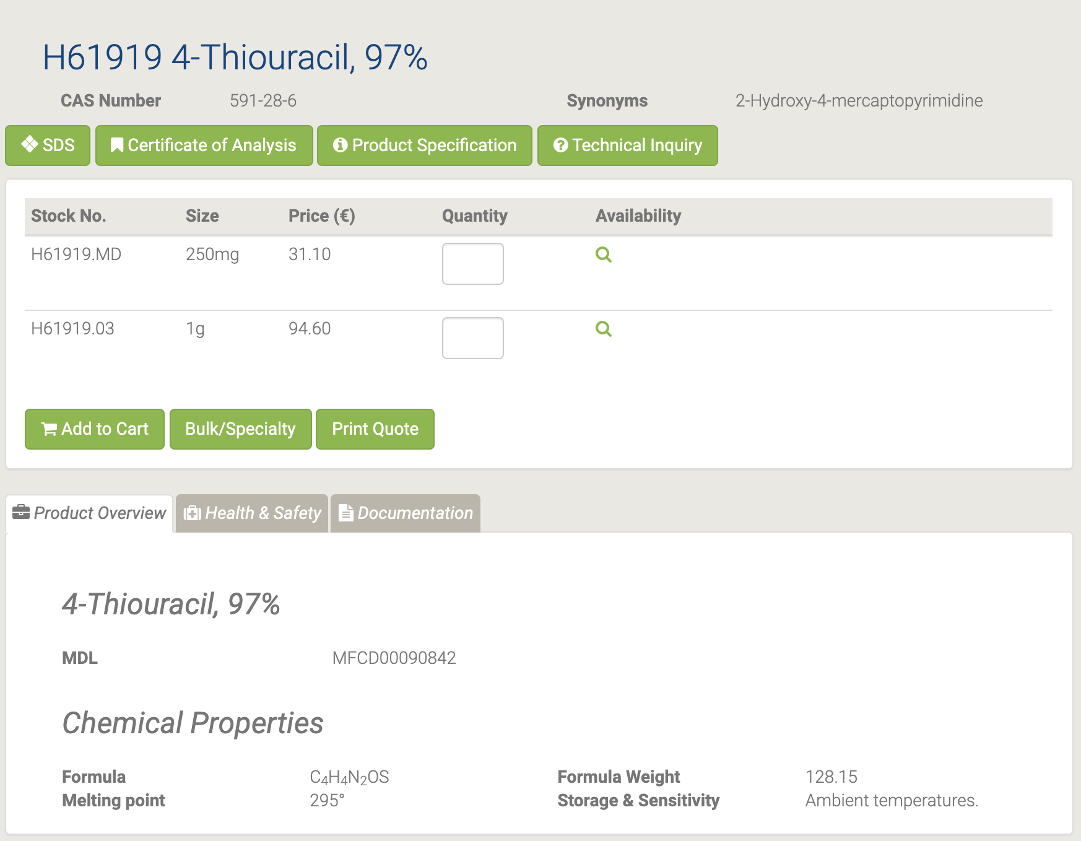

#### L01996 5,6-Dihydro-5-methyluracil

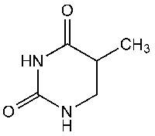

L01996 5,6-Dihydro-5-methyluracil [25]

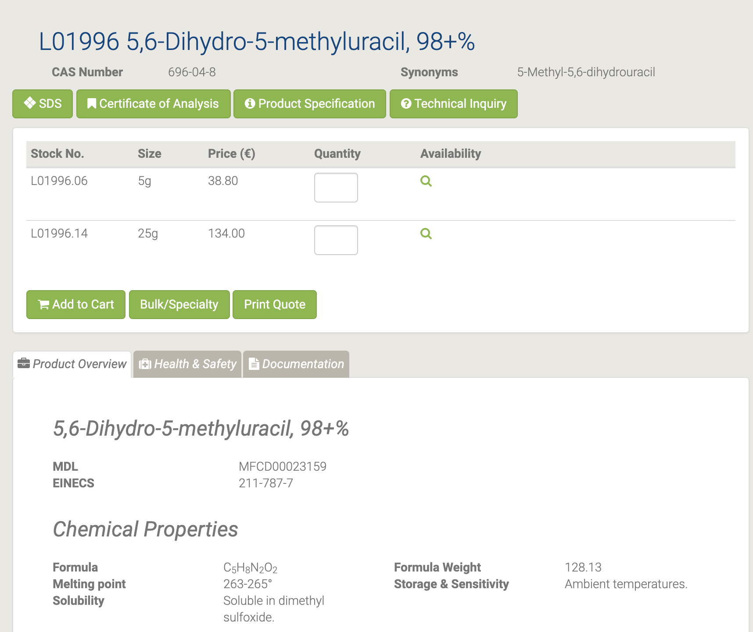

5,6-Дигидро-5-метилурацил используется в качестве активного фармацевтического ингредиента. [26-27]

#### L02292 5,6-Dihydro-6-methyluracil

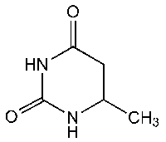

L02292 5,6-Dihydro-6-methyluracil [28]

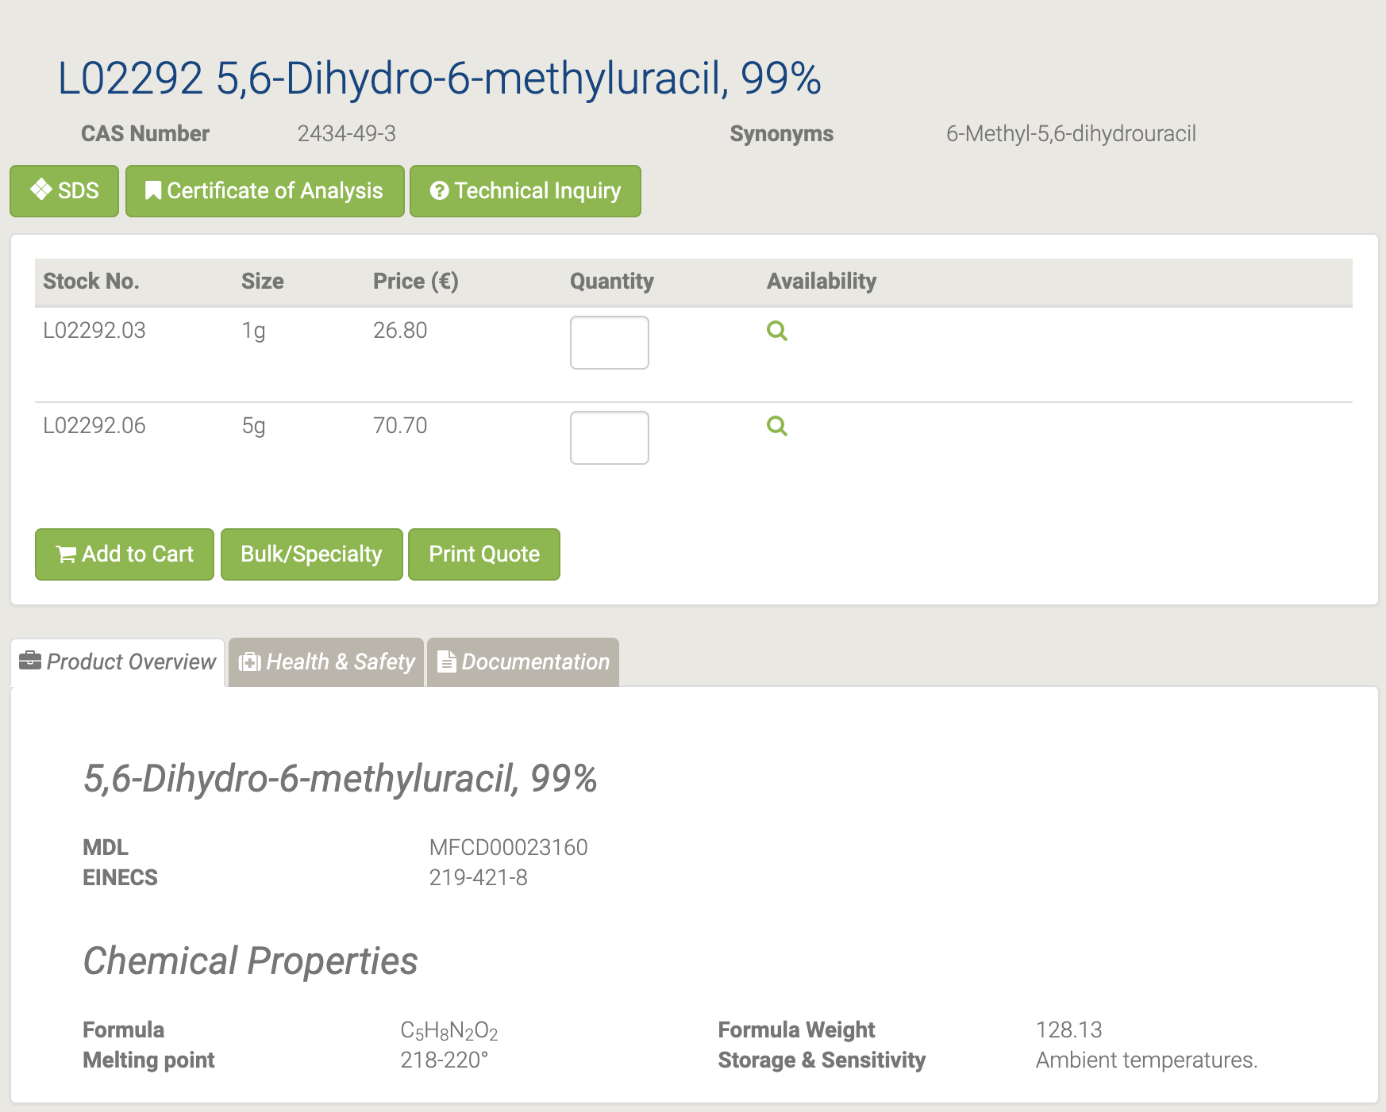

#### L01918 5,6-Dihydrouracil

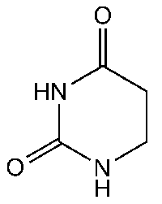

L01918 5,6-Dihydrouracil [29]

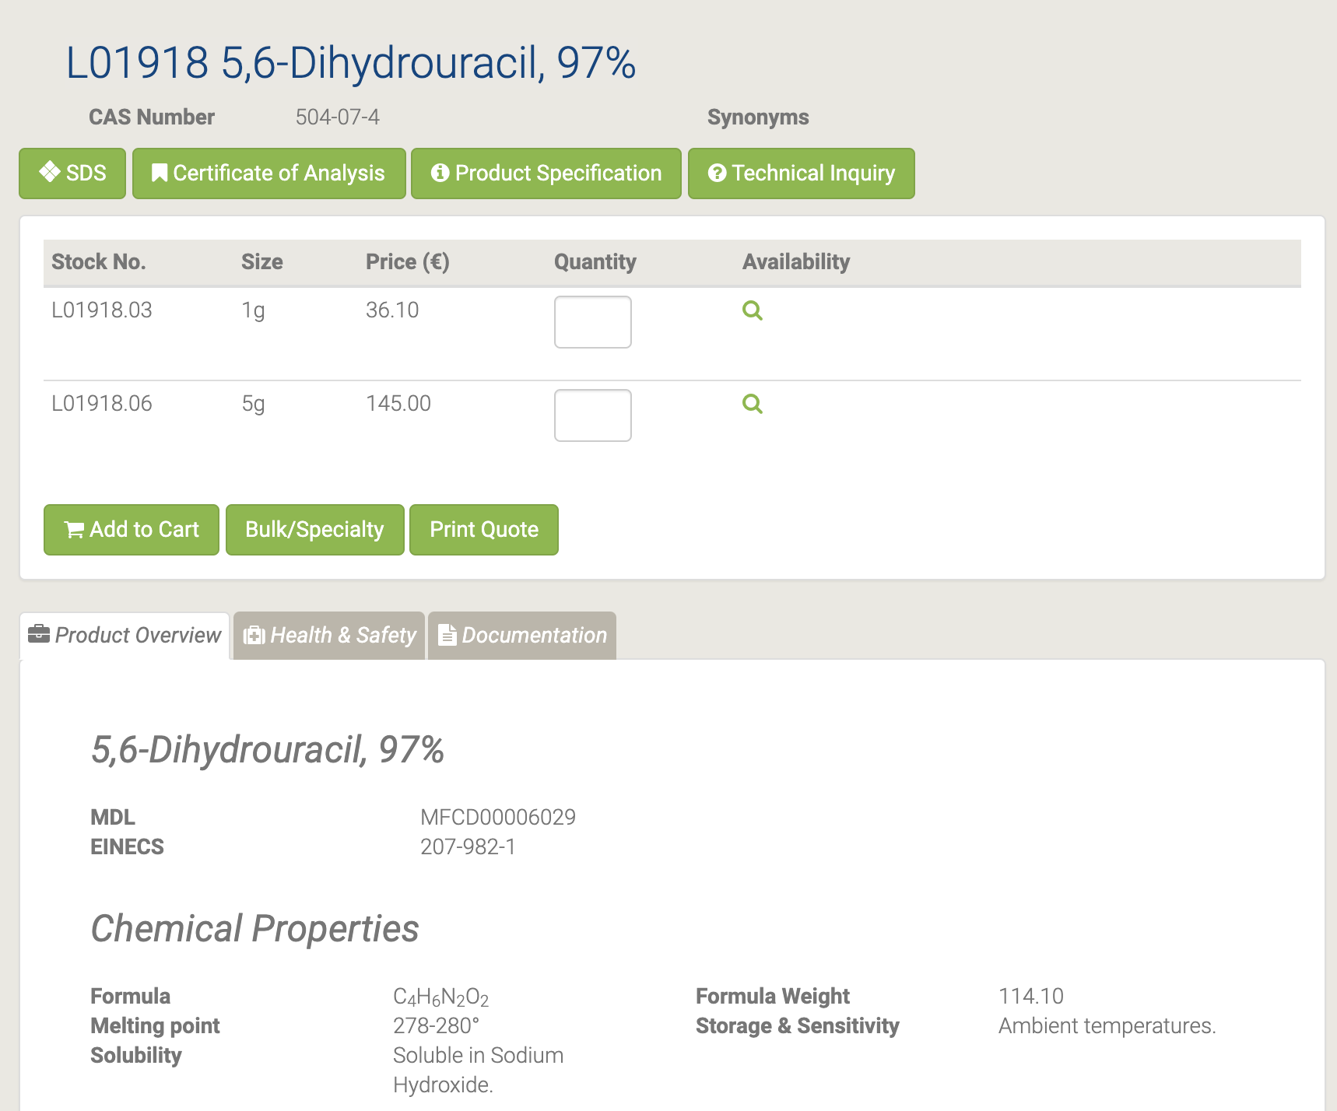

5,6-Дигидроурацил действует как промежуточное звено в катаболизме урацила [30-31].

#### 44378 5-Acetyluracil

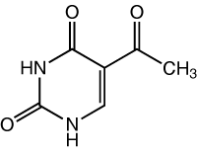

44378 5-Acetyluracil [32]

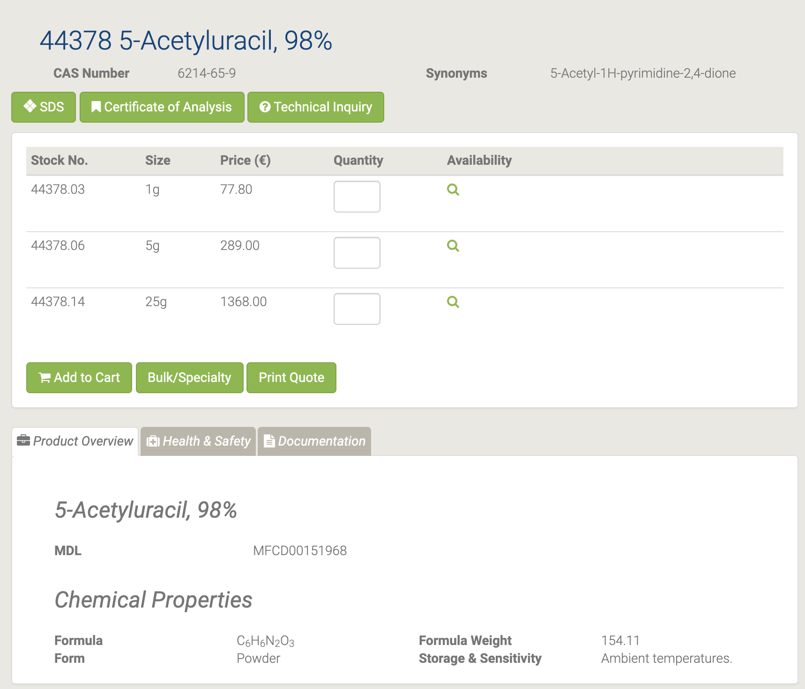

#### L04452 5-Aminouracil

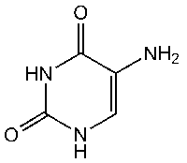

L04452 5-Aminouracil [33]

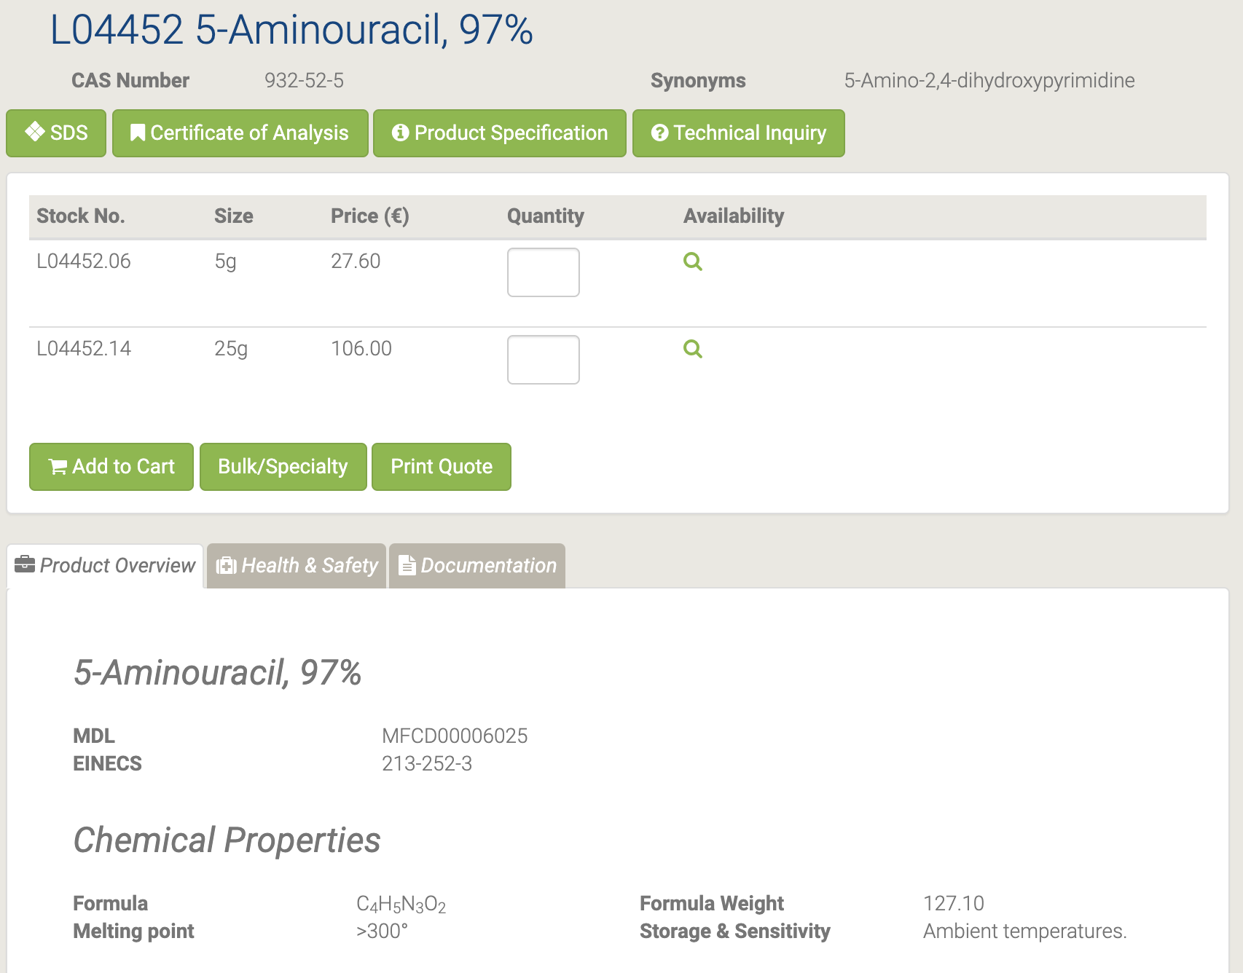

Конденсация с кротоновым альдегидом дает 2,4-диоксо-6-метилпиридо [3,2-d] пиримидин [34] и дигидрофолатредуктазы [35].

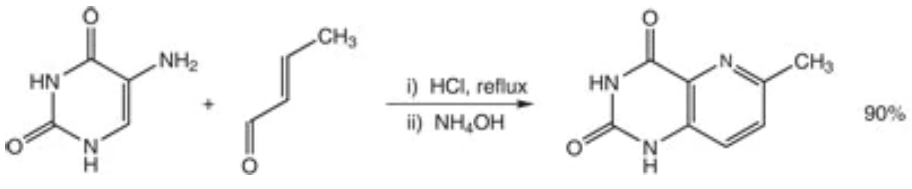

Обзор использования урацилов в качестве исходных материалов в гетероциклическом синтезе приведен в [36].

#### H27260 5-Bromo-2'-deoxyuridine

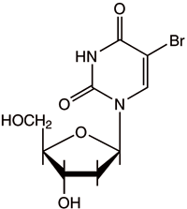

H27260 5-Bromo-2'-deoxyuridine [37]

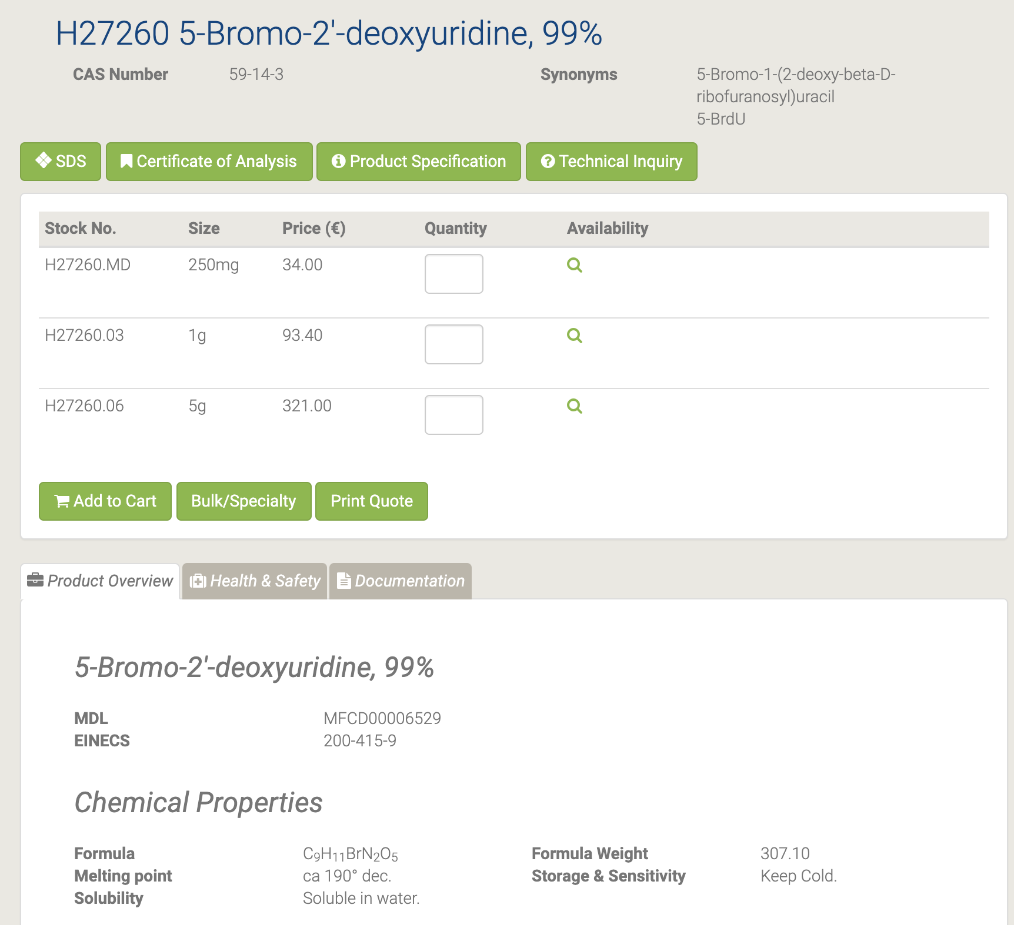

5-Бром-2'-дезоксиуридин (BrdU) представляет собой аналог тимидина, используемый для мечения ДНК. Он включается во вновь синтезированную ДНК вместо тимидина во время S-фазы клеточного цикла. Затем клетки, которые активно пролиферировали, можно обнаружить, денатурируя ДНК и давая возможность специфическим антителам нацеливаться на включение BrdU. Следовательно, 5-BrdU используется для изучения передачи сигналов клеток и других процессов, которые индуцируют пролиферацию клеток. [38-39] Аналог тимидина, предпочтительно включенный в клеточную ДНК вместо тимидина, вызывает повышенную радиочувствительность клетки [40]. Мутаген, используемый в генетических исследованиях [41]. Отзывы об использовании в диагностике и исследованиях [42].

#### B21034 5-Bromo-4-chloro-3-indolyl-beta-D-galactopyranoside

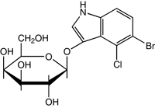

B21034 5-Bromo-4-chloro-3-indolyl-beta-D-galactopyranoside [43]

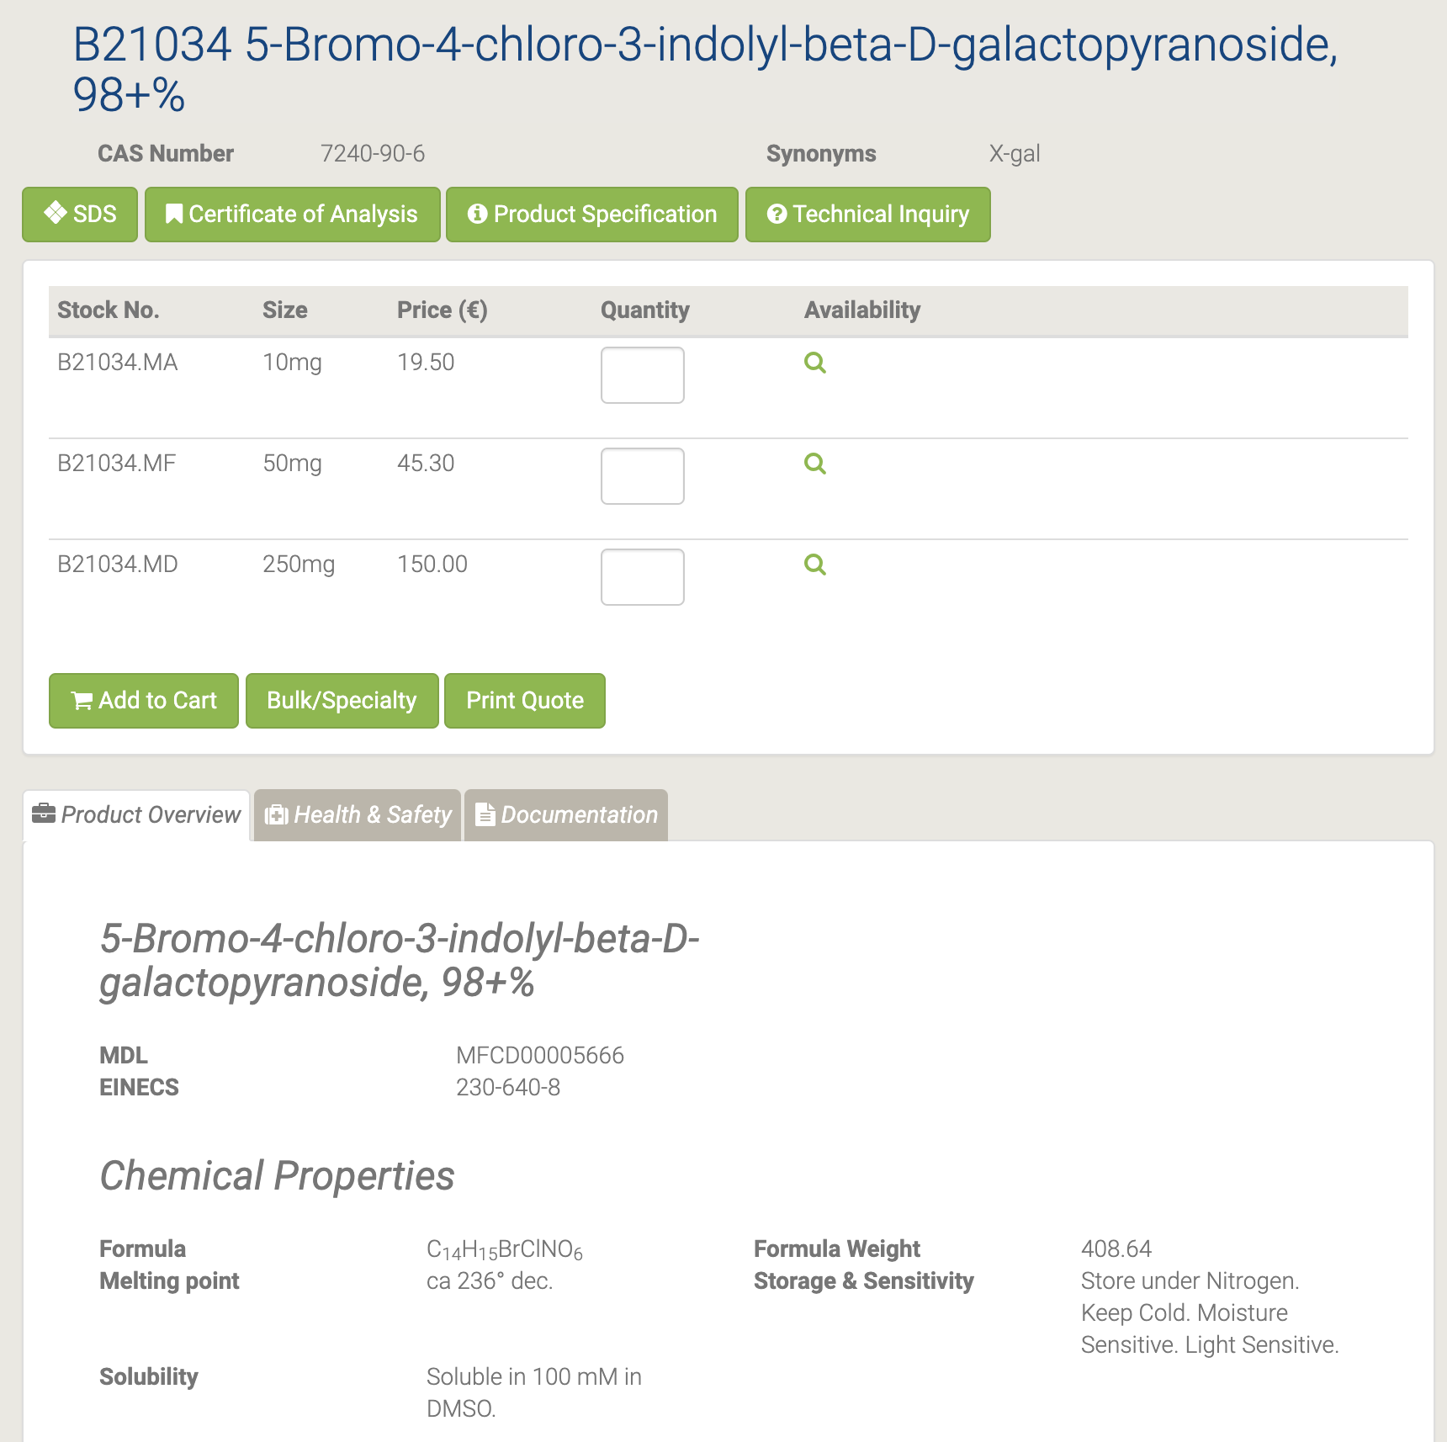

Это субстрат для бета-галактозидазы, которая расщепляет гликозидную связь с образованием 5-бром-4-хлор-3-гидрокси-1H-индола, который немедленно димеризуется с образованием продукта ярко-синего цвета. Он также используется для определения активности этого фермента в гистохимии и бактериологии. Он используется в качестве бесцветных, эндогенных или экзогенных предшественников пигментов, которые могут быть преобразованы с помощью биологических механизмов в окрашенные соединения. Они используются в биохимических анализах и в диагностике в качестве индикаторов, особенно в форме ферментных субстратов. X-Gal является предпочтительным субстратом для сине-белой селекции рекомбинантных бактериальных колоний с генотипом lac +.

Применялся при окрашивание X-gal эмбрионов электропорированными морскими брызгами (Ciona) [44] и при подавлении скоплений видов Vibrio [45].

#### A14799 5-Bromouracil

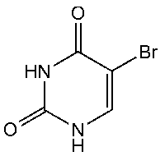

A14799 5-Bromouracil [46]

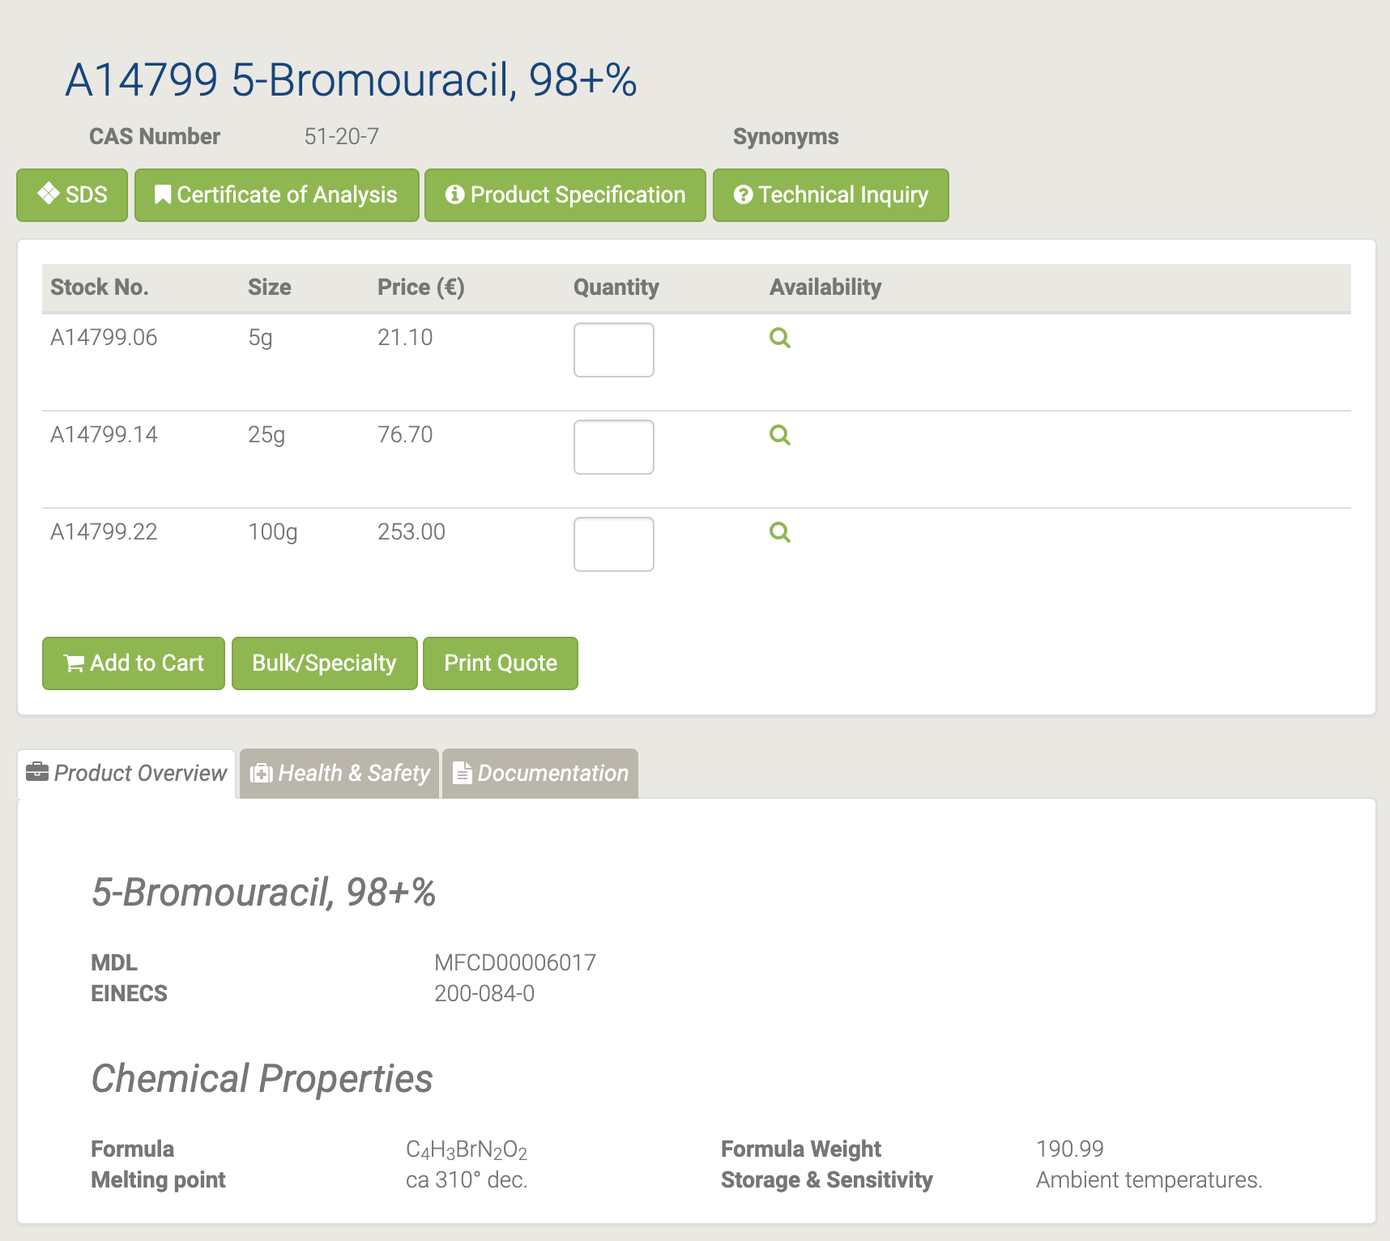

#### A18507 5-Bromouridine

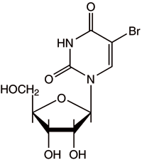

A18507 5-Bromouridine [47]

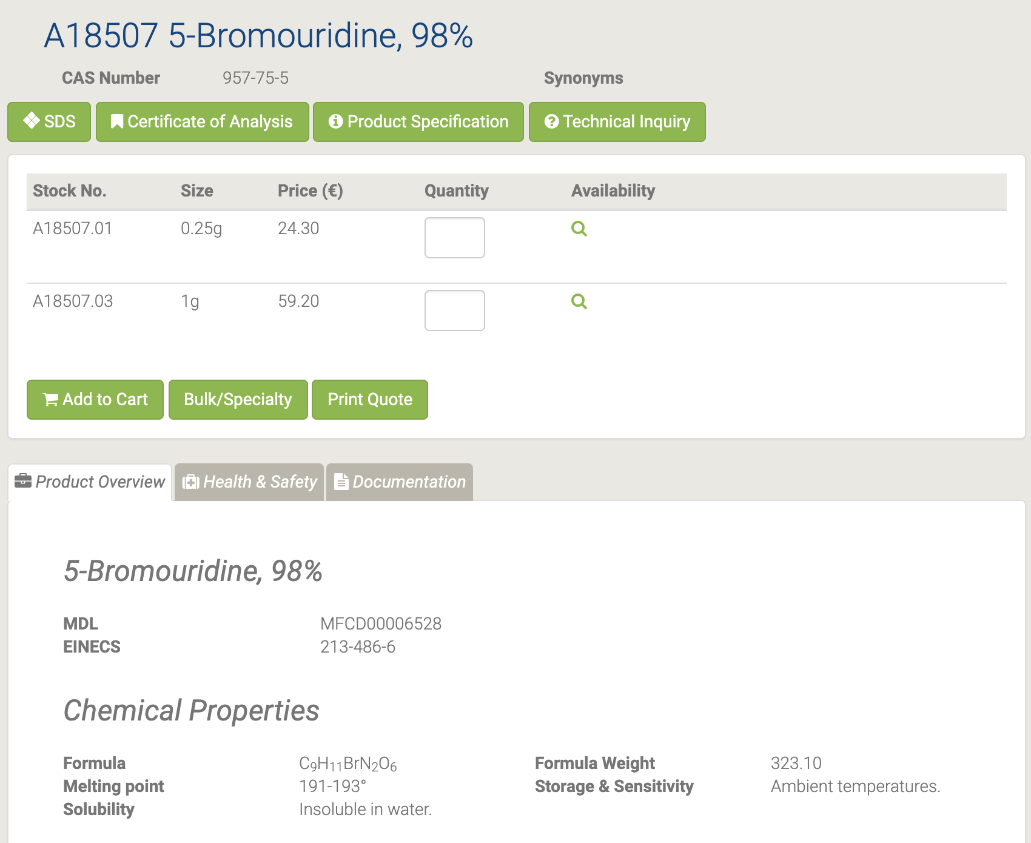

5-Бромуридин часто включается в РНК для иммуноцитохимического обнаружения и анализа с помощью цитометрии. Он обладает противовирусной активностью и подавляет активность вирусов, таких как вирус иммунодефицита человека. [48-49]

#### 44639 5-(Chloromethyl)uracil

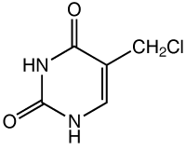

44639 5-(Chloromethyl)uracil [50]

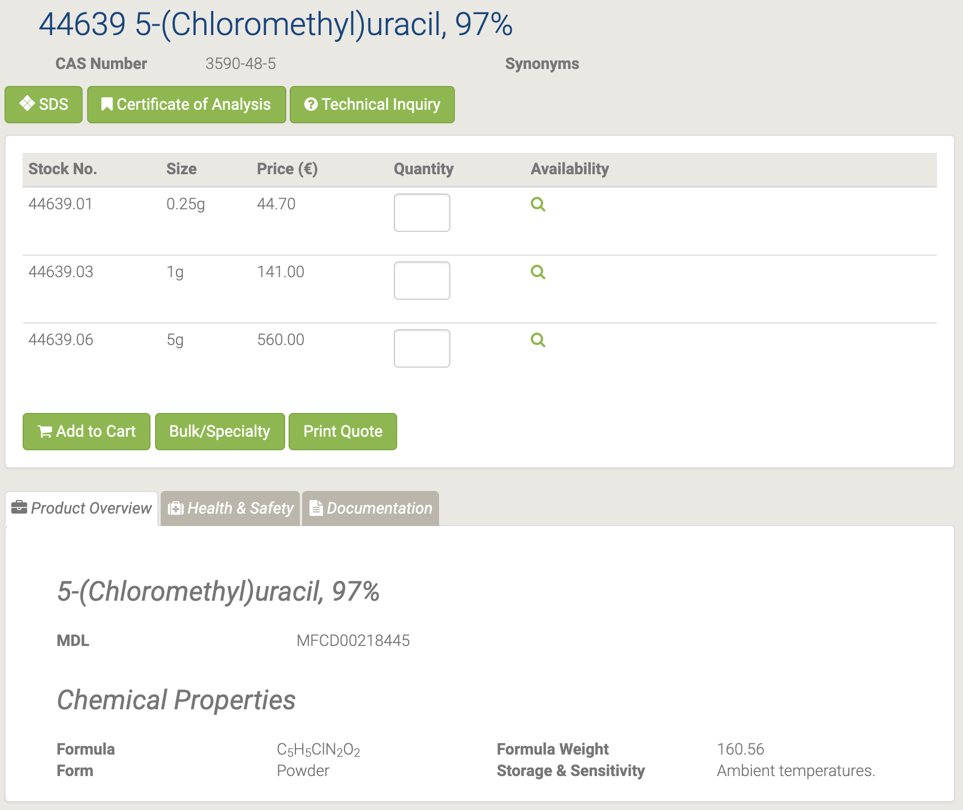

#### L08490 5-Cyanouracil

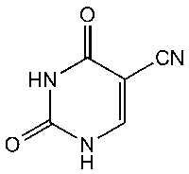

L08490 5-Cyanouracil [51]

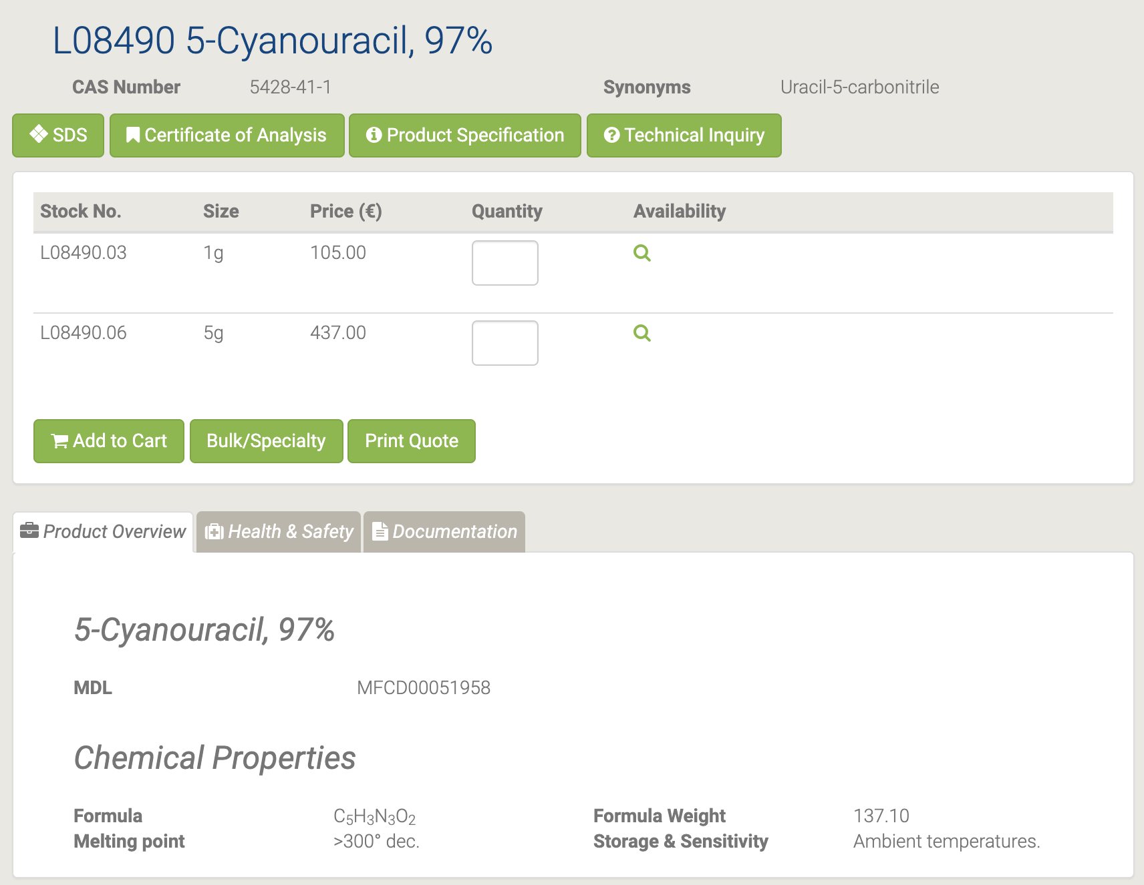

#### L10861 5-Ethyluracil

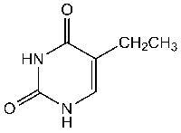

L10861 5-Ethyluracil [52]

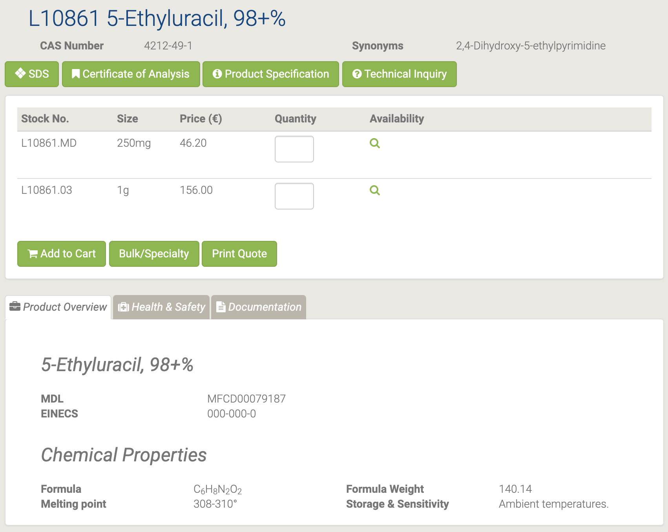

#### L16496 5-Fluorocytosine

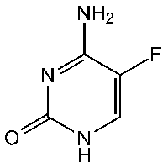

L16496 5-Fluorocytosine [53]

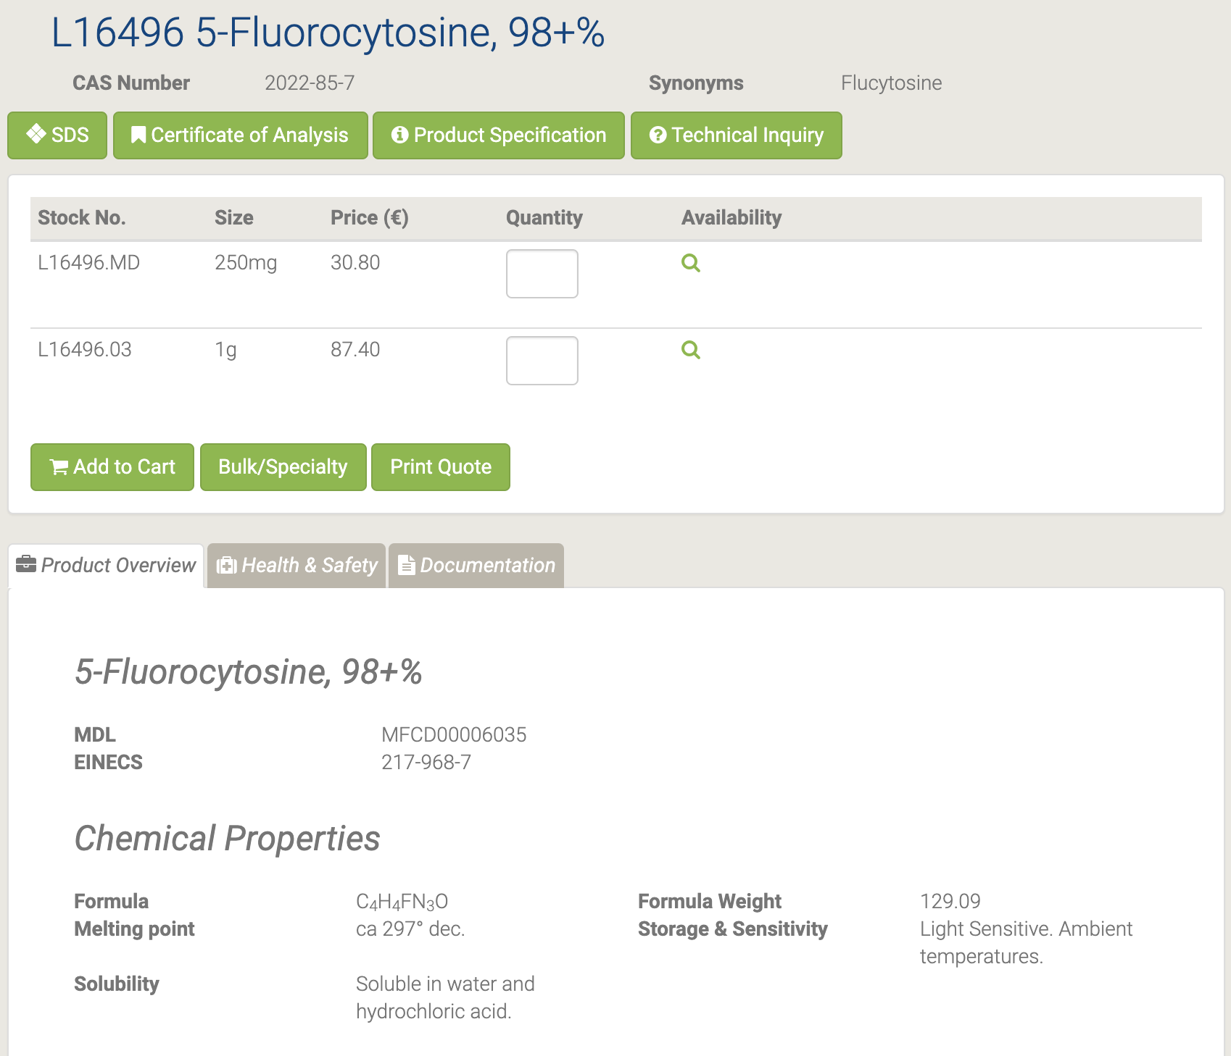

5-фторцитозин действует как противодиабетическое, противогрибковое и противомикробное средство. Он полезен для лечения серьезных инфекций, возникающих из-за чувствительных штаммов Candida или Cryptococcus neoformans и хромомикоза. Кроме того, он используется в исследованиях биосинтеза ТМП. [54-55]

#### L01682 5-(Hydroxymethyl)uracil

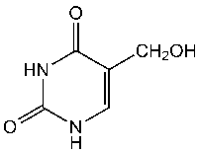

L01682 5-(Hydroxymethyl)uracil [56]

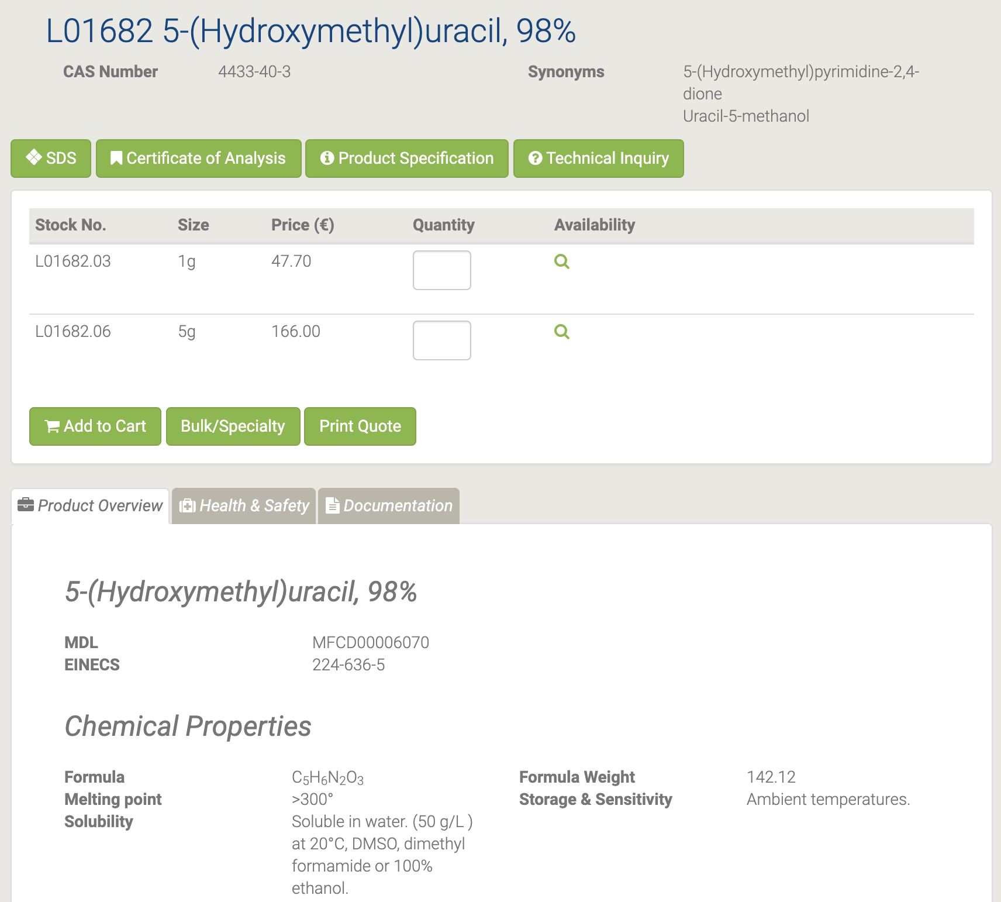

5- (Гидроксиметил) урацил служит стабильной основной окислительной модификацией тимина, образующейся под действием ионизирующего излучения. [57-58]

#### B25173 5-Iodo-1,3-dimethyluracil

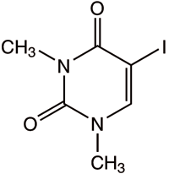

B25173 5-Iodo-1,3-dimethyluracil [59]

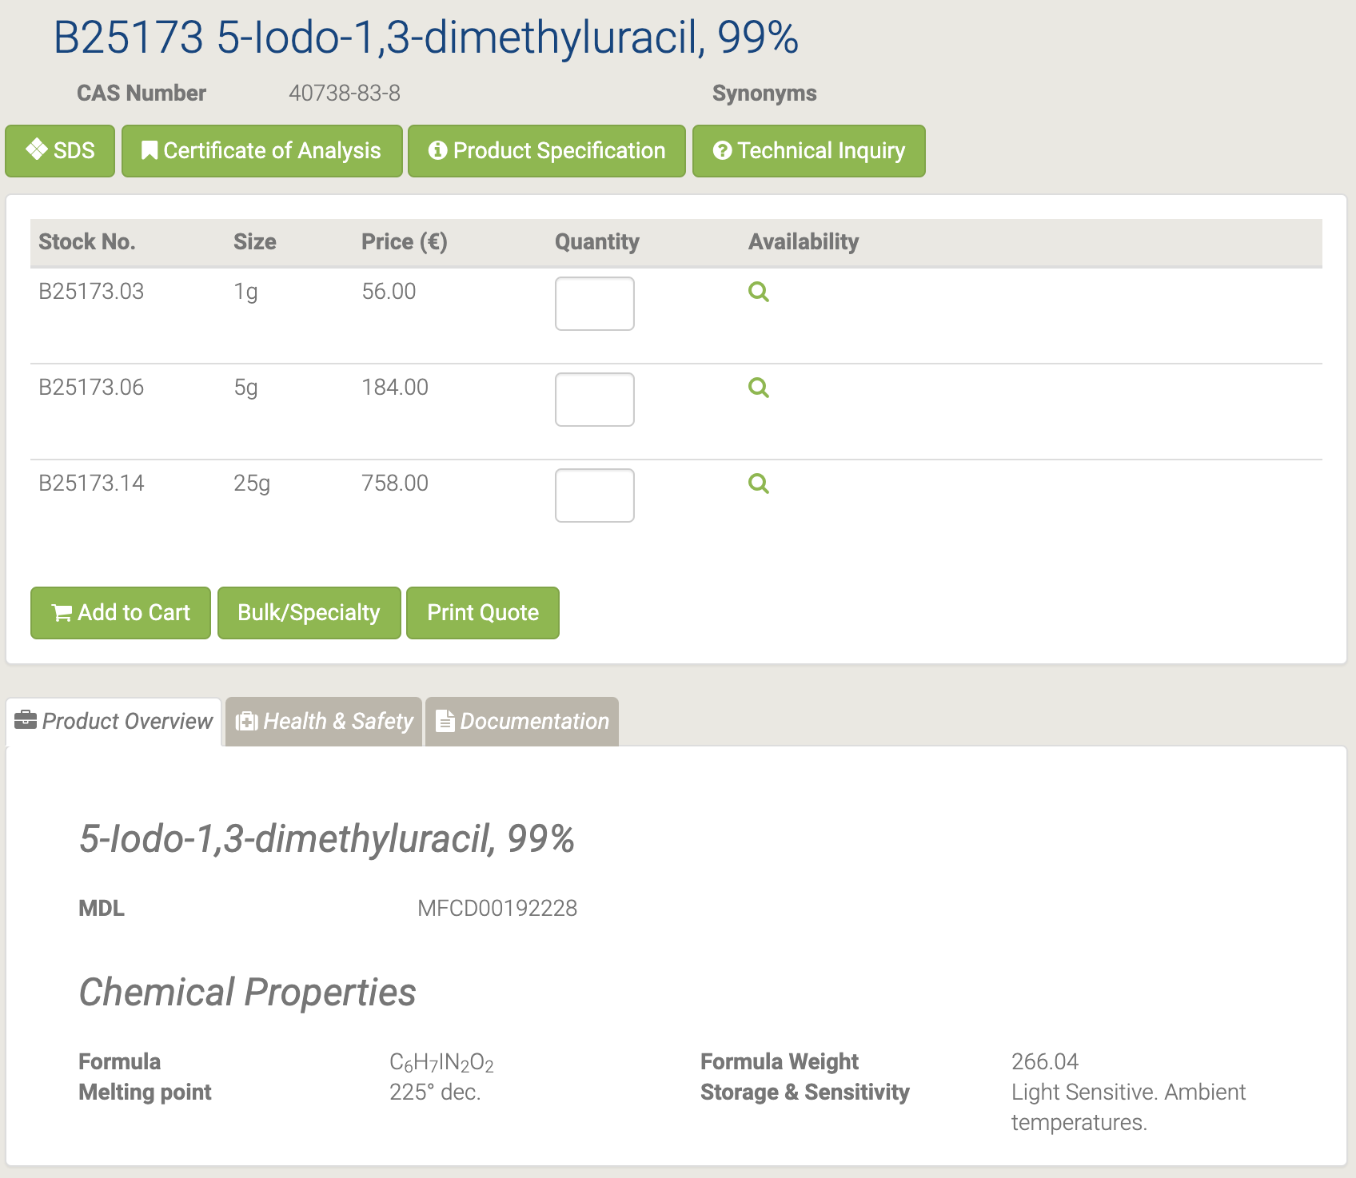

#### A18994 5-Iodouracil

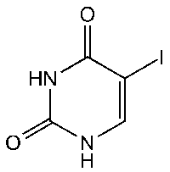

A18994 5-Iodouracil [60]



Он используется как промежуточное звено. Обладает противоопухолевым действием. [61-63]

#### H64259 5-Methyluridine

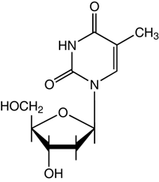

H64259 5-Methyluridine [64]

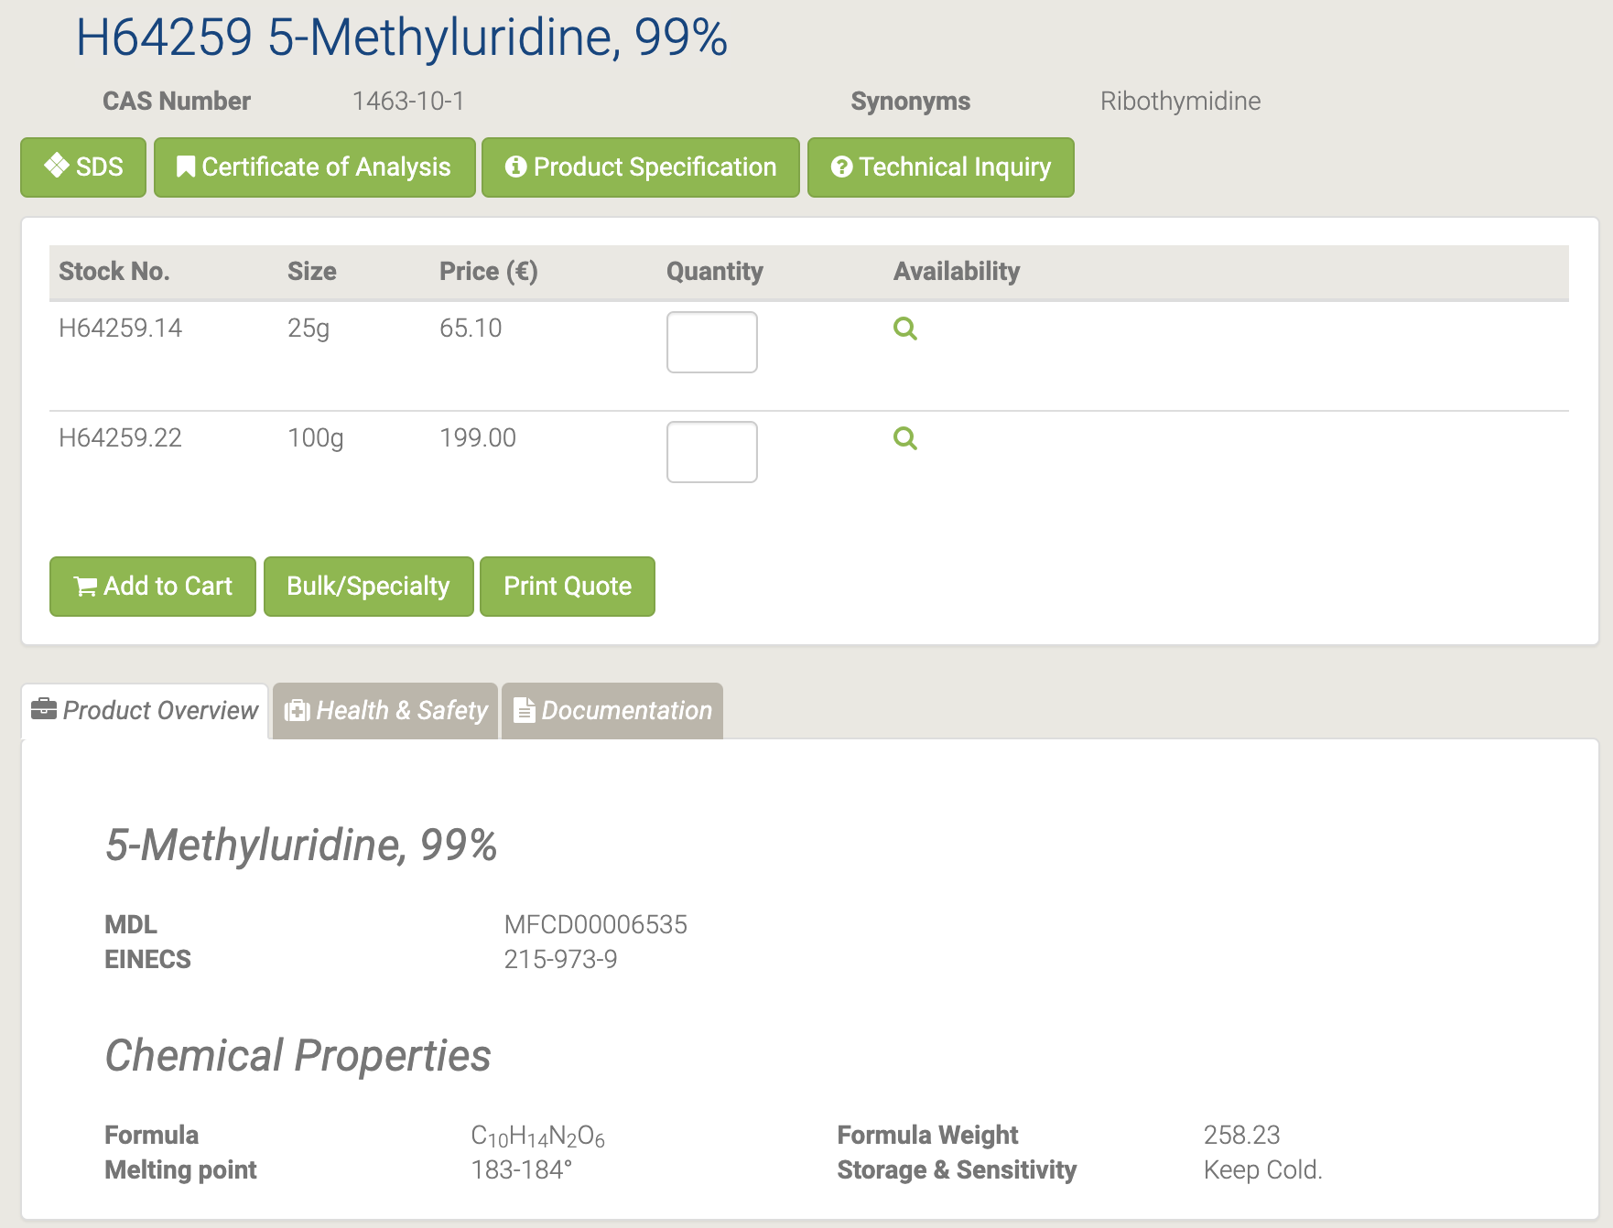

#### H55913 5-Nitro-6-methyluracil

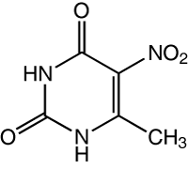

H55913 5-Nitro-6-methyluracil [65]

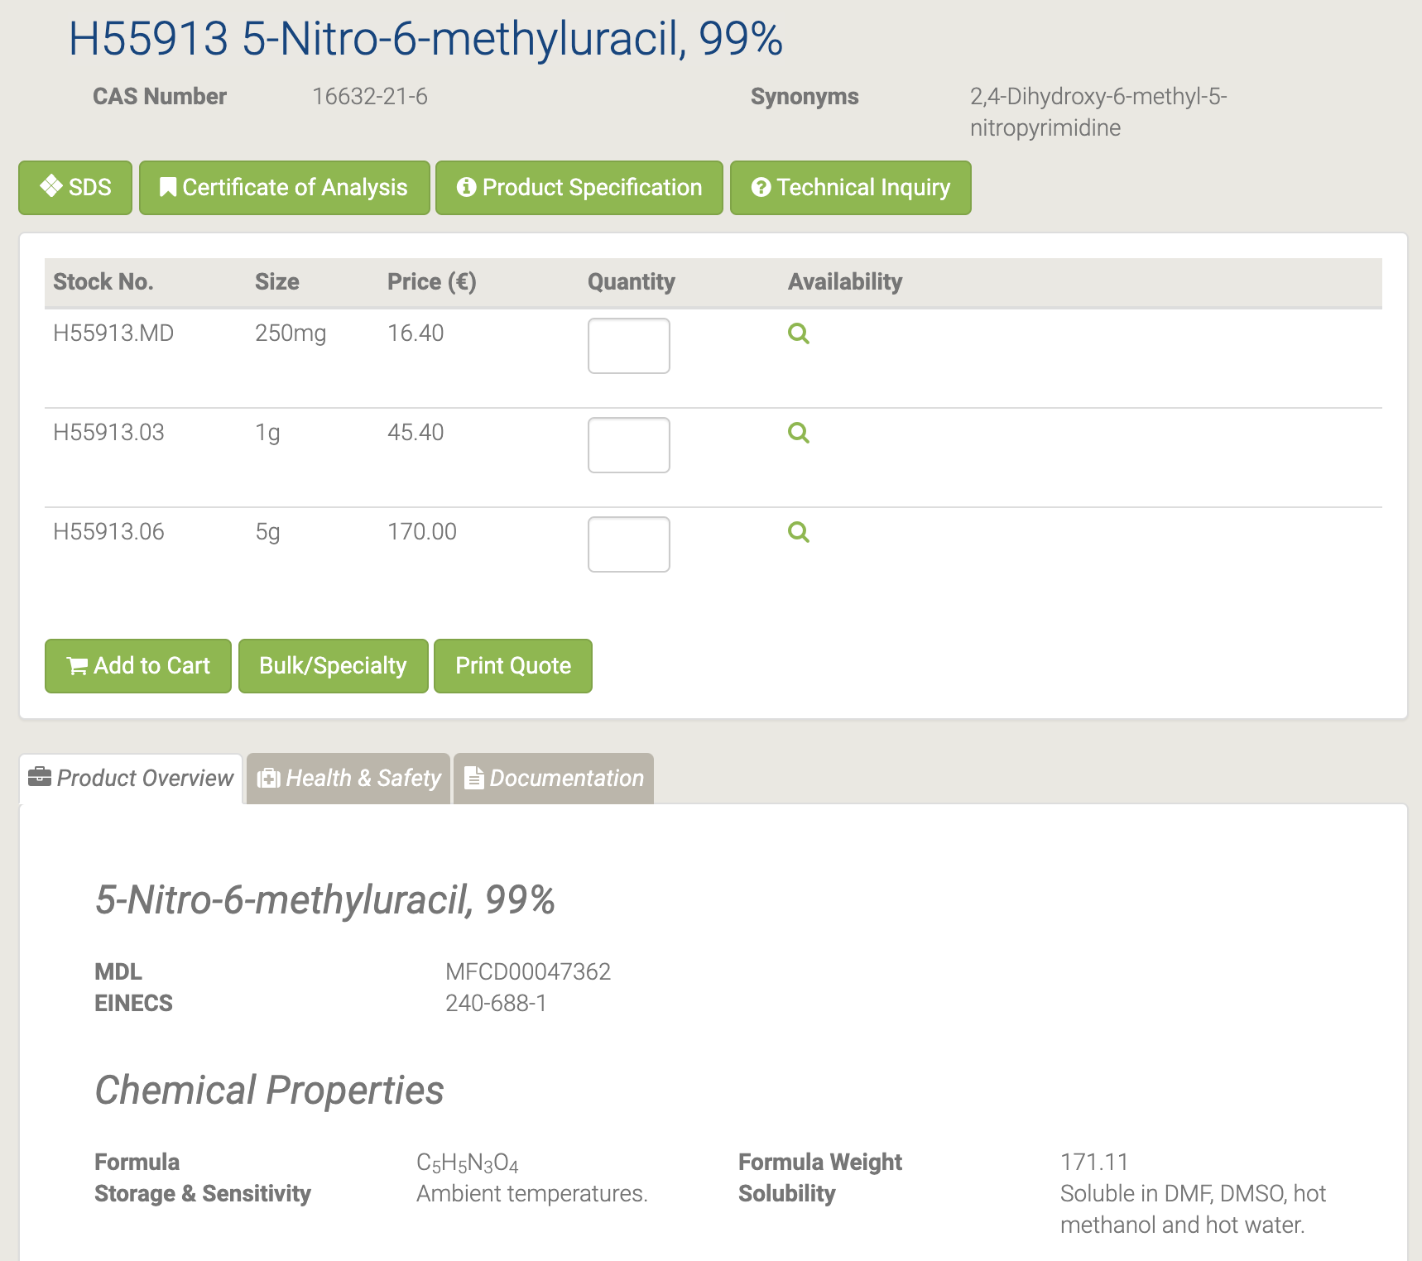

5-Нитро-6-метилурацил используется в качестве важного сырья и промежуточного продукта, используемого в органическом синтезе, фармацевтических препаратах, агрохимикатах и красителях. [66-67]

#### A12448 5-Nitrouracil

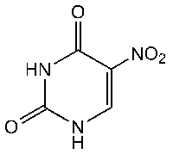

A12448 5-Nitrouracil [68]

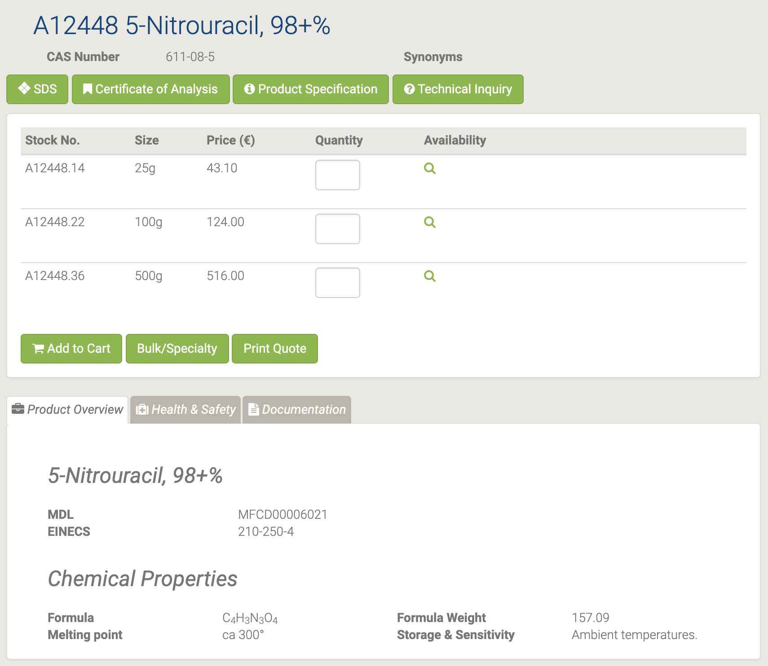

#### 44815 5'-O-(4,4'-Dimethoxytrityl)thymidine

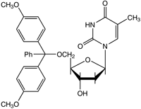

44815 5'-O-(4,4'-Dimethoxytrityl)thymidine [69]

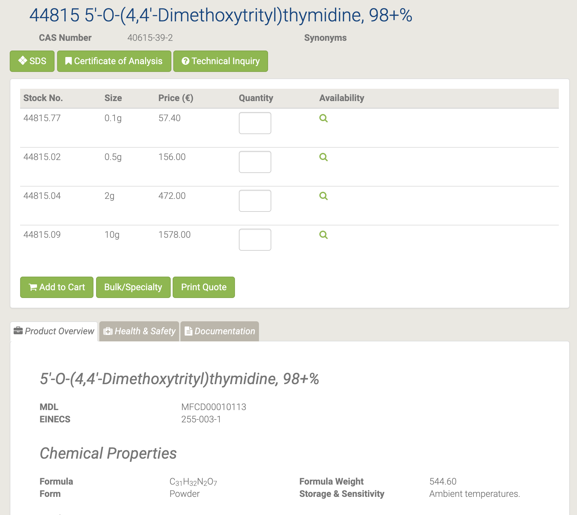

5'-O- (4,4'-Диметокситритил) тимидин используется в твердофазном синтезе полинуклеотидов и политимидиловых кислот методом блочного связывания фосфотриэфира. Кроме того, он используется в стереоселективном синтезе 3'-дезокси-3'-треогидроксиметилнуклеозида. В дополнение к этому, он используется в качестве исследовательского инструмента для противовирусных и противораковых исследований. [70-71]

#### H52780 5'-O-[(Diisopropylamino)-(2-cyanoethoxy)phosphinyl]-3'-O-(4,4'-dimethoxytrityl)-2'-deoxyinosine

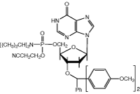

H52780 5'-O-[(Diisopropylamino)-(2-cyanoethoxy)phosphinyl]-3'-O-(4,4'-dimethoxytrityl)-2'-deoxyinosine [72]

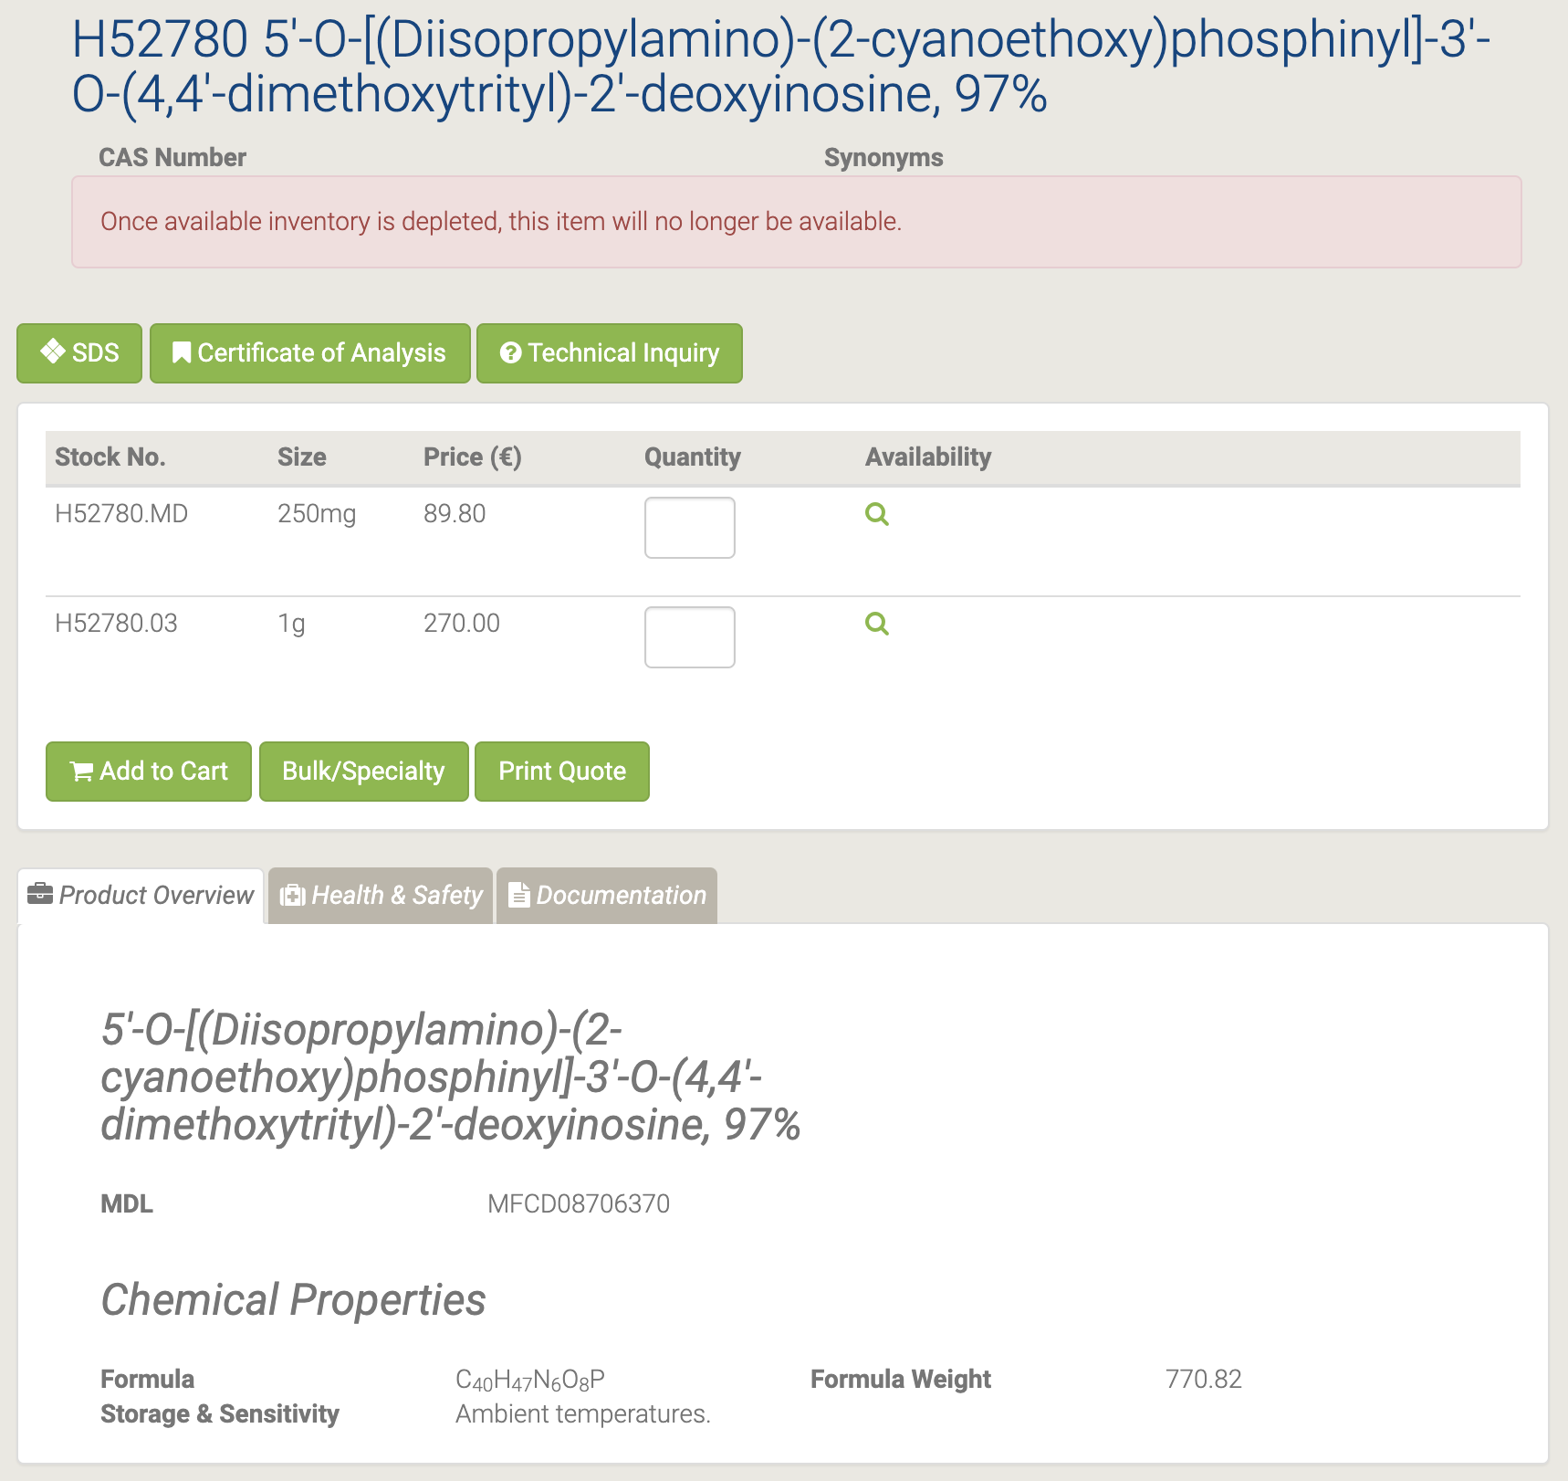

#### H52301 5'-O-(tert-Butyldimethylsilyl)thymidine

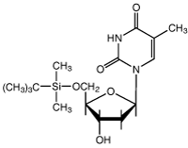

H52301 5'-O-(tert-Butyldimethylsilyl)thymidine [73]

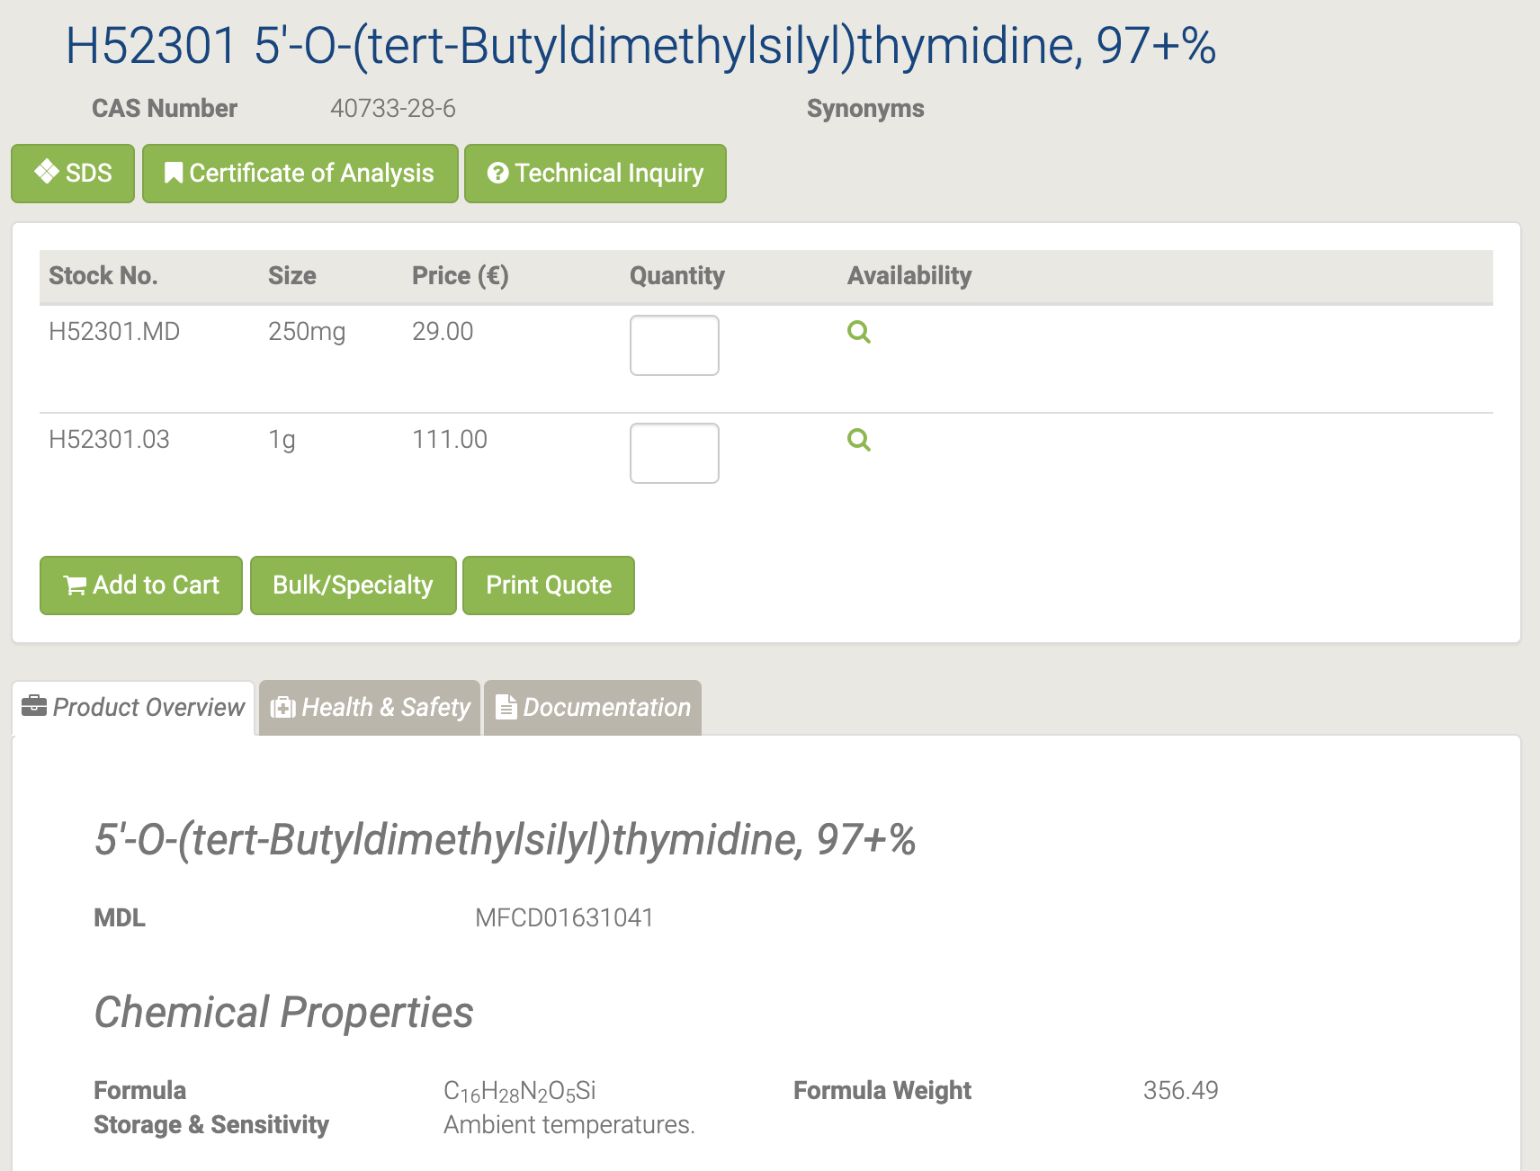

5'-O- (трет-Бутилдиметилсилил) тимидин используется в качестве промежуточного фармацевтического продукта [74-75].

#### H52782 5'-O-[(Diisopropylamino)-(2-cyanoethoxy)phosphinyl]-3'-O-(4,4'-dimethoxytrityl)thymidine

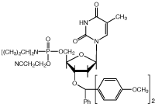

H52782 5'-O-[(Diisopropylamino)-(2-cyanoethoxy)phosphinyl]-3'-O-(4,4'-dimethoxytrityl)thymidine [76]

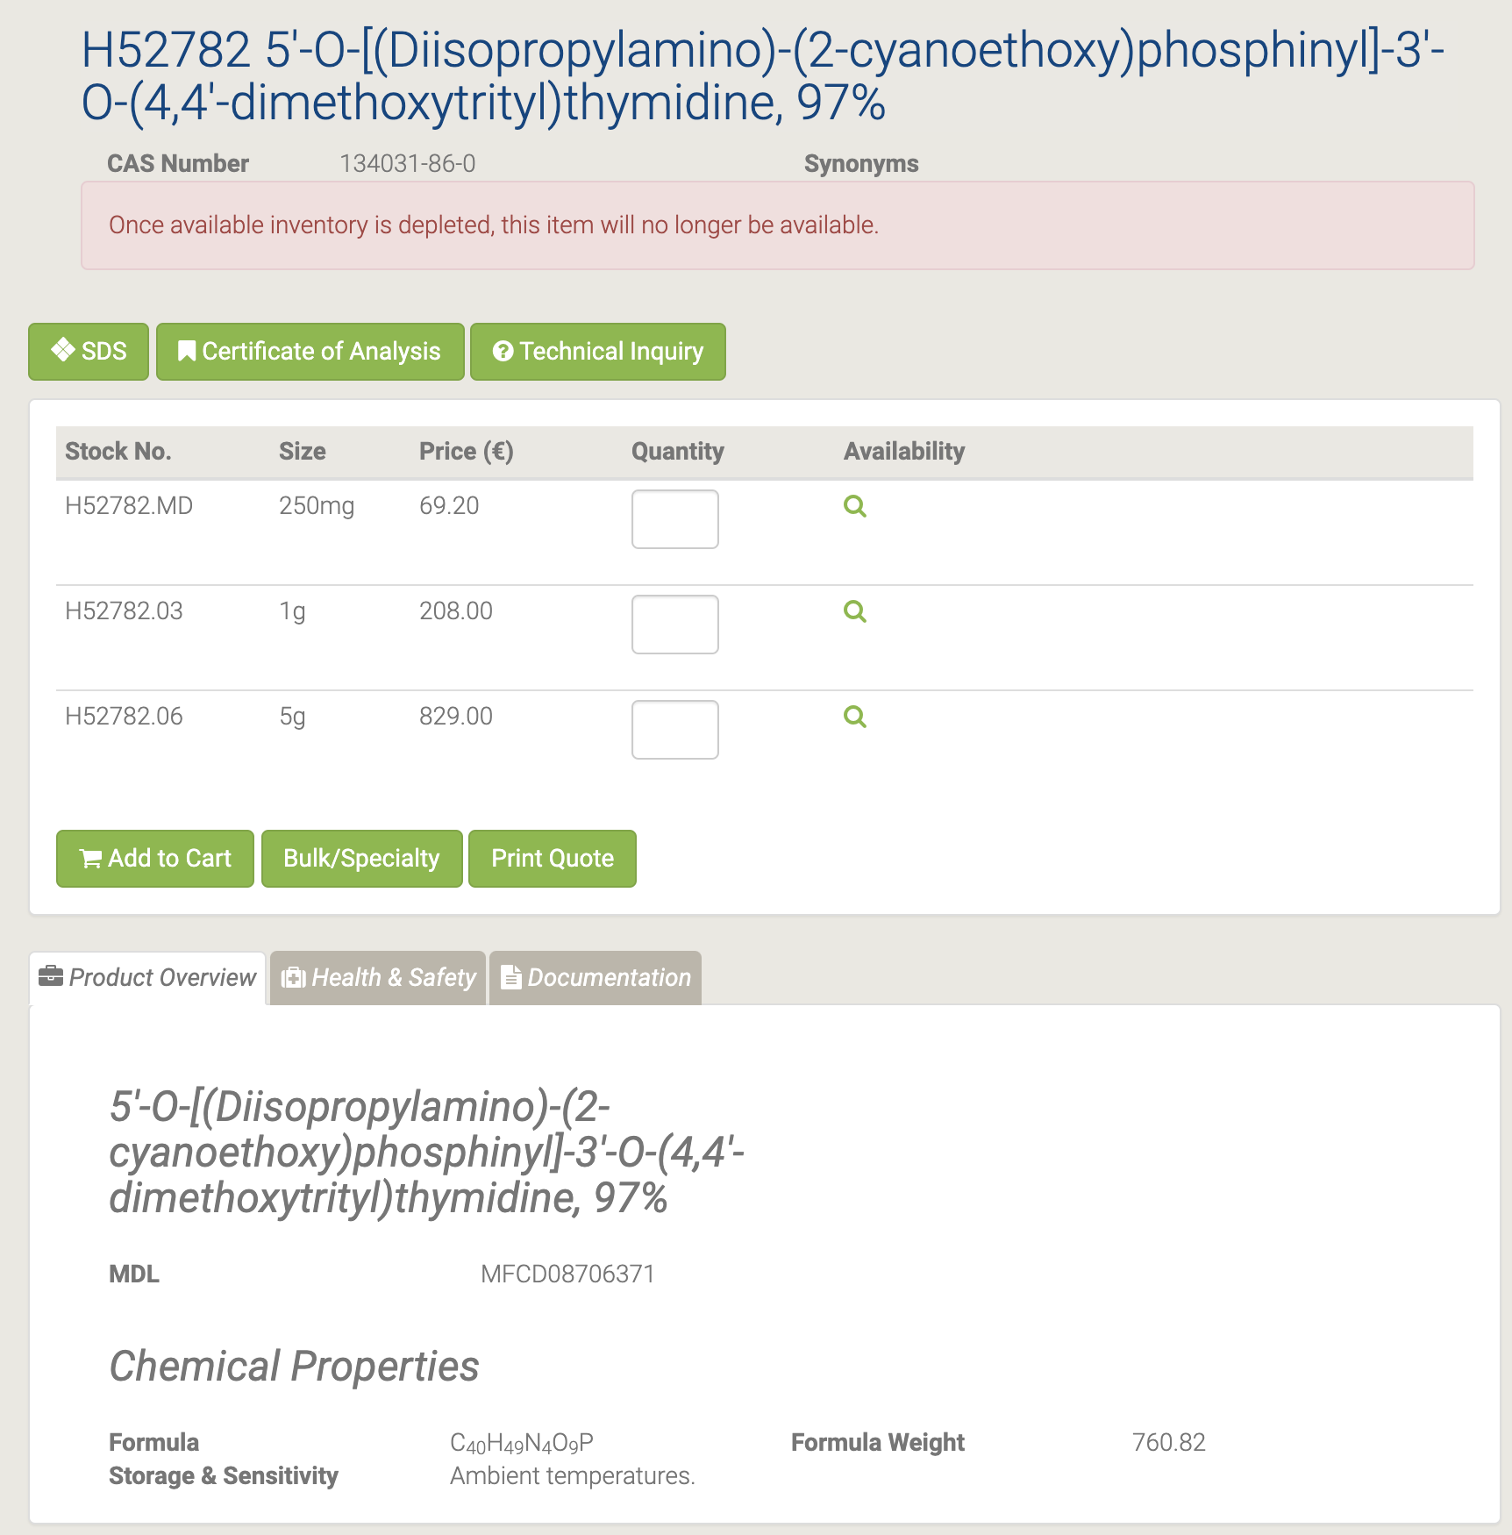

#### L16196 5-(Trifluoromethyl)uracil

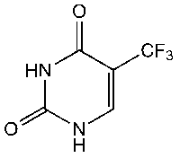

L16196 5-(Trifluoromethyl)uracil [77]

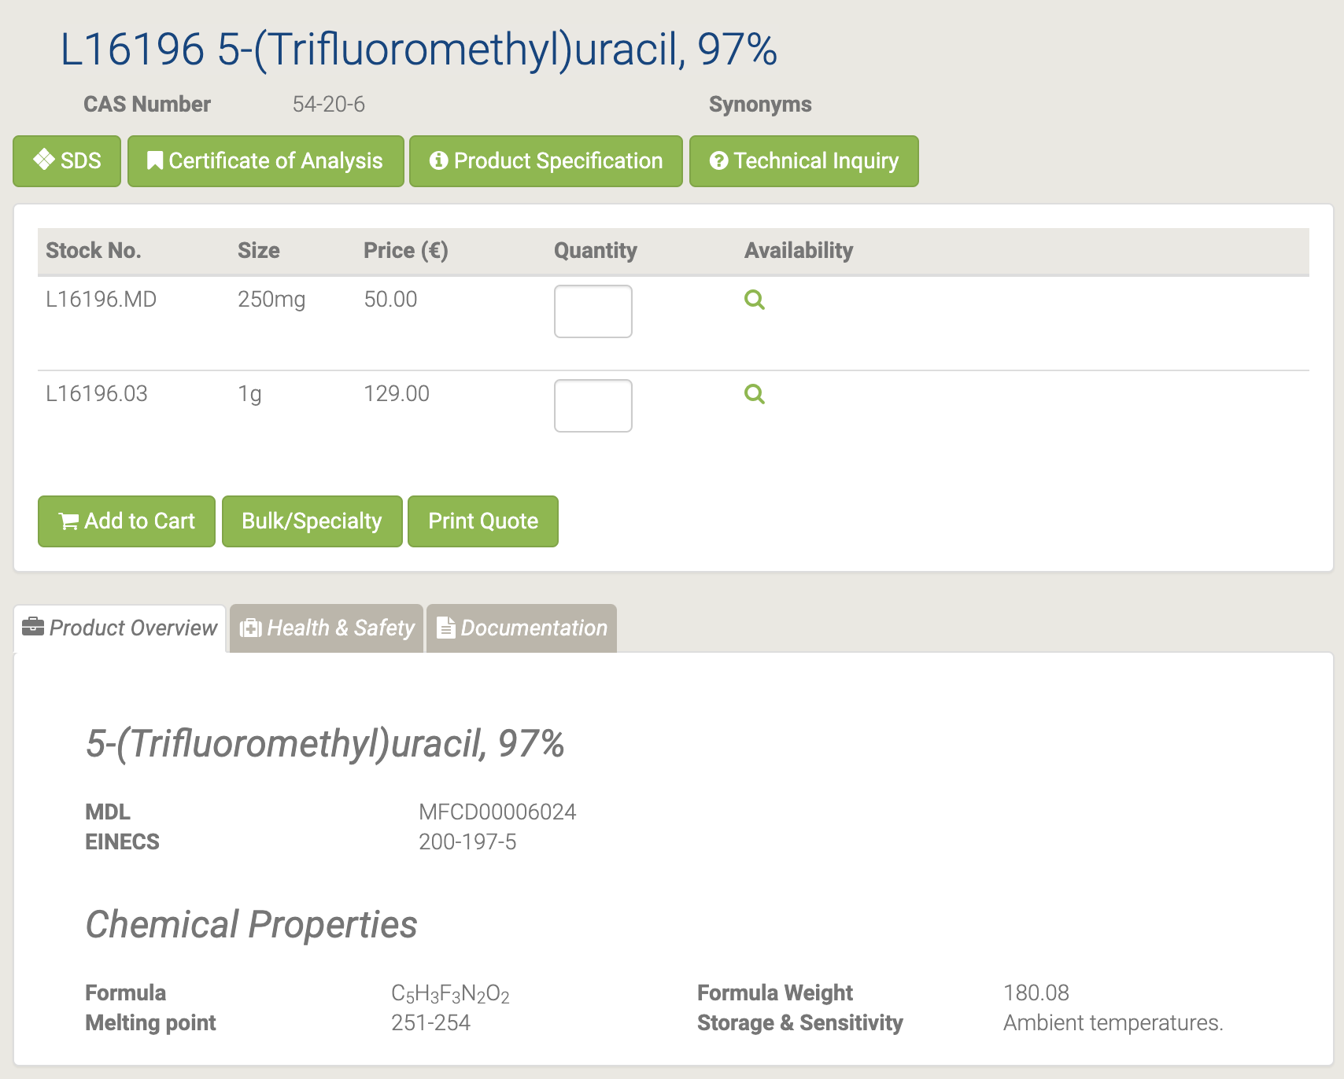

#### 44379 5-Vinyluracil

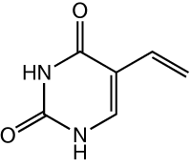

44379 5-Vinyluracil [78]

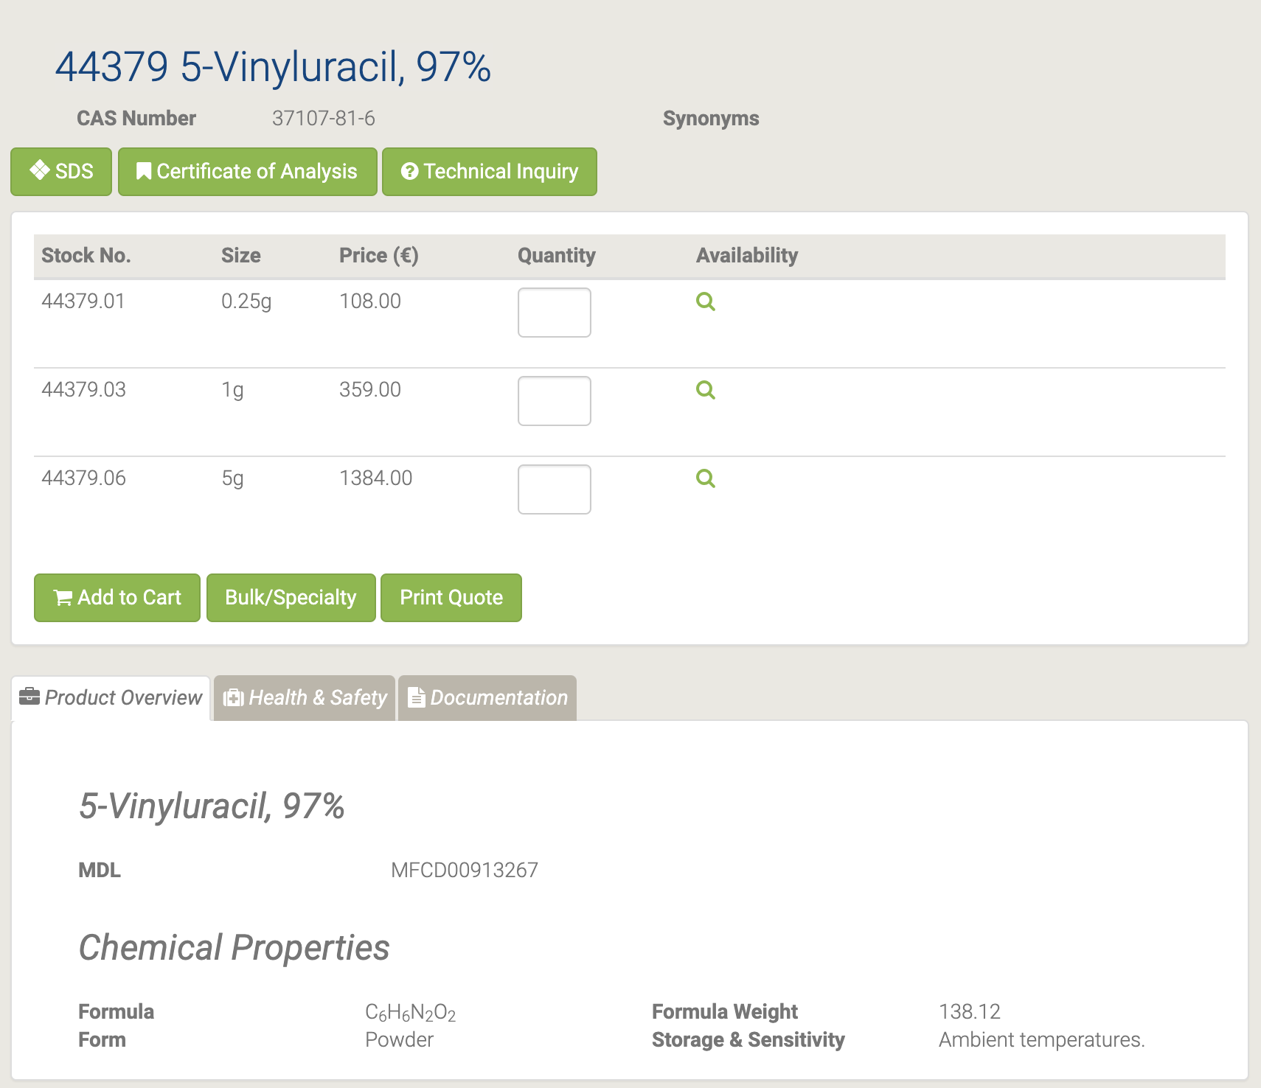

#### B25448 6-Amino-1-methyluracil

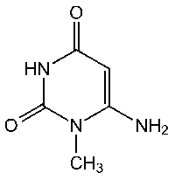

B25448 6-Amino-1-methyluracil [79]

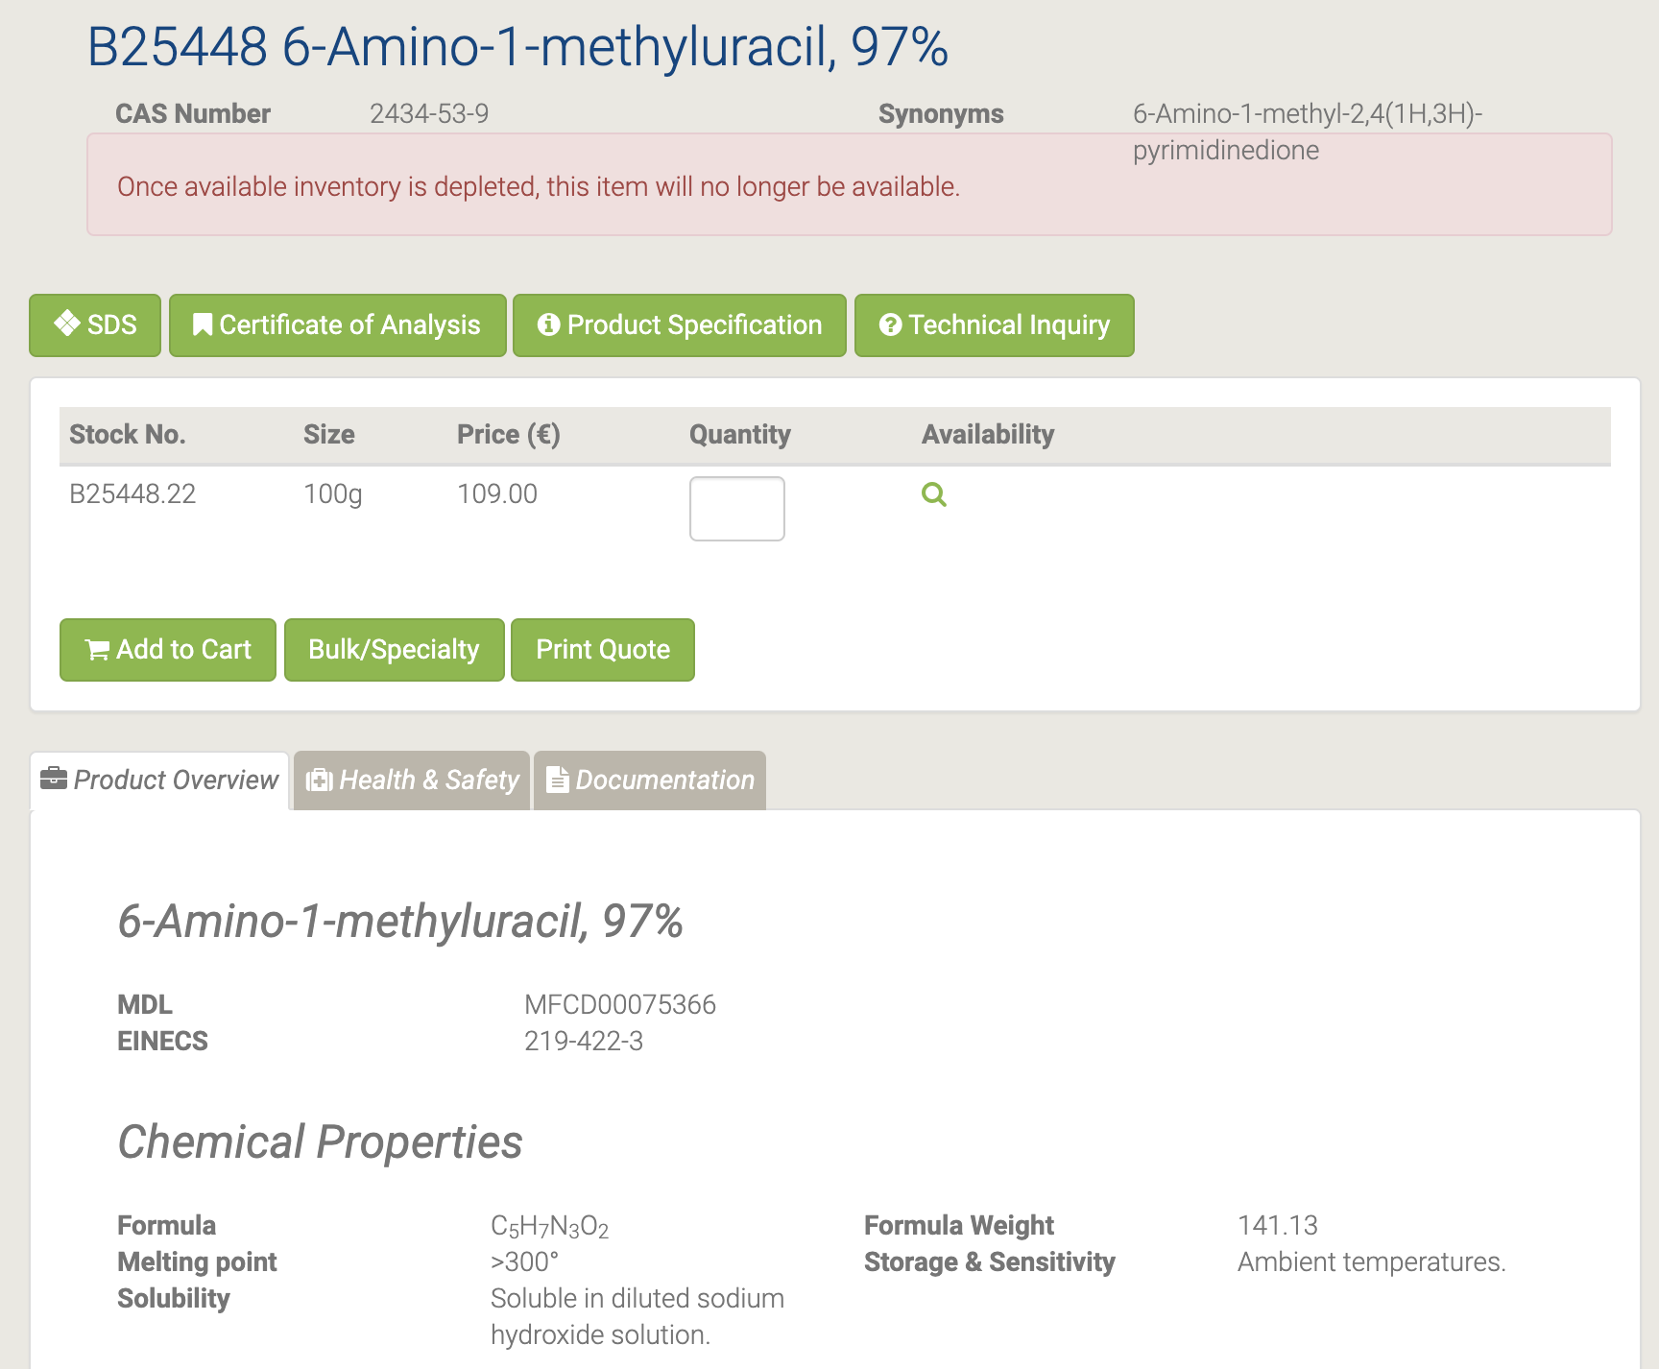

6-Амино-1-метилурацил может быть использован при получении 1,1? -Диметил-1H-спиро [пиримидо [4,5-b] хинолин-5,5? -Пирроло [2,3-d] пиримидина. ] -2,2?, 4,4?, 6? (1? H, 3H, 3? H, 7? H, 1? H) -пентаон, посредством реакции с изатином в присутствии каталитической п-толуолсульфоновой кислоты [80-81].

#### L03332 6-Aminouracil

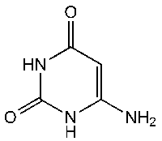

L03332 6-Aminouracil [82]

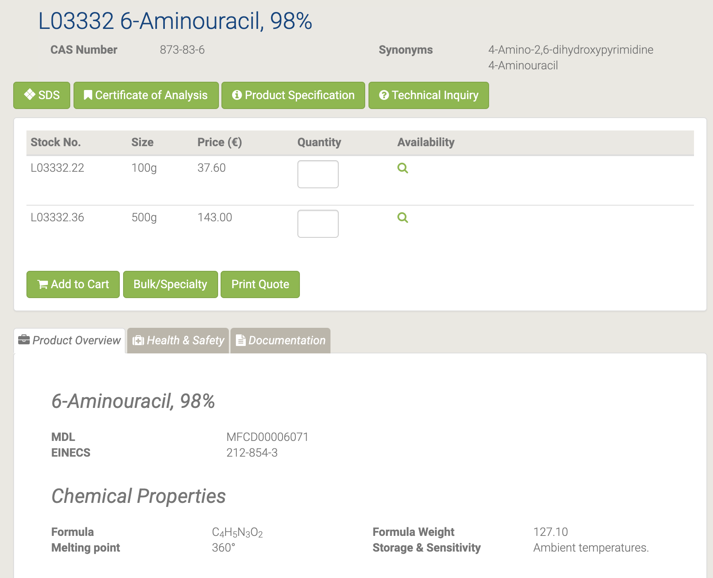

Силилирование способствует региоселективному алкилированию по 3-азоту [83]. Эти продукты являются промежуточными продуктами в универсальном синтезе ксантинов [84].

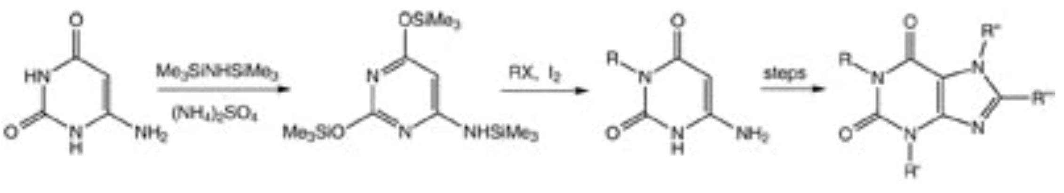

#### B21131 6-Chloro-3-indolyl-beta-D-galactopyranoside

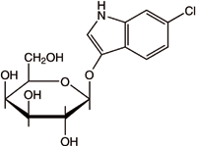

B21131 6-Chloro-3-indolyl-beta-D-galactopyranoside [85]

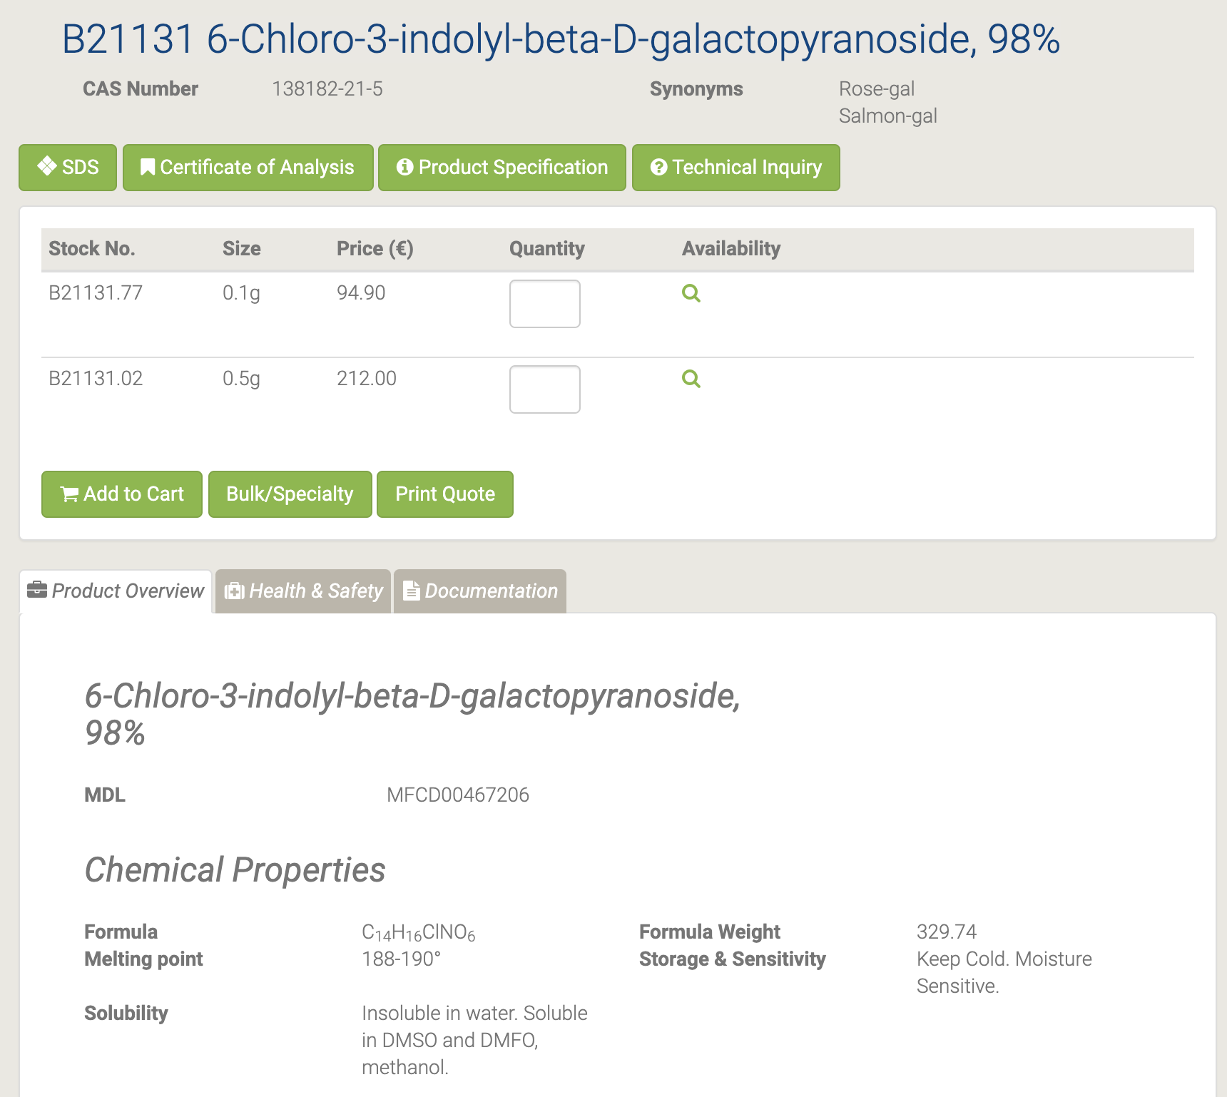

Используется в качестве промежуточного фармацевтического продукта для снижения токсичности и в качестве ферментного субстрата в диагностических реагентах. Salmon-gal используется в сочетании с IPTG для обнаружения активности β-галактозидазы в бактериальных колониях в колометрическом анализе для обнаружения рекомбинантов (белые) из нерекомбинированных (SALMON). В сочетании с X-glu, лосось полезен для одновременного обнаружения активности GUS и Lac на одной и той же пластине [86-87].

#### B21068 6-Chloro-3-indolyl-beta-D-glucuronide cyclohexylammonium salt

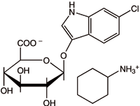

B21068 6-Chloro-3-indolyl-beta-D-glucuronide cyclohexylammonium salt [88]

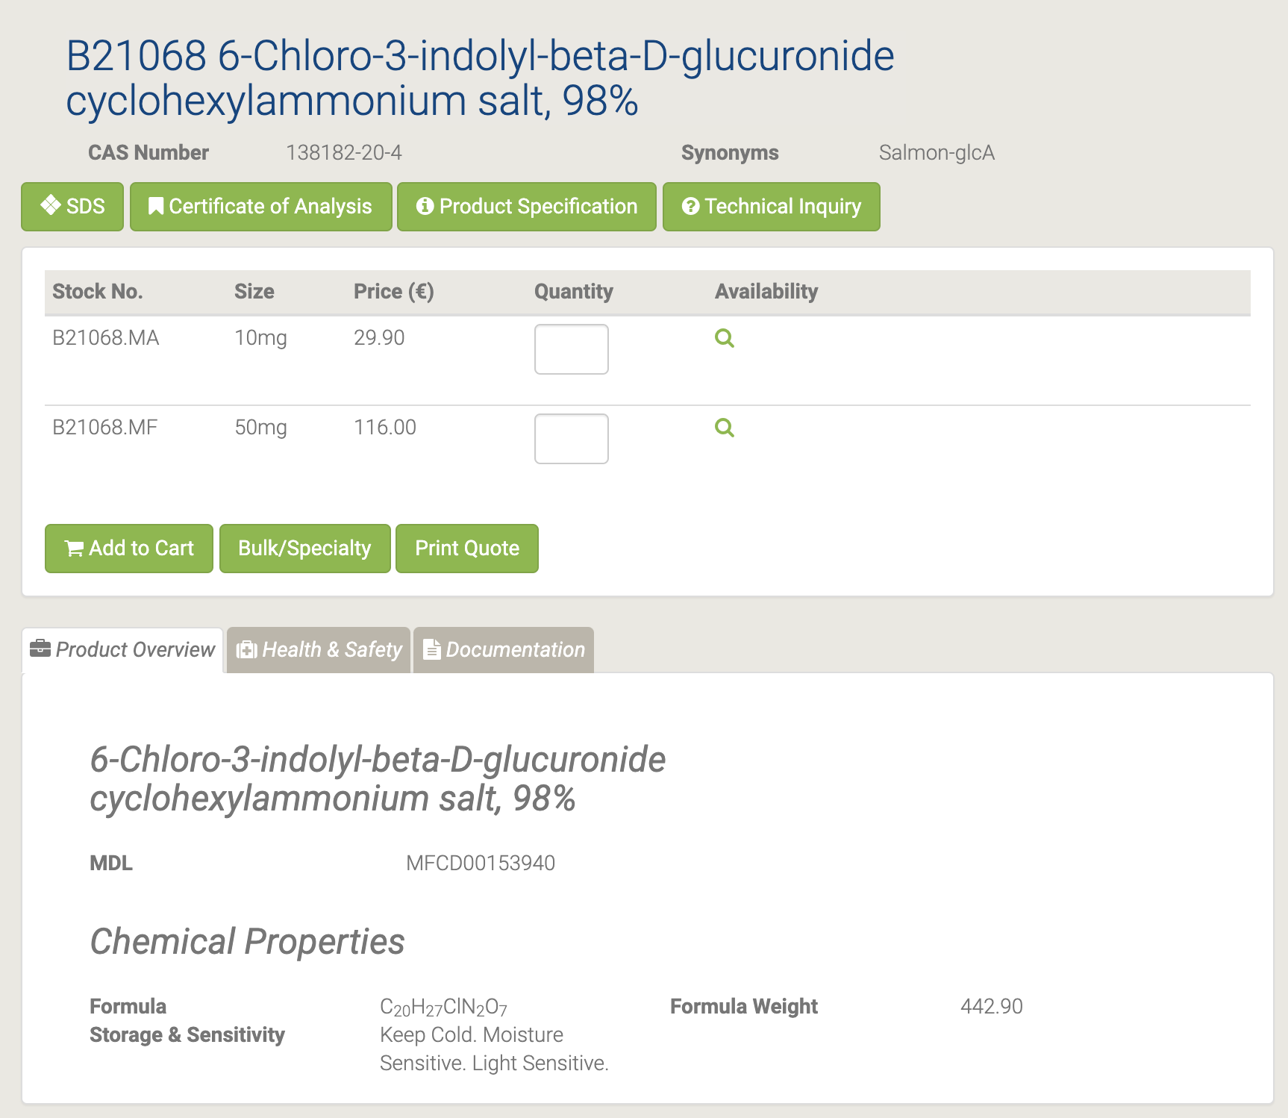

#### B21985 6-(Chloromethyl)uracil

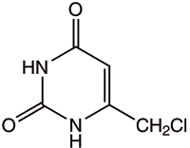

B21985 6-(Chloromethyl)uracil [89]

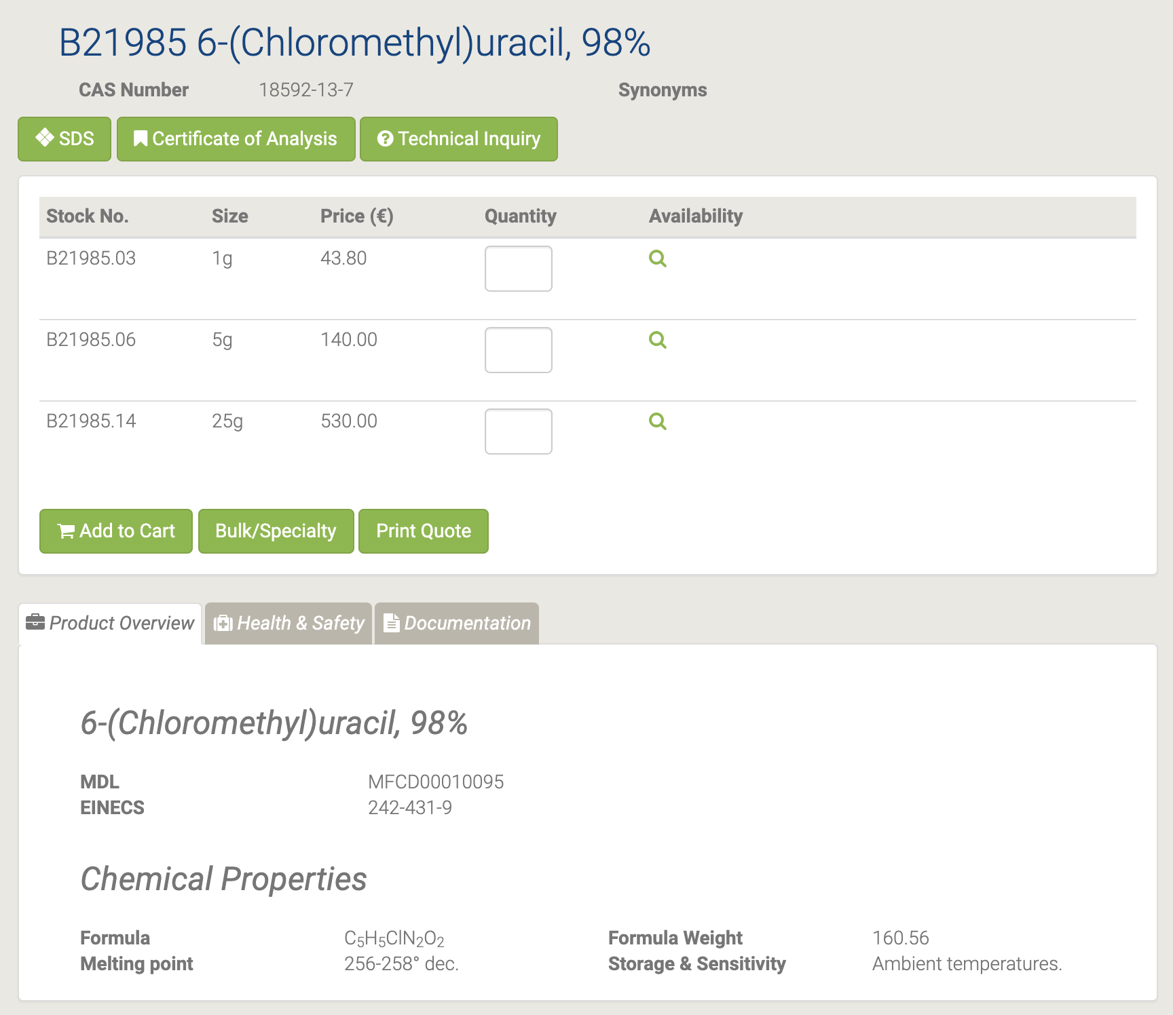

#### L01875 6-Chlorouracil

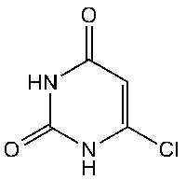

L01875 6-Chlorouracil [90]

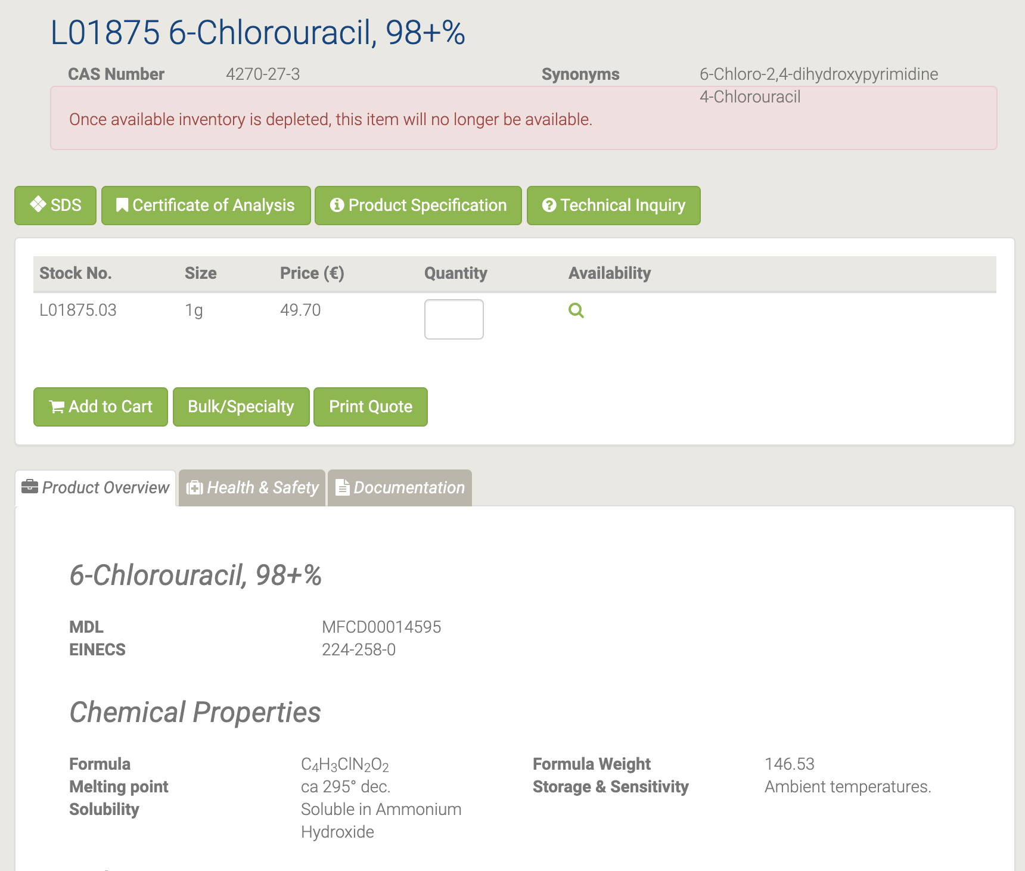

Хлорацил (4-хлороурацил; 6-хлороурацил) представляет собой галогенированный урацил, который полезен при исследованиях влияния галогенирования на стабильность пары оснований нуклеиновых кислот и сродство к ионам щелочных металлов. Взаимодействие 6-хлороурацила с 4- (диметиламино) пиридином, 4-метилпиридином и пиридин-4-илморфолином давало замещенные пиридинием урацилы в виде хлоридов, которые превращались в урацилаты пиридиния депротонированием. Эти гетероциклические мезомерные бетаины являются перекрестно-конъюгированными и, таким образом, содержат отдельные катионные (пиридиний) и анионные (урацилатные) части. Расчеты и рентгеновский анализ монокристаллов можно использовать для характеристики этих систем и сравнения солей с бетаинами. [91-92]

#### H51694 6-(Diethoxymethyl)uracil

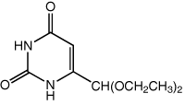

H51694 6-(Diethoxymethyl)uracil [93]

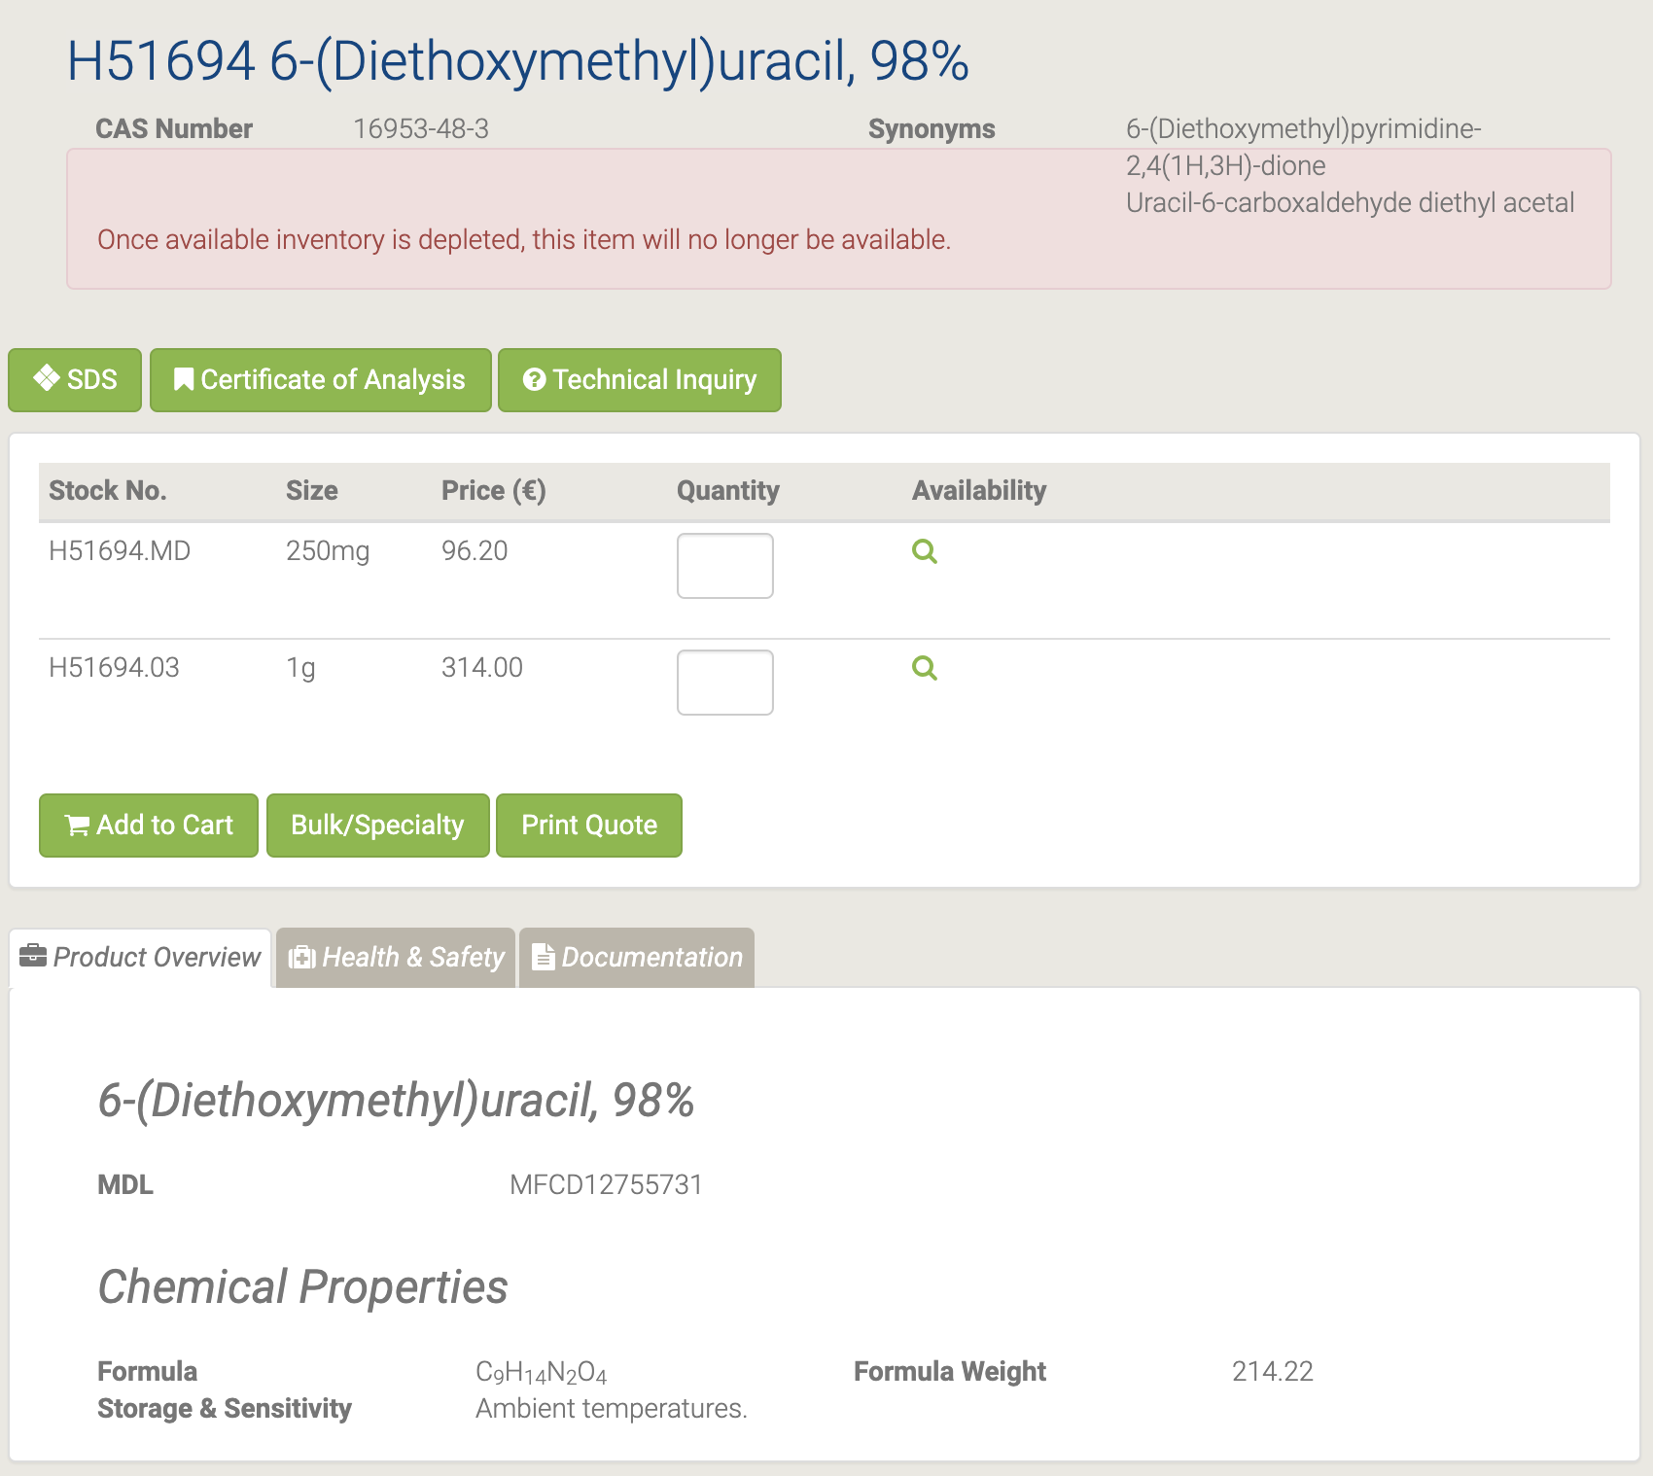

#### H66634 6-Iodouridine

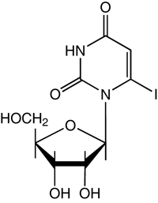

H66634 6-Iodouridine [94]

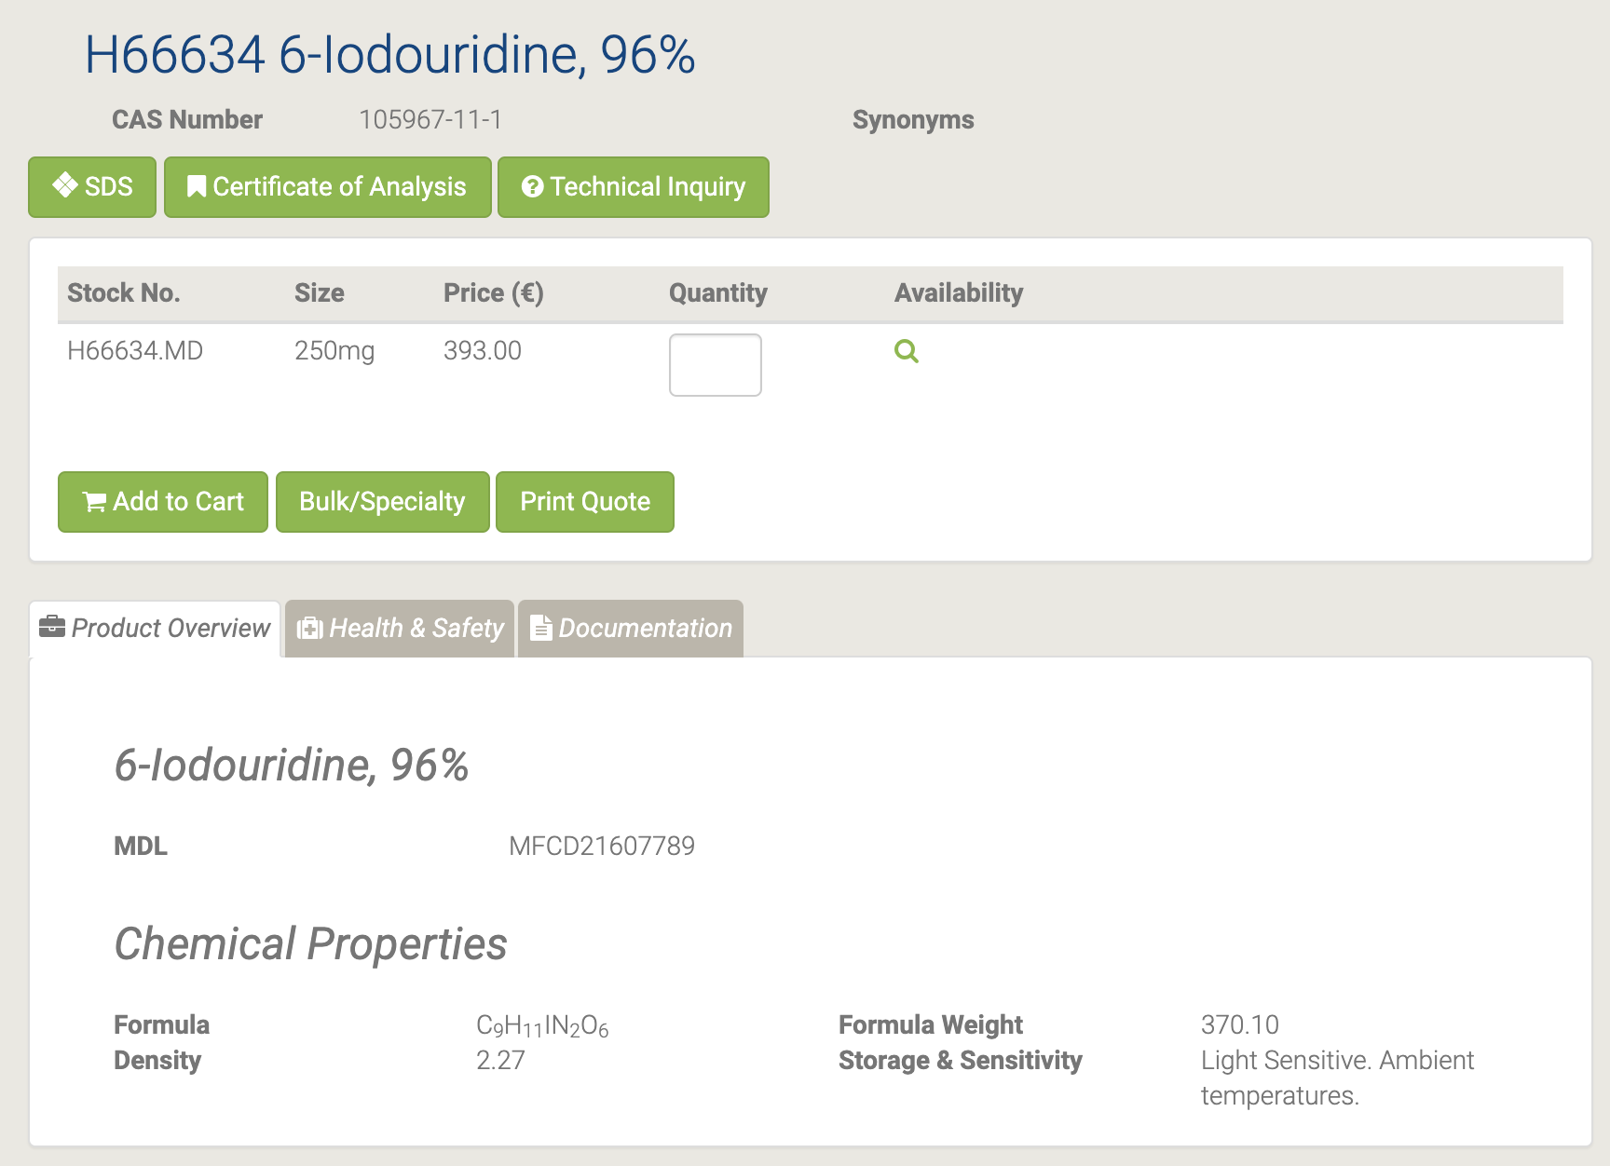

#### B24191 6-Methyluracil

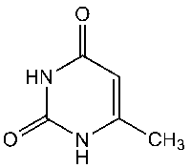

B24191 6-Methyluracil [95]

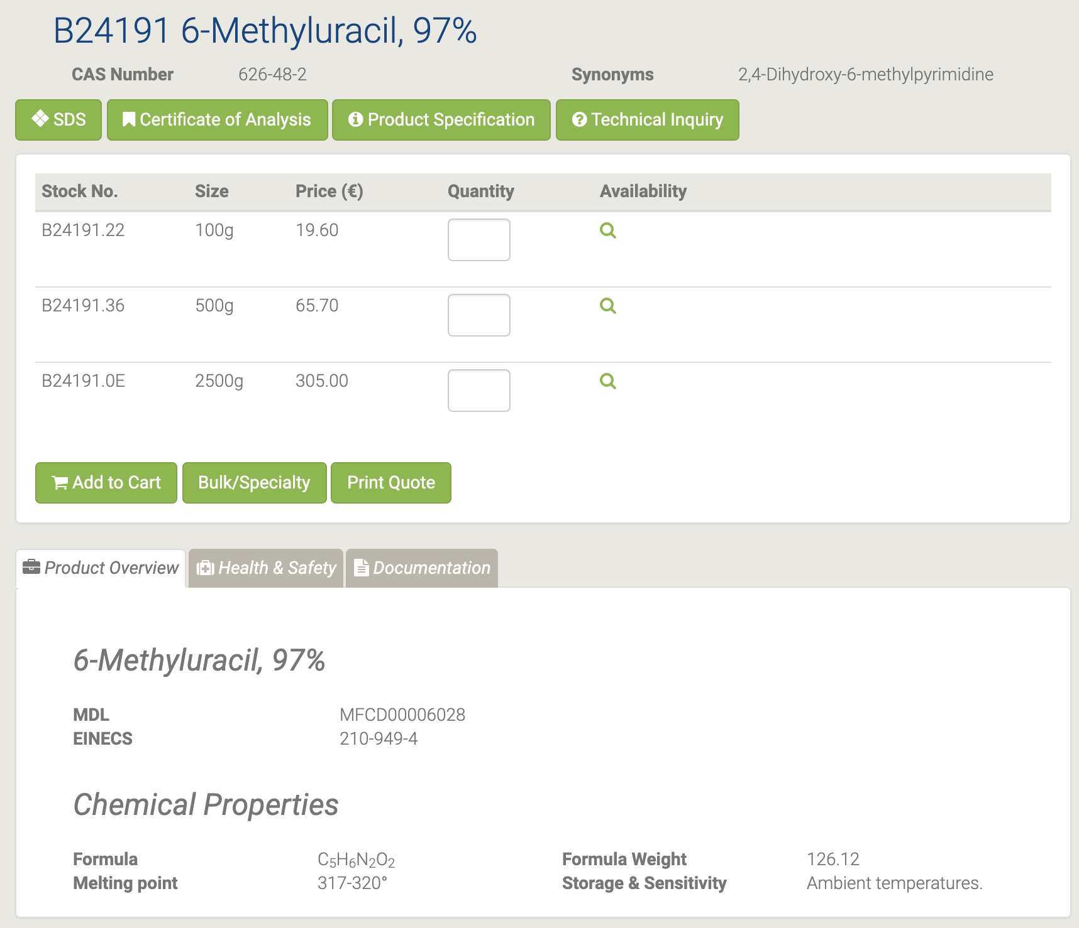

#### 44467 6-(Trifluoromethyl)uracil

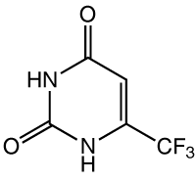

44467 6-(Trifluoromethyl)uracil [96]

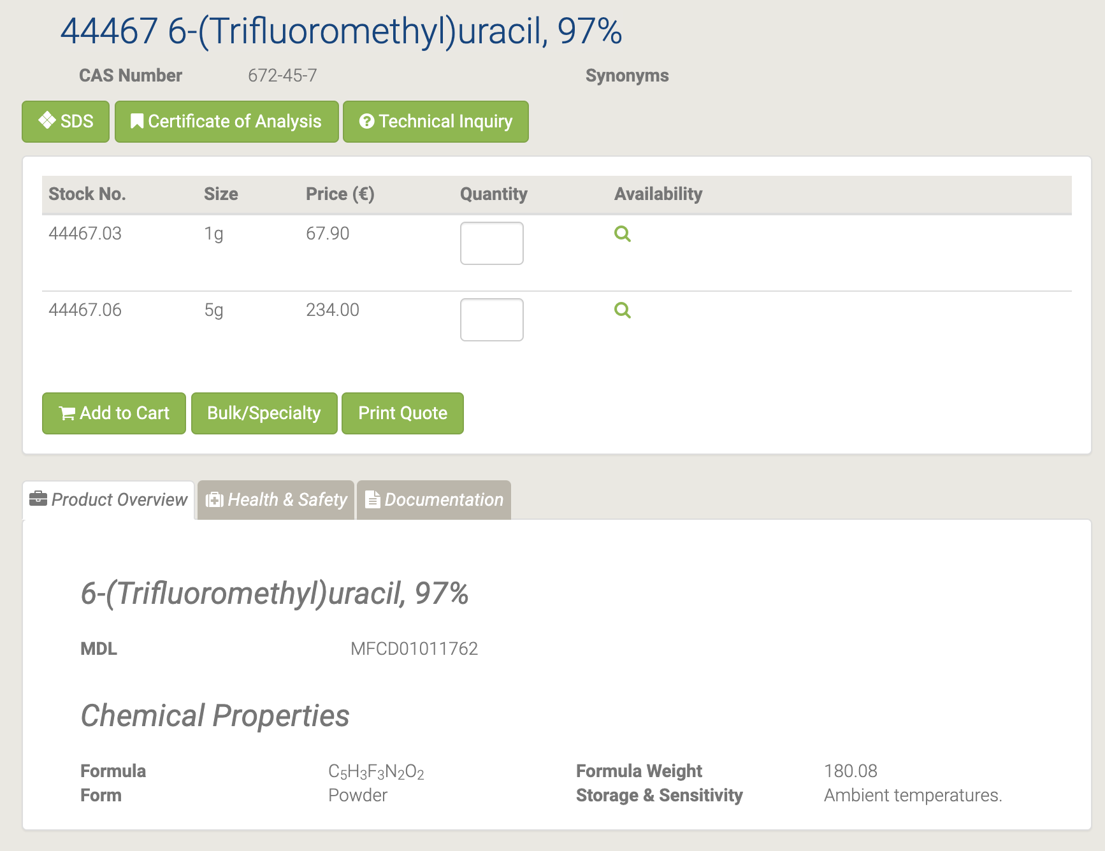

#### L03544 8-Bromoadenosine

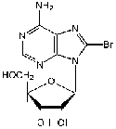

L03544 8-Bromoadenosine [97]

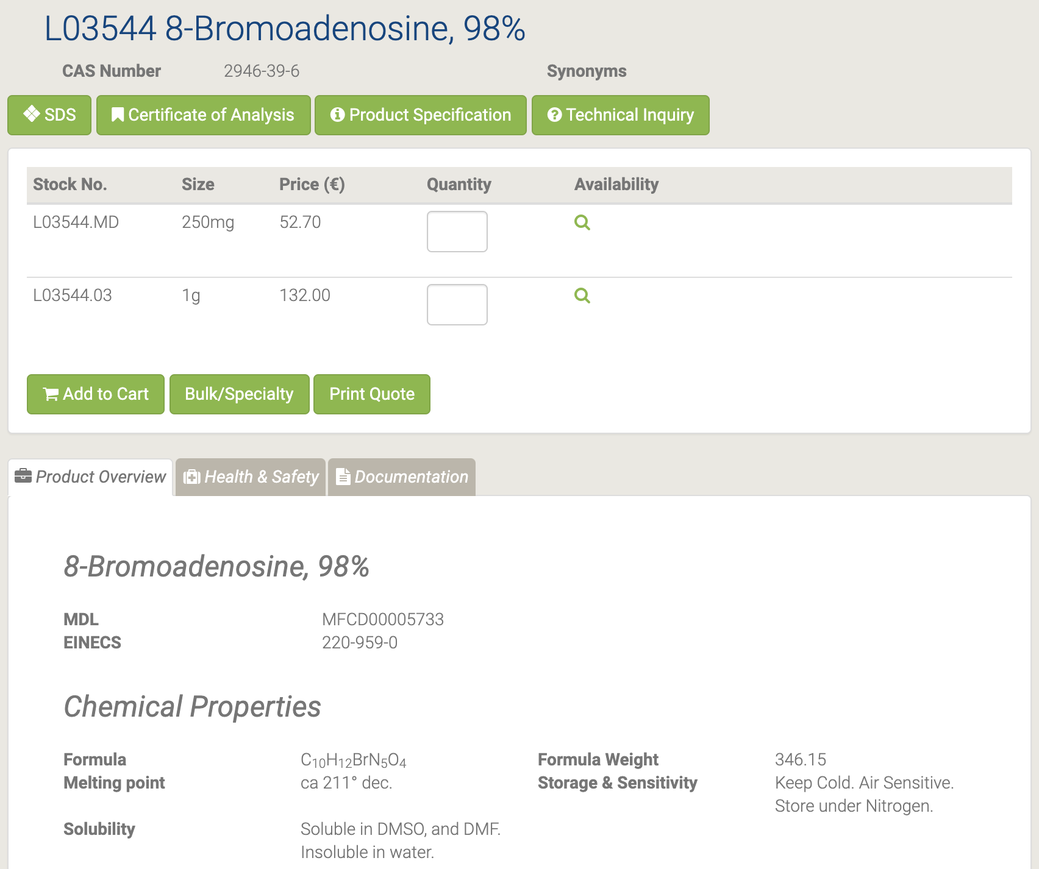

8-Бромаденозин является ингибитором связывания аденозина. [98-99]

#### L02992 8-Bromoguanosine hydrate

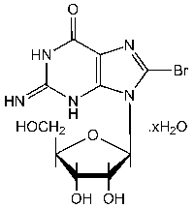

L02992 8-Bromoguanosine hydrate [100]

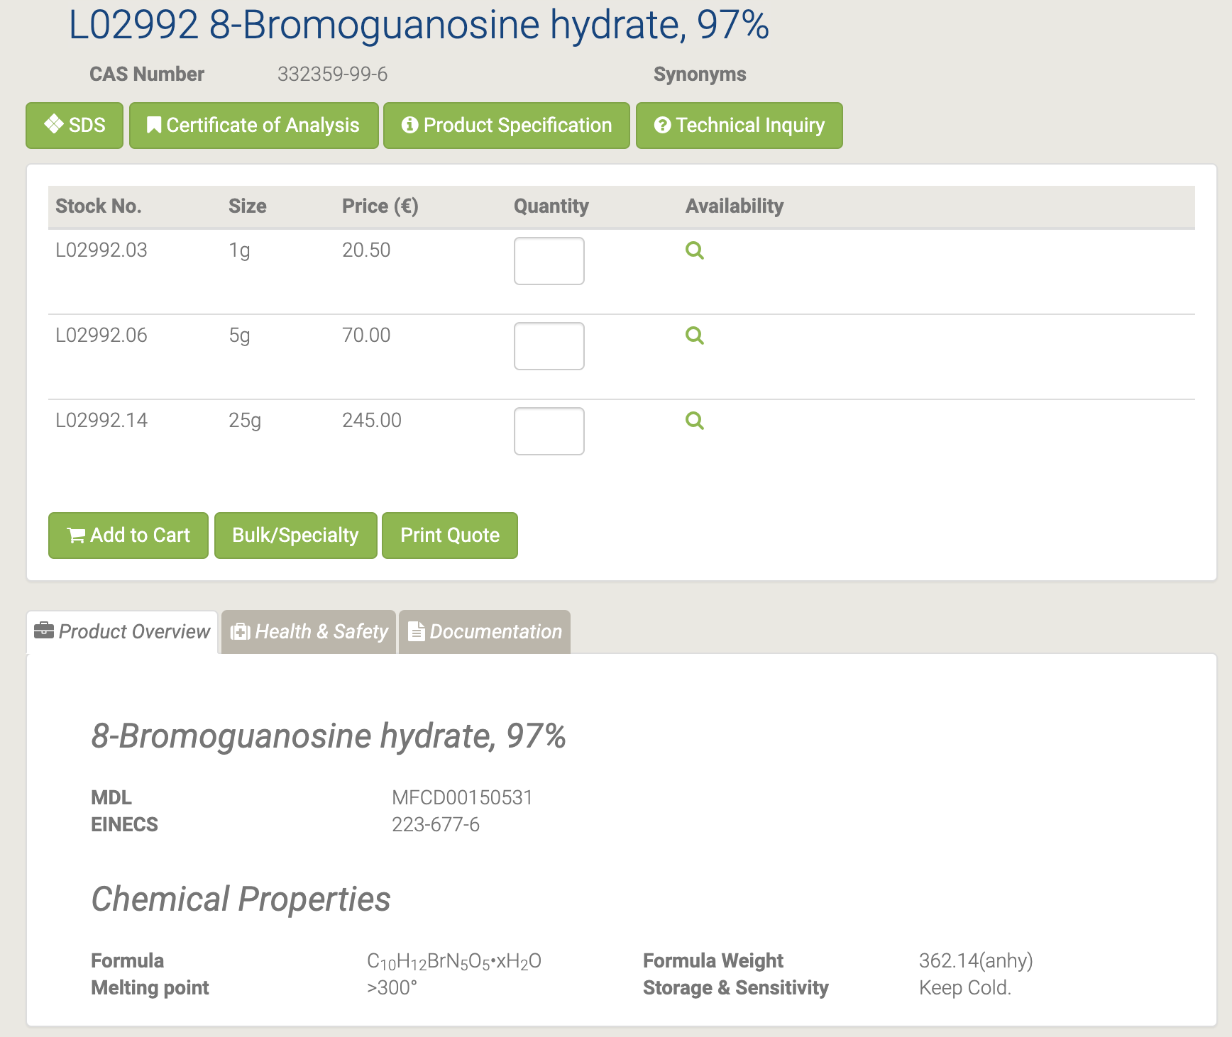

#### A16964 Adenine sulfate

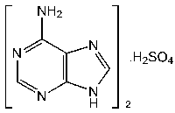

A16964 Adenine sulfate [101]

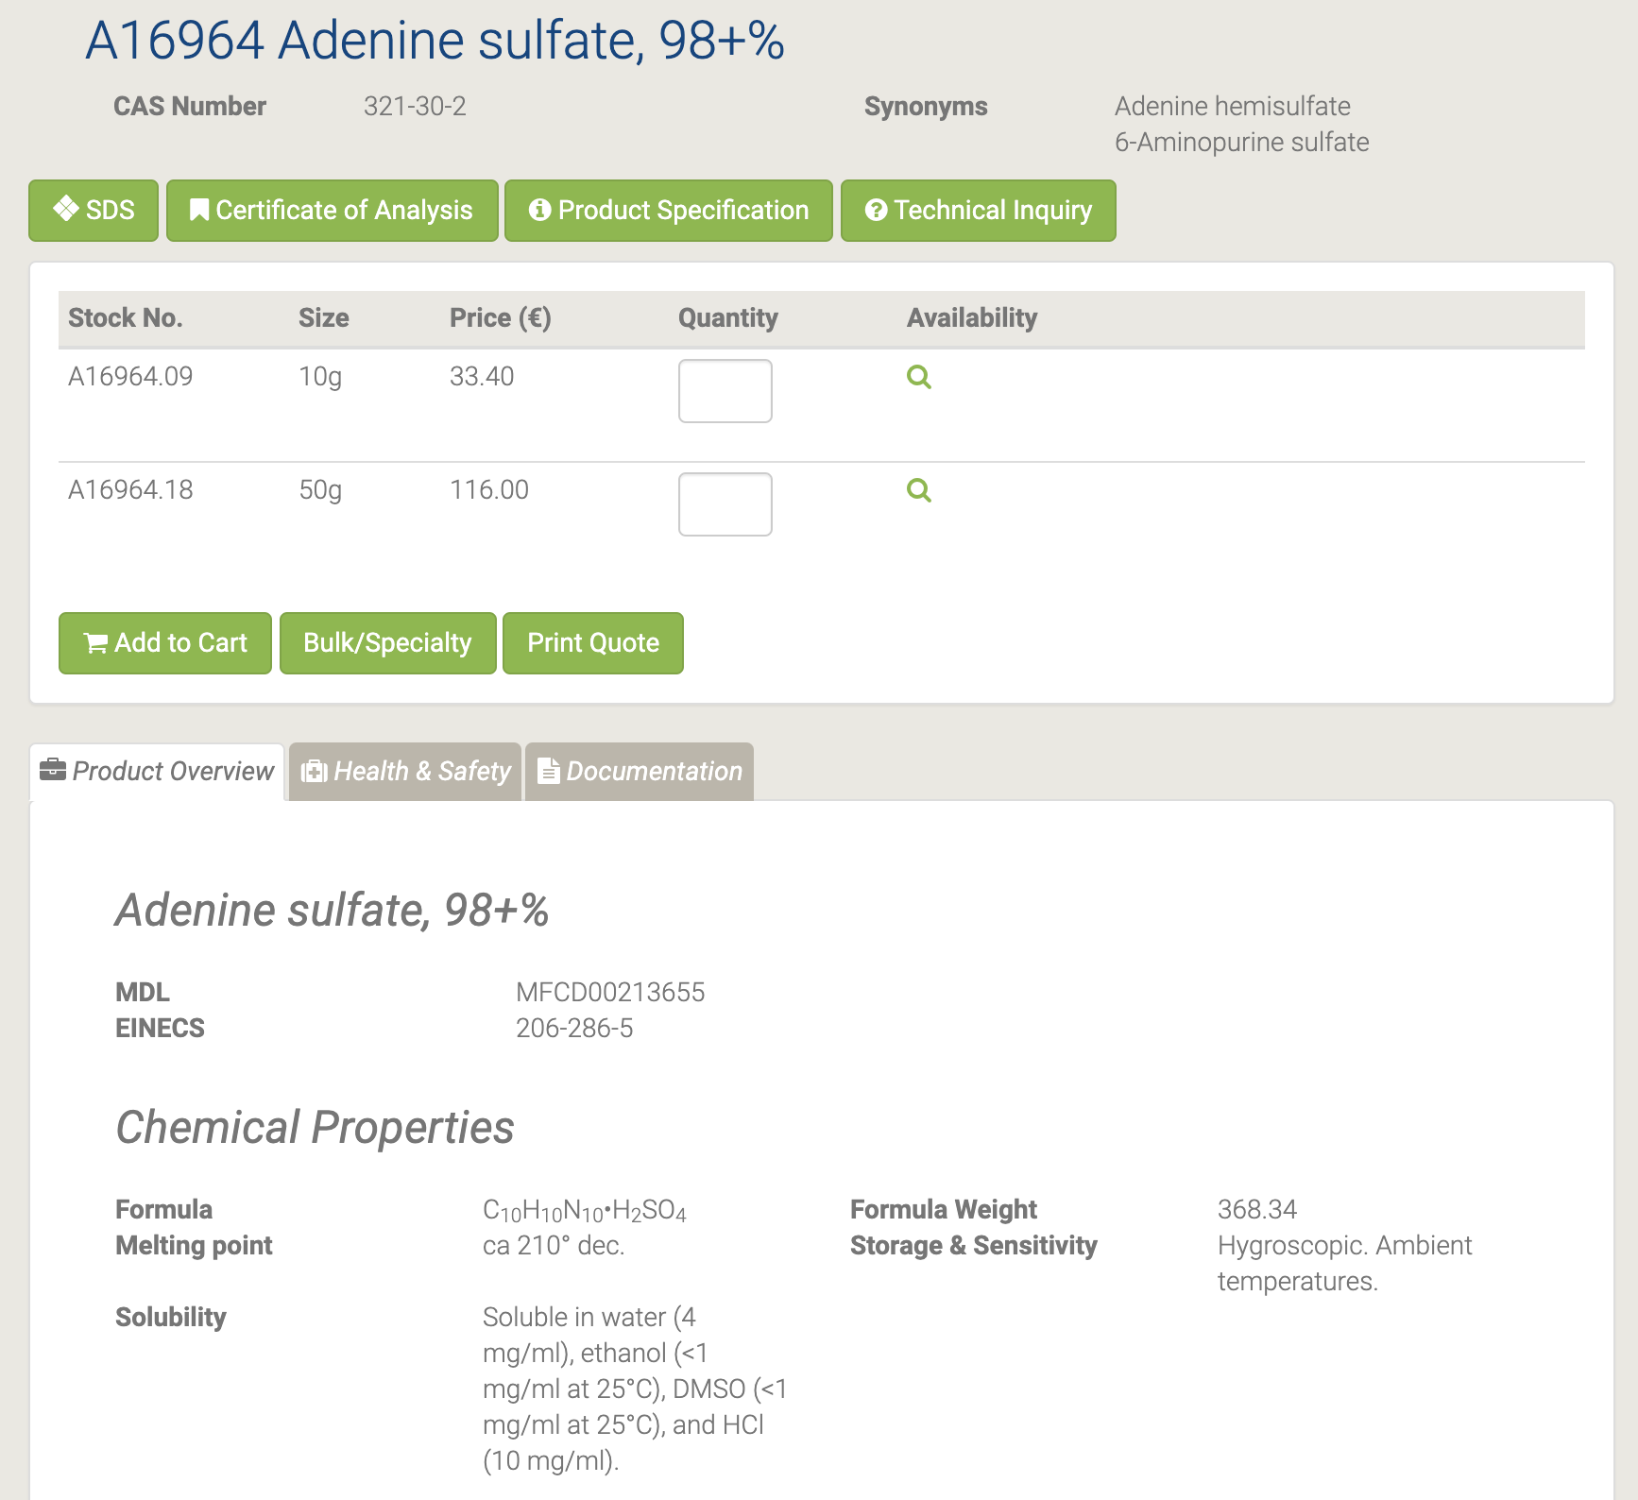

Он выполняет широкий спектр химических и биохимических ролей in vivo и in vitro, используя его в качестве регуляторной молекулы. Он действует как предшественник, субстрат или кофактор в различных биохимических путях. [102-103]

#### L14029 Adenosine-5'-diphosphate disodium salt

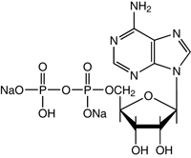

L14029 Adenosine-5'-diphosphate disodium salt [104]

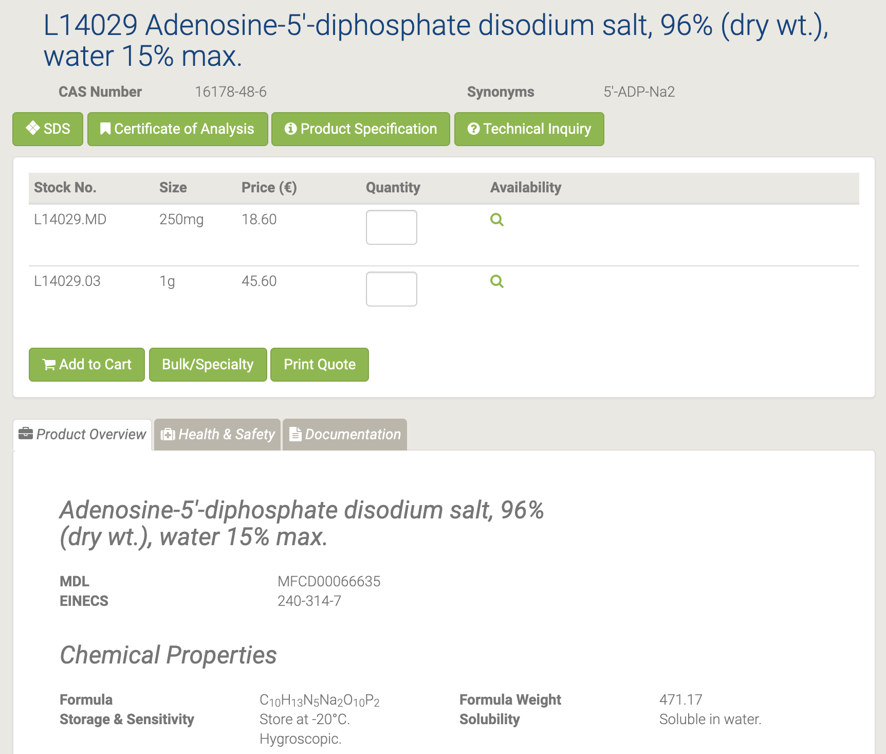

Динатриевая соль аденозин-5'-дифосфата является важным сырьем и промежуточным продуктом, используемым в органическом синтезе, фармацевтике и агрохимии. [105]

#### L14051 Adenosine-5'-monophosphoric acid

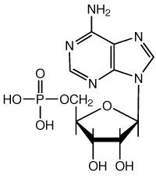

L14051 Adenosine-5'-monophosphoric acid [106]

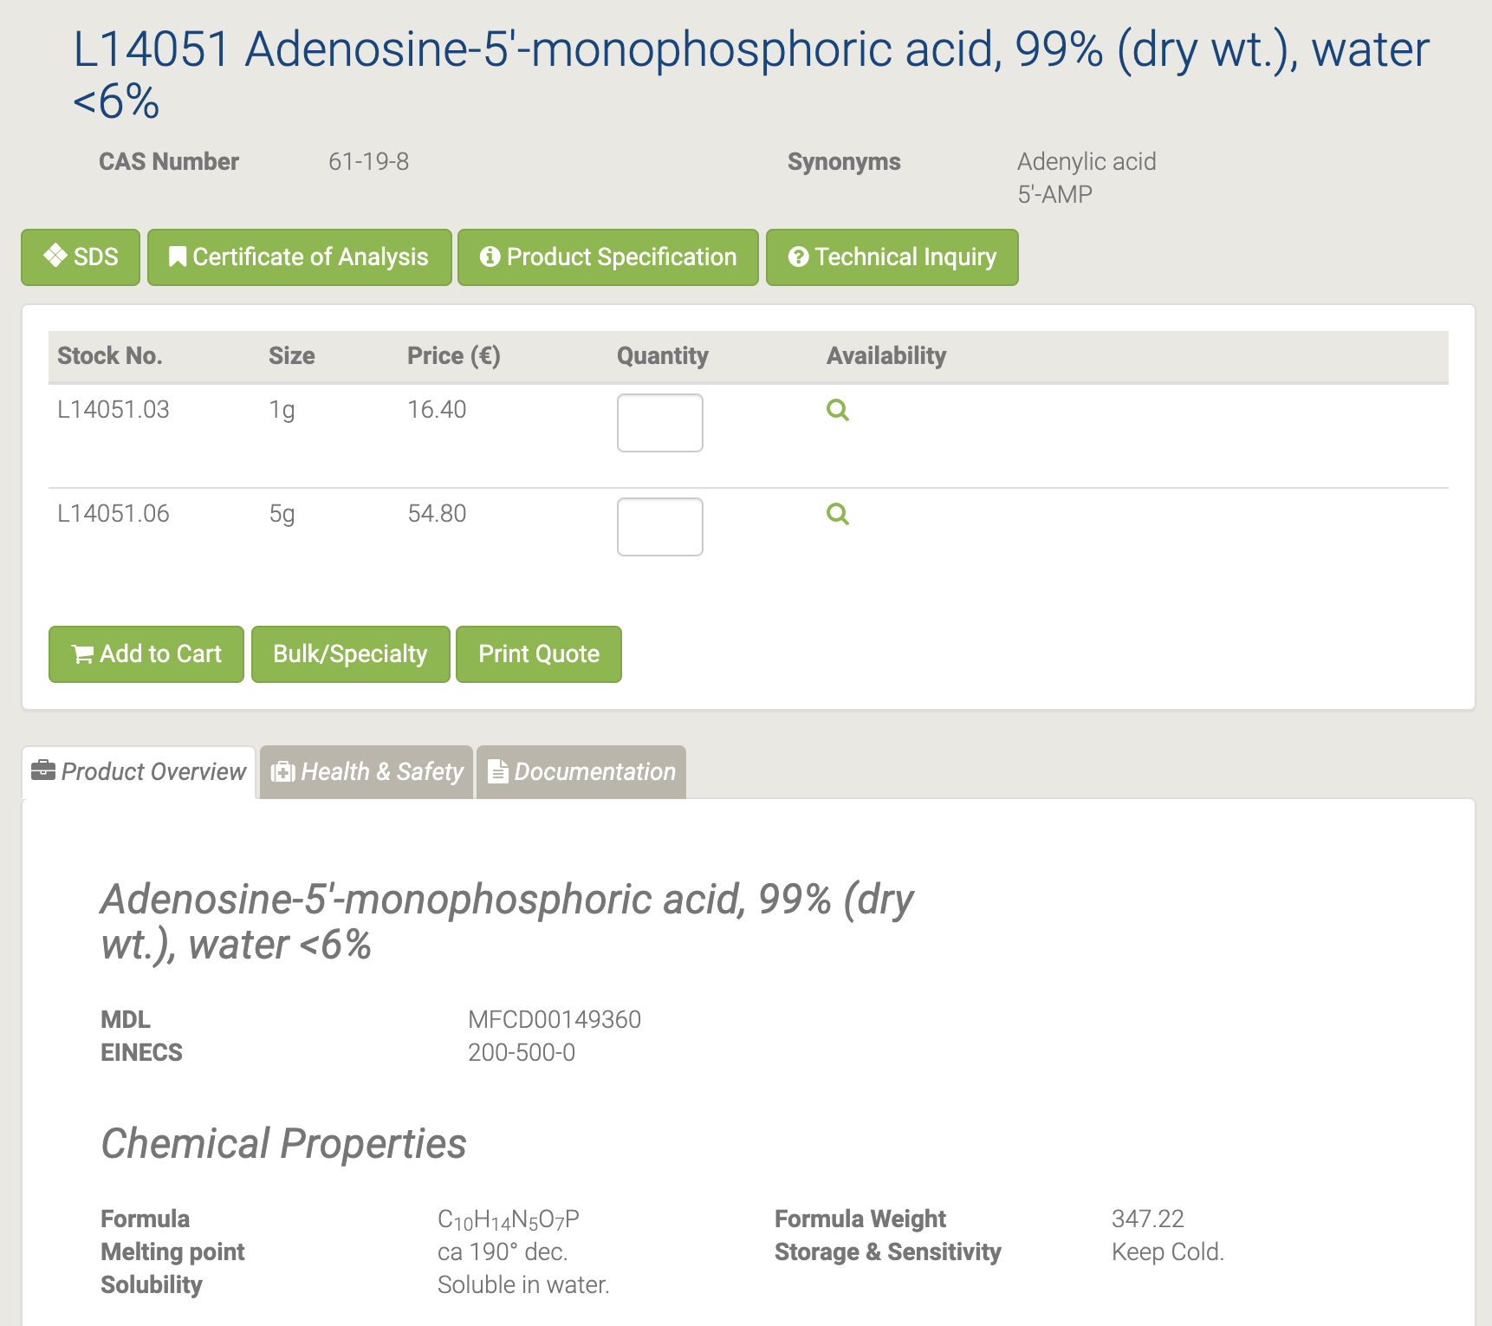

полезная детерминанта лиганда, которая облегчает связывание ингибиторов APS-редуктазы и активирует агонисты аденозинового рецептора. 5α-АМР является активатором класса протеинкиназ, известных как АМФ-активированная протеинкиназа, активатором фосфорилазы b в реакции полимеризации для синтеза разветвленных полисахаридов, реагентом при синтезе аденозин-5β-фосфоимидазолида, ингибитор активности эндогенной аденилилтрансферазы NMN (NMNAT), которая превращает NMN в NAD + [107-108].

#### L14522 Adenosine-5'-triphosphate disodium salt hydrate

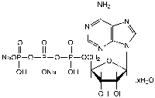

L14522 Adenosine-5'-triphosphate disodium salt hydrate [109]

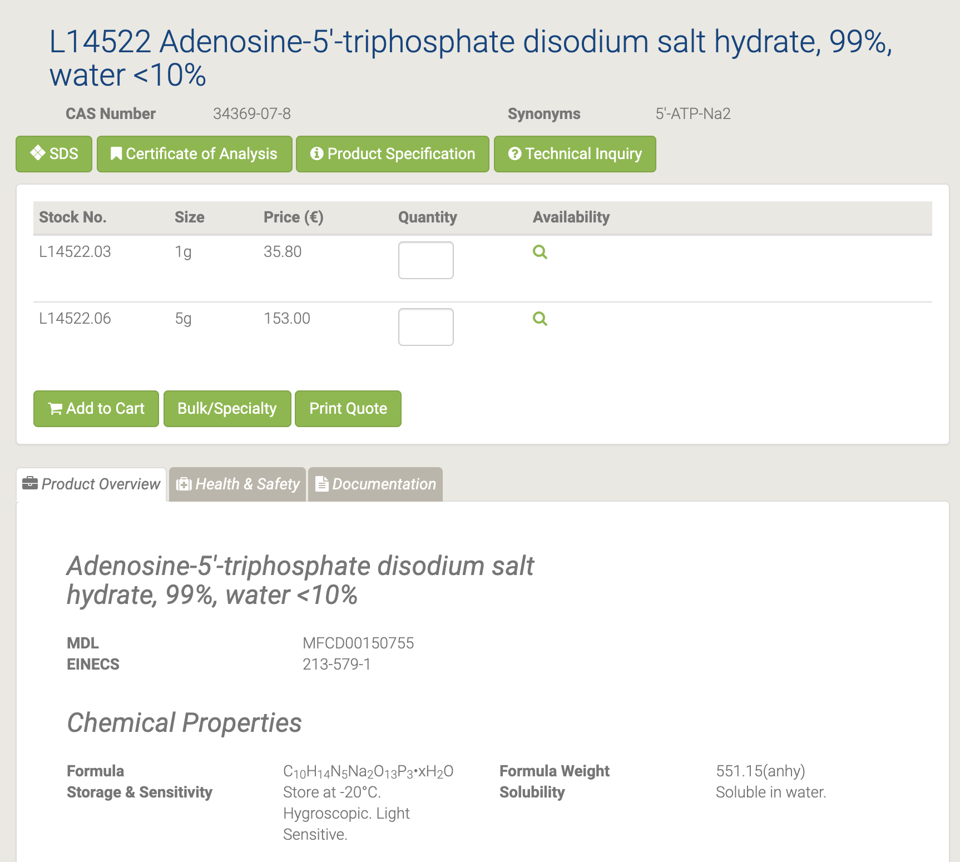

Гидрат динатриевой соли аденозин-5'-трифосфата используется как форма клеточной энергии. Он используется во многих клеточных процессах, дыхании, биосинтетических реакциях, подвижности и делении клеток. АТФ является субстратом многих киназ, участвующих в передаче сигналов клеток, и аденилатциклазы (ов), которые продуцируют второй мессенджер цАМФ. АТФ обеспечивает метаболическую энергию для работы метаболических насосов. АТФ служит коферментом в широком спектре ферментативных реакций [110-111].

#### A10781 Adenosine

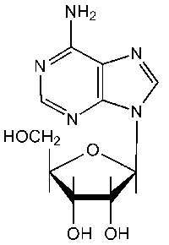

A10781 Adenosine [112]

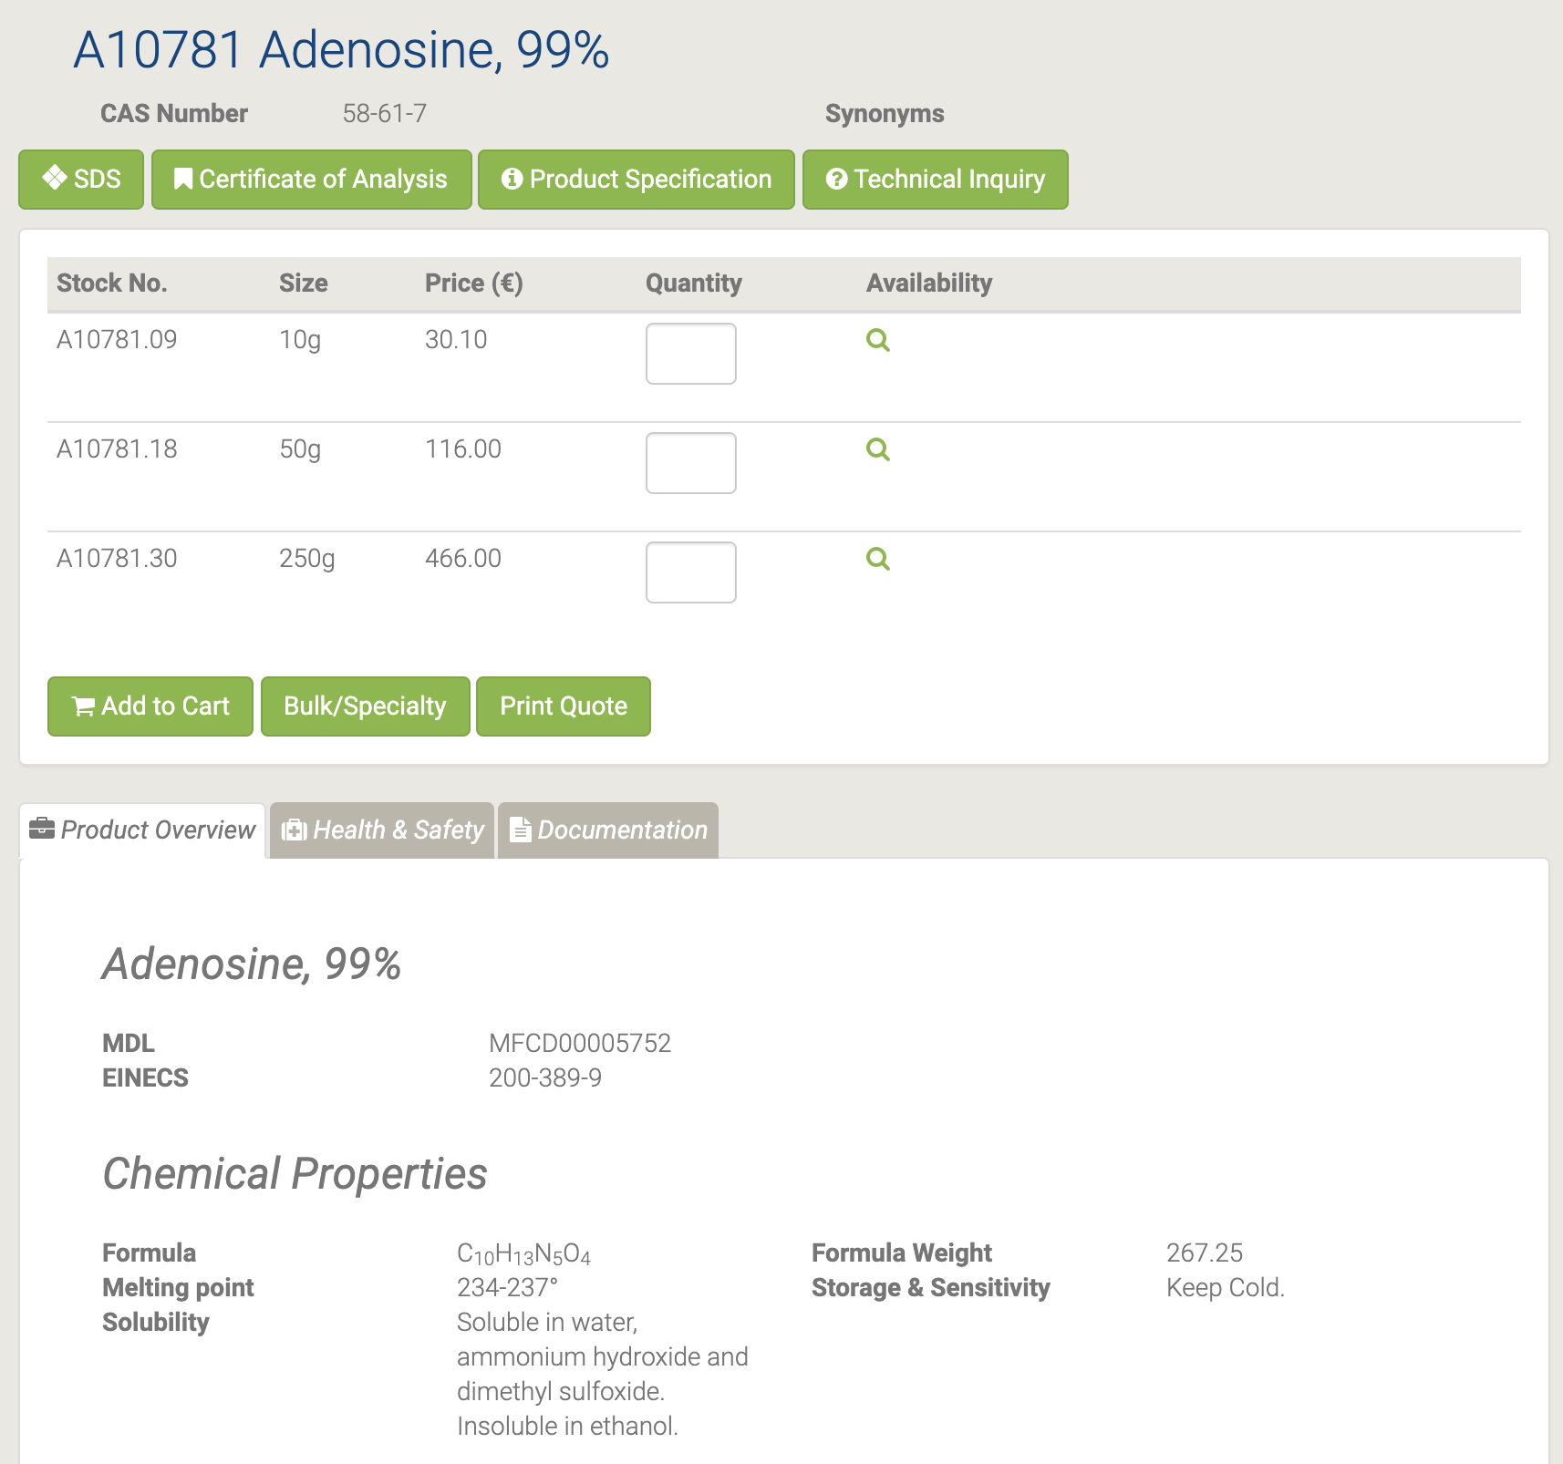

Аденозин служит нуклеотидом. Он также играет важную роль в регуляции кровотока к различным органам за счет расширения сосудов. Он активно участвует в биохимических процессах, таких как передача энергии в виде аденозинтрифосфата и аденозиндифосфата. Кроме того, он используется в лекарствах, в частности, в качестве антиаритмического средства для лечения ряда наджелудочковых тахикардий. Он используется для утолщения волос у людей с истонченными волосами [113-114].

#### L09020 beta-D-Glucosamine pentaacetate

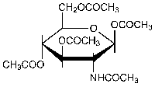

L09020 beta-D-Glucosamine pentaacetate [115]

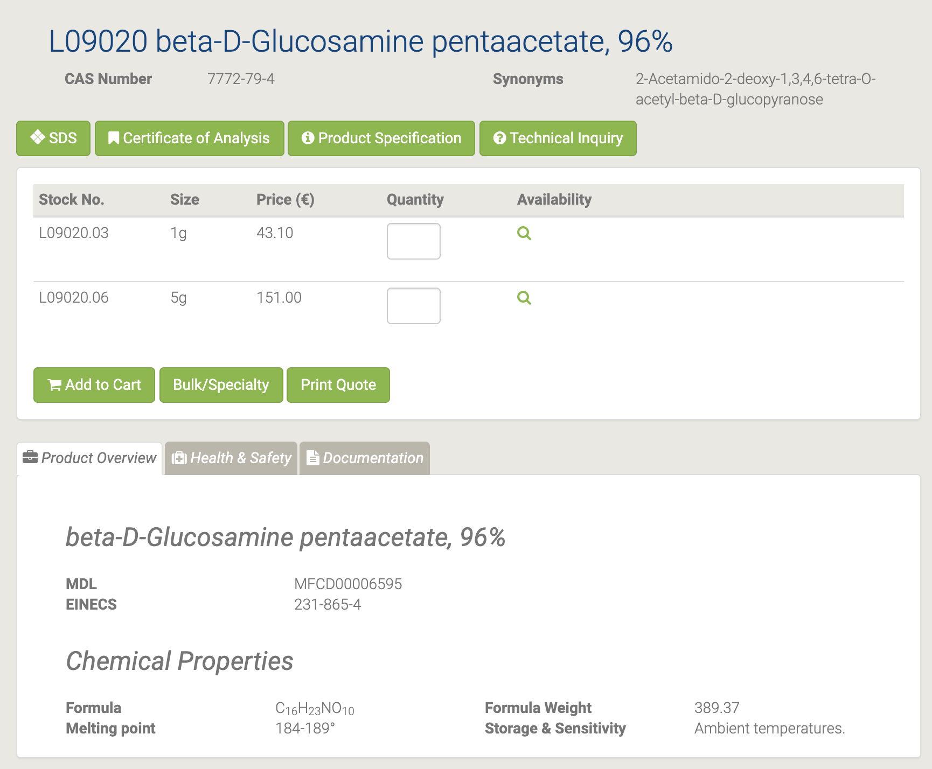

#### H26557 Casein Peptone

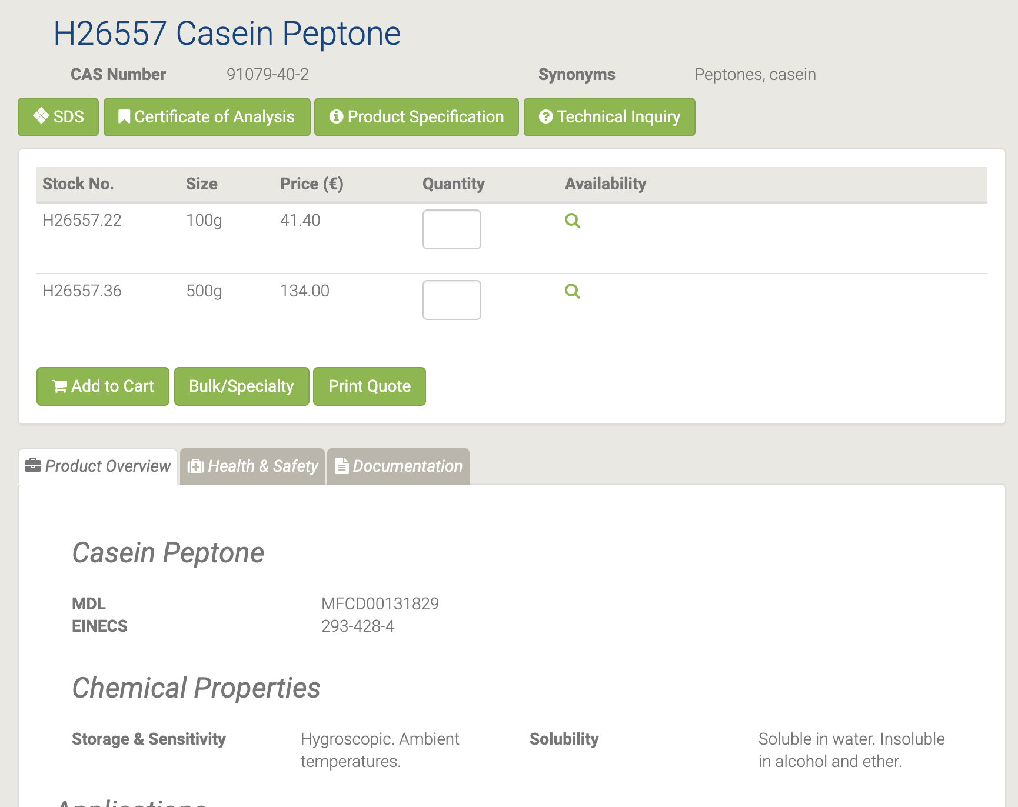

H26557 Casein Peptone [116]

Казеиновый пептон используется в питательных средах для роста бактерий и грибов. Он используется в производстве антибиотиков и ферментов. Это также важно для аналитической микробиологии и промышленного процесса ферментации. Он также используется в бактериальной диагностике и в агропродовольственной, косметической и фармацевтической ферментации для производства биомассы [117-118].

#### A13707 Casein

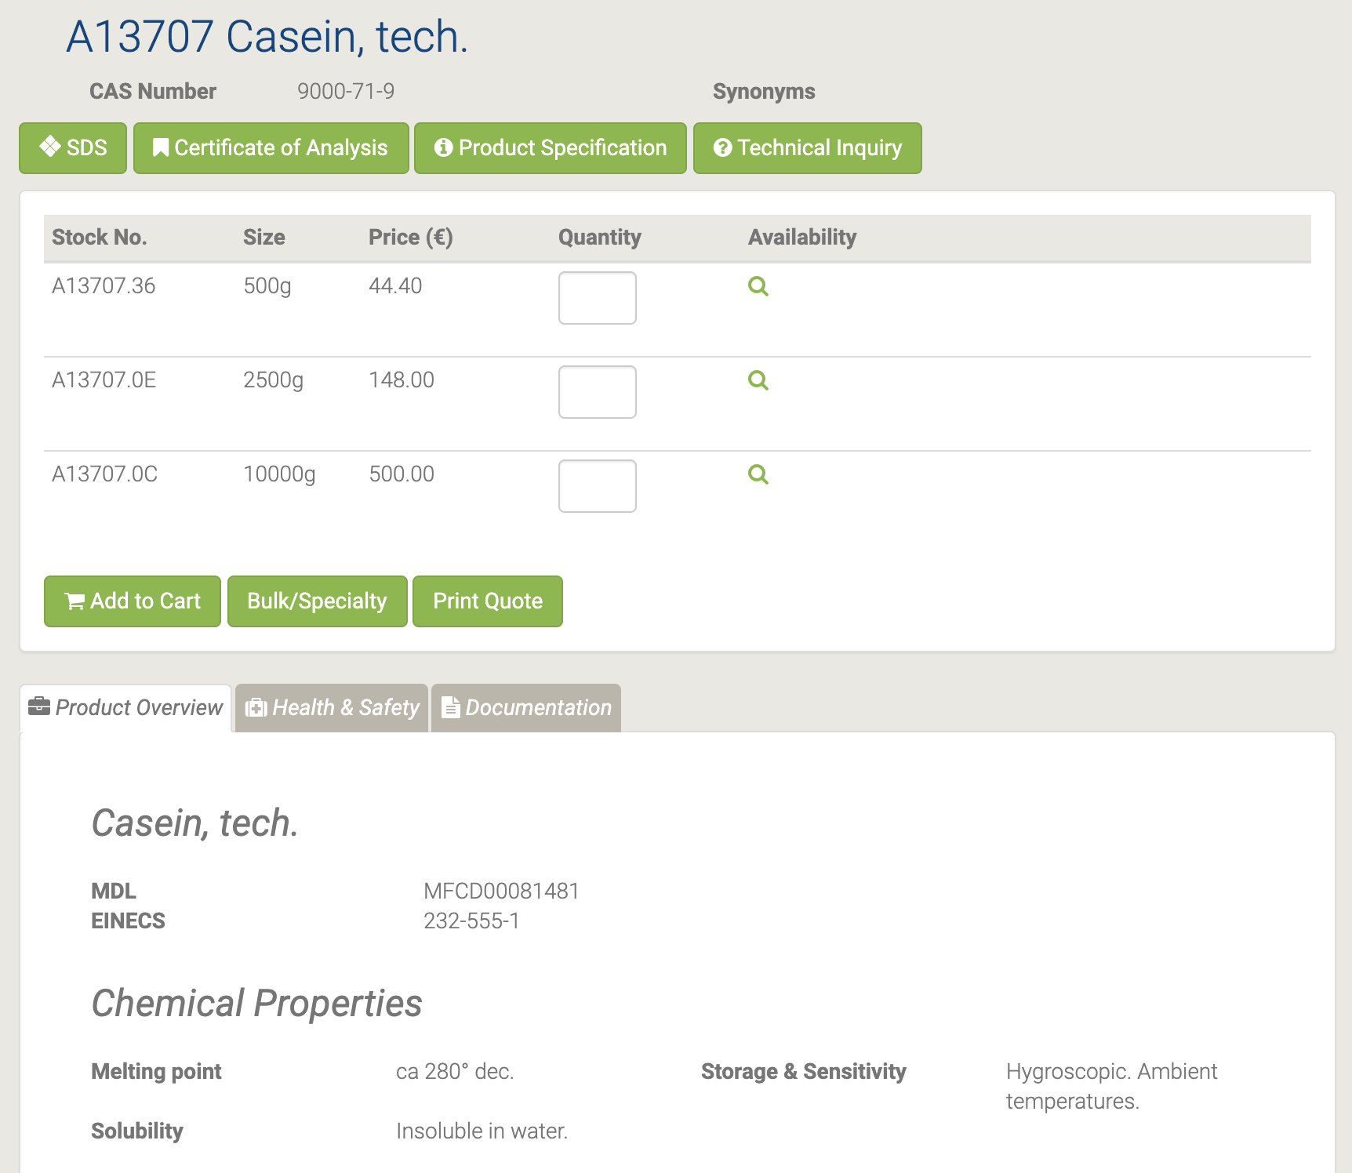

A13707 Casein, tech. [119]

Натуральный источник белка, обычно выделяемый из коровьего молока. Казеин широко используется в качестве пищевой добавки. Он используется в продуктах для реминерализации зубов для стабилизации аморфного фосфата кальция. Он также используется в качестве органического клея и связующего вещества для безопасных спичек. Он содержит аминокислоты, углеводы и два неорганических элемента, таких как кальций и фосфор. Кроме того, он также используется в производстве трансформаторного щита из-за его маслопроницаемости [120-121].

#### H52427 D-erythro-Sphingosine hydrochloride

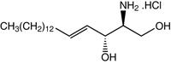

H52427 D-erythro-Sphingosine hydrochloride [122]

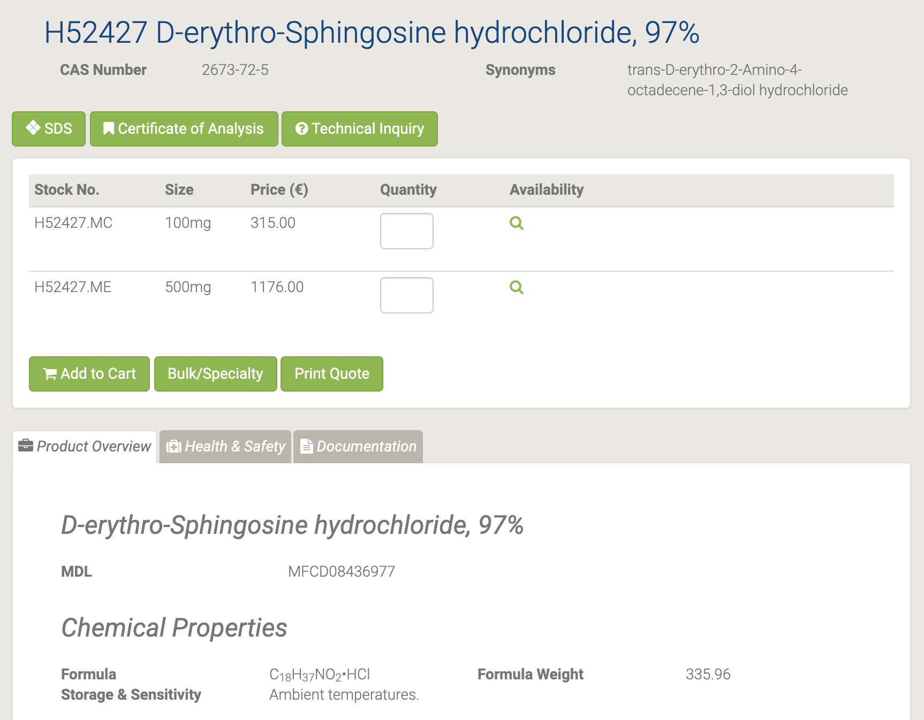

Ингибитор протеинкиназы C и кальмодулинзависимых ферментов, но может стимулировать тучные клетки путем активации протеинкиназы C.

#### H27853 (E)-5-(2-Bromovinyl)-2'-deoxyuridine

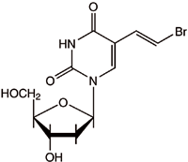

H27853 (E)-5-(2-Bromovinyl)-2'-deoxyuridine [123]

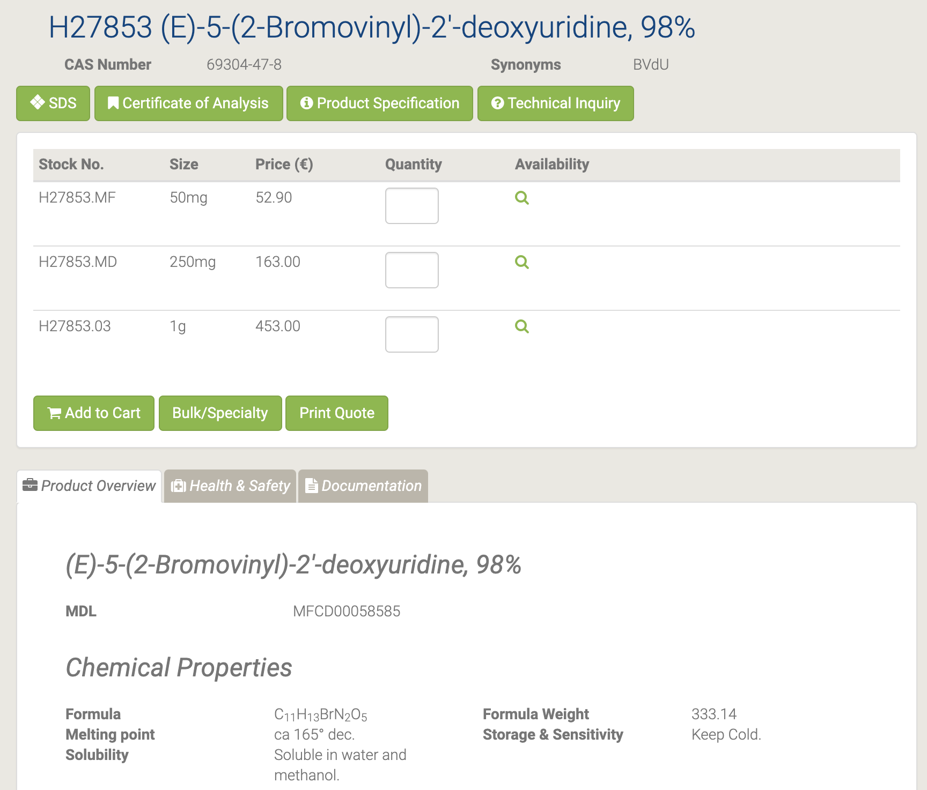

Он используется в качестве промежуточного фармацевтического продукта [124].

#### H26507 Ethyl uracil-5-carboxylate

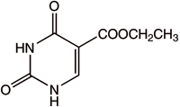

H26507 Ethyl uracil-5-carboxylate [125]

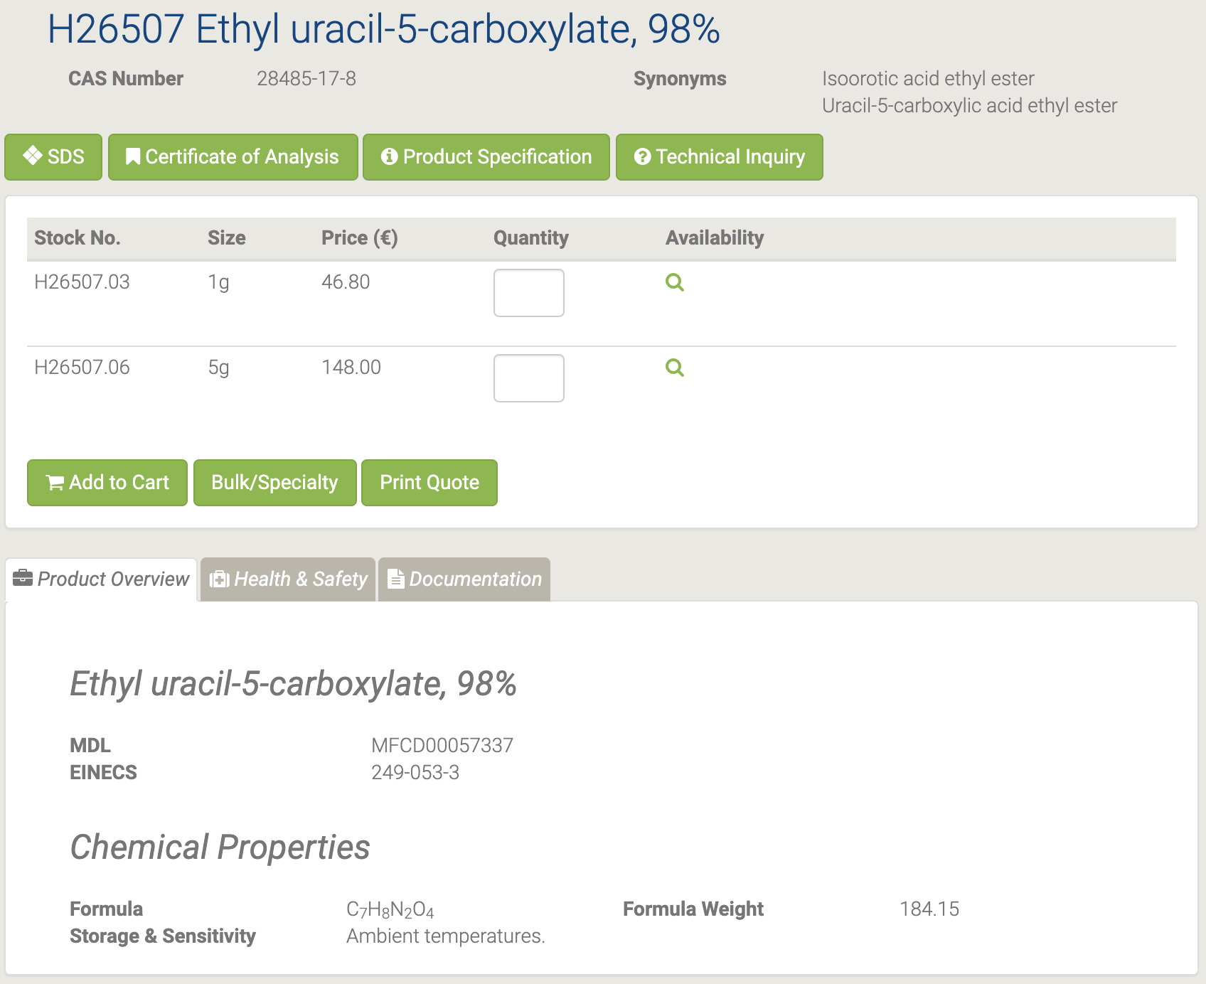

#### A14495 Flavin adenine dinucleotide disodium salt hydrate

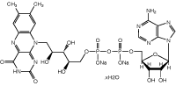

A14495 Flavin adenine dinucleotide disodium salt hydrate [126]

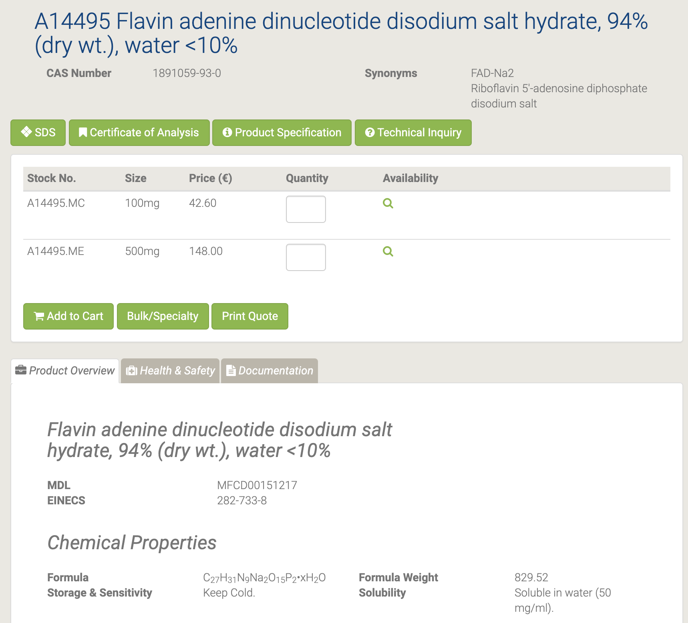

Флавинадениндинуклеотид (FAD) используется в качестве окислительно-восстановительного кофактора (переносчика электронов) флавопротеинами, включая сукцинатдегидрогеназу (комплекс), α-кетоглутаратдегидрогеназу, фактор, вызывающий апоптоз 2 (AIF-M2, AMID), фолат / FAD-зависимые тРНК метилтрансферазы. и N-гидроксилирующие флавопротеинмонооксигеназы. ФАД является компонентом комплекса пируватдегидрогеназы [127-128].

#### A12024 Guanine

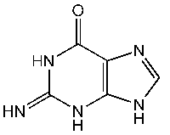

A12024 Guanine [129]

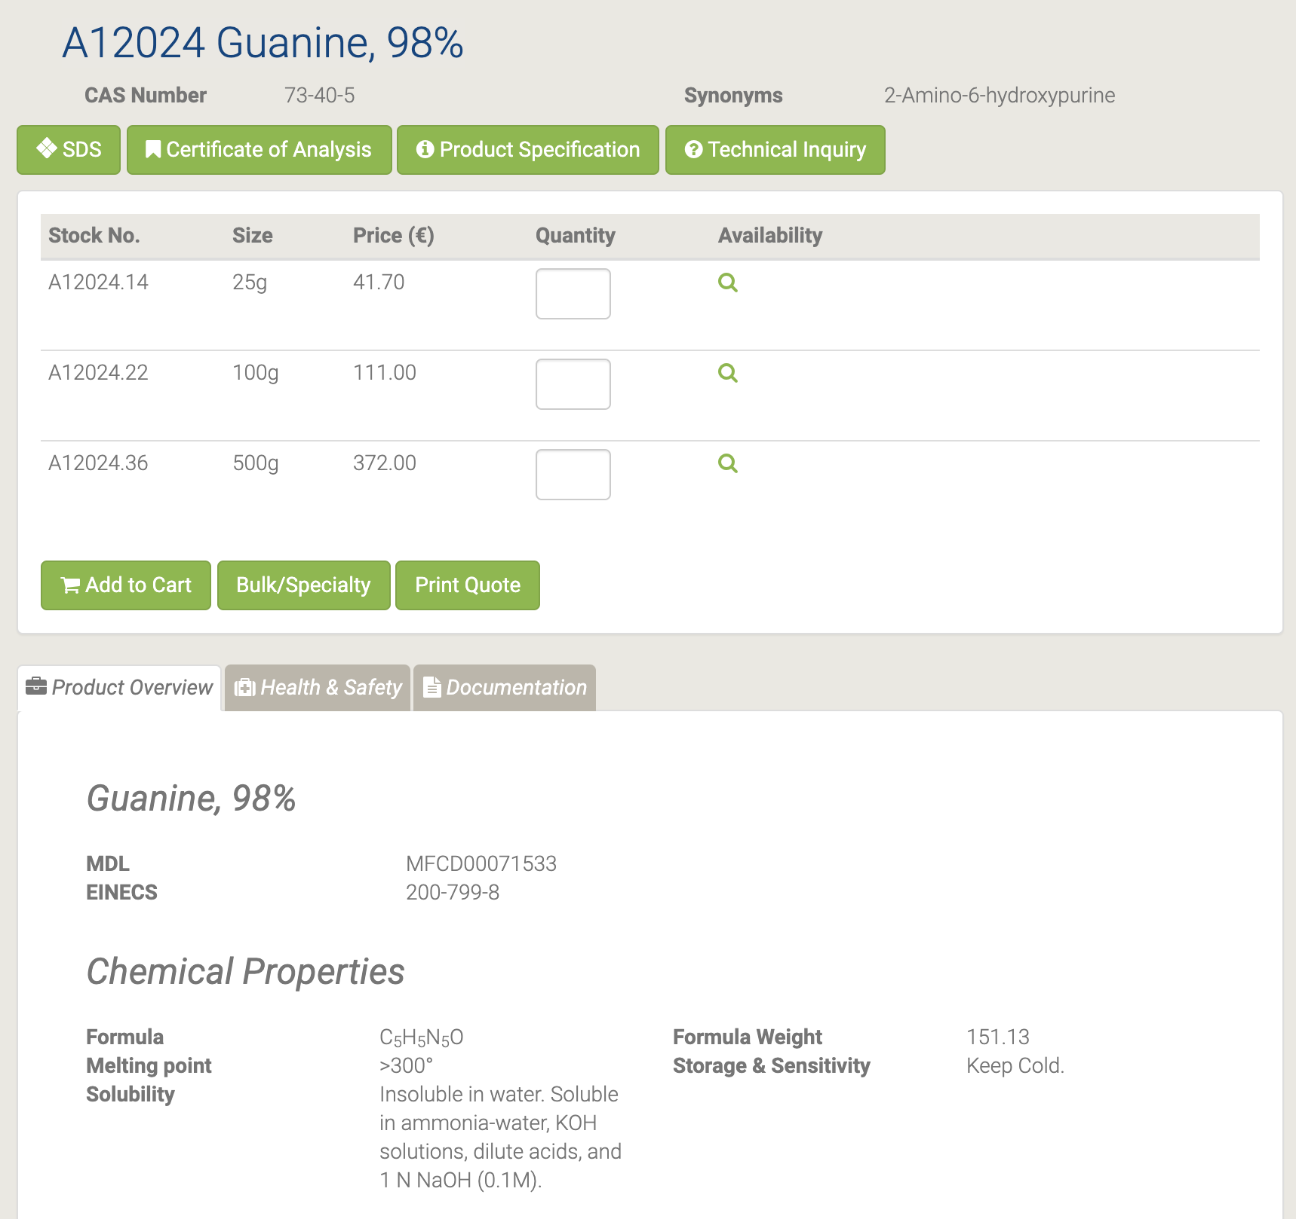

Используется в качестве азотистого основания, включенного в биологические нуклеиновые кислоты. Гуанин - подходящий реагент, используемый для исследования механизма электрохимического окисления гуанина и аденина с использованием стеклоуглеродного микроэлектрода и циклической и дифференциальной импульсной вольтамперометрии. Его можно использовать при получении мономеров пептидной нуклеиновой кислоты (ПНК) со смешанной последовательностью [130-132].

#### A11532 Guanine hydrochloride

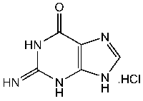

A11532 Guanine hydrochloride [133]

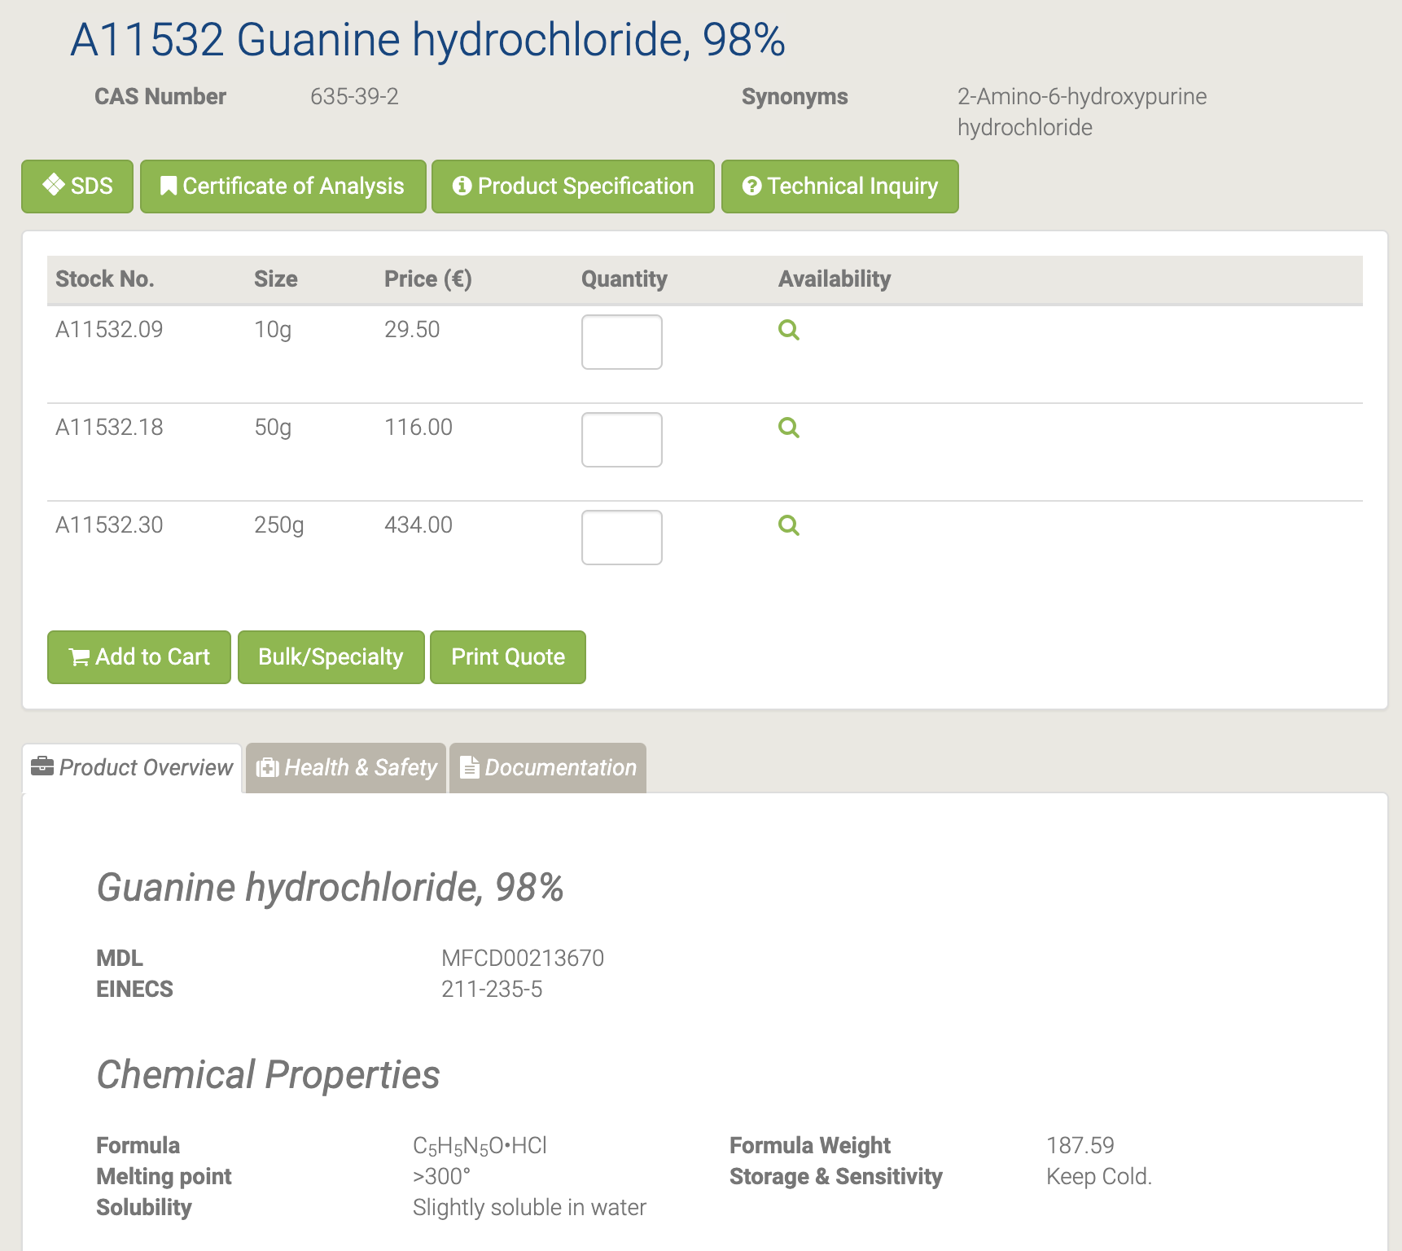

Гидрохлорид гуанина - один из сильнейших денатурирующих агентов. Он в основном используется при очистке белков и исследованиях сворачивания белков. Это азотистое основание, используемое в биохимических исследованиях [134-135].

#### A11328 Guanosine

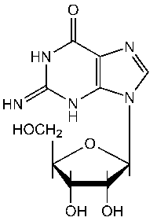

A11328 Guanosine [136]

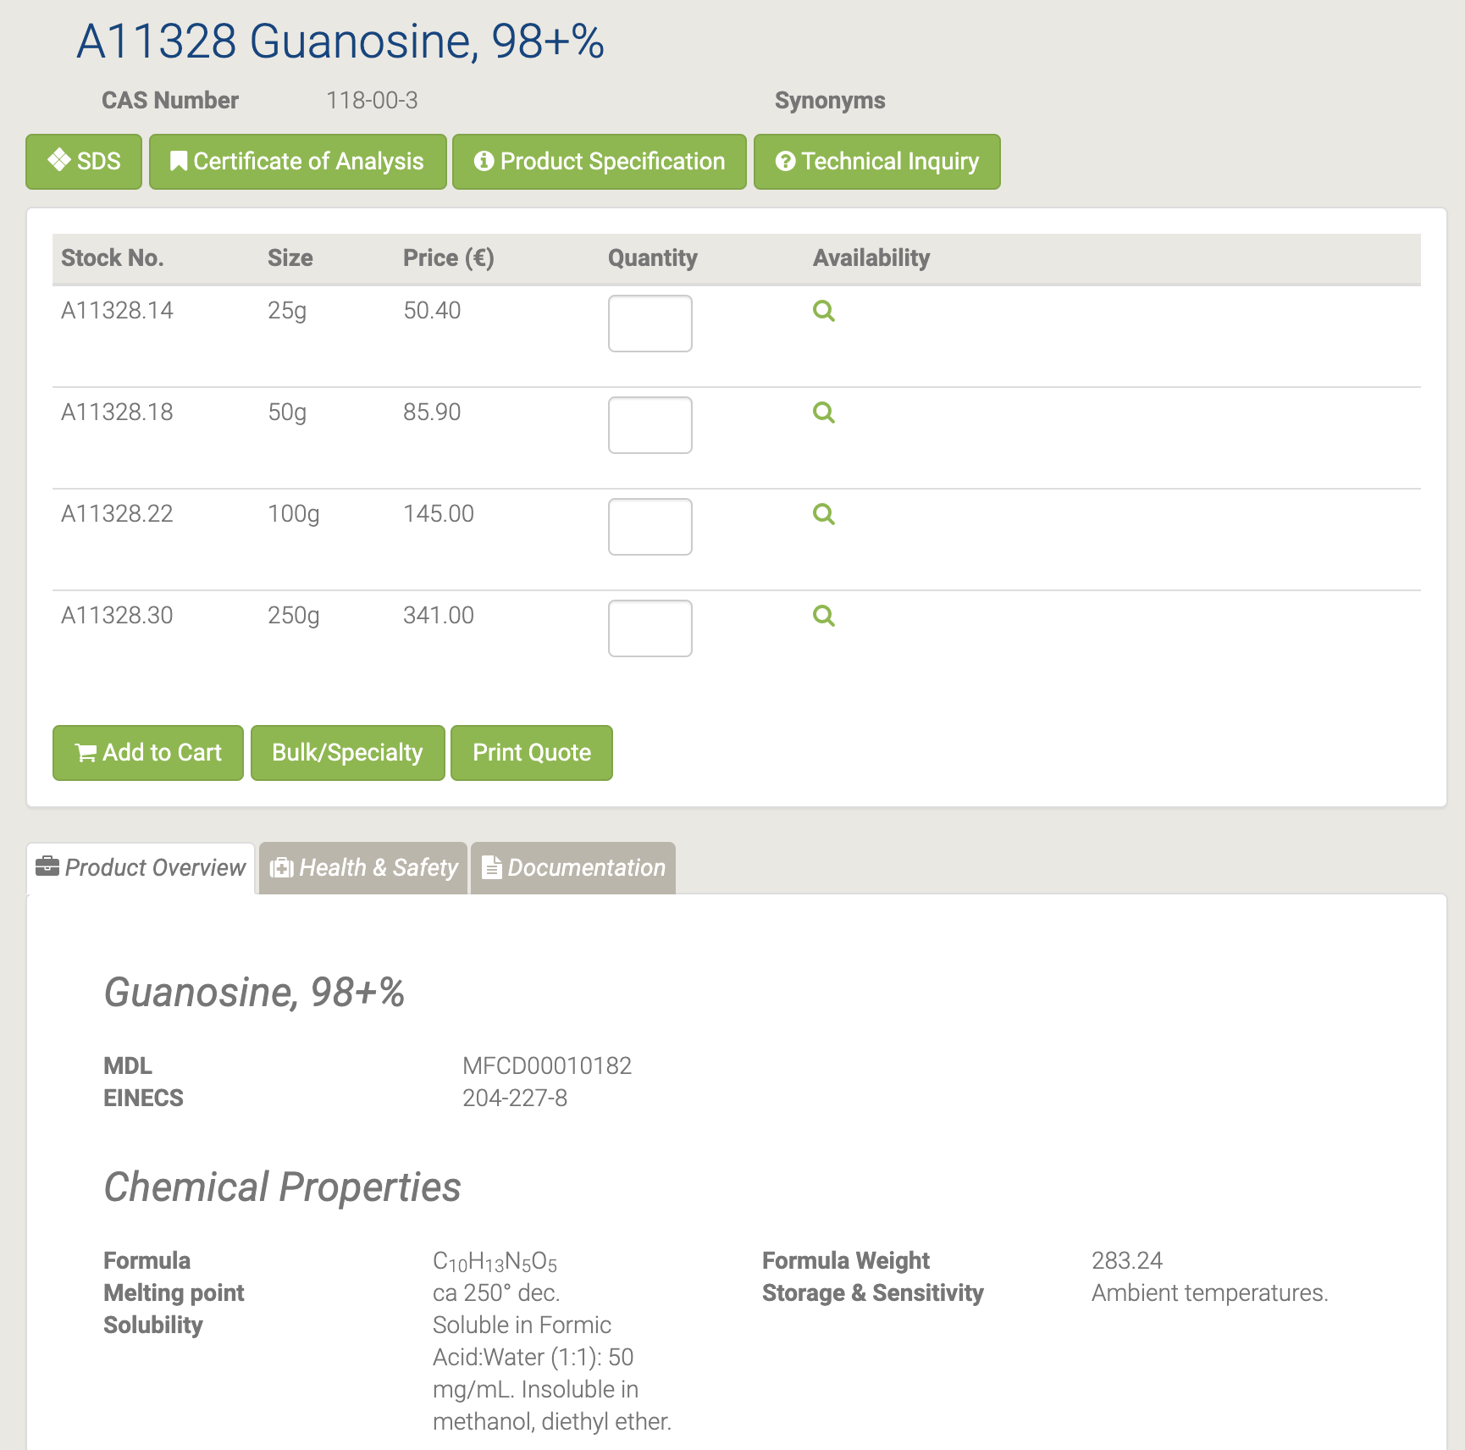

Гуанозин используется в составе нуклеиновых кислот. Он используется в металлических красках, искусственном жемчуге, пластике, косметической промышленности и т. Д. Он также использовался в фармакокинетике в качестве пролекарства. Гуанозин используется в клеточных культурах как предшественник GMP [137-138].

#### A18579 Hematoporphyrin dihydrochloride

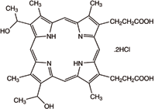

A18579 Hematoporphyrin dihydrochloride [139]

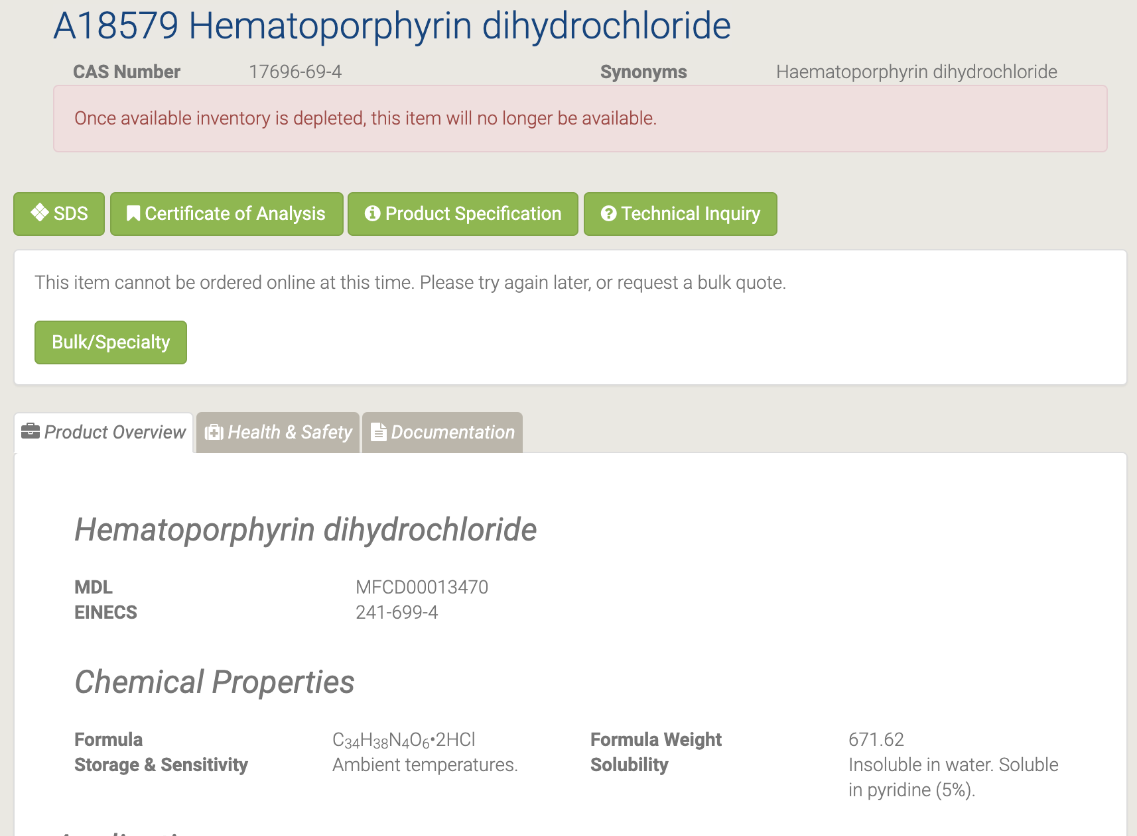

Эндогенный порфирин образуется в результате кислотного гидролиза гемоглобина. Он используется в качестве активного фармацевтического промежуточного соединения [140-141].

#### H26694 Meat Peptone

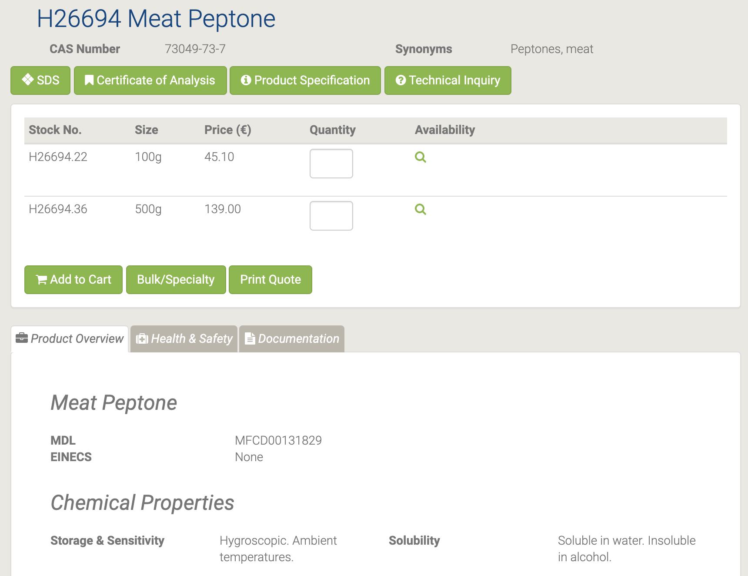

H26694 Meat Peptone [142]

Пептон используется в питательных средах для выращивания бактерий и грибов Мясо Пептон используется для обычного и массового культивирования организмов, который используется для производства антибиотиков, ферментов и витаминов. Он также полезен для выращивания различных микроорганизмов. Кроме того, он используется в питательных средах, в промышленности ферментации и в фармацевтической промышленности[143-144].

#### H31888 Methyl 1,2,3,4-tetra-O-acetyl-beta-D-glucuronate

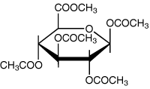

H31888 Methyl 1,2,3,4-tetra-O-acetyl-beta-D-glucuronate [145]

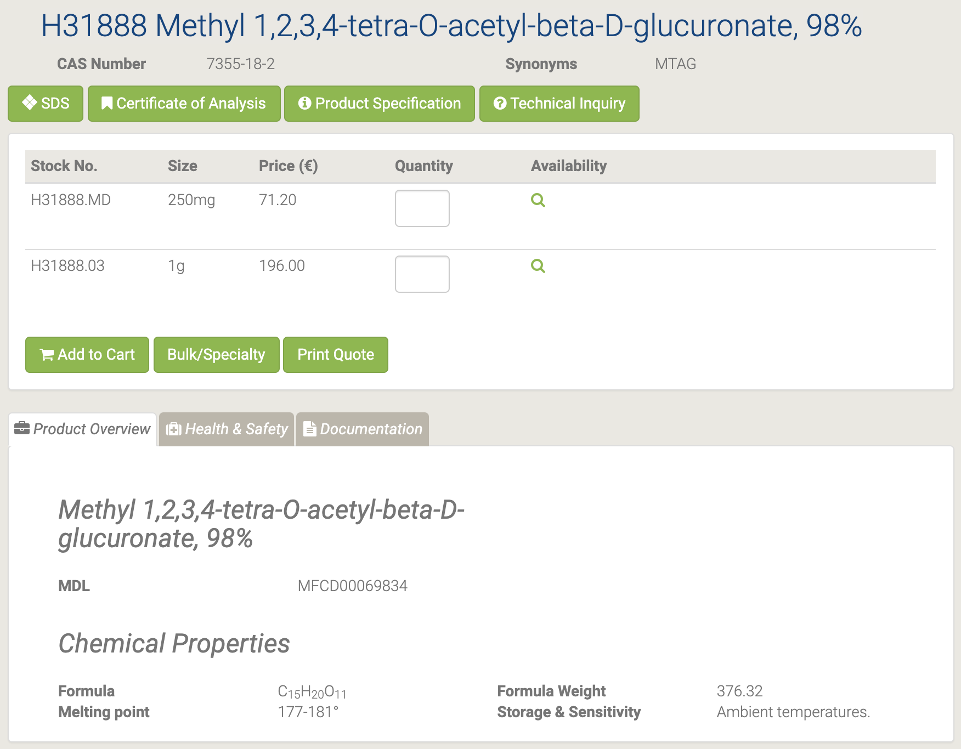

#### H52303 N-Benzoyl-2'-deoxyadenosine

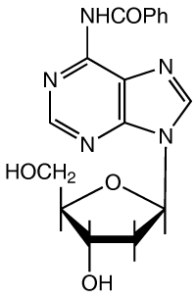

H52303 N-Benzoyl-2'-deoxyadenosine [146]

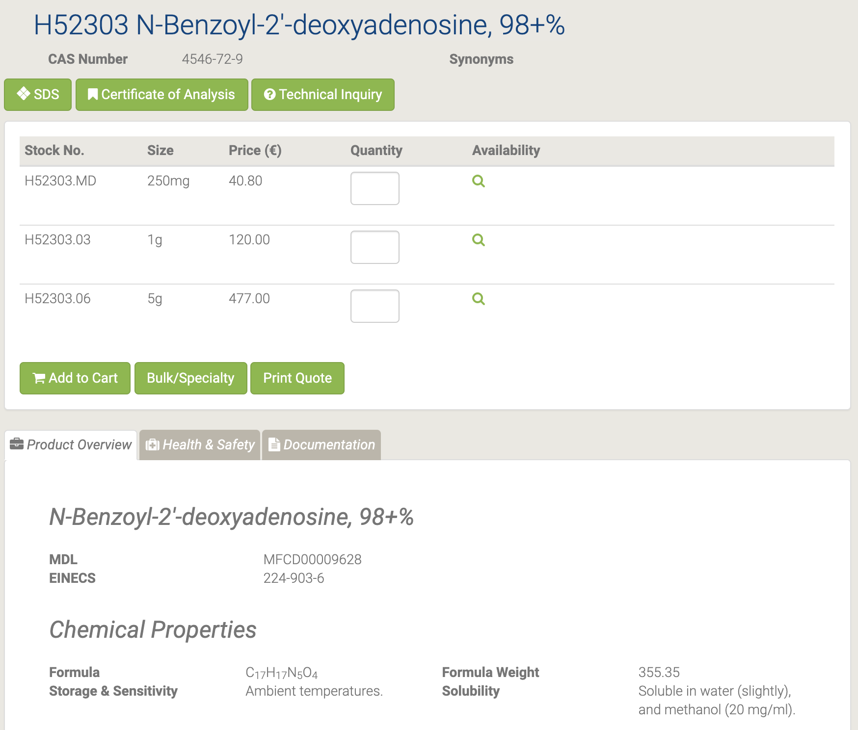

Реагент в синтезе 2 ', 5'-дидезоксицитидинов и других производных 2'-дезоксицитидина. Реагент в синтезе моно- и диамино аналогов 2? -Деоксиаденозина, кордицепина, 9- (3-дезокси-α-D-трео-пентофуранозил) -аденина и 9- (2-дезокси-α-D-трео-пентофуранозила) аденин [147-148].

#### H52306 N-Benzoyl-3'-O-(4,4'-dimethoxytrityl)-2'-deoxyadenosine

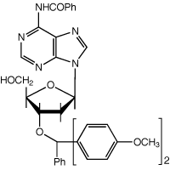

H52306 N-Benzoyl-3'-O-(4,4'-dimethoxytrityl)-2'-deoxyadenosine [149]

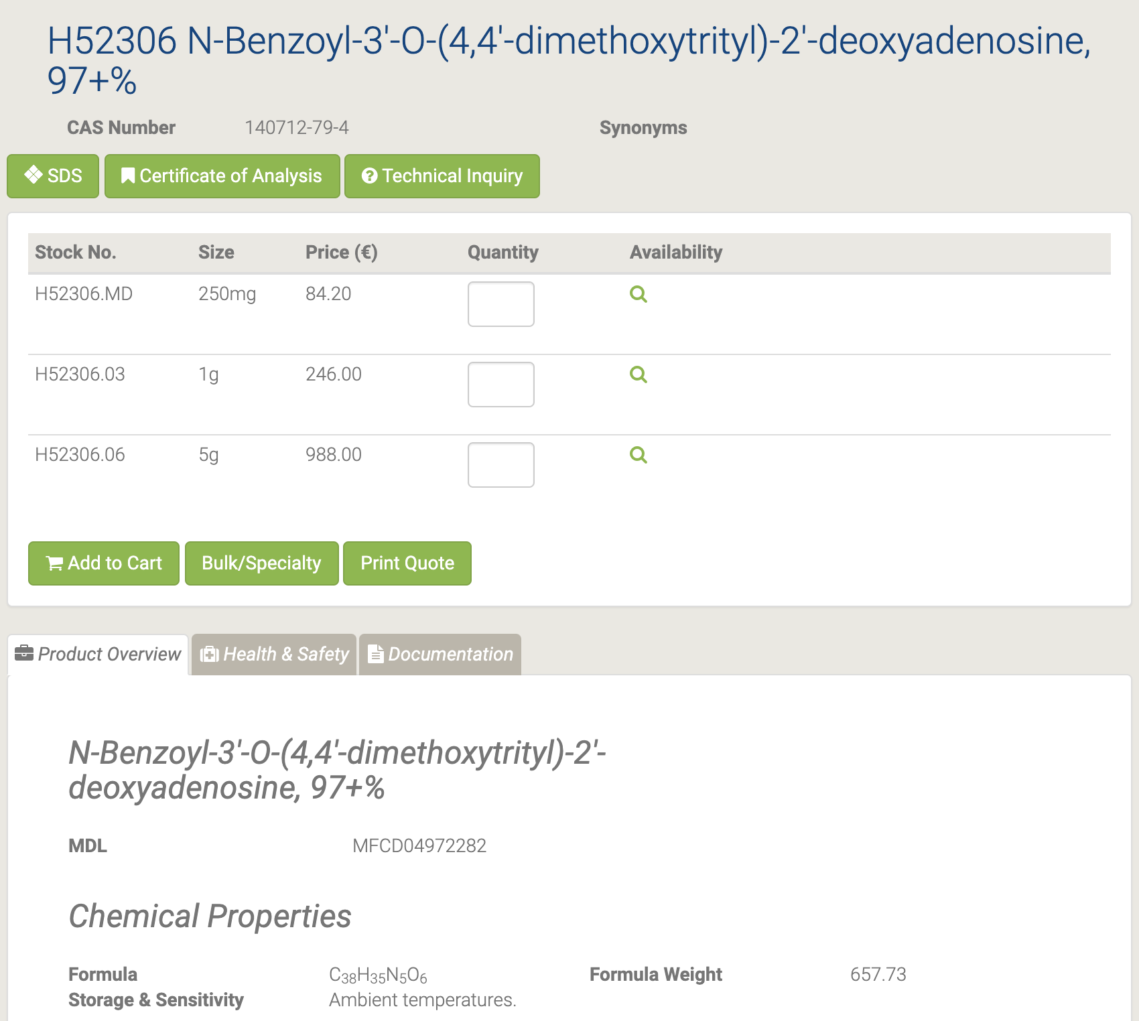

В качестве промежуточного фармацевтического продукта используется N-бензоил-3'-O- (4,4'-диметокситритил) -2'-дезоксиаденозин. N-бензоил-3'-O- (4,4'-диметокситритил) -2'-дезоксиаденозин используется в качестве промежуточного фармацевтического продукта.

#### H52799 N-Benzoyl-3'-O-(4,4'-dimethoxytrityl)-2'-deoxycytidine

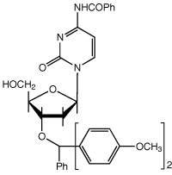

H52799 N-Benzoyl-3'-O-(4,4'-dimethoxytrityl)-2'-deoxycytidine [150]

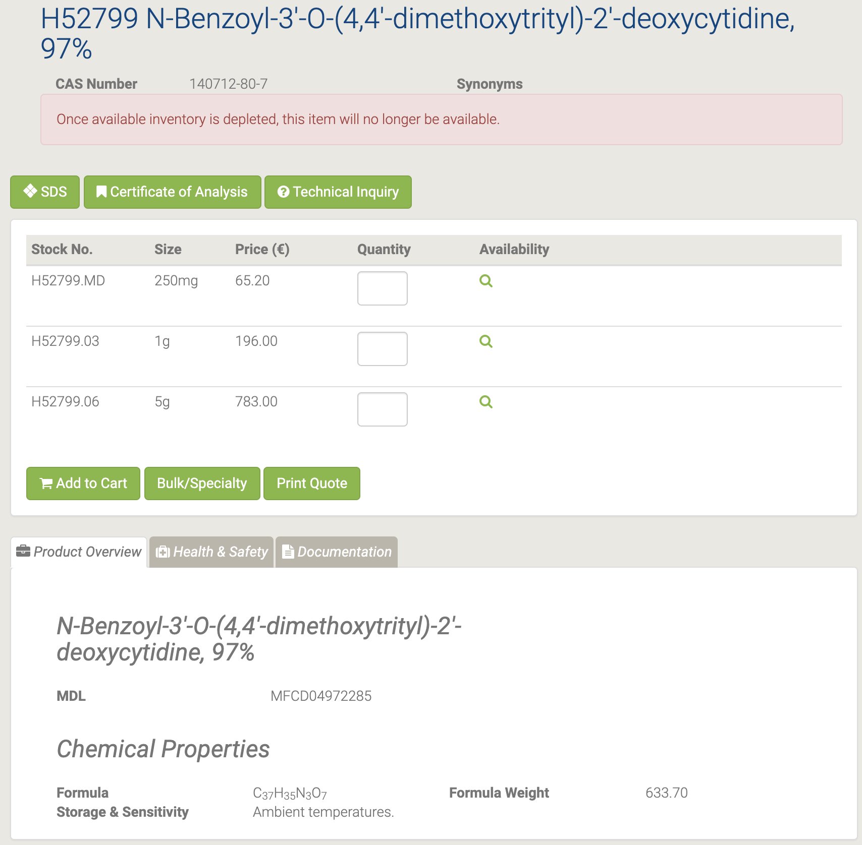

#### H52807 N-Benzoyl-5'-O-[(diisopropylamino)-(2-cyanoethoxy)phosphinyl]-3'-O-(4,4'-dimethoxytrityl)-2'-deoxyadenosine

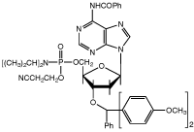

H52807 N-Benzoyl-5'-O-[(diisopropylamino)-(2-cyanoethoxy)phosphinyl]-3'-O-(4,4'-dimethoxytrityl)-2'-deoxyadenosine [151]

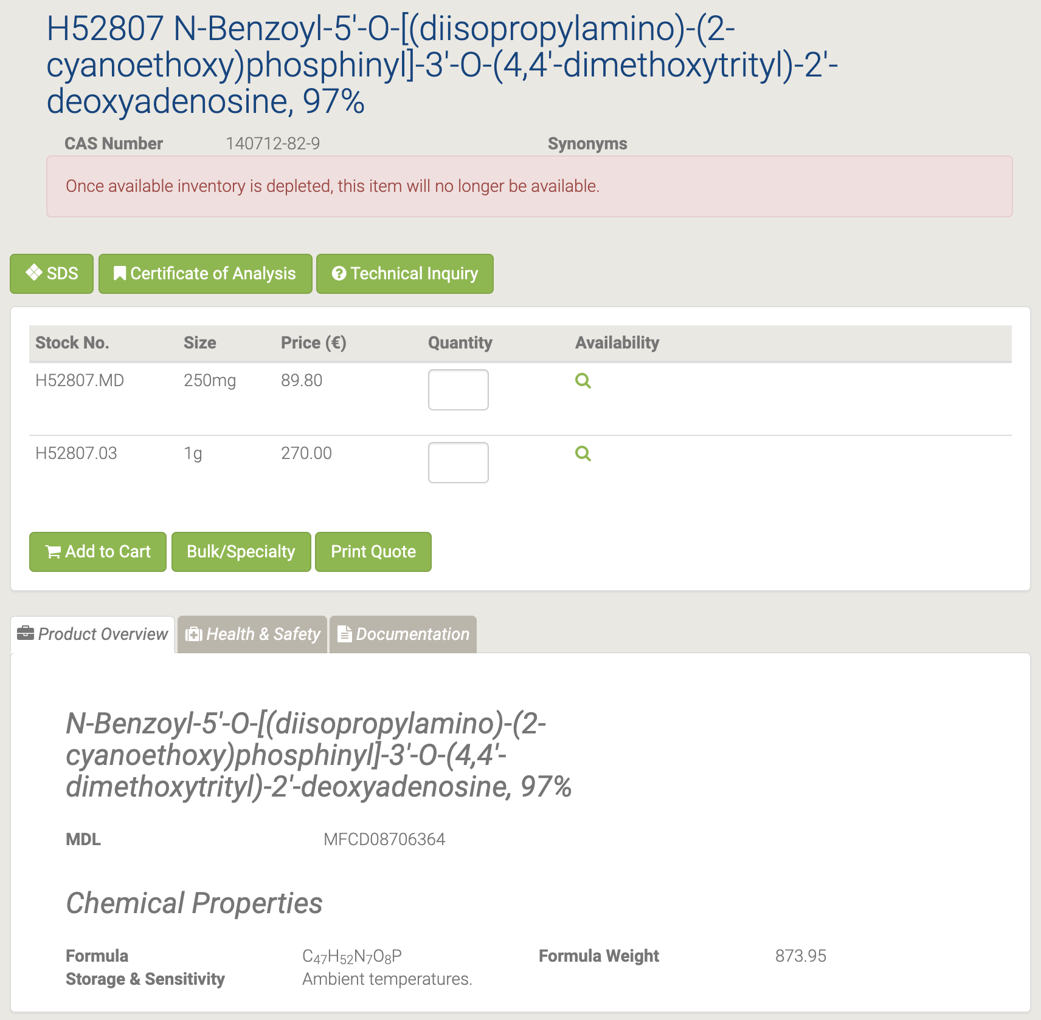

#### H52732 N-Benzoyl-5'-O-[(diisopropylamino)-(2-cyanoethoxy)phosphinyl]-3'-O-(4,4'-dimethoxytrityl)-2'-deoxycytidine

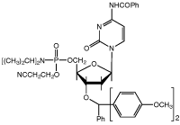

H52732 N-Benzoyl-5'-O-[(diisopropylamino)-(2-cyanoethoxy)phosphinyl]-3'-O-(4,4'-dimethoxytrityl)-2'-deoxycytidine [152]

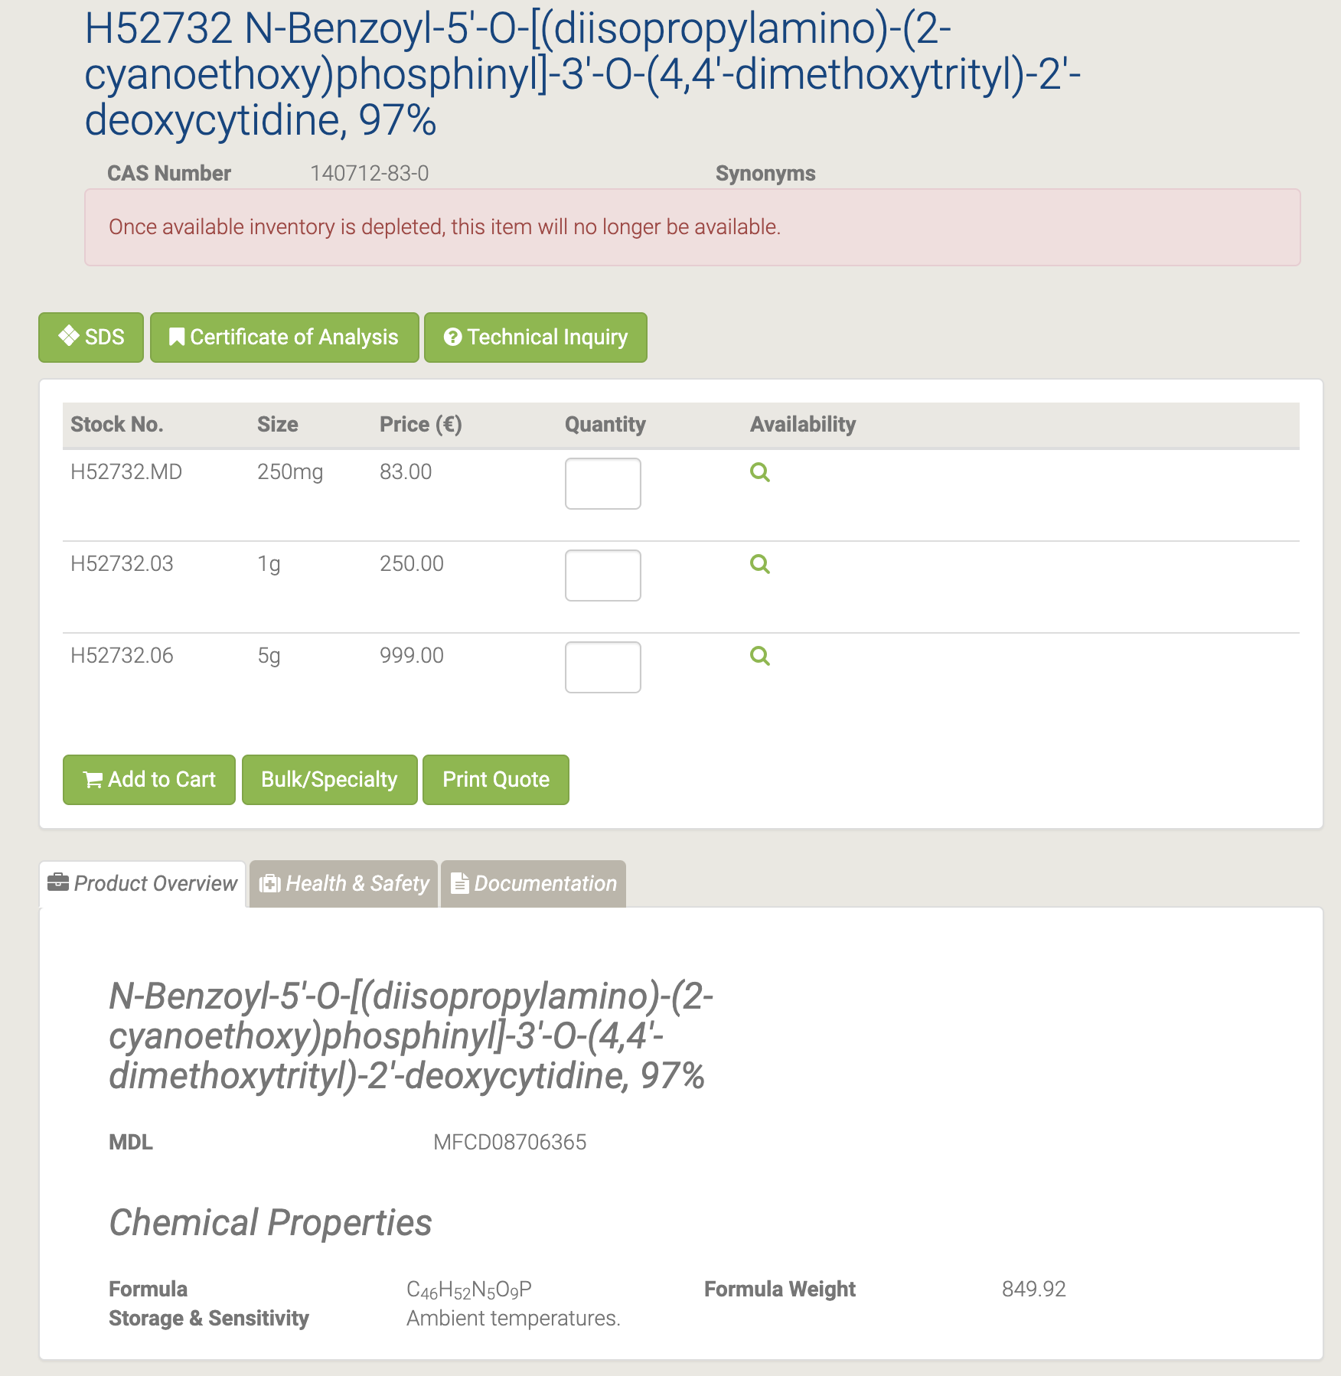

#### H52309 N-Benzoyl-5'-O-tert-butyldimethylsilyl-2'-deoxyadenosine

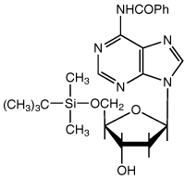

H52309 N-Benzoyl-5'-O-tert-butyldimethylsilyl-2'-deoxyadenosine [153]

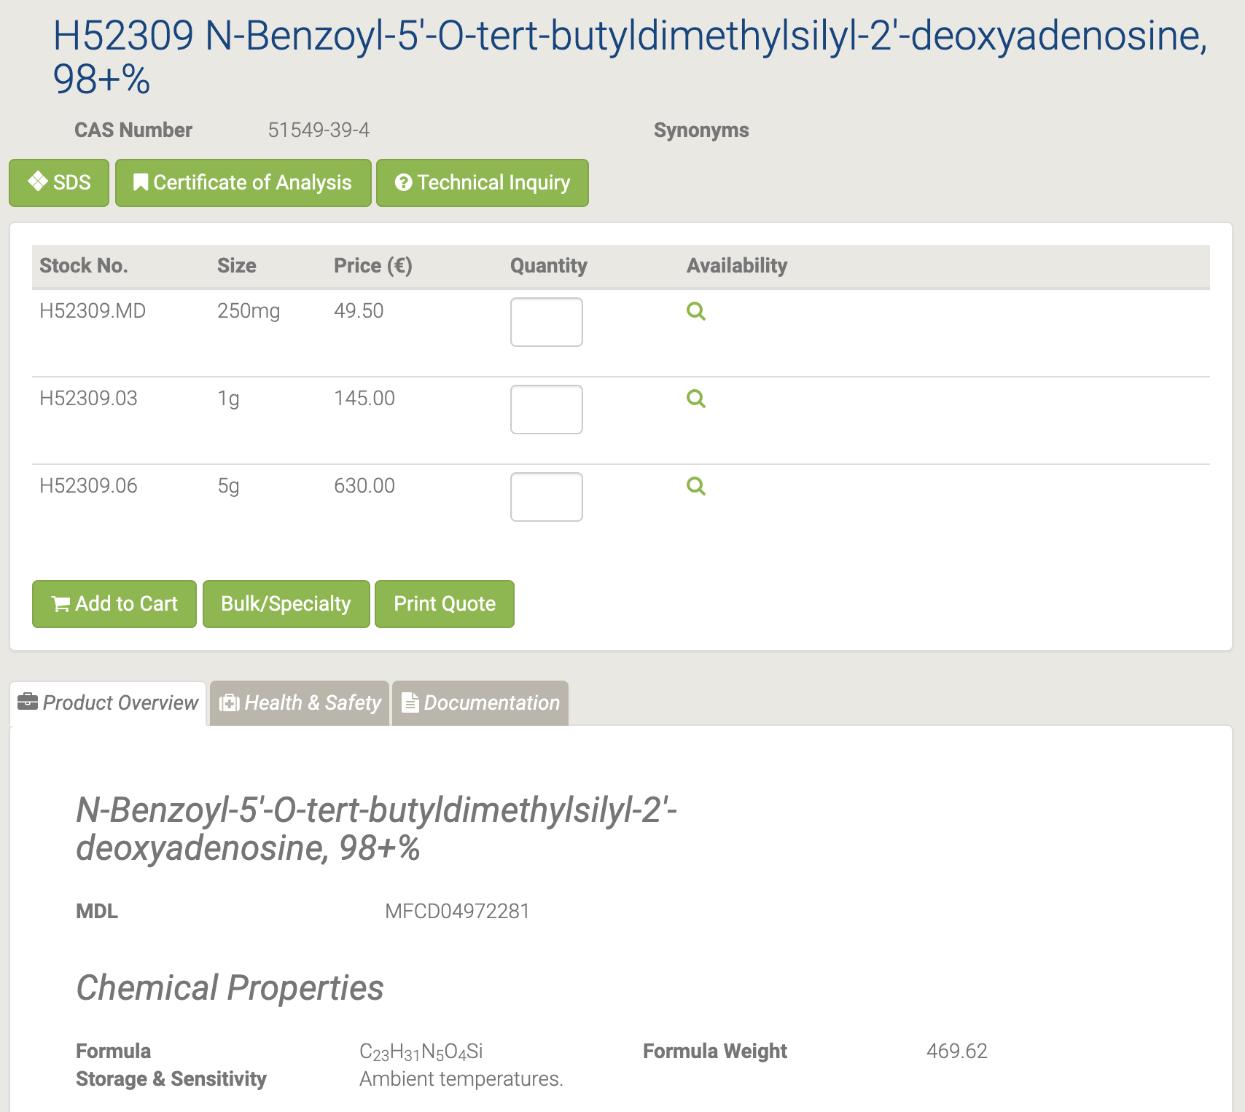

N-Бензоил-5'-O-трет-бутилдиметилсилил-2'-дезоксиаденозин используется в качестве промежуточного фармацевтического продукта [154].

#### H52296 N-Benzoyl-5'-O-tert-butyldimethylsilyl-2'-deoxycytidine

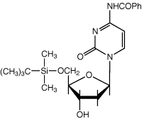

H52296 N-Benzoyl-5'-O-tert-butyldimethylsilyl-2'-deoxycytidine [155]

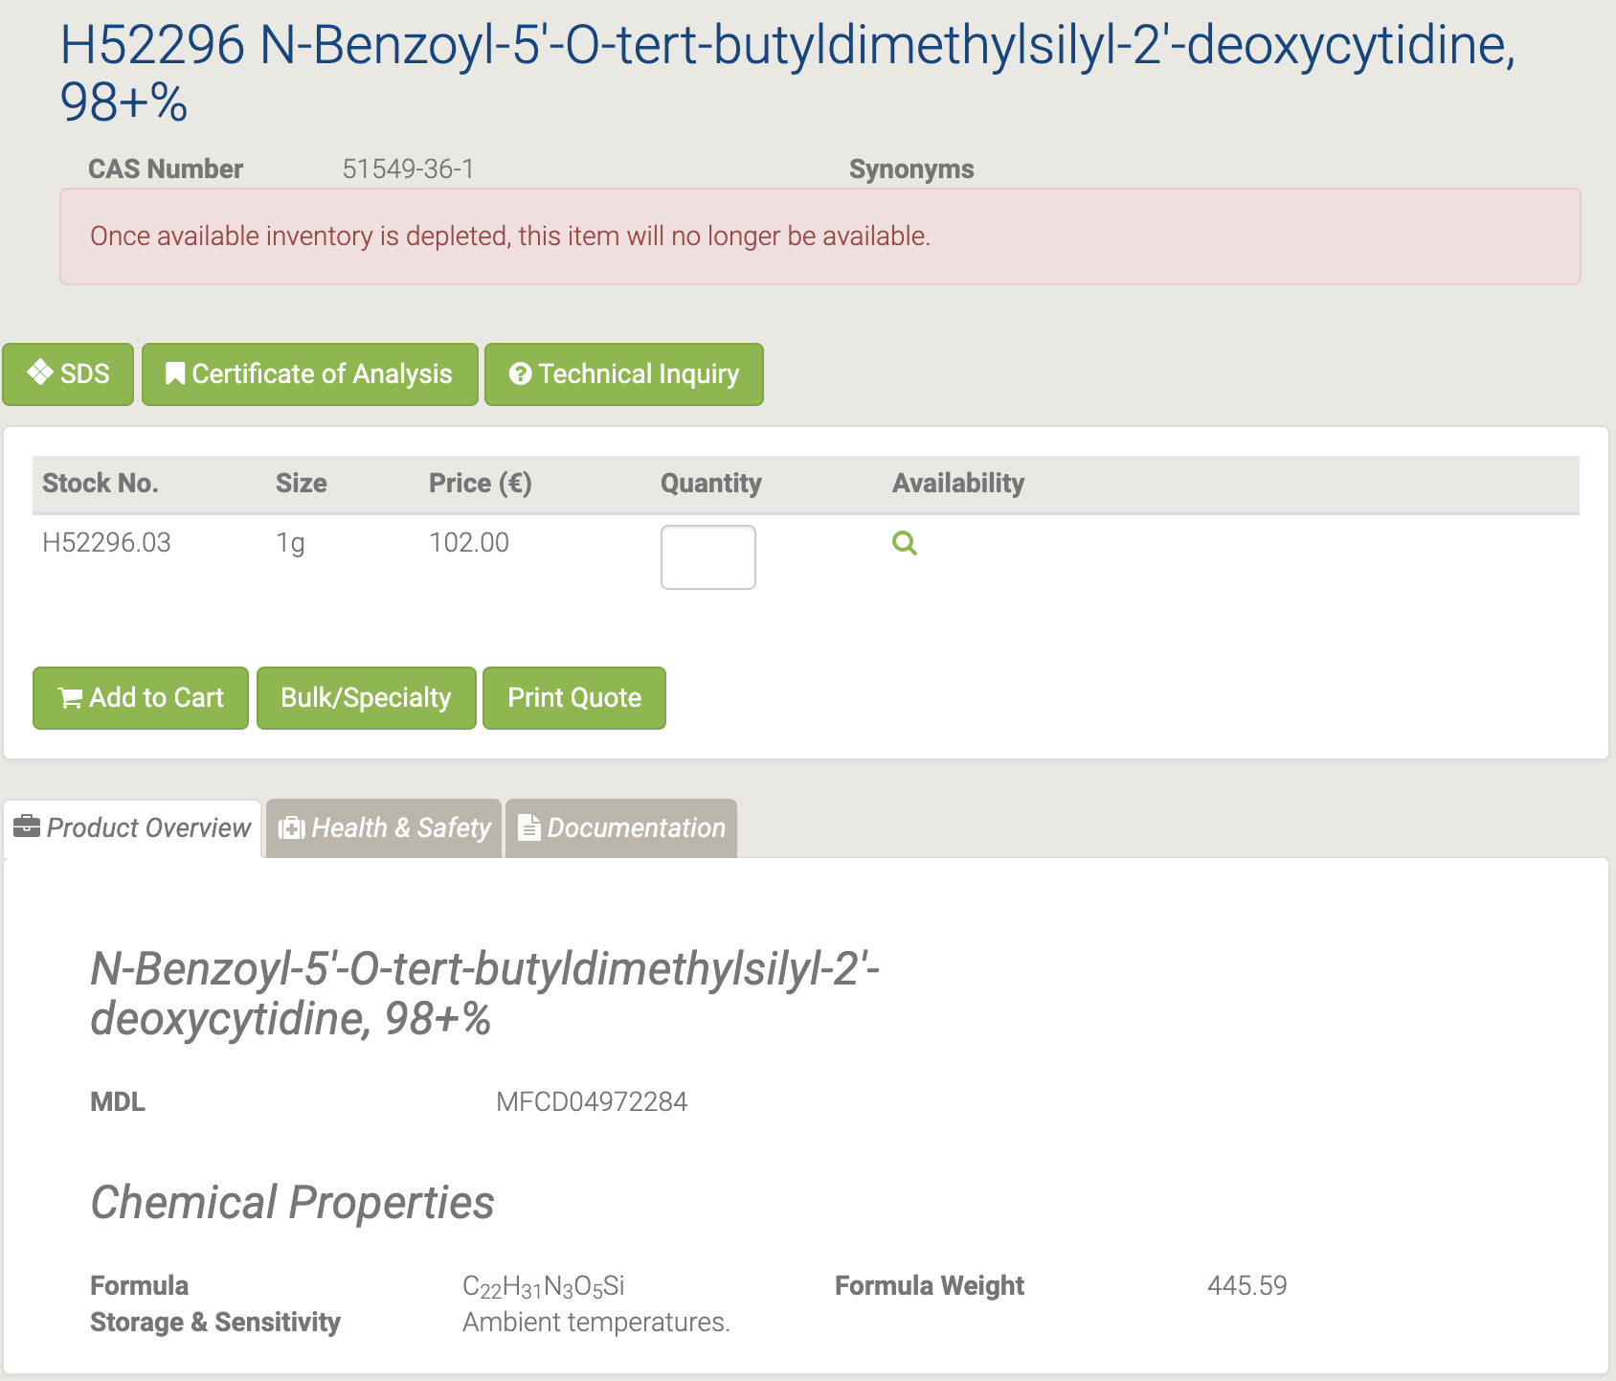

#### H52730 N-Isobutyryl-2'-deoxyguanosine

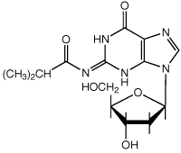

H52730 N-Isobutyryl-2'-deoxyguanosine [156]

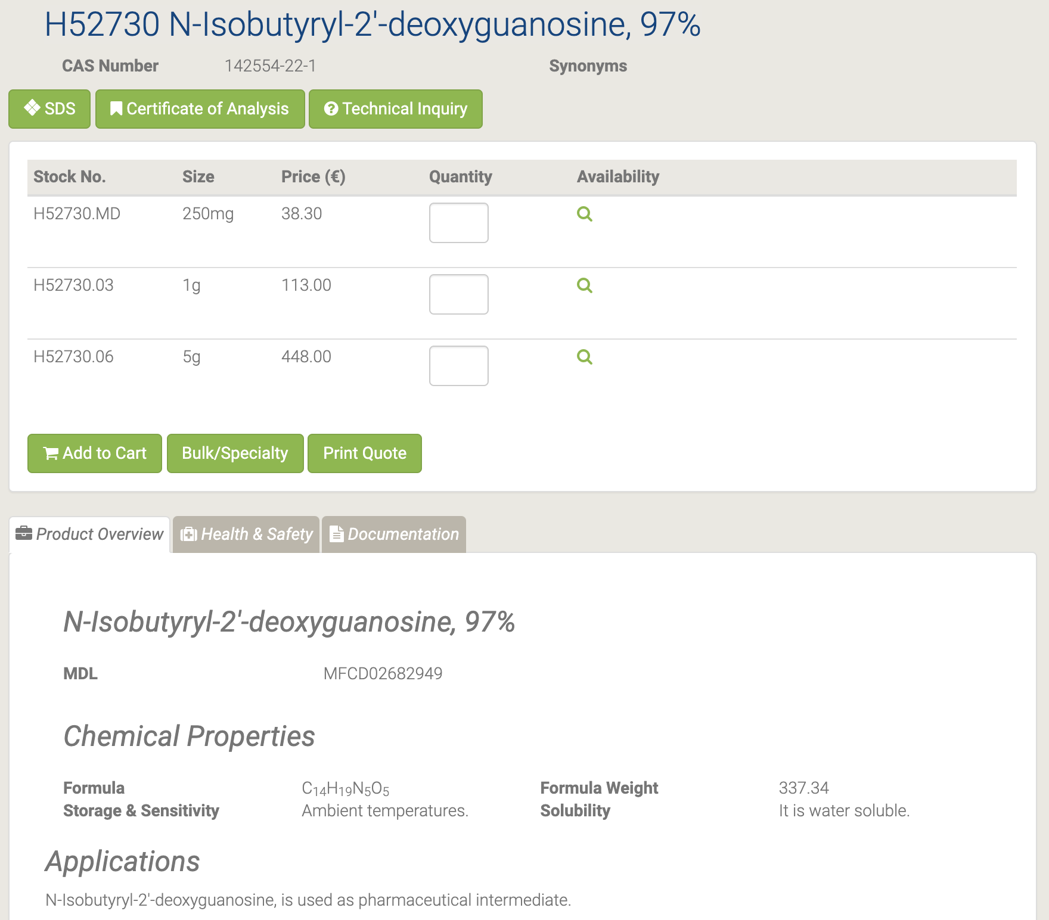

N-Изобутирил-2'-дезоксигуанозин используется в качестве промежуточного фармацевтического продукта [157-158].

#### H52746 N-Isobutyryl-3'-O-(4,4'-dimethoxytrityl)-2'-deoxyguanosine

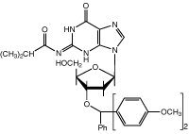

H52746 N-Isobutyryl-3'-O-(4,4'-dimethoxytrityl)-2'-deoxyguanosine [159]

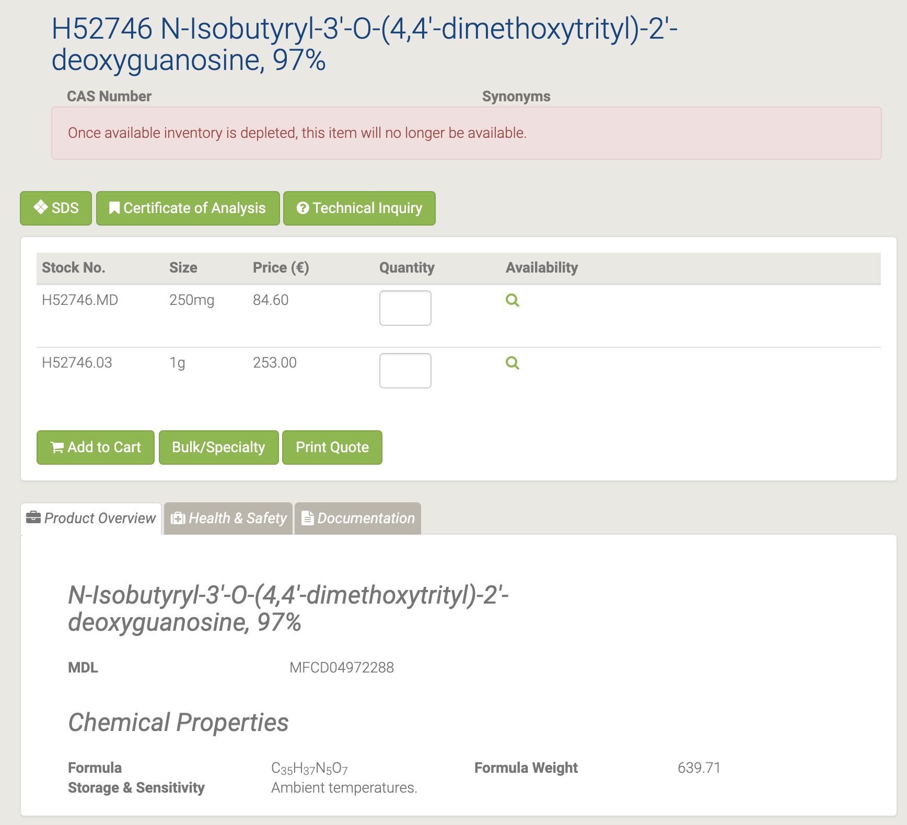

#### H52411 N-Isobutyryl-5'-O-[(diisopropylamino)-(2-cyanoethoxy)phosphinyl]-3'-O-(4,4'-dimethoxytrityl)-2'-deoxyguanosine

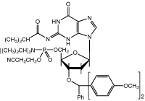

H52411 N-Isobutyryl-5'-O-[(diisopropylamino)-(2-cyanoethoxy)phosphinyl]-3'-O-(4,4'-dimethoxytrityl)-2'-deoxyguanosine [160]

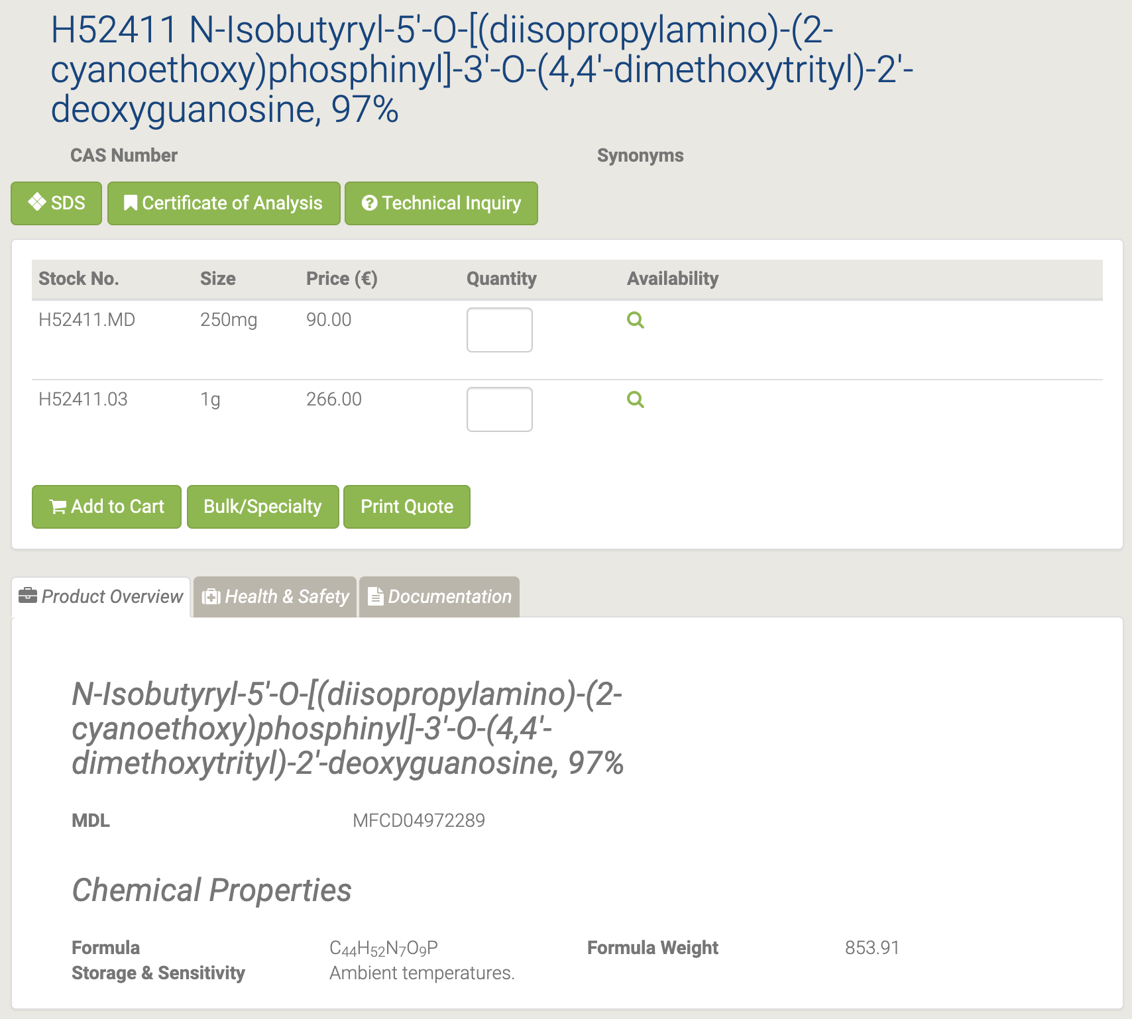

#### H52726 N-Isobutyryl-5'-O-tert-butyldimethylsilyl-2'-deoxyguanosine

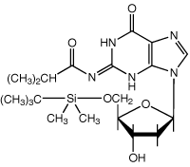

H52726 N-Isobutyryl-5'-O-tert-butyldimethylsilyl-2'-deoxyguanosine [161]

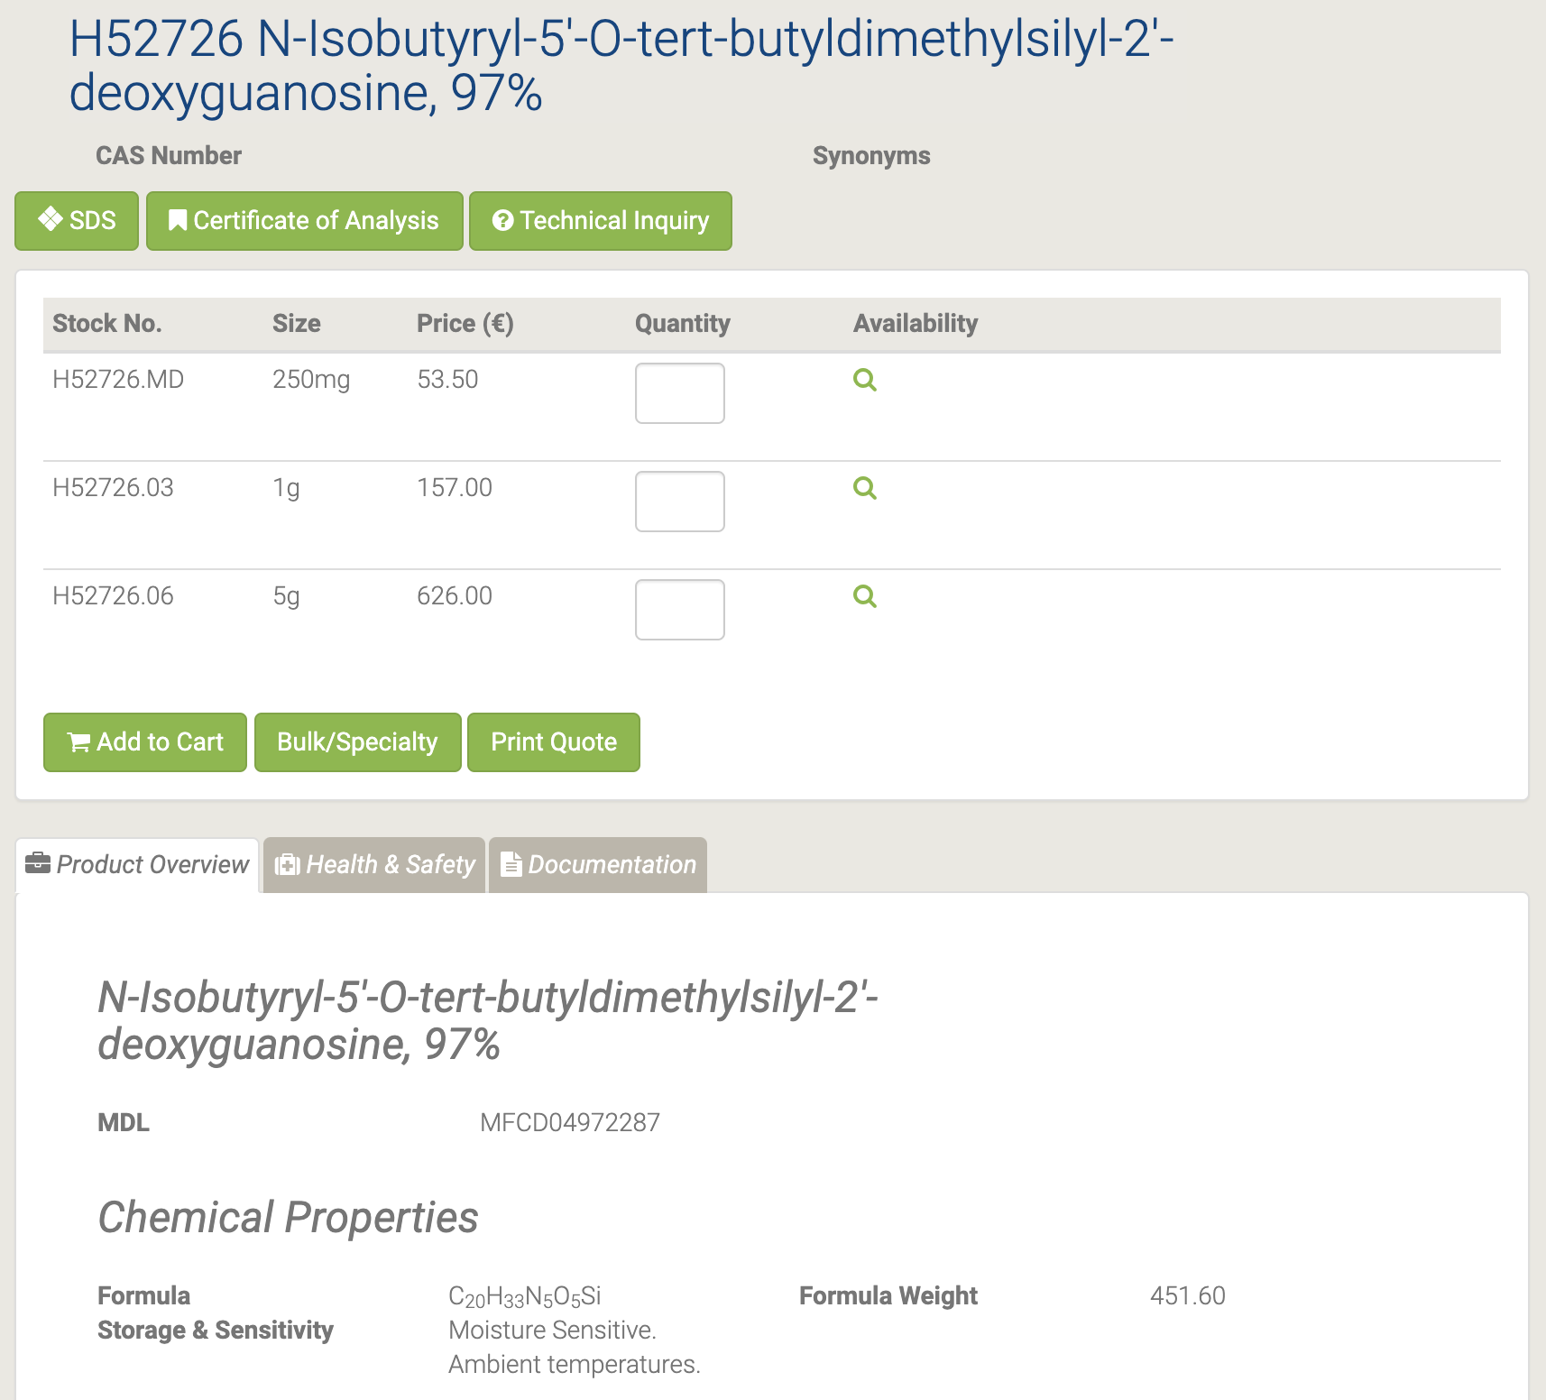

N-Изобутирил-5'-O-трет-бутилдиметилсилил-2'-дезоксигуанозин используется в качестве промежуточного фармацевтического продукта.

#### L16407 O,O'-Bis(trimethylsilyl)-5-fluorouracil

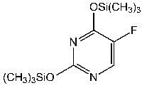

L16407 O,O'-Bis(trimethylsilyl)-5-fluorouracil [162]

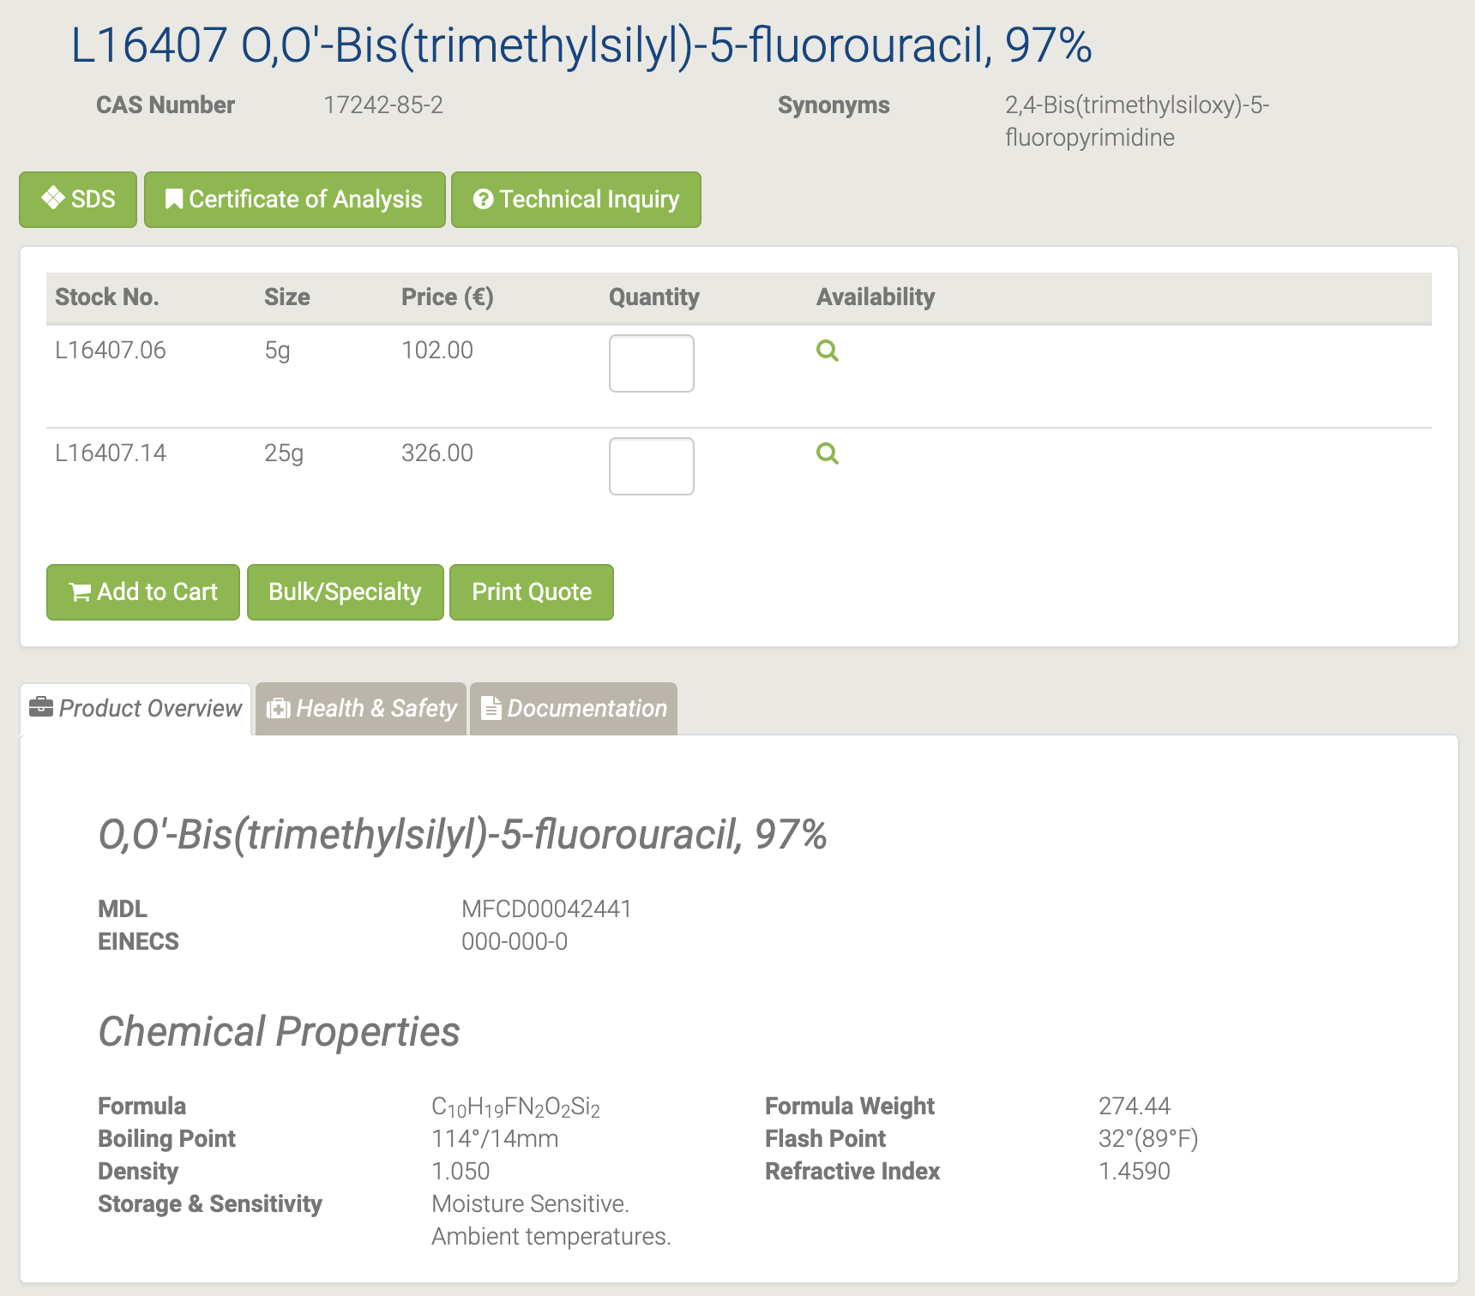

#### A11493 Thymidine

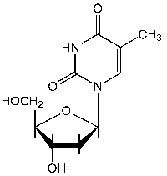

A11493 Thymidine [163]

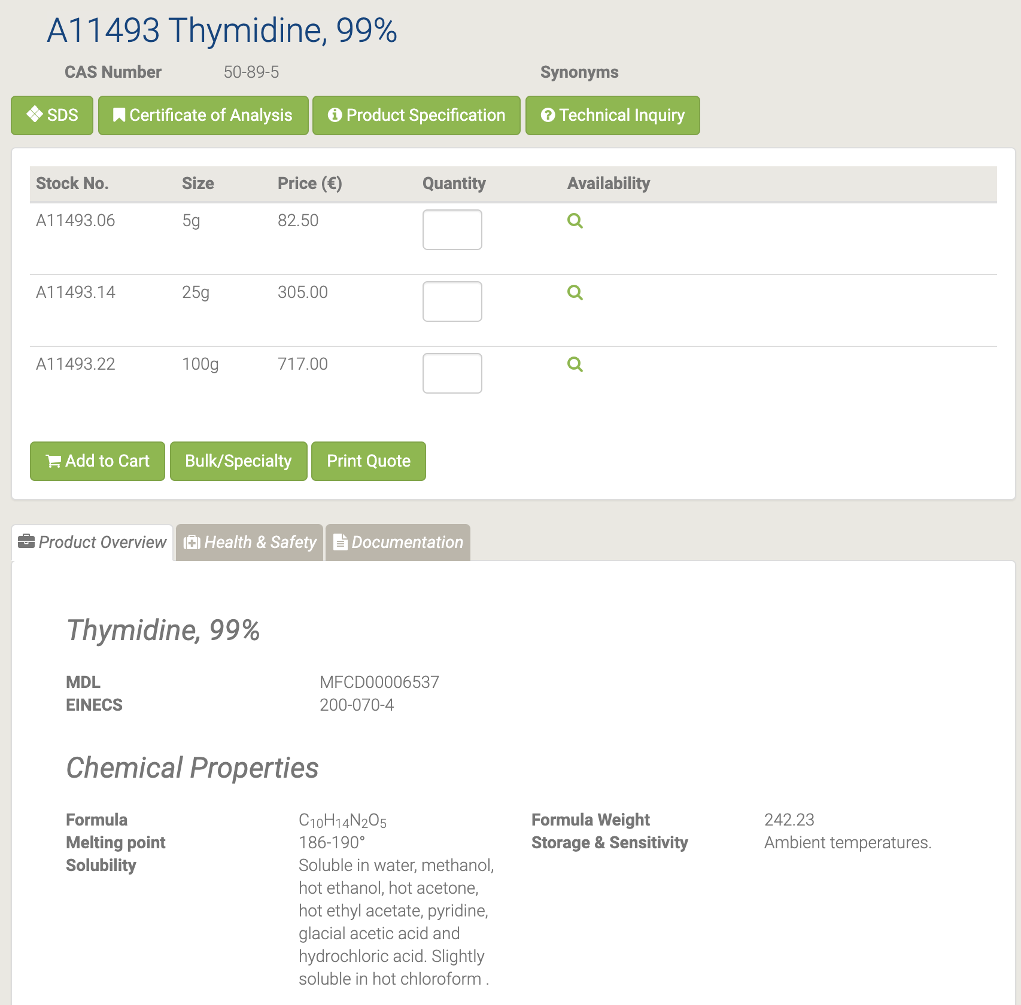

Тимидин используется при синтезе активного фармацевтического ингредиента, такого как зидовудин. Он также соединяется с дезоксиаденозином в двухцепочечной дезоксирибонуклеиновой кислоте. Он используется для синхронизации клеток в фазе G1 / ранней S в клеточной биологии [164-165].

#### A15879 Thymine

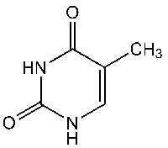

A15879 Thymine [166]

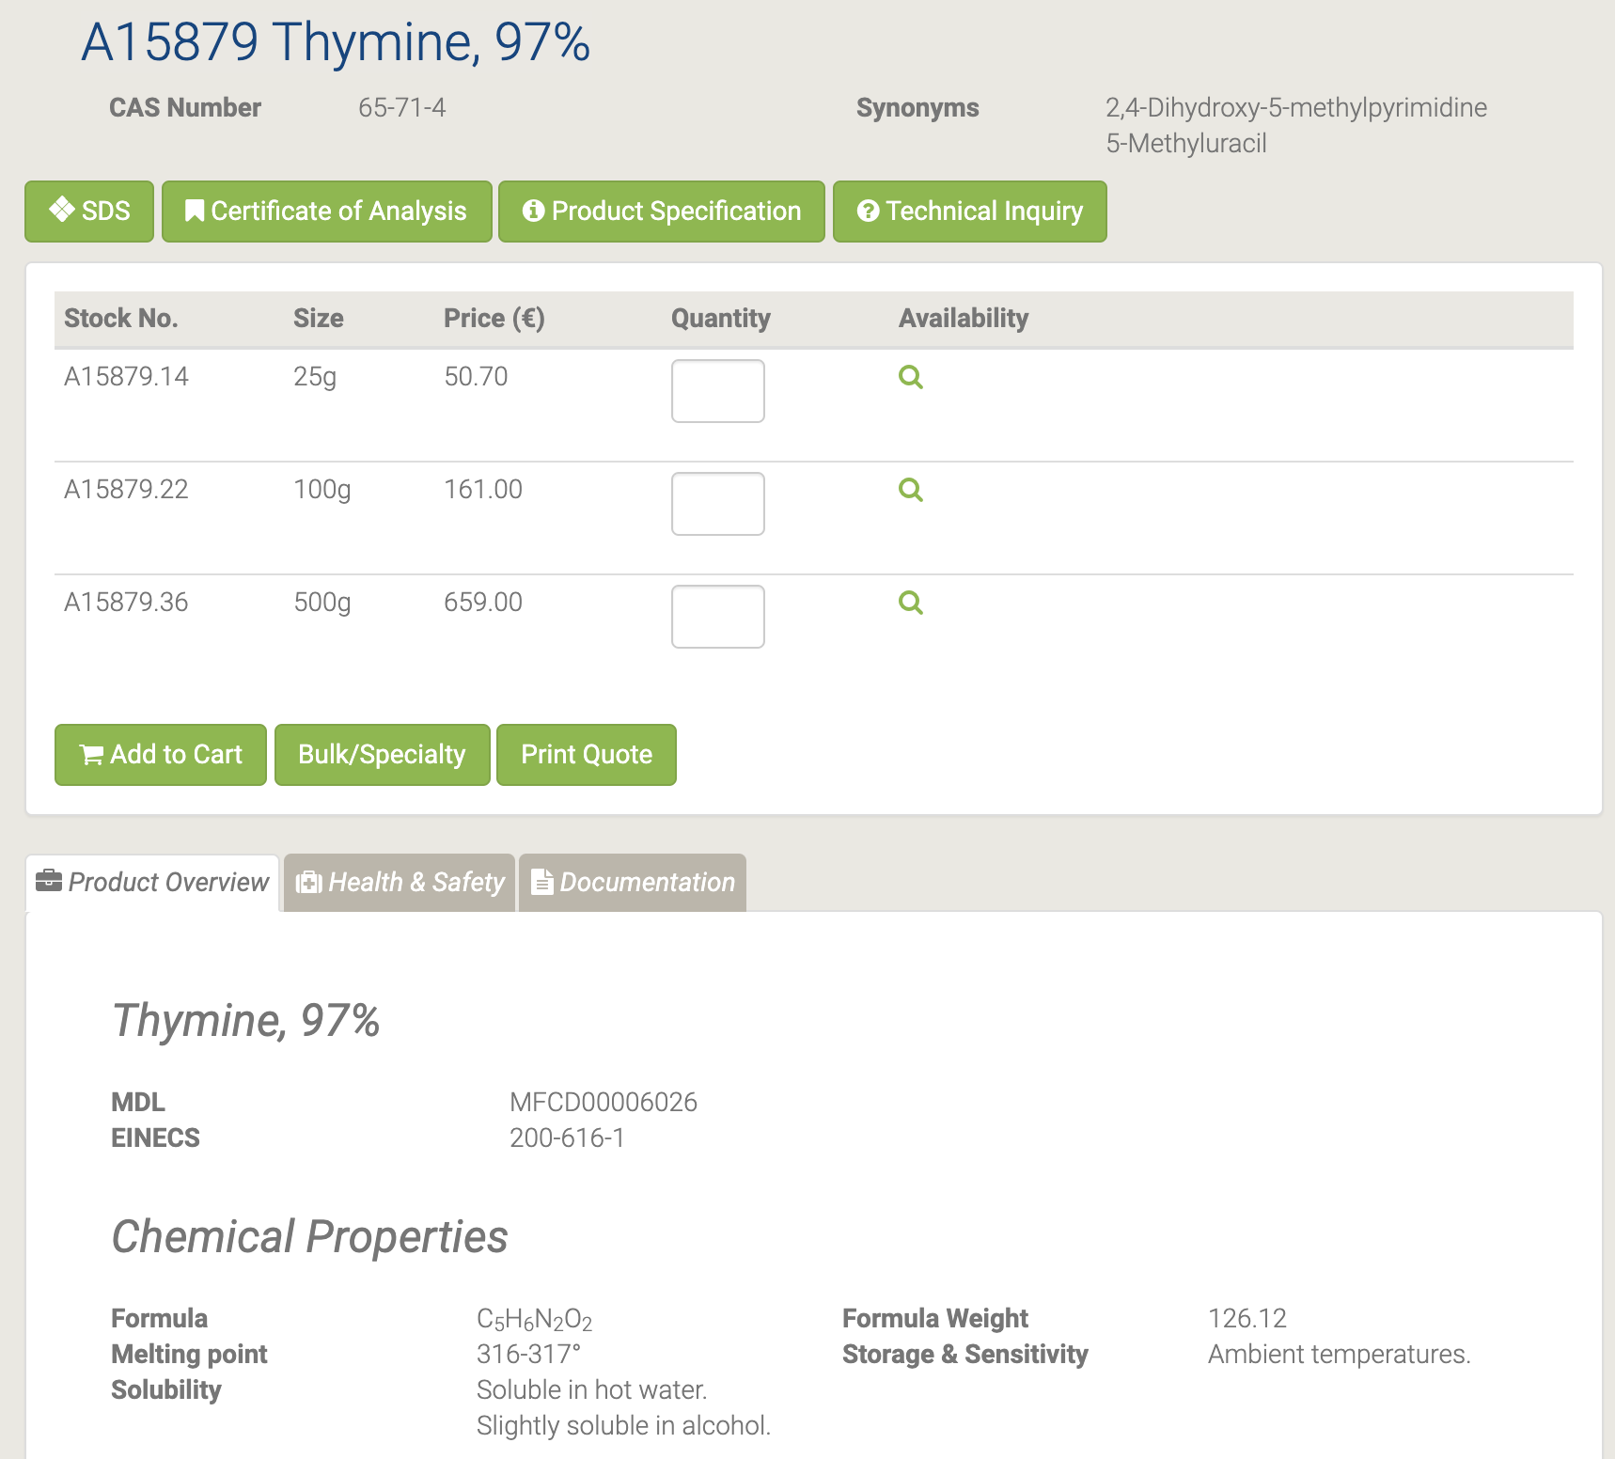

Тимин является одним из четырех азотистых оснований, наряду с аденином, гуанином и цитозином, обнаруженных в дезоксирибонуклеиновых кислотах (ДНК). Тимин может быть использован для изучения химических процессов, которые влияют на структуру ДНК, таких как радиационно-индуцированное образование радикалов, приводящее к реакциям сшивания оснований и дериватизациям. Тимин можно использовать для изучения параметров кинетики и энергии водородных связей с другими азотистыми основаниями, такими как аденин. Тимин используется для разработки чувствительных детекторов тяжелых металлов (ртути) на основе координационной химии и структур наночастиц [167].

#### H27219 Uracil-5-boronic acid

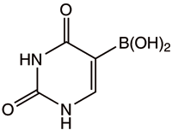

H27219 Uracil-5-boronic acid [168]

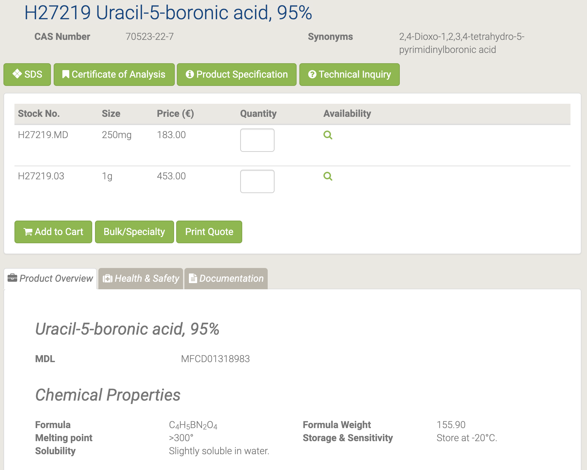

Он находит свое применение при исследовании взаимодействий между бороновыми кислотами и цис-диол-содержащими биомолекулами с помощью аффинного капиллярного электрофореза. Он также используется в качестве активного фармацевтического промежуточного продукта [169].

#### H51098 Uracil-5-carboxaldehyde

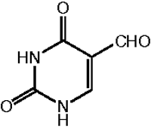

H51098 Uracil-5-carboxaldehyde [170]

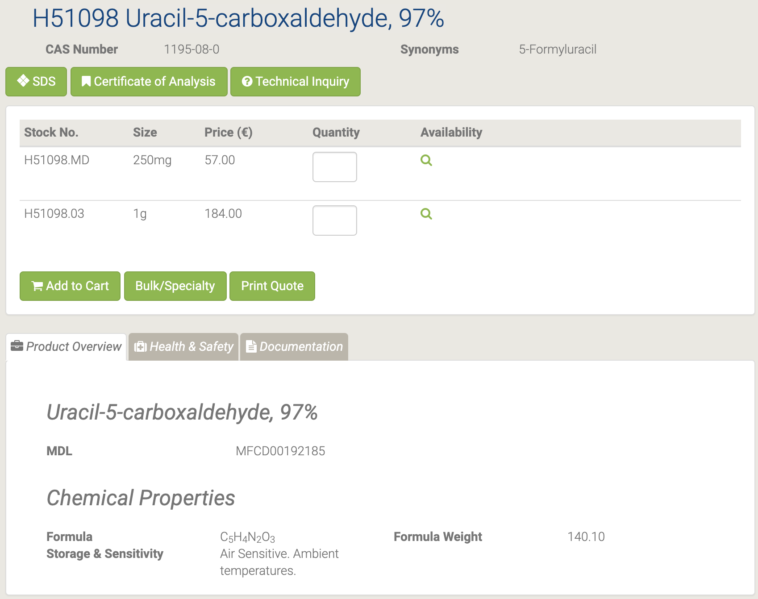

#### H50469 Uracil-6-carboxaldehyde monohydrate

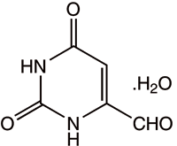

H50469 Uracil-6-carboxaldehyde monohydrate [171]

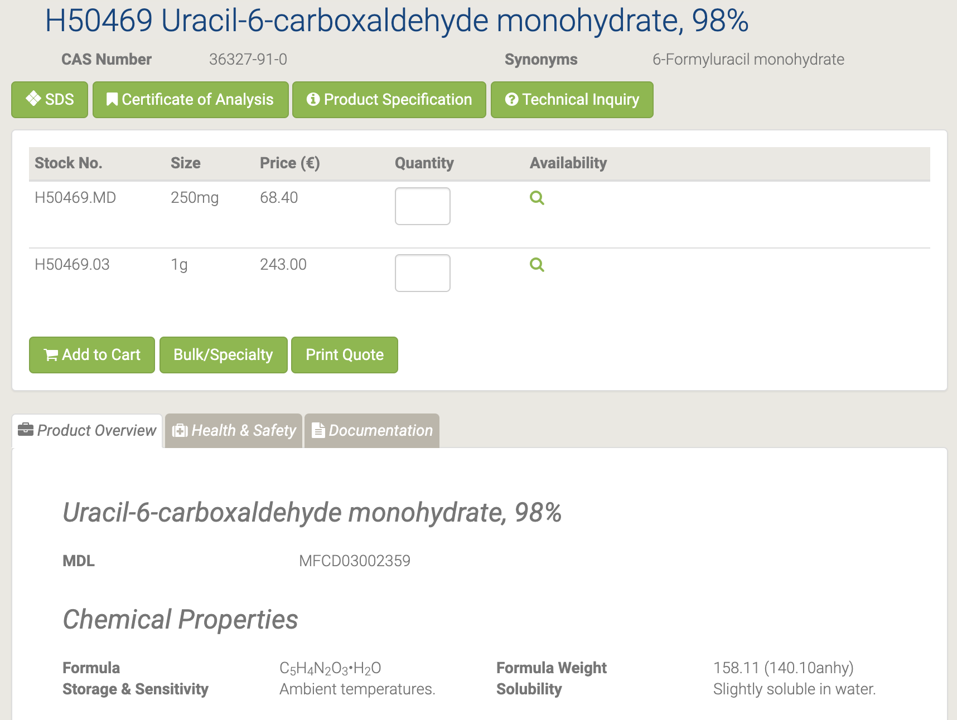

Моногидрат урацил-6-карбоксальдегида используется в качестве промежуточных фармацевтических продуктов [172].

#### A15570 Uracil

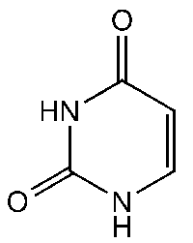

A15570 Uracil [173]

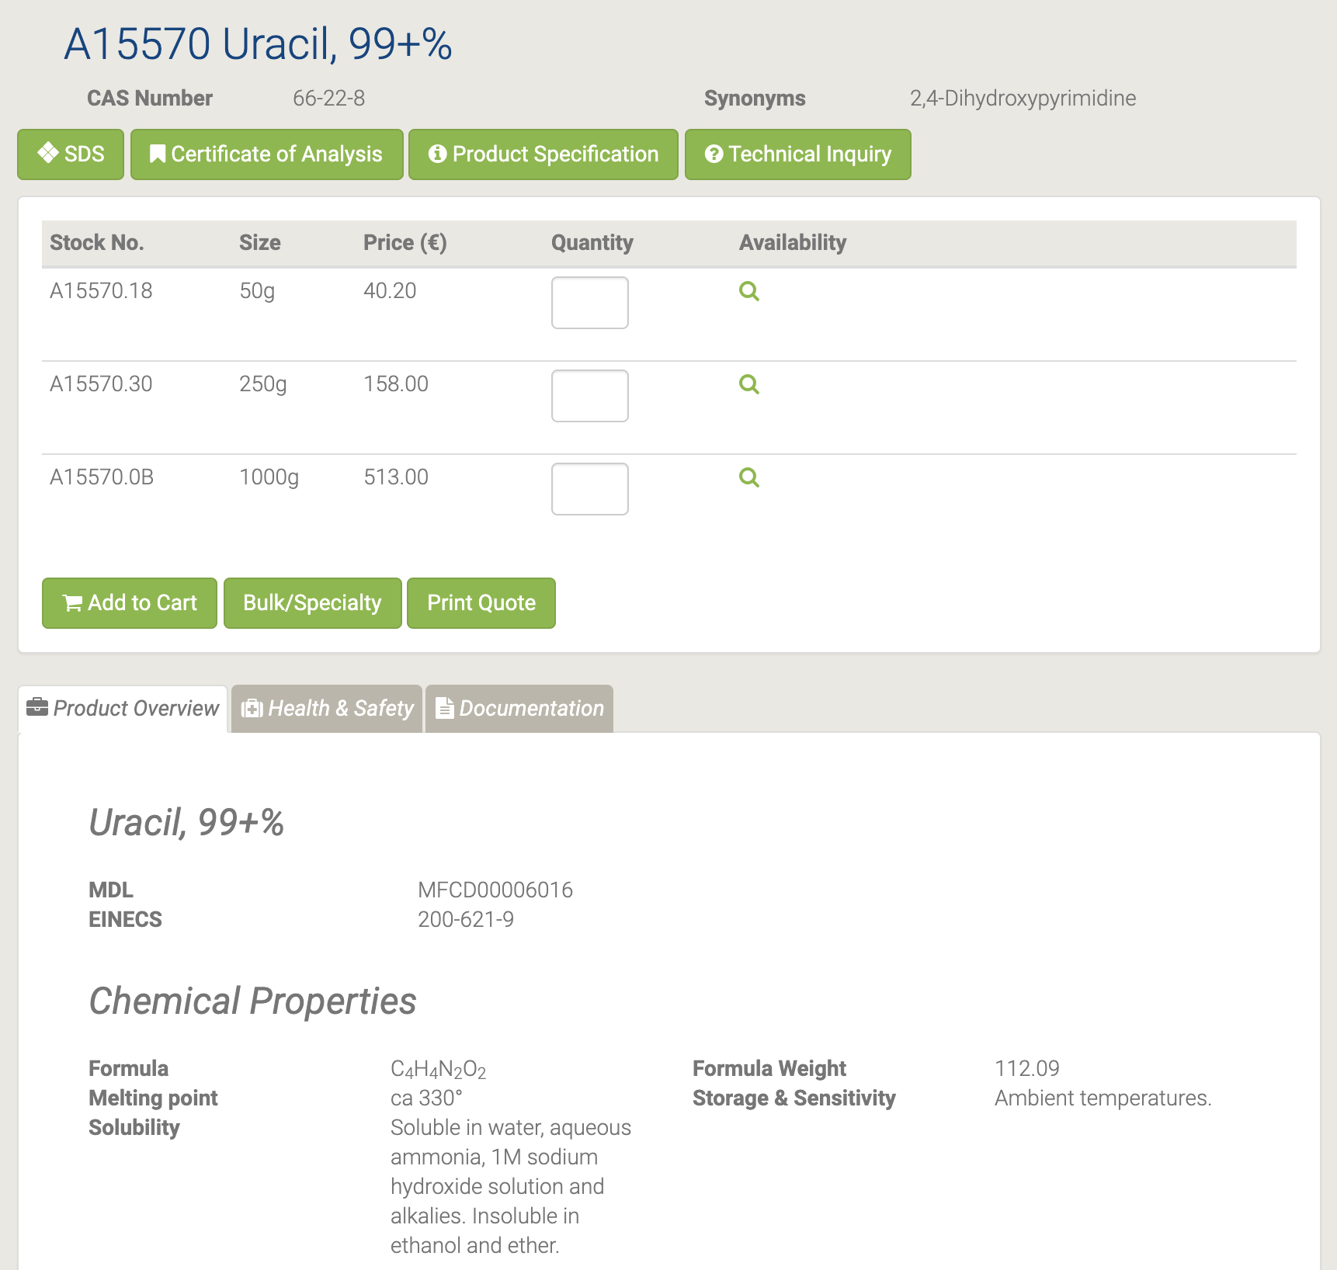

Урацил производится путем гидролиза нуклеиновой кислоты и используется в биохимических исследованиях. Он служит аллостерическим регулятором и коферментом для реакций в организме человека и растений. Он реагирует с фтором с образованием 5-фторурацила, который является противораковым препаратом. Кроме того, он используется для доставки лекарств и в фармацевтике. В дополнение к этому он используется в синтезе кофеина и при определении микробного загрязнения томатов [175-176]. Обзор использования урацилов в качестве исходных материалов в гетероциклическом синтезе [174].

#### A18601 Uridine-5'-monophosphate disodium salt

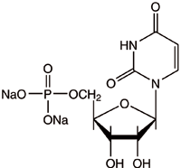

A18601 Uridine-5'-monophosphate disodium salt [177]

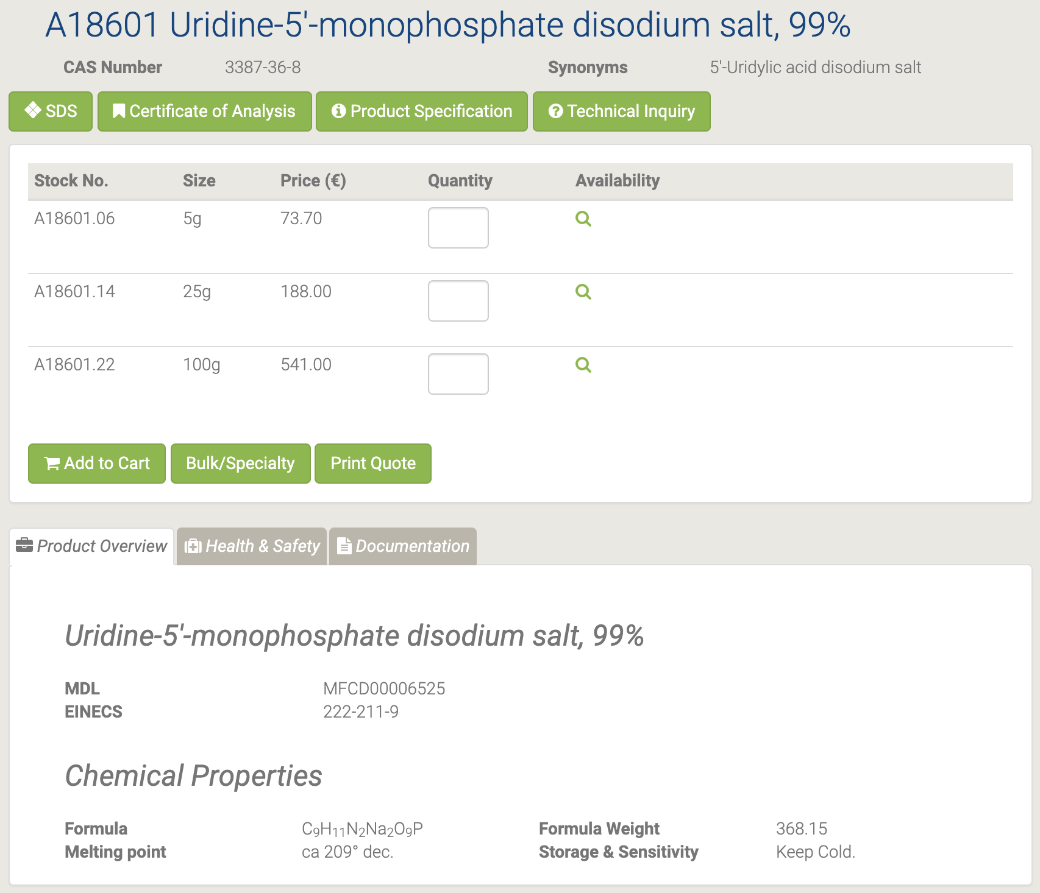

### Chemical Integrity Analysis

During irradiation, it is important to maintain the chemical integrity of the material; only an atom or a few atoms in a molecule should be marked, but the structure and composition should remain unchanged. To comply with this requirement, it is necessary to estimate the bond energies in the molecule - the dissociation energy. The table shows data from [178]

|  |  |  |
| --- | --- | --- |
| bond type | D0 | |
| kkal | eV |
| С2+ | 126±15 | 5,5 |
| С2 | 144±3 | 6,3 |
| С2- | 187±10 | 8,1 |
| CH+ | 93,8±0,5 | 4,1 |
| CH- | 110±7 | 4,8 |
| CO+ | 192,9±0,1 | 8,4 |
| CN- | 239±1,5 | 10,4 |
| N2- | 201,4±0,2 | 8,8 |
| NH- | 85±5 | 3,7 |

The data in the table are given for 0 ° K, recalculation to 298 ° K gives an increase of 0.04 eV, which can be neglected in the estimation.

Thus, we obtain the requirements for the boundary neutron energy - no more than 3.7 eV, which is higher than the energy of 0.4 eV, up to which neutrons are considered thermal, from which it follows that the dissociation process of nucleosides will not occur in the thermal region of the spectrum of irradiating neutrons.

The second point worth paying attention to is undesirable reactions leading to a change in the element, for example:

815O -> 715N + e+ +νe

615C -> 715N+ e- +νe—

Obviously, in this case, the chemical integrity of the nucleoside will be violated; therefore, it is necessary to select the resonance energy for the useful reaction of absorption of the thermal neutron 714N with the formation of stable 715N.

Consider interesting options for molecular transformation for uracil

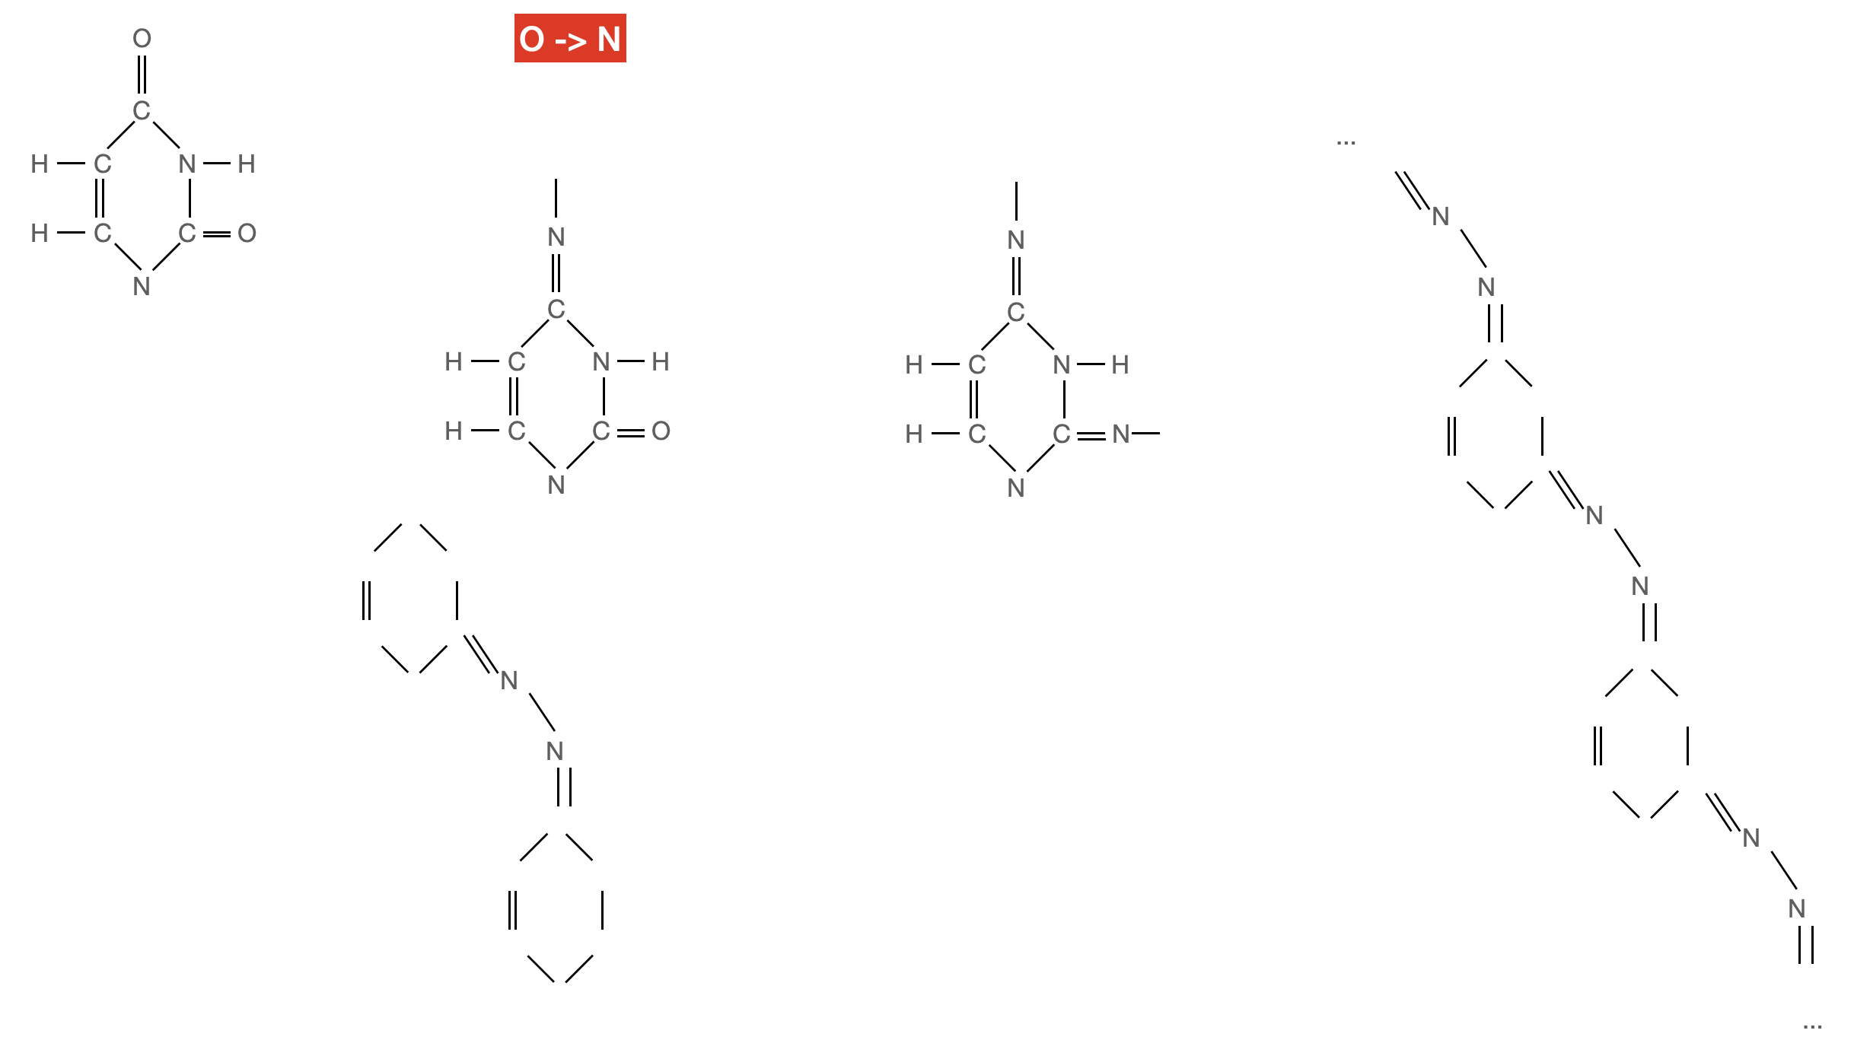

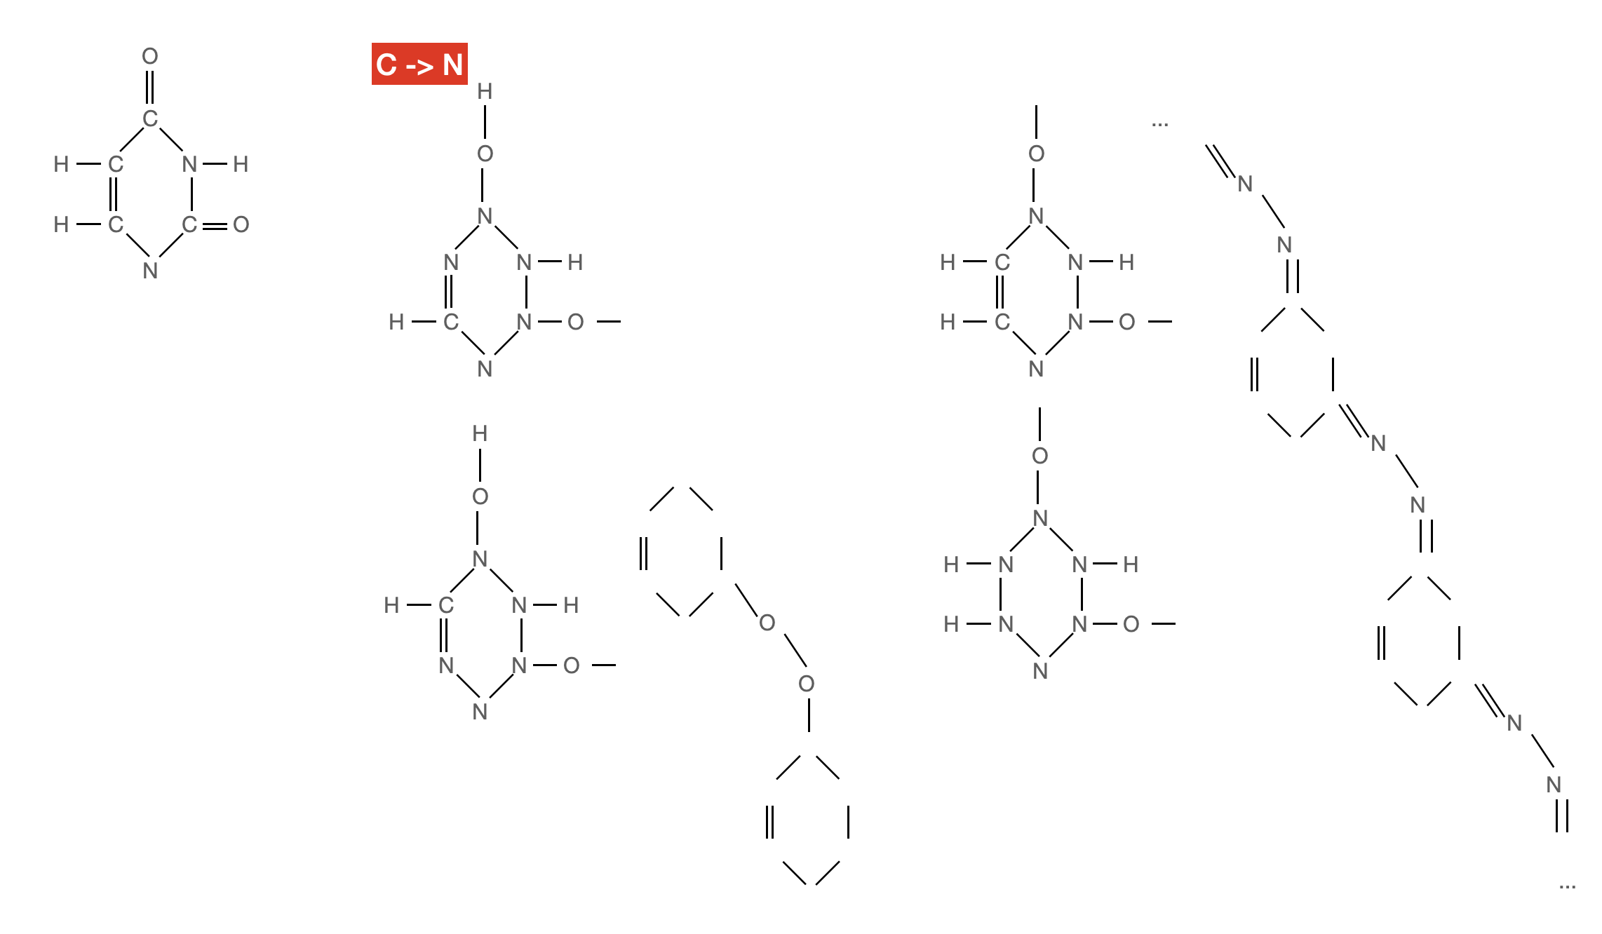

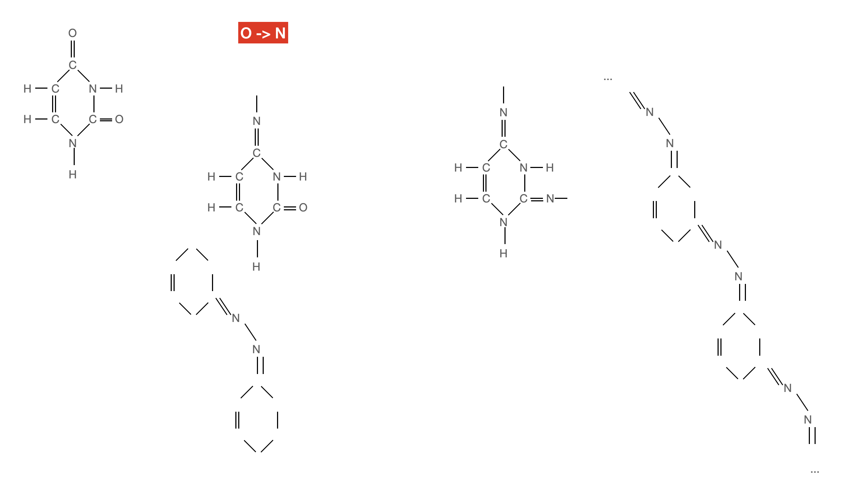

In the process, interesting structures are obtained that can be studied in dynamics and different energies and taking into account the environment, for example, in DNA or RNA. If the chains are long, they can roll up into three-dimensional figures - spirals, globules, and transform during the decay of isotopes.

Another interesting case in transition:

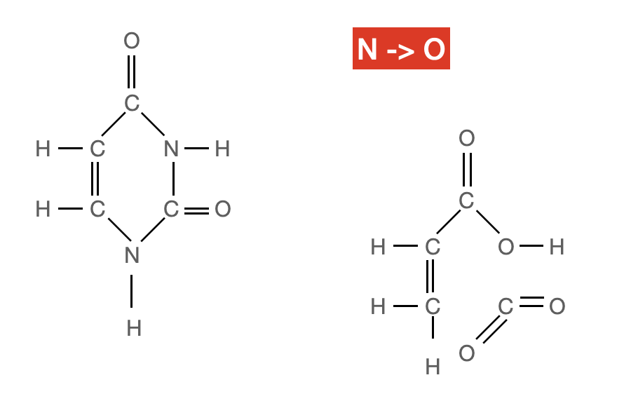

In the forward direction, the uracil is “disassembled”, and in the opposite direction, it is “assembled”. Perhaps there is potential here in the study of the formation of life, since uracil is included in RNA.

### Physical calculation

To ensure the course of the processes of interest to us, we are most interested in the capture of neutrons. The capture cross section is resonant. In our case, when the thermal motion of atoms, molecular effects and crystal bonds are comparable to the neutron energy, the cross section is inversely proportional to the square root of the neutron energy. [179] p. 231

The resonant cross section is a function of the resonance width, resonance energy, temperature and mass number of elements.

The cross sections must be measured experimentally, using the Rutherford installation, and for different elements they will be different, depending on their structure and composition. Theoretically, there should be a resonance in the resonance region of isolated nitrogen nuclei - for a label or nitrogen, carbon, oxygen - to modify nucleosides. These values ​​are described by the Breit-Wigner formula [179] p. 231, can be taken from the BROND reference library [180].

Also, it is especially important for the yield of the product to avoid resonant capture of 715N [182] in the energy spectrum and maximally be in the resonance of 7N14 [181].

For the physical calculation, it will also be necessary to take into account the geometry - the irradiated ampoule has cylindrical symmetry and the kinetic equation can be taken from [179] p.29.

Thermalization of neutrons inside the liquid in the ampoule will also contribute to the process; the calculation model can be taken from [179] p.569.

It is also possible that a positive contribution to the quality of the process can be made by the return of thermal neutrons to the ampoule due to elastic scattering on iron, if the ampoules are placed in cylindrical iron tubes open from the end for the neutron flux, and a coolant-moderator is placed in the gap between the tube and the ampoule in order to to provide thermal conditions and slowing down of the returned neutrons.

Beryllium can be used to increase the number of neutrons, for the alpha source (, n) or for the neutron source for the reaction (n, 2n).

The figure shows a schematic diagram of a laboratory setup.

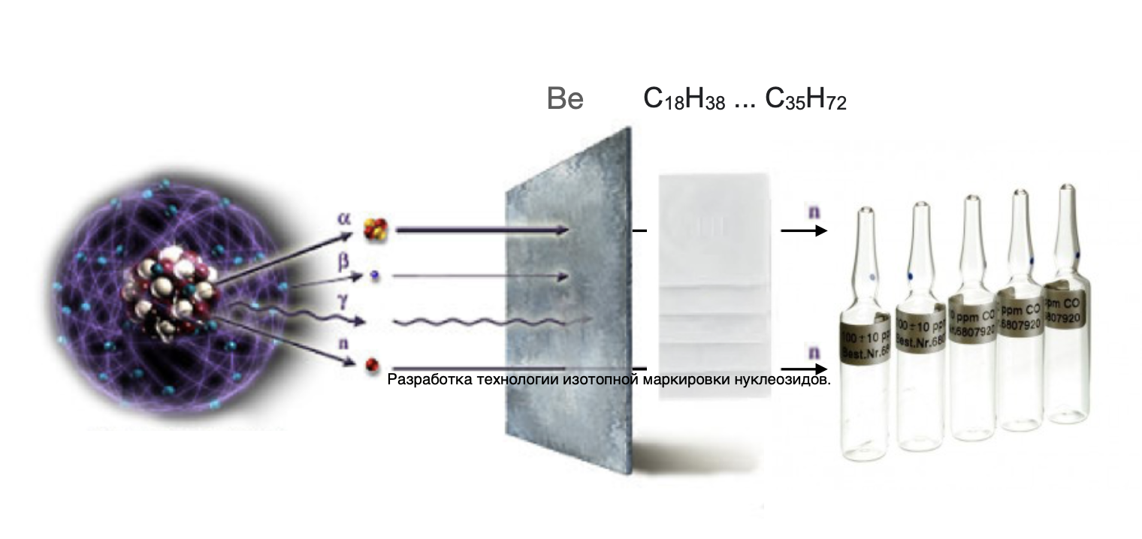

## Innovativeness

The innovation of the solution lies in the acceleration of the production of isotopically labeled nucleosides in comparison with the method of growing biological organisms in an isotopic medium, for example, E. coli in an isotopic ammonia medium, with the subsequent isolation of the drug.

## Created commercial product and its characteristics.

Based on the above, our team proposes to develop, within the framework of R&D, a technology for isotope labeling of nucleosides using a thermal neutron laboratory setup.

**Sources of alpha radiation**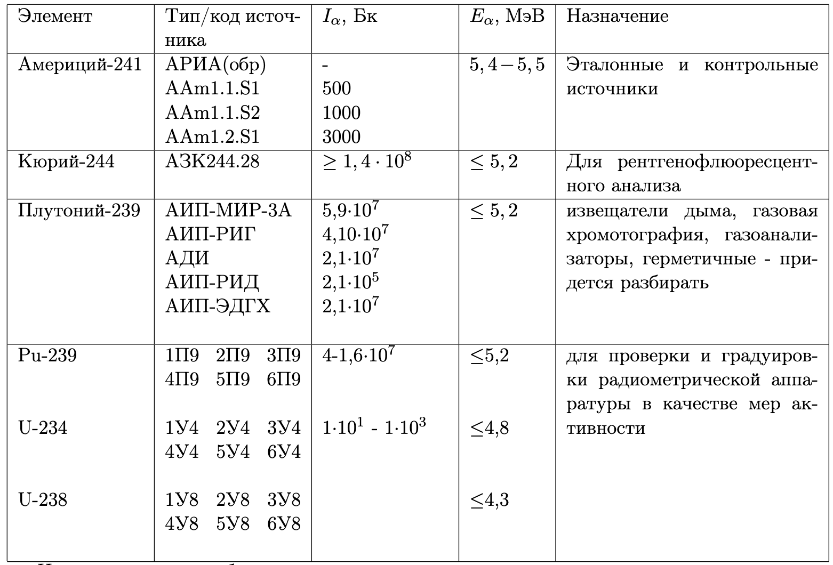

Table 2 - Sources of alpha radiation of the State Corporation "Rosatom" JSC "Isotop"

neutron sources

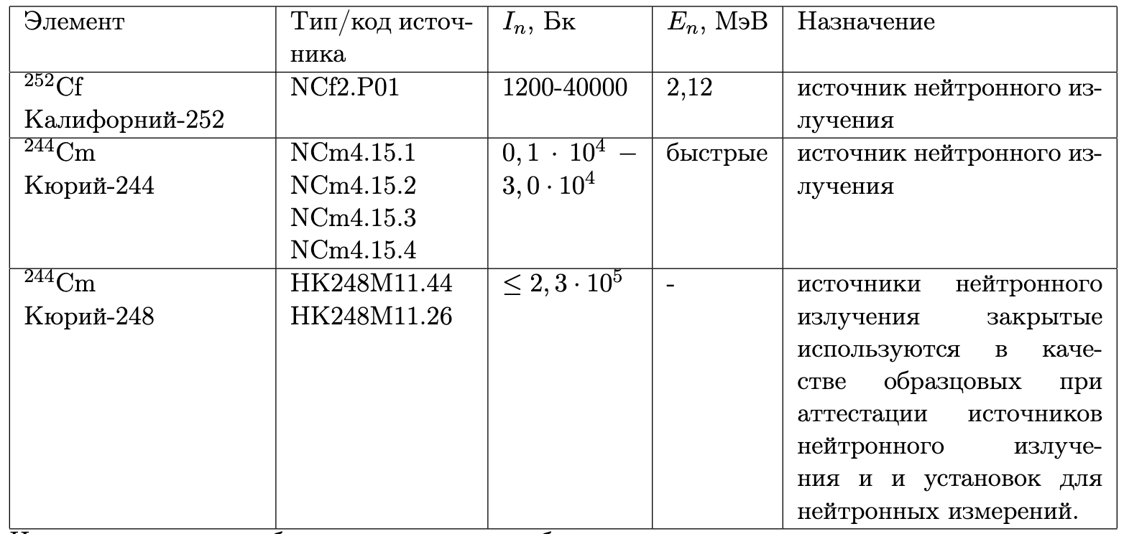

Table 3 - Sources of neutron radiation of the State Corporation "Rosatom" JSC "Izotop"

**Sources of gamma radiation**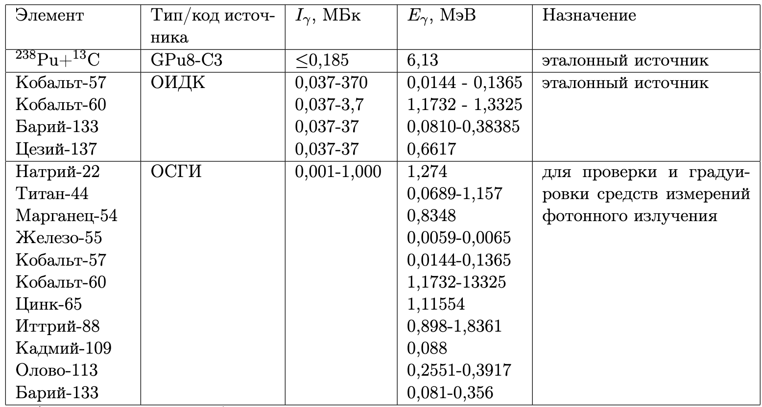

Table 4 - Sources of gamma radiation of the State Corporation "Rosatom" JSC "Isotop"

As a result of the work, products with the following characteristics will be obtained:

|  |  |  |
| --- | --- | --- |
| Code | Quantity, mg | Price, € |
| H50287.03 | 1000 | 642 |
| L19664.06 | 5000 | 366 |
| H33038.06 | 5000 | 231 |
| L03686.06 | 5000 | 272,4 |
| 44748.06 | 5000 | 495 |
| A11166.06 | 5000 | 489 |
| A16026.06 | 5000 | 489 |
| H27412.03 | 1000 | 1251 |
| H52741.06 | 5000 | 2745 |
| H52408.06 | 5000 | 2487 |
| B21190.MD | 250 | 516 |
| H61919.03 | 1000 | 283,8 |
| L01996.06 | 5000 | 116,4 |
| L02292.06 | 5000 | 212,1 |
| L01918.06 | 5000 | 435 |
| 44378.06 | 5000 | 867 |
| L04452.06 | 5000 | 82,8 |
| H27260.06 | 5000 | 963 |
| B21034.MD | 250 | 450 |
| A14799.06 | 5000 | 63,3 |
| A18507.03 | 1000 | 177,6 |
| 44639.06 | 5000 | 1680 |
| L08490.06 | 5000 | 1311 |
| L10861.03 | 1000 | 468 |
| L16496.03 | 1000 | 262,2 |
| L01682.06 | 5000 | 498 |
| B25173.06 | 5000 | 552 |
| A18994.09 | 10000 | 153,6 |
| H64259.14 | 25000 | 195,3 |
| H55913.06 | 5000 | 510 |
| A12448.14 | 25000 | 129,3 |
| 44815.04 | 2000 | 1416 |
| H52780.03 | 1000 | 810 |
| H52301.03 | 1000 | 333 |
| H52782.06 | 5000 | 2487 |
| L16196.03 | 1000 | 387 |
| 44379.06 | 5000 | 4152 |
| B25448.22 | 100000 | 327 |
| L03332.22 | 100000 | 112,8 |
| B21131.02 | 500 | 636 |
| B21068.MA | 10 | 89,7 |
| B21985.06 | 5000 | 420 |
| L01875.03 | 1000 | 149,1 |
| H51694.03 | 1000 | 942 |
| H66634.MD | 250 | 1179 |
| B24191.22 | 100000 | 58,8 |
| 44467.06 | 5000 | 702 |
| L03544.03 | 1000 | 396 |
| L02992.06 | 5000 | 210 |
| A16964.09 | 10000 | 100,2 |
| L14029.03 | 1000 | 136,8 |
| L14051.06 | 5000 | 164,4 |
| L14522.06 | 5000 | 459 |
| A10781.09 | 10000 | 90,3 |
| L09020.06 | 5000 | 453 |
| H26557.22 | 100000 | 124,2 |
| A13707.36 | 500000 | 133,2 |
| H52427.MC | 100000 | 945 |
| H27853.03 | 1000 | 1359 |
| H26507.06 | 5000 | 444 |
| A14495.ME | 500000 | 444 |
| A12024.14 | 25000 | 125,1 |
| A11532.09 | 10000 | 88,5 |
| A11328.14 | 25000 | 151,2 |
| A18579 | 0 | 0 |
| H26694.22 | 100000 | 135,3 |
| H31888.03 | 1000 | 588 |
| H52303.06 | 5000 | 1431 |
| H52306.06 | 5000 | 2964 |
| H52799.06 | 5000 | 2349 |
| H52807.03 | 1000 | 810 |
| H52732.06 | 5000 | 2997 |
| H52309.06 | 5000 | 1890 |
| H52296.03 | 1000 | 306 |
| H52730.06 | 5000 | 1344 |
| H52746.03 | 1000 | 759 |
| H52411.03 | 1000 | 780 |
| H52726.06 | 5000 | 1878 |
| L16407.06 | 5000 | 306 |
| A11493.06 | 5000 | 247,5 |
| A15879.14 | 25000 | 152,1 |
| H27219.03 | 1000 | 1359 |
| H51098.03 | 1000 | 552 |
| H50469.03 | 1000 | 729 |
| A15570.18 | 50000 | 120,6 |
| A18601.06 | 5000 | 221,1 |

And also for each article a production technology and drug control will be drawn up.

**Plans for the creation and protection of intellectual property.**

In the course of work on the project, Heavy Nucleosides LLC plans to develop a technology for isotopic labeling of nucleosides. The developed technologies will be patented, and the software created during the development process will undergo state registration.

During the preliminary study of the proposed R&D project, the patent landscape was studied using the databases of the European Patent Office (espacenet.com). A preliminary patent search showed that there are no titles of protection that in any way hinders the promotion of the proposed product on the European market.

# PROSPECTS FOR COMMERCIALIZATION

**The volume and capacity of the product market, analysis of the current state and development prospects of the industry in which the innovative project is being implemented.**

Isotope-labeled nucleosides are used in genetic analysis and biotechnology research. The market is currently growing steadily.

The options for using the system by industry are considered:

• livestock and agriculture - development of PCR tests, production and conduct of PCR tests

• bigfarama - conducting clinical trials of drugs on animals

• medicine - development and implementation of tests

• biology - study of molecular structures, development and implementation of tests

• materials science - neutron optics, spectrometry, structure analysis, production of new materials with isotopic doping

• quantum information systems - production, quality control

• radio industry - reliability tests under radiation background, quality control

• chemistry - studying the conditions of chemical processes, structures, production of radioisotope reagents

• geology - the study of the chemical composition and structure

• archeology - clarification of characteristics of isotope age determination

As you can see, the scope of application of labeled nucleosides is wide and the main goal will be to reduce the cost of drugs and the time of their production.

## Competitive advantages

Working with sources of ionizing radiation requires certification and bringing laboratory equipment and organizational structure (job descriptions, work schedules, working conditions, personnel qualifications) in accordance with radiation safety standards, which in some cases will be either impossible or difficult for some reason: organizational , financial, political, environmental, etc. Therefore, faced with a similar problem, laboratories are forced to look for another way of research. Our product solves this problem. We label with long-lived non-radioactive isotopes. The use of isotopic methods can significantly accelerate scientific research in comparison with indirect methods, and conducting research in the immediate vicinity of the facility will allow the use of labeling with short-lived isotopes, which may be useful in studies of the kinetics of the process.

## Planned cost of the product. Cost calculation.

The cost of a product consists of the following components:

1. One-time, which in turn are divided into:

1.1. Laboratory retrofitting costs

1.2. Software development costs - marketing platform

These costs are one-time

2. Current, which are divided into:

2.1. Direct costs of making experiments:

2.2.1. Materials.

2.2.2. Works and services performed by third parties.

2.2. Direct costs of maintaining a marketing platform

2.3. Indirect costs

The development time will be 1 year and the cost is 3 million rubles.

|  |  |
| --- | --- |
| Cost item | Сумма, € |
| Wage | 15 000 |
| Tax | 1 500 |
| Payment for the work of co-executors | 10 000 |
| Materials | 23 500 |
| Overheads | 10 000 |
| Total: | 40 000 |

Target segments of consumers of the created product and assessment of effective demand

In the B2B sector, our clients can be:

• Laboratories for genetic analysis.

• Biotech companies

• Chemical industry - studying the conditions of chemical processes, structures, production of radioisotope reagents

• Livestock and agriculture - development of PCR tests, production of PCR tests

• Bigfarama - labeling of clinical drugs

• Medicine - development of labeled tests

• Biology - study of molecular structures, test development

• Materials science - neutron optics, spectrometry, structure analysis, production of new materials with isotopic doping

## Description of the business model of the project. Promotion strategy.

Initially, it is planned to create a laboratory, purchase material and conduct experiments to obtain the timing and volumes of the yield of useful products, after which the conclusion of contracts for the production of isotopically labeled nucleosides. After analyzing the market, material will be purchased for the production of finished products, without prior ordering. Production will be gradually automated and the transition to an automated technological process will be fully implemented.

Based on the results of the laboratory's work and the demand for drugs, the system will be scaled up - expanding the existing laboratory and organizing new production laboratories.

# PROJECT TEAM

## The number of employees, the direction of their activities and their qualifications

Currently, the project employs 3 people:

|  |  |  |  |  |
| --- | --- | --- | --- | --- |
| №п.п. | Full name | Employment type | Role in the project team | Qualification |
| 1 | Yukhnovsky Ilya Alexandrovich | In the state | CEO, founder | Physicist, programmer |
| 2 | Trubin Mikhail Yurievich | In the state | Founder | Chemist, programmer |
| 3 | Yukhnovskaya Natalia Nikolaevna | In the state | Founder | Accountant, clerk |

# TECHNICAL SUPPORT OF PROJECT IMPLEMENTATION

**Calendar plan**

The entire startup is planned to be implemented in 12 months

The following stages will be identified in the project implementation timeline:

Stage 1: organizing a laboratory, purchasing nucleosides, conducting experiments

Stage 2: laboratory automation, creation of the basic functionality of a cloud marketing application, production.

**Availability of fixed assets and required space for project implementation**

For the implementation of the project in Russia, it is possible to use a laboratory certified for working with radioactive materials and an agreement was obtained with the director of the V.I. academician F.M. Mitenkov.

Also, the institute is going to meet the project in the joint use of the available laboratory equipment.

Lab images are shown below:

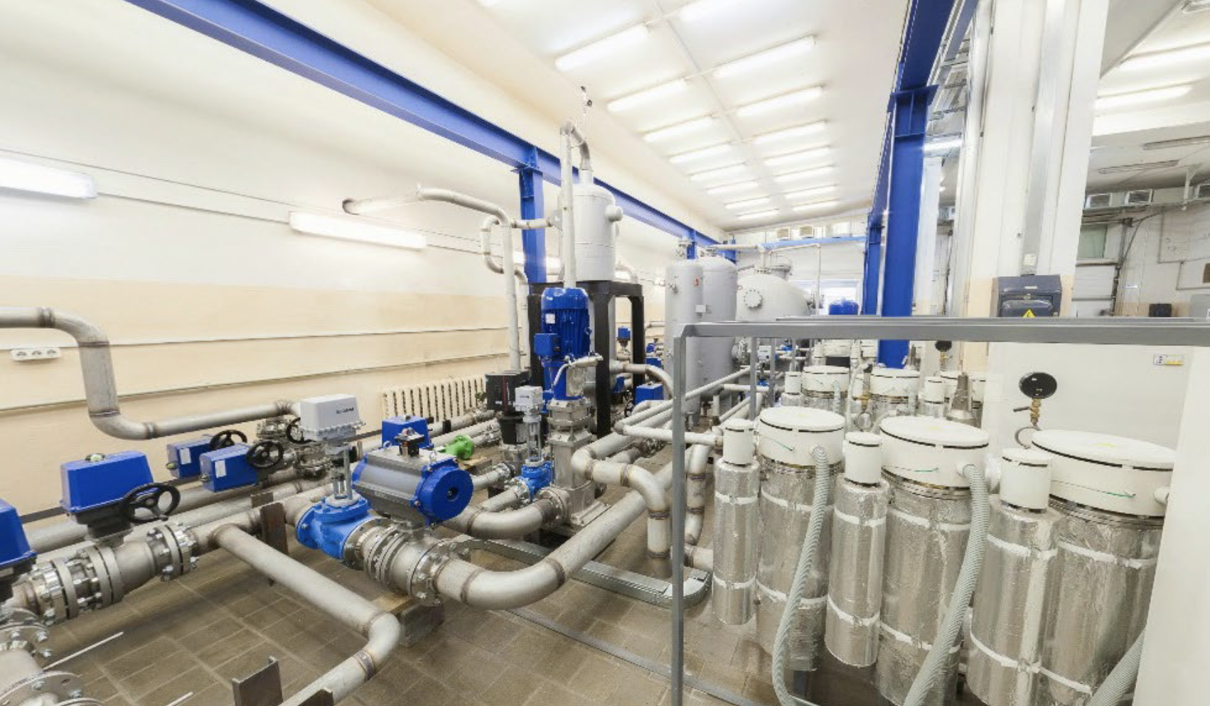

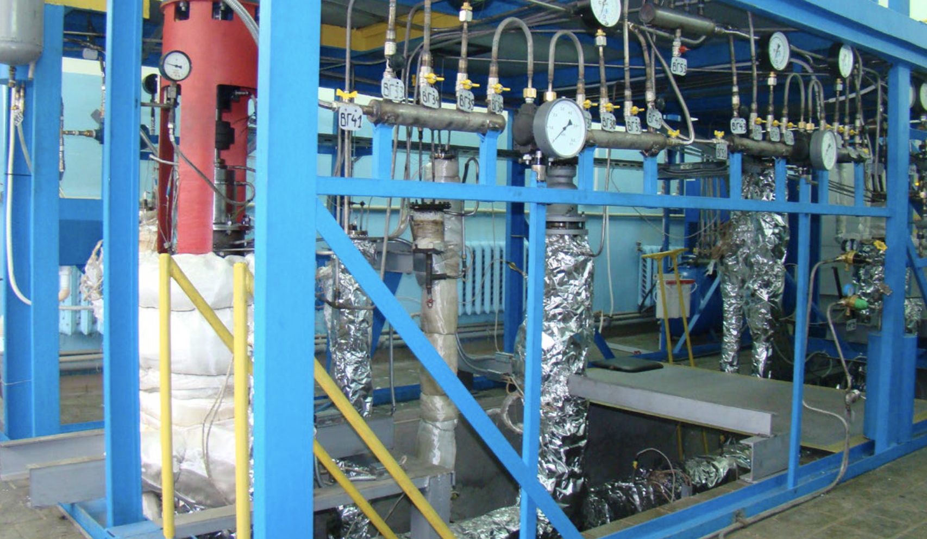

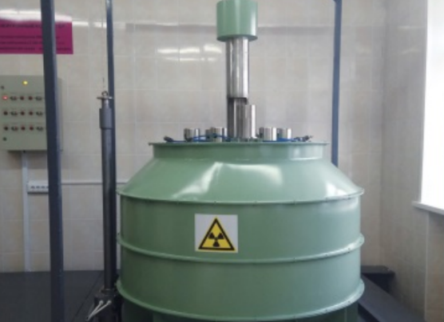

If interested organizations or universities have it, it is possible to create a laboratory on their territory, and due to the fact that the requirement for the heat flux of neutrons is low, it is possible to replace the thermal column with an alpha radiation source with a beryllium target, in accordance with radiation safety standards and regulatory requirements for work with ionizing radiation of the state where the beneficiary is located.

# FINANCIAL PLAN

## Total project financing

The total need for funds required for the project is 40,000 euros. It is planned to raise funds by participating in an accelerator and business development programs, attracting the full amount for 49% of the company's share. The participants' own contribution to the project will be carried out by knowledge and intellectual work.

**Previously attracted financing for the implementation of the project from budgetary and non-budgetary sources**

Previously, no funds were attracted from any credit sources for the development of the project.

Much has already been done at its own expense, namely, the idea of a biotechnological laboratory was born in the Docophila startup, competencies in nuclear medicine and bioengineering have been developed by the participants for over 20 years.

**Key economic targets**

The preliminary planning period for calculating the economic indicators of the project is 1 year.

According to the planned economic calculations (see Appendix 1), it is planned to make a profit starting from the 1st year of the project implementation. Payback ratio (ROI) by the end of the planning period 2021-2022 reaches the level of 159.13%.

**Possible moments, types and sources of risks, measures to reduce them**

During the preparation of the business plan for the project, an analysis was made for the project's resistance to various kinds of risks. During the analysis, it was possible to classify the risks into groups. The result of the analysis showed a good level of resistance and a margin of safety to the risks of different groups. In order to further increase resilience, it is necessary to consider groups of risks and assess the possibility of occurrence for each case.

**Scientific and technical risks**

Since the project is at the development stage, despite the good scientific groundwork, there is a risk of outstripping and entering the market for similar products of competing companies. However, given the wide range of applications of the technology, it is possible to quickly modify the functionality of laboratory equipment, taking into account the customer's requirements. Thus, the risk of this group can be assessed as “Low”, however, the company will still take measures to reduce the risks of this group, protecting the property rights to algorithms, robotic units, reactors and software developed as part of the project.

**Market risks**

Market risk is the appearance on the market of new competitors of the company, which could not be taken into account in the course of the analysis. Reducing the risks of this group is due to the rather tight deadlines for research and development. The risks of this group can be characterized as “Medium”.

**Operational risks**

The risks were considered:

- Late procurement of laboratory equipment

- Rising prices for components used in the project and laboratory equipment

- Force majeure of co-executors providing reactor production services

- Sharp rise in prices for consumables

Most of the risks that fall into this group are rated as “Medium”, but we will try to minimize them by urgently purchasing equipment and consumables to minimize the risk of inflation. We estimate the risks of non-fulfillment of obligations by the contractors as "Low".

**Regulatory risks**

Regulatory risks include changes in the regulatory framework that prohibit our use of sources of ionizing radiation. According to our estimates, this option is referred to as “Medium” risk levels.

**Financial risks**

The main risk of this group is the possible failure to fulfill the credit obligations assumed. This risk will be minimized by a possible refusal to attract credit funds at the start stage, not counting sowing. According to our estimates, this option is referred to as “Medium” risk levels.

# Список литературы

1. Кнорре Д. Г., Мызина С. Д. Биологическая химия. — 3. — Москва: Высшая школа, 2000. — 479 с. — 7000 экз. — ISBN 5060037207.

2. Ligasová, A., & Koberna, K. (2018). DNA Replication: From Radioisotopes to Click Chemistry. Molecules, 23(11), 3007. doi:10.3390/molecules23113007

3. Reichard, P.; Estborn, B. Utilization of desoxyribosides in the synthesis of polynucleotides.J. Biol. Chem.1951,188, 839–846. [PubMed]

4. Downing, M.; Schweigert, B.S. Role of vitamin B12 in nucleic acid metabolism. IV. Metabolism of C14-labeledthymidine by Lactobacillus leichmannii.J. Biol. Chem.1956,220, 521–526. [PubMed]

5. Friedkin, M.; Tilson, D.; Roberts, D. Studies of deoxyribonucleic acid biosynthesis in embryonic tissues withthymidine-C14.J. Biol. Chem.1956,220, 627–637. [PubMed]

6. Friedkin, M.; Wood, H.I. Utilization of thymidine-C14 by bone marrow cells and isolated thymus nuclei.J. Biol. Chem.1956,220, 639–651. [PubMed]

7. Audi G., Bersillon O., Blachot J., Wapstra A. H. The NUBASE evaluation of nuclear and decay properties // Nuclear Physics A. — 2003. — Т. 729. — С. 3—128. — doi:10.1016/j.nuclphysa.2003.11.001. — Bibcode: 2003NuPhA.729....3A.

8. Audi G., Wapstra A. H., Thibault C. The AME2003 atomic mass evaluation (II). Tables, graphs, and references (англ.) // Nuclear Physics A. — 2003. — Vol. 729. — P. 337—676. — doi:10.1016/j.nuclphysa.2003.11.003. — Bibcode: 2003NuPhA.729..337A.

9. Audi G., Bersillon O., Blachot J., Wapstra A. H. The NUBASE evaluation of nuclear and decay properties // Nuclear Physics A. — 2003. — Т. 729. — С. 3—128. — doi:10.1016/j.nuclphysa.2003.11.001. — Bibcode: 2003NuPhA.729....3A.

10. Enoto, T., Wada, Y., Furuta, Y. et al. Photonuclear reactions triggered by lightning discharge. Nature 551, 481–484 (2017). <https://doi.org/10.1038/nature24630>

11. ru.qaz.wiki/wiki/isotopes_of_nitrogen

12. <https://www.alfa.com/>.

13. <https://www.alfa.com/en/catalog/H50287/>

14. <https://www.alfa.com/en/catalog/L19664/>

15. <https://www.alfa.com/en/catalog/H33038/>

16. <https://www.alfa.com/en/catalog/L03686/>

17. <https://www.alfa.com/en/catalog/044748/>

18. <https://www.alfa.com/en/catalog/A11166/>

19. <https://www.alfa.com/en/catalog/A16026/>

20. <https://www.alfa.com/en/catalog/H27412/>

21. <https://www.alfa.com/en/catalog/H52741/>

22. <https://www.alfa.com/en/catalog/H52408/>

23. https://www.alfa.com/en/catalog/B21190/

24. <https://www.alfa.com/en/catalog/H61919/>

25. <https://www.alfa.com/en/catalog/L01996/>

26. Luisa M.P.F. Amaral.; Piotr Szterner.; Manuel A.V. Ribeiro da Silva. Enthalpies of formation of 5,6-dihydro-5-methyluracil and 5,6-dihydro-6-methyluracil. The Journal of Chemical Thermodynamics. 2013, 64, 187-192.

27. Paul L. Coe .; Ratnakar R. Talekar.; Richard T. Walker. The synthesis of difluoro and trifluoro analogues of pyrimidine deoxyribonucleosides: a novel approach using elemental fluorine. Journal of Fluorine Chemistry. 1994, 69, (1), 19-24.

28. <https://www.alfa.com/en/catalog/L02292/>

29. <https://www.alfa.com/en/catalog/L01918/>

30 David Kupfer; Ruth Partridge. 6β-Hydroxylation of triamcinolone acetonide by a hepatic enzyme system: The effect of phenobarbital and 1-benzyl-2-thio-5,6-dihydrouracil.Archives of Biochemistry and Biophysics.1970, 140 23-28.

31. André B.P. van Kuilenburga; Henk van Lenthe; Arno van Cruchten and Willem Kulik. Quantification of 5,6-Dihydrouracil by HPLC-Electrospray Tandem Mass Spectrometry.Clinical Chemistry.2004, 50 236-238.

32. <https://www.alfa.com/en/catalog/044378/>

33. <https://www.alfa.com/en/catalog/L04452/>

34.: J. Chem. Soc. (C), 1745 (1967). An improved procedure has been used in synthesis of inhibitors of human thymidylate synthase: J. Med. Chem., 27, 1710 (1984),

35. J. Med. Chem., 39, 1836 (1996)

36. Adv. Heterocycl. Chem., 55, 130 (1992)

37. <https://www.alfa.com/en/catalog/H27260/>

38. Chen Li,; Avrum I. Gotlieb. Transforming Growth Factor-β Regulates the Growth of Valve Interstitial Cellsin Vitro. The American Journal of Pathology. 2011, 179 (4), 1746-1755 .

39. Yu Gui et. al. Signaling mechanisms mediating uridine adenosine tetraphosphate-induced proliferation of human vascular smooth muscle cells. Journal of Cardiovascular Pharmacology. 2011 , 58(6), 654-662 .

40. Int. J. Radiat. Oncol. Biol. Phys., 10, 1399 (1984); 21, 709 (1991).

41. Mutat. Res., 258, 161 (1991).

42. Histochem. J., 27, 339, 923 (1995; 28, 531 (1996).

43. https://www.alfa.com/en/catalog/B21034/

44. Cold Spring Harbor protocols.20092009(12), prot5346.

45. Microbiol. Methods.200666(3), 552-555.

46. <https://www.alfa.com/en/catalog/A14799/>

47. <https://www.alfa.com/en/catalog/A18507/>

48. Jonatha M. Gott.; Michael C. Willis.; Tad H. Koch.; Olke C. Uhlenbeck. A specific, UV-induced RNA-protein crosslink using 5-bromouridine-substituted RNA. Biochemistry. 1991, 30 (25), 6290-6295.

49. Paul O. P. Ts'o.; Sunney I. Chan. Interaction and Association of Bases and Nucleosides in Aqueous Solutions. II. Association of 6-Methylpurine and 5-Bromouridine and Treatment of Multiple Equilibria. J. Am. Chem. Soc. 1964, 86 (19), 4176-4181.

50. <https://www.alfa.com/en/catalog/044639/>

51. <https://www.alfa.com/en/catalog/L08490/>

52. <https://www.alfa.com/en/catalog/L10861/>

53. <https://www.alfa.com/en/catalog/L16496/>

54. Olszewska, A.; Dadová, J.; Mačková, M.; Hocek, M. Cleavage of DNA containing 5-fluorocytosine or 5-fluorouracil by type II restriction endonucleases. Bioorg. Med. Chem. 2015, 23 (21), 6885-6890.

55. Perumalla, S. R.; Sun, C. C. Enabling Tablet Product Development of 5-Fluorocytosine Through Integrated Crystal and Particle Engineering. J. Pharm. Sci. 2014, 103 (4), 1126-1132.

56. https://www.alfa.com/en/catalog/L01682/

57. Ikuko Kato; Joseph H. Vogelman; Vladimir Dilman; Jerzy Karkoszka; Krystyna Frenkel; Nancy P. Durr; Norman Orentreich; Paolo Toniolo. Effect of supplementation with chromium picolinate on antibody titers to 5-hydroxymethyl uracil.European Journal of Epidemiology.1998, 14 621-626.

58. Henri Faure; Mireille Mousseau; Jean Cadet; Catherine Guimier; Michelle Tripier; Hassan Hida & Alain Favier. Urine 8-Oxo-7, 8-Dihydro-2?-Deoxyguanosine vs. 5-(Hydroxymethyl) Uracil as DNA Oxidation Marker in Adriamycin-Treated Patients.Free Radical Research.1998, 28 377-382.

59. <https://www.alfa.com/en/catalog/B25173/>

60. https://www.alfa.com/en/catalog/A18994/

61. Morris J. Robins.; Philip J. Barr.Nucleic acid related compounds. 31. Smooth and efficient palladium-copper catalyzed coupling of terminal alkynes with 5-iodouracil nucleosides.Tetrahedron Lett.198122(5), 421-424.

62. MC Willis.; BJ Hicke.; OC Uhlenbeck.; TR Cech.; TH Koch. Photocrosslinking of 5-iodouracil-substituted RNA and DNA to proteins.Science.1993,262(5137), 1255-1257.

63. For a review of the use of uracils as starting materials in heterocyclic synthesis, see: Adv. Het. Chem., 55, 130 (1992).

64. <https://www.alfa.com/en/catalog/H64259/>

65. <https://www.alfa.com/en/catalog/H55913/>

66. W Snipes.; B Benson. Electron Spin Resonance of a Gamma-Irradiated Single Crystal of 5-Nitro-6-Methyluracil. The Journal of Chemical Physics.196848 (10), 4666-4669.

67. E Sagstuen.; TB Melø.; T Henriksen. Free radicals in pyrimidines. An ESR-study of electron-irradiated single crystals of 5-nitro-6-methyluracil at 77° K. Radiation research.197250 (2), 261-275.

68. <https://www.alfa.com/en/catalog/A12448/>

69. https://www.alfa.com/en/catalog/044815/

70. Sontakke, V. A.; Shinde, V. S.; Lönnberg, H.; Ora, M. Synthesis and Stability of Nucleoside 3',5'-Cyclic Phosphate Triesters Masked with Enzymatically and Thermally Labile Phosphate Protecting Groups. Eur. J. Org. Chem. 2015, 2015 (2), 389-394.

71. Gimenez Molina, A.; Jabgunde, A. M.; Virta, P.; Lonnberg, H. Assembly of Short Oligoribonucleotides from Commercially Available Building Blocks on a Tetrapodal Soluble Support. Curr. Org. Synth. 2015, 12 (2), 202-207.

72. <https://www.alfa.com/en/catalog/H52780/>

73. <https://www.alfa.com/en/catalog/H52301/>

74. Masayoshi Takase; Masahiko Inouye. Highly efficient recognition of native TpT by artificial ditopic hydrogen-bonding receptors possessing a conformationally well-defined linkage. J. Org. Chem. 2003, 68, (3),1134-1137

75. Yixin Lu. Recent advances in the stereocontrolled synthesis of antisense phosphorothioates. Mini Reviews in Medicinal Chemistry. 2006, 6, (3),319-330

76. <https://www.alfa.com/en/catalog/H52782/>

77. <https://www.alfa.com/en/catalog/L16196/>

78. <https://www.alfa.com/en/catalog/044379/>

79. https://www.alfa.com/en/catalog/B25448/

80. Minoo Dabiri; Seyyedeh Cobra Azimi; Hamid Reza Khavasi; Ayoob Bazgir. A novel reaction of 6-amino-uracils and isatins. Tetrahedron. 2008, 64,(30-31), 7307-7311.

81. Olga I.Kalchenko; Sergiy O.Cherenok; Andriy V.Solovyov; Vitaly I.Kalchenko. Influence of calixarenes on chromatographic separation of benzene or uracil derivatives. Chromatographia. 2009, 70,(5), 717-721.

82. https://www.alfa.com/en/catalog/L03332/

83. Tetrahedron Lett., 32, 6539 (1991).

84. Synthesis, 1295 (1995)

85 https://www.alfa.com/en/catalog/B21131/

86. Simonson MS, et al. Rapid characterization of growth-arrest genes in transient transfection assays. BioTechniques.199518(3), 434-6, 438, 440-2.

87. Aimin Liu, et al. Alteration of limb and brain patterning in early mouse embryos by ultrasound-guided injection of Shh-expressing cells.Mechanisms of Development.199875(1-2), 107-115.

88. <https://www.alfa.com/en/catalog/B21068/>

89. <https://www.alfa.com/en/catalog/B21985/>

90. <https://www.alfa.com/en/catalog/L01875/>

91. Hongdeng Qiu.; Shengxiang Jiang.; Xia Liu. N-Methylimidazolium anion-exchange stationary phase for high-performance liquid chromatography. Journal of Chromatography A. 2006, 1103, (2), 265-270.

92. Troy Voelke.; Tim Ewell.; Jean Joo.; Eric D. Edstrom. o-Nitrobenzyl as a photocleavable nitrogen protecting group for indoles, benzimidazole, and 6-chlorouracil. Tetrahedron Letters. 1998, 39, (5-6), 359-362.

93. <https://www.alfa.com/en/catalog/H51694/>

94. <https://www.alfa.com/en/catalog/H66634/>

95. <https://www.alfa.com/en/catalog/B24191/>

96. <https://www.alfa.com/en/catalog/044467/>

97. https://www.alfa.com/en/catalog/L03544/

98. Nahid Waleh; Hiroki Kajino; Anne Marilise Marrache; David Ginzinger; Christine Roman; Steven R Seidner; Timothy J M Moss; Jean-Claude Fouron, Alejandro Vazquez-Tello; Sylvain Chemtob; Ronald I Clyman. Prostaglandin E2--mediated relaxation of the ductus arteriosus: effects of gestational age on g protein-coupled receptor expression, signaling, and vasomotor control. Circulation. 2004, 110, (16), 2326-2332.

99.Y T van den Hoogen; C M Hilgersom; D Brozda; K Lesiak; P F Torrence; C Altona. Conformational analysis of brominated pA2'-5'A2'-5'A analogs. An NMR and model-building study. European Journal of Biochemistry. 1989, 182, (3), 629-637.

100. <https://www.alfa.com/en/catalog/L02992/>

101. <https://www.alfa.com/en/catalog/A16964/>

102. Nuki, G. Human purine metabolism: Some recent advances and relationships with immunodeficiency.Ann Rheum Dis.1983,428-11.

103. Sonali Jana.; Gyan Singh Shekhawat. Plant growth regulators, adenine sulfate and carbohydrates regulate organogenesis and in vitro flowering of Anethum graveolens.Acta Physiologiae Plantarum,2011,33,(2), 305-311.

104. <https://www.alfa.com/en/catalog/L14029/>

105. Yasukazu Yoshida.; Satoshi Furuta.; Etsuo Niki. Effects of metal chelating agents on the oxidation of lipids induced by copper and iron. Biochimica et Biophysica Acta (BBA) - Lipids and Lipid Metabolism. 1993, 1210 (1), 81-88.

106. https://www.alfa.com/en/catalog/L14051/

107. Markus Hafner; Pablo Landgraf; Janos Ludwig; Amanda Rice; Tolulope Ojo; Carolina Lin; Daniel Holoch; Cindy Lim; Thomas Tuschl. Identification of microRNAs and other small regulatory RNAs using cDNA library sequencing. Methods. 2008, 44, (1), 3-12.

108. Marianne Suter; Uwe Riek; Roland Tuerk; Uwe Schlattner; Theo Wallimann; Dietbert Neumann. Dissecting the role of 5'-AMP for allosteric stimulation, activation, and deactivation of AMP-activated protein kinase. Journal of Biological Chemistry. 2006, 281, (43), 32207-32216.

109. https://www.alfa.com/en/catalog/L14522/

110. Chao Qi.; Qi-Li Tang.; Ying-Jie Zhu.; Xin-Yu Zhao.; Feng Chen. Microwave-assisted hydrothermal rapid synthesis of hydroxyapatite nanowires using adenosine 5'-triphosphate disodium salt as phosphorus source. 2012, 85 71-73.

111. Emil Pop.; Viorel Soran.; Georgeta Laz’r. The Effect of ATP (Disodium Salt) upon Rotational Streaming. Physiologia Plantarum. 1967, 20 (3), 617-623.

112. https://www.alfa.com/en/catalog/A10781/

113. Lebon, G.; Edwards, P. C.; Leslie, A. G.; Tate, C. G. Molecular Determinants of CGS21680 Binding to the Human Adenosine A2A Receptor. Mol. Pharmacol. 2015, 87 (6), 907-915.

114. Carlsson, M.; Jögi, J.; Bloch, K. M.; Hedén, B.; Ekelund, U.; Ståhlberg, F.; Arheden, H. Submaximal adenosine-induced coronary hyperaemia with 12 h caffeine abstinence: implications for clinical adenosine perfusion imaging tests. Clin. Physiol. Funct. Imaging 2015, 35 (1), 49-56.

115. <https://www.alfa.com/en/catalog/L09020/>

116. https://www.alfa.com/en/catalog/H26557/

117. Frohnert, A.; Kreißel, K.; Lipp, P.; Dizer, H.; Hambsch, B.; Szewzyk, R.; Selinka, H. C. Removal of Surrogate Bacteriophages and Enteric Viruses from Seeded Environmental Waters Using a Semi-technical Ultrafiltration Unit. Food. Enviorn. Virol. 2015, 7 (2), 173-182.

118. Baltierra-Trejo, E.; Sánchez-Yáñez, J. M.; Buenrostro-Delgado, O.; Márquez-Benavides, L. Production of short-chain fatty acids from the biodegradation of wheat straw lignin by Aspergillus fumigatus. Bioresour. Technol. 2015, 196, 418-425.

119. https://www.alfa.com/en/catalog/A13707/

120. Irshad, I.; Kanekanian, A.; Peters, A.; Masud, T. Antioxidant activity of bioactive peptides derived from bovine casein hydrolysate fractions. J. Food Sci. Technol. 2015, 52 (1), 231-239.

121. Sharma, A. K.; Sawhney, I. K. Modelling moisture sorption characteristics in dried acid casein using connectionist paradigm vis-à-vis classical methods. J. Food Sci. Technol. 2015, 52 (1), 151-160.

122. <https://www.alfa.com/en/catalog/H52427/>

123. https://www.alfa.com/en/catalog/H27853/

124. C. Desgranges.; G. Razaka.; M. Rabaud.; H. Bricaud .; J. Balzarini.; E. de Clercq. Phosphorolysis of (E)-5-(2-bromovinyl)-2'-deoxyuridine (BVDU) and other 5-substituted-2'-deoxyuridines by purified human thymidine phosphorylase and intact blood platelets.Biochem. Pharmacol. 1983, 32 (23),3583-3590 .

125. <https://www.alfa.com/en/catalog/H26507/>

126. <https://www.alfa.com/en/catalog/A14495/>

127. Enza M Torchetti; Francesco Bonomi; Michele Galluccio; Elisabetta Gianazza; Teresa A Giancaspero; Stefania Iametti; Cesare Indiveri; Maria Barile. Human FAD synthase (isoform 2): a component of the machinery that delivers FAD to apo-flavoproteins. FEBS Journal. 2011, 278 (22), 4434-4449.

128. Djemel Hamdane; Manuela Argentini; David Cornu; Hannu Myllykallio; Stéphane Skouloubris; Gaston Hui-Bon-Hoa; Béatrice Golinelli-Pimpaneau. Insights into folate/FAD-dependent tRNA methyltransferase mechanism: role of two highly conserved cysteines in catalysis. Journal of Biological Chemistry. 2011, 286 (42), 36268-36280.

129. https://www.alfa.com/en/catalog/A12024/

130. A M Oliveira-Brett.; V Diculescu.; J A P Piedade. Electrochemical oxidation mechanism of guanine and adenine using a glassy carbon microelectrode.Bioelectrochemistry,2002,55(1-2), 61-62.

131. K Phillips.; Z Dauter.; A I Murchie.; D M Lilley.; B Luisi. The crystal structure of a parallel-stranded guanine tetraplex at 0.95 A resolution.J Mol Biol.1997,273(1), 171-182.

132. Dueholm KL, et al. Synthesis of peptide nucleic acid monomers containing the four natural nucleobases: thymine, cytosine, adenine, and guanine and their oligomerization.J. Org. Chem.1994,59(19), 5767-5773.

133. <https://www.alfa.com/en/catalog/A11532/>

134. Sadleir, K. R.; Eimer, W. A.; Cole, S. L.; Vassar, R. A β reduction in BACE1 heterozygous null 5XFAD mice is associated with transgenic APP level. Mol. Neurodegener. 2015, 10 (1), 1-16.

135. Sahoo, D. K.; Sahu, P. K. Stability-Indicating RP-HPLC Method for the Determination of Valaciclovir Hydrochloride in Bulk and Pharmaceutical Dosage Forms. Chem. Sci. Trans. 2014, 3 (2), 510-517.

136. <https://www.alfa.com/en/catalog/A11328/>

137. Thomas R. Cech; Arthur J. Zaug; Paula J. Grabowski. In vitro splicing of the ribosomal RNA precursor of tetrahymena: Involvement of a guanosine nucleotide in the excision of the intervening sequence. Zeitschrift für Kristallographie-Crystalline Materials.1981, 27, 487-496.

138. Michel F; Hanna M; Green R; Bartel DP; Szostak JW.The guanosine binding site of the Tetrahymena ribozyme. Nature.1989, 342, 391-395.

139. https://www.alfa.com/en/catalog/A18579/

140. R K DiNello and D H Dolphin. Substituted hemins as probes for structure-function relationships in horseradish peroxidase.J. Bio. Chem.1981,2566903-6912.

141. Johan Moan.; Sverre Sandberg.; Terje Christensen.; Stein Elander. Hematoporphyrin Derivative: Chemical Composition, Photochemical and Photosensitizing Properties.Porphyrin Photosensitization,1; Kessel, David; Springer US; 1983; 165-179

142. <https://www.alfa.com/en/catalog/H26694/>

143. Angel-Cuapio, A.; Figueroa-Montero, A.; Favela-Torres, E.; Viniegra-González, G.; Perraud-Gaime, I.; Loera, O. Critical Values of Porosity in Rice Cultures of Isaria fumosorosea by Adding Water Hyacinth: Effect on Conidial Yields and Quality. Appl. Biochem. Biotechnol. 2015, 177 (2), 446-457.

144. Cardoso, V. M.; Borelli, B. M.; Lara, C. A.; Soares, M. A.; Pataro, C.; Bodevan, E. C.; Rosa, C. A. The influence of seasons and ripening time on yeast communities of a traditional Brazilian cheese. Food Res. Int. 2015, 69, 331-340.

145. <https://www.alfa.com/en/catalog/H31888/>

146. https://www.alfa.com/en/catalog/H52303/

147. N. S. Rao,; P. Kumar,; V. K. Chauhan,; B. S. Garg,; K. C. Gupta. Microwave Assisted High Yielding Preparation Of N-Protected 2?-Deoxyribonucleosides Useful For Oligonucleotide Synthesis. Nucleosides, Nucleotides and Nucleic Acids. 2002, 21 (4-5), 393-400.

148. Piet Herdewijn,; Jan Balzarini,; Rudi Pauwels,; Gerard Janssen,; Arthur Van Aerschot,; Erik De Clercq. Synthesis and Biological Activity of the Mono- and Diamino Analogues of 2?-Deoxyadenosine, Cordycepin, 9-(3-Deoxy-α-D-Threo-Pentofuranosyl)-Adenine (A Structural Component of Agrocin 84) and 9-(2-Deoxy-α-D-Threo-Pentofuranosyl)Adenine. Nucleosides and Nucleotides. 1989, 8(7), 1231-1257.

149. <https://www.alfa.com/en/catalog/H52306/>

150. <https://www.alfa.com/en/catalog/H52799/>

151. <https://www.alfa.com/en/catalog/H52807/>

152. <https://www.alfa.com/en/catalog/H52732/>

153. https://www.alfa.com/en/catalog/H52309/

154. S.K.Burley; A.H.J.Wang. Structure of N-benzoyl-5'-O-tert-butyldimethylsilyl-2'-deoxyadenosine monohydrate. Acta Cryst. 1987, C43, 988-990

155. <https://www.alfa.com/en/catalog/H52296/>

156. https://www.alfa.com/en/catalog/H52730/

157. R Kierzek. The Synthesis of 5’-O-Dimethoxytrityl-N-Acyl-2?-Deoxynucleosides. Improved ''Transient Protection''Approach1. Nucleosides & Nucleotides. 19854 (5), 641-649.

158. BS Sproat.; DM Brown. A new linkage for solid phase synthesis of oligodeoxyribonucleotides. Nucleic acids research. 198513 (8), 2979-2987.

159. <https://www.alfa.com/en/catalog/H52746/>

160. <https://www.alfa.com/en/catalog/H52411/>

161. <https://www.alfa.com/en/catalog/H52726/>

162. <https://www.alfa.com/en/catalog/L16407/>

163. https://www.alfa.com/en/catalog/A11493/

164. Datta, D.; Bera, R. K.; Jana, S.; Manna, B.; Roy, D.; Anoop, A.; Raj, C. R.; Pathak, T. A Rationally Designed Thymidine-Based Self-Assembled Monolayer on a Gold Electrode for Electroanalytical Applications. Chem. Asian J. 2015, 10 (7), 1554-1560.

165. Salpin, J. Y.; Scuderi, D. Structure of protonated thymidine characterized by infrared multiple photon dissociation and quantum calculations. Rapid Commun. Mass Spectrom. 2015, 29 (20), 1898-1904.

166. https://www.alfa.com/en/catalog/A15879/

167. Ole Maaløe.; Philip C. Hanawalt. Thymine deficiency and the normal DNA replication cycle. I. J. Mol. Biol. 1961, 3 (2),144-155 .

168. https://www.alfa.com/en/catalog/H27219/

169. Chenchen Lü, et al. Probing the Interactions between Boronic Acids and cis-Diol-Containing Biomolecules by Affinity Capillary Electrophoresis.Anal. Chem.,2013,85(4), 2361-2369.

170. <https://www.alfa.com/en/catalog/H51098/>

171. https://www.alfa.com/en/catalog/H50469/

172. Michael P. Groziak; Ronghui Lin. The 5?,6-Oxomethylene Transglycosidic Tether for Conformational Restriction of Pyrimidine Ribonucleosides. Investigation of 6-Formyl- and 6-(Hydroxymethyl)uridine 5?-Carboxaldehydes. Tetrahedron.2000, 56, 9885-9893.

173. https://www.alfa.com/en/catalog/A15570/

174. Adv. Het. Chem., 55, 130 (1992).

175. Fornaro, T.; Burini, D.; Biczysko, M.; Barone, V. Hydrogen-Bonding Effects on Infrared Spectra from Anharmonic Computations: Uracil-Water Complexes and Uracil Dimers. J. Phys. Chem. A 2015, 119 (18), 4224-4236.

176. Cavaleiro, A. M.; Kim, S. H.; Seppala, S.; Nielsen, M. T.; Nørholm, M. H. Accurate DNA assembly and genome engineering with optimized uracil excision cloning. ACS Synth. Biol. 2015, 4 (9), 1042-1046.

177. https://www.alfa.com/en/catalog/A18601/

ПРИЛОЖЕНИЕ 1 –

|  |  |  |  |  |
| --- | --- | --- | --- | --- |
| Статья затрат | Расход | | Доход | |
|  | Сумма, руб. | Сумма, евро (90 руб/€) | Сумма, млн. руб. | Сумма, евро (90 руб/€) |
| Заработная плата (ФОТ) | 1 200 000 | 13 333 |  |  |
| Налоги на ФОТ | 168 000 | 1 870 |  |  |
| Оплата работ соисполнителей | 1 840 000 | 20 444 |  |  |
| Материалы: | 1 840 131 | 20 446 |  |  |
| H50287.03 | 19260 | 214 |  |  |
| L19664.06 | 10980 | 122 |  |  |
| H33038.06 | 6930 | 77 |  |  |
| L03686.06 | 8172 | 90,8 |  |  |
| 44748.06 | 14850 | 165 |  |  |
| A11166.06 | 14670 | 163 |  |  |
| A16026.06 | 14670 | 163 |  |  |
| H27412.03 | 37530 | 417 |  |  |
| H52741.06 | 82350 | 915 |  |  |
| H52408.06 | 74610 | 829 |  |  |
| B21190.MD | 15480 | 172 |  |  |
| H61919.03 | 8514 | 94,60 |  |  |
| L01996.06 | 3492 | 38,8 |  |  |
| L02292.06 | 6363 | 70,7 |  |  |
| L01918.06 | 13050 | 145 |  |  |
| 44378.06 | 26010 | 289 |  |  |
| L04452.06 | 2484 | 27,6 |  |  |
| H27260.06 | 28890 | 321 |  |  |
| B21034.MD | 13500 | 150 |  |  |
| A14799.06 | 1899 | 21,10 |  |  |
| A18507.03 | 5328 | 59,20 |  |  |
| 44639.06 | 50400 | 560 |  |  |
| L08490.06 | 39330 | 437 |  |  |
| L10861.03 | 14040 | 156 |  |  |
| L16496.03 | 7866 | 87,4 |  |  |
| L01682.06 | 14940 | 166 |  |  |
| B25173.06 | 16560 | 184 |  |  |
| A18994.09 | 4608 | 51,2 |  |  |
| H64259.14 | 5859 | 65,1 |  |  |
| H55913.06 | 15300 | 170 |  |  |
| A12448.14 | 3879 | 43,1 |  |  |
| 44815.04 | 42480 | 472 |  |  |
| H52780.03 | 24300 | 270 |  |  |
| H52301.03 | 9990 | 111 |  |  |
| H52782.06 | 74610 | 829 |  |  |
| L16196.03 | 11610 | 129 |  |  |
| 44379.06 | 124560 | 1384 |  |  |
| B25448.22 | 9810 | 109 |  |  |
| L03332.22 | 3384 | 37,6 |  |  |
| B21131.02 | 19080 | 212 |  |  |
| B21068.MA | 2691 | 29,9 |  |  |
| B21985.06 | 12600 | 140 |  |  |
| L01875.03 | 4473 | 49,7 |  |  |
| H51694.03 | 28260 | 314 |  |  |
| H66634.MD | 35370 | 393 |  |  |
| B24191.22 | 1764 | 19,6 |  |  |
| 44467.06 | 21060 | 234 |  |  |
| L03544.03 | 11880 | 132 |  |  |
| L02992.06 | 6300 | 70 |  |  |
| A16964.09 | 3006 | 33,4 |  |  |
| L14029.03 | 4104 | 45,6 |  |  |
| L14051.06 | 4932 | 54,8 |  |  |
| L14522.06 | 13770 | 153 |  |  |
| A10781.09 | 2709 | 30,1 |  |  |
| L09020.06 | 13590 | 151 |  |  |
| H26557.22 | 3726 | 41,4 |  |  |
| A13707.36 | 3996 | 44,4 |  |  |
| H52427.MC | 28350 | 315 |  |  |
| H27853.03 | 40770 | 453 |  |  |
| H26507.06 | 13320 | 148 |  |  |
| A14495.ME | 13320 | 148 |  |  |
| A12024.14 | 3753 | 41,7 |  |  |
| A11532.09 | 2655 | 29,5 |  |  |
| A11328.14 | 4536 | 50,4 |  |  |
| A18579 | 0 | 0 |  |  |
| H26694.22 | 4059 | 45,1 |  |  |
| H31888.03 | 17640 | 196 |  |  |
| H52303.06 | 42930 | 477 |  |  |
| H52306.06 | 88920 | 988 |  |  |
| H52799.06 | 70470 | 783 |  |  |
| H52807.03 | 24300 | 270 |  |  |
| H52732.06 | 89910 | 999 |  |  |
| H52309.06 | 56700 | 630 |  |  |
| H52296.03 | 9180 | 102 |  |  |
| H52730.06 | 40320 | 448 |  |  |
| H52746.03 | 22770 | 253 |  |  |
| H52411.03 | 23400 | 260 |  |  |
| H52726.06 | 56340 | 626 |  |  |
| L16407.06 | 9180 | 102 |  |  |
| A11493.06 | 7425 | 82,5 |  |  |
| A15879.14 | 4563 | 50,7 |  |  |
| H27219.03 | 40770 | 453 |  |  |
| H51098.03 | 16560 | 184 |  |  |
| H50469.03 | 21870 | 243 |  |  |
| A15570.18 | 3618 | 40,2 |  |  |
| A18601.06 | 6633 | 73,7 |  |  |
| H50287.03 | 19260 | 214 |  |  |
| Накладные расходы | 320 000 | 3 555 |  |  |
| Продажи готовой продукции |  |  | 5 520 393 | 61 338 |
| H50287.03 |  |  | 57780 | 642 |
| L19664.06 |  |  | 32940 | 366 |
| H33038.06 |  |  | 20790 | 231 |
| L03686.06 |  |  | 24516 | 272,4 |
| 44748.06 |  |  | 44550 | 495 |
| A11166.06 |  |  | 44010 | 489 |
| A16026.06 |  |  | 44010 | 489 |
| H27412.03 |  |  | 112590 | 1251 |
| H52741.06 |  |  | 247050 | 2745 |
| H52408.06 |  |  | 223830 | 2487 |
| B21190.MD |  |  | 46440 | 516 |
| H61919.03 |  |  | 25542 | 283,8 |
| L01996.06 |  |  | 10476 | 116,4 |
| L02292.06 |  |  | 19089 | 212,1 |
| L01918.06 |  |  | 39150 | 435 |
| 44378.06 |  |  | 78030 | 867 |
| L04452.06 |  |  | 7452 | 82,8 |
| H27260.06 |  |  | 86670 | 963 |
| B21034.MD |  |  | 40500 | 450 |
| A14799.06 |  |  | 5697 | 63,3 |
| A18507.03 |  |  | 15984 | 177,6 |
| 44639.06 |  |  | 151200 | 1680 |
| L08490.06 |  |  | 117990 | 1311 |
| L10861.03 |  |  | 42120 | 468 |
| L16496.03 |  |  | 23598 | 262,2 |
| L01682.06 |  |  | 44820 | 498 |
| B25173.06 |  |  | 49680 | 552 |
| A18994.09 |  |  | 13824 | 153,6 |
| H64259.14 |  |  | 17577 | 195,3 |
| H55913.06 |  |  | 45900 | 510 |
| A12448.14 |  |  | 11637 | 129,3 |
| 44815.04 |  |  | 127440 | 1416 |
| H52780.03 |  |  | 72900 | 810 |
| H52301.03 |  |  | 29970 | 333 |
| H52782.06 |  |  | 223830 | 2487 |
| L16196.03 |  |  | 34830 | 387 |
| 44379.06 |  |  | 373680 | 4152 |
| B25448.22 |  |  | 29430 | 327 |
| L03332.22 |  |  | 10152 | 112,8 |
| B21131.02 |  |  | 57240 | 636 |
| B21068.MA |  |  | 8073 | 89,7 |
| B21985.06 |  |  | 37800 | 420 |
| L01875.03 |  |  | 13419 | 149,1 |
| H51694.03 |  |  | 84780 | 942 |
| H66634.MD |  |  | 106110 | 1179 |
| B24191.22 |  |  | 5292 | 58,8 |
| 44467.06 |  |  | 63180 | 702 |
| L03544.03 |  |  | 35640 | 396 |
| L02992.06 |  |  | 18900 | 210 |
| A16964.09 |  |  | 9018 | 100,2 |
| L14029.03 |  |  | 12312 | 136,8 |
| L14051.06 |  |  | 14796 | 164,4 |
| L14522.06 |  |  | 41310 | 459 |
| A10781.09 |  |  | 8127 | 90,3 |
| L09020.06 |  |  | 40770 | 453 |
| H26557.22 |  |  | 11178 | 124,2 |
| A13707.36 |  |  | 11988 | 133,2 |
| H52427.MC |  |  | 85050 | 945 |
| H27853.03 |  |  | 122310 | 1359 |
| H26507.06 |  |  | 39960 | 444 |
| A14495.ME |  |  | 39960 | 444 |
| A12024.14 |  |  | 11259 | 125,1 |
| A11532.09 |  |  | 7965 | 88,5 |
| A11328.14 |  |  | 13608 | 151,2 |
| A18579 |  |  | 0 | 0 |
| H26694.22 |  |  | 12177 | 135,3 |
| H31888.03 |  |  | 52920 | 588 |
| H52303.06 |  |  | 128790 | 1431 |
| H52306.06 |  |  | 266760 | 2964 |
| H52799.06 |  |  | 211410 | 2349 |
| H52807.03 |  |  | 72900 | 810 |
| H52732.06 |  |  | 269730 | 2997 |
| H52309.06 |  |  | 170100 | 1890 |
| H52296.03 |  |  | 27540 | 306 |
| H52730.06 |  |  | 120960 | 1344 |
| H52746.03 |  |  | 68310 | 759 |
| H52411.03 |  |  | 70200 | 780 |
| H52726.06 |  |  | 169020 | 1878 |
| L16407.06 |  |  | 27540 | 306 |
| A11493.06 |  |  | 22275 | 247,5 |
| A15879.14 |  |  | 13689 | 152,1 |
| H27219.03 |  |  | 122310 | 1359 |
| H51098.03 |  |  | 49680 | 552 |
| H50469.03 |  |  | 65610 | 729 |
| A15570.18 |  |  | 10854 | 120,6 |
| A18601.06 |  |  | 19899 | 221,1 |
| Итого: | 3 000 000 |  | 5 520 393 | 61 338 |